**Appendix**

1. Method(Line1—Line89) 1

1.1 Seismic vulnerability curves for masonry concrete buildings 1

1.2 The FLO-2D 3

2. Figure(Line90—Line114) 5

2.1 Building data 5

2.2 Precipitation record data of the Tangjiashan Rainfall Station 5

3. Table (Line115—Line150) 7

3.1 Building data 7

3.2 Parameters of masonry concrete building vulnerability calculation 9

3.3 Representative parameter values in masonry concrete building vulnerability calculation 1

References: 1

# 1. Method(Line1—Line89)

## 1.1 Seismic vulnerability curves for masonry concrete buildings

Seismic behavior of damaged buildings, and their relative seismic safety, may be suitably represented by their seismic capacity modified because of damage, the so-called residual capacity (REC). In the framework of a mechanically based assessment of seismic vulnerability, REC may be evaluated based on pushover curves obtained for the structure in different (initial) damage state configurations.

Given a suitably defined ultimate displacement on the intact or damaged pushover curve, the transformation of the pushover curve into bilinear form allows significant parameters to be estimated for the equivalent SDOF structure: nonlinear strength ; yield and ultimate displacement, and ; displacement ductility capacity; and the elastic period,;

|  |  |  |
| --- | --- | --- |
|  |  | (1) |

In this study, the ESDOF system is fully defined by the mass, *m*\*, the base shear coefficient, , ductility , and period , and by considering the transformation factor *Γ* relating MDOF representative displacements and forces (, ) to SDOF displacements and forces (; );

|  |  |  |
| --- | --- | --- |
|  |  | (2) |

The residual capacity is defined for each damage state (i=0,1,2,3,4,5, where 0 represents the intact structure) as the spectral acceleration that determines the collapse of the building. It can also be considered as the elastic spectrum acceleration of the maximum allowable capacity in the equivalent single-degree-of-freedom structure (ESDOF). The ESDOF characteristics (, , and ) are determined by the considered damage state . To determine the (or ), it is required to discover the connection between the seismic demand (displacement) and the seismic intensity, which could be expressed by the peak ground acceleration or spectral acceleration (). Therefore, under the assumption of the equal displacement rule, the can be simply calculated as the product of the base shear coefficient and the displacement capacity in terms of ductility

|  |  |  |
| --- | --- | --- |
|  | for | (4) |

|  |  |  |
| --- | --- | --- |
|  | for | (3) |
|  |  |  |

Therefore, the evaluation of the and of the equivalent system is important for estimation of the safety level before and after the earthquake.

In addition, due to the universality and convenience of peak ground acceleration as an earthquake damage intensity parameter, it can be used to evaluate the residual capacity:

|  |  |  |
| --- | --- | --- |
|  |  | (5) |

In any case, the (and analogously ) depends on and of the intact (i = 0) or damaged (i = 1,2,3,4,5) equivalent system. Hence, estimation of these two factors for different structural systems and mechanism types for varying damage levels becomes crucial in the estimate of pre-earthquake and post-earthquake safety levels.

Adopting a HAZUS-like methodology, building specific vulnerability curves may be represented as lognormal functions with the following analytical formulation:

|  |  |  |
| --- | --- | --- |
|  |  | (6) |

Only collapse fragility curves are considered; hence, Eq.6 expresses the probability of attaining collapse state given peak ground acceleration . Therefore, the term in the denominator in the natural logarithm argument, representing peak ground acceleration corresponding to 50% probability of attaining collapse damage state is, by definition, the residual capacity . This means that a reduction of building residual capacity is directly readable as a backward shift in the median value of the corresponding vulnerability curve.

*Φ* is the standard normal cumulative distribution function, while the term *β* represents a global value of dispersion (Eq. 7). To obtain a probabilistic representation of structural demand, given seismic intensity, suitable dispersion because of modeling uncertainties and to inherent randomness associated with earthquake variability should be introduced and, for intensity-based assessments, a global value of dispersion considered. Because proper determination of model uncertainties and response randomness with a full probabilistic analysis requires excessive computational effort, it is often pragmatically suggested to adopt predefined best estimate values. In this study, = 0.242, =0.57.

|  |  |  |
| --- | --- | --- |
|  |  | (7) |

## 1.2 The FLO-2D

FLO-2D is a volume conservation model developed by FLO-2D Software Inc.. Flood routing in two dimensions is accomplished through a numerical integration of the equations of motion and the conservation of fluid volume for either a water flow or a debris flow. The accuracy of FLO-2D model simulation was verified by O’Brien et al., which was found that the simulated flow velocity and mud depth have very high accuracy with the measured data, so the model has been widely used. It is a simple volume conservation model and has a number of components to simulate street flow, buildings and obstructions, sediment transport, spatially variable rainfall and infiltration.

The governing equations include the continuity equation (Eq. 8) and the equation of motion (Eq. 9):

|  |  |  |
| --- | --- | --- |
|  |  | (8) |
|  |  | (9) |

where *h* is the flow depth; *v* is the depth-averaged velocity in one of the eight flow directions, and it is solved independently from the other seven directions in each direction; *i* is the intensity on the flow surface; *g* is the gravitational acceleration; t is time; is the friction slope, expressed as a function of the bed slope (i.e.,), the pressure gradient, the convective acceleration and the local acceleration terms.

The total friction slope, , is the sum of the yield slope, the viscous slope, and the turbulent dispersive slope. Based on the rheological model developed by O'Brien et al., can be written as:

|  |  |  |
| --- | --- | --- |
|  |  | (10) |

where , and are the yield stress, unit weight and viscosity of the debris flow mixture, respectively; *K* is a laminar flow resistance factor; is the equivalent Manning coefficient, which accounts for both the boundary roughness and the resistance arising from the solid-particle contact. can be expressed as

|  |  |  |
| --- | --- | --- |
|  |  | (11) |

where *n* is the Manning coefficient and is the volumetric sediment concentration, which is the ratio of the volume of the solid material to the volume of water and the solid material. When simulating the rainfall runoff, only the third term of Eq. (10) (i.e., the equivalent Manning coefficient term) is considered. If a debris flow is simulated, then the first term (i.e., yield stress term) and the second term (i.e., viscosity term) will also be introduced. The viscosity, (Pa·s), and yield stress, (kPa) are functions of , and can be expressed in an empirical form as:

|  |  |  |
| --- | --- | --- |
|  |  | (12) |
|  |  | (13) |

in which ，， and are the empirical coefficients defined by laboratory experiments.

# 2. Figure(Line90—Line114)

## 2.1 Building data

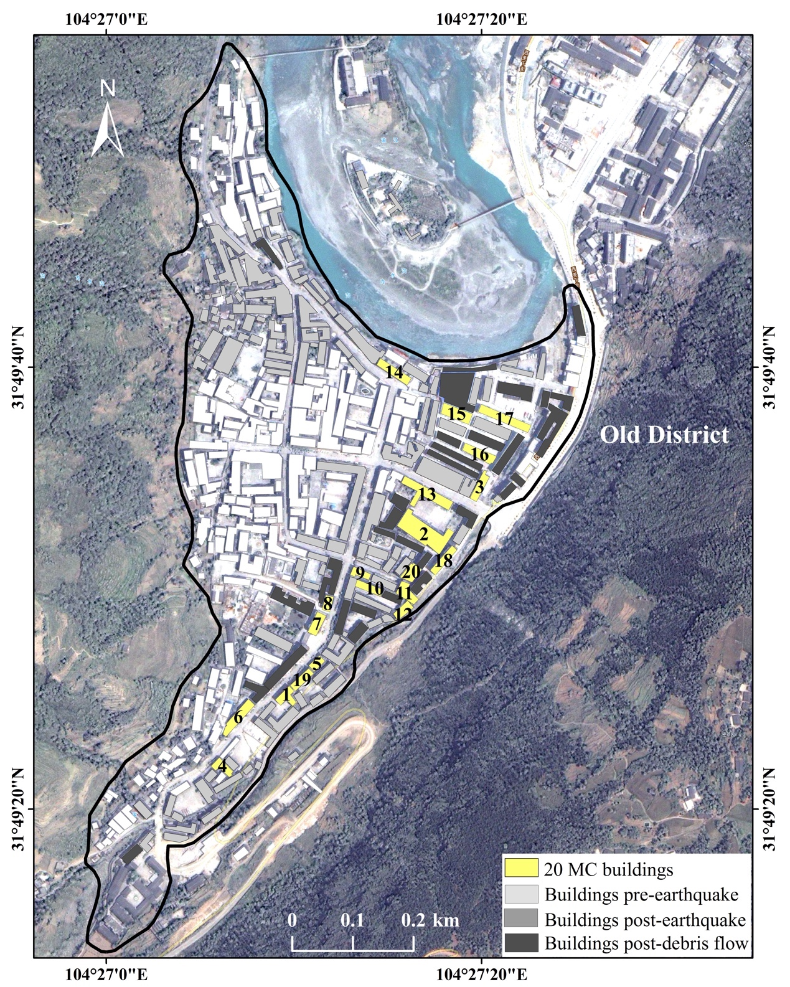

Fig. S1 Distribution of buildings in the old district of Beichuan County pre-earthquake (340), post-earthquake (173) and post-debris flow (63).

## 2.2 Precipitation record data of the Tangjiashan Rainfall Station

The rainstorm continued from the early morning of September 23, 2008 to the morning of September 24, in Beichuan County. According to the record of the Tangjiashan rainfall station which near Beichuan County, the rainfall at 24 hour on September 23 was 173.8 mm, of which the maximum hourly rain intensity was 61 mm; the rainfall at 0-5 on September 24 was 57.9 mm. The rainfall that eventually induced the debris flow was 5-6 hour, and its reached 41 mm/ h, and the previous cumulative rainfall has reached 231.7 mm.

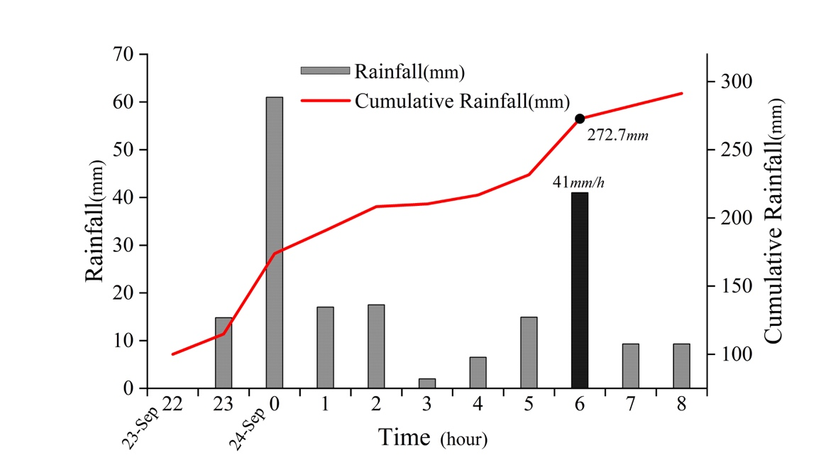

Fig. S2 Hourly and cumulative rainfall on 23-24 September 2008 at Tangjiashan Station.

# 3. Table (Line115—Line150)

## 3.1 Building data

**Table S1 Properties of the damaged MC buildings in Beichuan county.**

|  |  |  |  |  |  |  |  |  |
| --- | --- | --- | --- | --- | --- | --- | --- | --- |
| **No.** | | **Area ()** | **Building usage** | **Floor** | **Height**  **(m)** | **Residue Floor** | **Residue Height(m)** | **Damage State** |
| 1 | 526.822909 | | office | 3 | 9.6 | 3 | 9.6 | Cllapse |
| 2 | 2627.915601 | | office | 4 | 12.8 | 1 | 3.2 | Cllapse |
| 3 | 586.0315054 | | office | 3 | 9.6 | 2 | 6.4 | Cllapse |
| 4 | 463.3149836 | | office | 5 | 16 | 3 | 9.6 | Severe |
| 5 | 313.6515465 | | office | 2 | 6.4 | 2 | 6.4 | Severe |
| 6 | 925.4164639 | | residence | 5 | 16 | 4 | 12.8 | Severe |
| 7 | 564.247107 | | residence | 4 | 12.8 | 3 | 9.6 | Severe |
| 8 | 321.7272867 | | residence | 4 | 12.8 | 3 | 9.6 | Severe |
| 9 | 347.9864878 | | residence | 4 | 12.8 | 3 | 9.6 | Severe |
| 10 | 511.1694346 | | residence | 4 | 12.8 | 3 | 9.6 | Severe |
| 11 | 653.6908238 | | office | 5 | 16 | 4 | 12.8 | Severe |
| 12 | 458.0550682 | | office | 2 | 6.4 | 1 | 3.2 | Severe |
| 13 | 1456.153714 | | office | 4 | 12.8 | 3 | 9.6 | Severe |
| 14 | 773.5494115 | | residence | 7 | 22.4 | 6 | 19.2 | Severe |
| 15 | 892.6315444 | | residence | 3 | 9.6 | 1 | 3.2 | Severe |
| 16 | 772.1722723 | | office | 3 | 9.6 | 2 | 6.4 | Severe |
| 17 | 1146.121426 | | residence | 6 | 19.2 | 6 | 19.2 | Severe |
| 18 | 600.1829402 | | residence | 6 | 19.2 | 5 | 16 | Moderate |
| 19 | 504.1211654 | | office | 4 | 12.8 | 3 | 9.6 | Slight |
| 20 | 582.9668025 | | residence | 3 | 9.6 | 2 | 6.4 | Slight |

**Table S2 Classification of earthquake-debris flow disaster chain damage levels of buildings.**

|  |  |  |
| --- | --- | --- |
| **Damage degree** | **Damage description** | |
| **Earthquake** | **Debris flow** |
| **None** | The load-bearing walls are basically intact, the roof and floor are intact; individual non-load-bearing components are slightly damaged, such as slight cracks in individual doors and windows; the structure is functional and can be used without repairs. | Some sediment accumulation on the ground |
| **Slight** | No damage to the load-bearing wall or slight cracks in some cases, the roof and floor are intact; some non-load-bearing components are slightly damaged, or some are obviously damaged, such as the collapse of the eaves, the slippage of the sloping roof, and obvious indoor plastering cracks; the basic function of the structure is not affected, and it can be used continuously with a little repair or no repair. | Less than half a story is buried |
| **Moderate** | Most load-bearing walls have slight cracks, some walls have obvious cracks, and some walls have serious cracks; individual roofs and floors have cracks, and most non-load-bearing components have obvious damage, such as the sloping roof has more displacement、deformation and sliding tiles, and falling off of the indoor plastering surface; the basic function of the structure is affected to a certain extent, and it can be used after repair. | Less than one story is buried |
| **Severe** | Most load-bearing walls have obvious cracks, and some are seriously damaged, such as wall dislocation, broken, internal or external tilt or partial collapse; roofs and floors have cracks, and part of the sloped roof collapses or is seriously displaced and deformed; the non-load-bearing components are seriously damaged, such as the non-load-bearing wall collapses in pieces; or the overall structure is obviously inclined; the basic functions of the structure are severely affected, and even some functions are lost, which is difficult to repair or has no repair value. | More than one story is buried |
| **Complete** | Most of the walls are severely damaged, the structure is on the verge of collapse or has collapsed, the function of the structure no longer exists, and there is no possibility of repair. | Two or more stories are buried |

## 3.2 Parameters of masonry concrete building vulnerability calculation

**Table S3 The calculation parameters of the MC building vulnerability.**

|  |  |  |  |  |  |  |
| --- | --- | --- | --- | --- | --- | --- |
| ***S*** |  |  |  |  |  |  |
| 1.15 |  | 0.45 s | 0.91 | 12000 N | 0.57 | 0.242 |

The site coefficient ***S***will use the spectral shape of the C-type soil(1.15) that meets the conditions of the Beichuan site by comparing European regulations (Xiang 2012);the damping correction coefficient , and the value is 1 (Xiang 2012); the characteristic period , here is 0.45s(MOHURD 2001); the mode shape participation coefficient is 0.91, the seismic mass at the generic *ith* story is 12000N(Yin 2004).

## 3.3 Representative parameter values in masonry concrete building vulnerability calculation

**Table S4 Representative parameters of the ESDOF system for the structure in different configurations (intact, post- earthquake and post-debris flows ) and residual capacity in terms of spectral acceleration and peak ground acceleration.**

|  |  |  |  |  |  |  |  |  |  |  |  |  |  |  |  |  |
| --- | --- | --- | --- | --- | --- | --- | --- | --- | --- | --- | --- | --- | --- | --- | --- | --- |
| No. | Damage State | *Intact* | | | | | *Post - Earthquake* | | | | | *Post - Debris flows* | | | | |
| *u* | *Cb(g)* | *Teq(s)* | *RECsa,0* | *RECag,0* | *u-k* | *Cb(g),k* | *Teq(s),k* | *RECsa,k* | *RECag,k* | *u-k* | *Cb(g),k* | *Teq(s),k* | *RECsa,k* | *RECag,k* |
| 1 | D4 | 2.99005 | 5.01753 | 0.10055 | 3.23123 | 0.25114 | — | 1.67807 | 0.17388 | 0.35160 | 0.04725 | 0 | 0 | 0 | 1 | 0 |
| 2 | D4 | 2.49254 | 4.83833 | 0.11824 | 2.89748 | 0.26481 | — | 0.64704 | 0.16167 | 0.76754 | 0.09591 | 0 | 0 | 0 | 1 | 0 |
| 3 | D4 | 2.99005 | 5.01753 | 0.10055 | 3.23123 | 0.25114 | — | 1.19862 | 0.16798 | 0.55256 | 0.07175 | 0 | 0 | 0 | 1 | 0 |
| 4 | D3 | 2.19403 | 4.73081 | 0.13369 | 2.67820 | 0.27676 | 0.99502 | 1.88509 | 0.16405 | 0.99658 | 0.12637 | 0.65837 | 0.37702 | 0.15563 | 0.95545 | 0.11494 |
| 5 | D3 | 3.98507 | 5.37592 | 0.07932 | 3.82860 | 0.23473 | 1.49254 | 2.15681 | 0.12523 | 1.29562 | 0.12541 | 1.48756 | 0.43136 | 0.09700 | 1.04533 | 0.07837 |
| 6 | D3 | 2.19403 | 4.73081 | 0.13369 | 2.67820 | 0.27676 | 0.74627 | 2.42369 | 0.16706 | 0.77169 | 0.09965 | 0.24378 | 0.48474 | 0.12941 | 0.89459 | 0.08948 |
| 7 | D3 | 2.49254 | 4.83833 | 0.11824 | 2.89748 | 0.26481 | 0.99502 | 2.15496 | 0.15344 | 0.99634 | 0.11816 | 0.65837 | 0.43099 | 0.11885 | 0.96111 | 0.08829 |
| 8 | D3 | 2.49254 | 4.83833 | 0.11824 | 2.89748 | 0.26481 | 0.99502 | 2.15496 | 0.15344 | 0.99634 | 0.11816 | 0.65837 | 0.43099 | 0.11885 | 0.96111 | 0.08829 |
| 9 | D3 | 2.49254 | 4.83833 | 0.11824 | 2.89748 | 0.26481 | 0.99502 | 2.15496 | 0.15344 | 0.99634 | 0.11816 | 0.65837 | 0.43099 | 0.11885 | 0.96111 | 0.08829 |
| 10 | D3 | 2.49254 | 4.83833 | 0.11824 | 2.89748 | 0.26481 | 0.99502 | 2.15496 | 0.15344 | 0.99634 | 0.11816 | 0.65837 | 0.43099 | 0.11885 | 0.96111 | 0.08829 |
| 11 | D3 | 2.19403 | 4.73081 | 0.13369 | 2.67820 | 0.27676 | 0.74627 | 2.42369 | 0.16706 | 0.77169 | 0.09965 | 0.24378 | 0.48474 | 0.12941 | 0.89459 | 0.08948 |
| 12 | D3 | 3.98507 | 5.37592 | 0.07932 | 3.82860 | 0.23473 | 2.98507 | 1.29408 | 0.11432 | 1.65258 | 0.14602 | 3.97512 | 0.25882 | 0.08855 | 1.15152 | 0.07881 |
| 13 | D3 | 2.49254 | 4.83833 | 0.11824 | 2.89748 | 0.26481 | 0.99502 | 2.15496 | 0.15344 | 0.99634 | 0.11816 | 0.65837 | 0.43099 | 0.11885 | 0.96111 | 0.08829 |
| 14 | D3 | 1.85288 | 4.60793 | 0.16028 | 2.39979 | 0.29731 | 0.49751 | 2.79966 | 0.19038 | 0.40485 | 0.05957 | 0.07794 | 0.55993 | 0.12933 | 0.85161 | 0.08513 |
| 15 | D3 | 2.99005 | 5.01753 | 0.10055 | 3.23123 | 0.25114 | 2.98507 | 1.07787 | 0.12526 | 1.59557 | 0.15448 | 3.97512 | 0.21557 | 0.09702 | 1.13828 | 0.08537 |
| 16 | D3 | 2.99005 | 5.01753 | 0.10055 | 3.23123 | 0.25114 | 1.49254 | 1.79644 | 0.13721 | 1.26980 | 0.13467 | 1.48756 | 0.35929 | 0.10628 | 1.04137 | 0.08555 |
| 17 | D3 | 1.99502 | 4.65913 | 0.14757 | 2.52033 | 0.28749 | 0.49751 | 3.11125 | 0.18059 | 0.37260 | 0.05201 | 0.17081 | 0.62225 | 0.13988 | 0.77353 | 0.08364 |
| 18 | D2 | 1.99502 | 4.65913 | 0.14757 | 2.52033 | 0.28749 | 1.19403 | 3.94234 | 0.14645 | 1.24895 | 0.14138 | 0.99005 | 0.78847 | 0.11344 | 0.99802 | 0.08751 |
| 19 | D1 | 2.49254 | 4.83833 | 0.11824 | 2.89748 | 0.26481 | 2.39005 | 3.76314 | 0.11611 | 2.34971 | 0.21088 | 2.98342 | 0.75263 | 0.08994 | 1.29835 | 0.09026 |
| 20 | D1 | 2.99005 | 5.01753 | 0.10055 | 3.23123 | 0.25114 | 3.43507 | 3.58395 | 0.09715 | 2.88401 | 0.21655 | 4.72512 | 0.71679 | 0.07525 | 1.44650 | 0.08413 |