Phase 2: Org Setup & Configuration

**1.Salesforce Edition**

Choose the **Salesforce Developer Edition** for your project.

* Provides all tools needed for practice, development, and testing.
* Free to use, supports all key features, and is ideal for student projects.

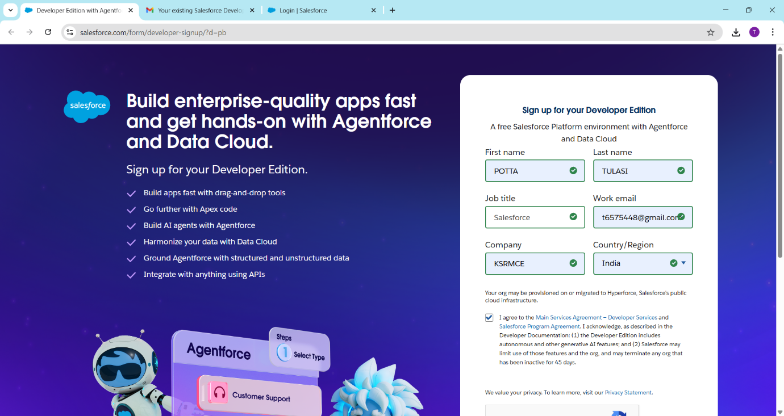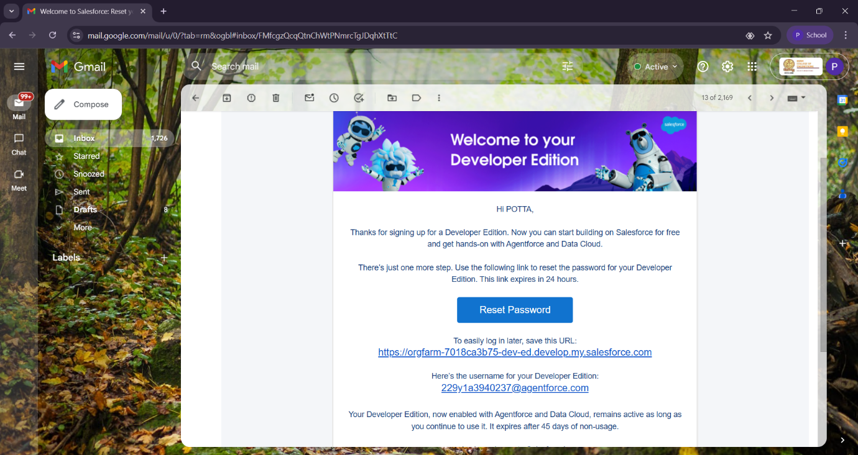

**2. Company Profile Setup**

* Navigate to **Setup → Company Information**.
* Update your organization details:
  + Organization Name
  + Time Zone: **GMT +05:30**
  + Currency: **INR**
  + Default Language: **English (India)**
* Confirm the main contact details.

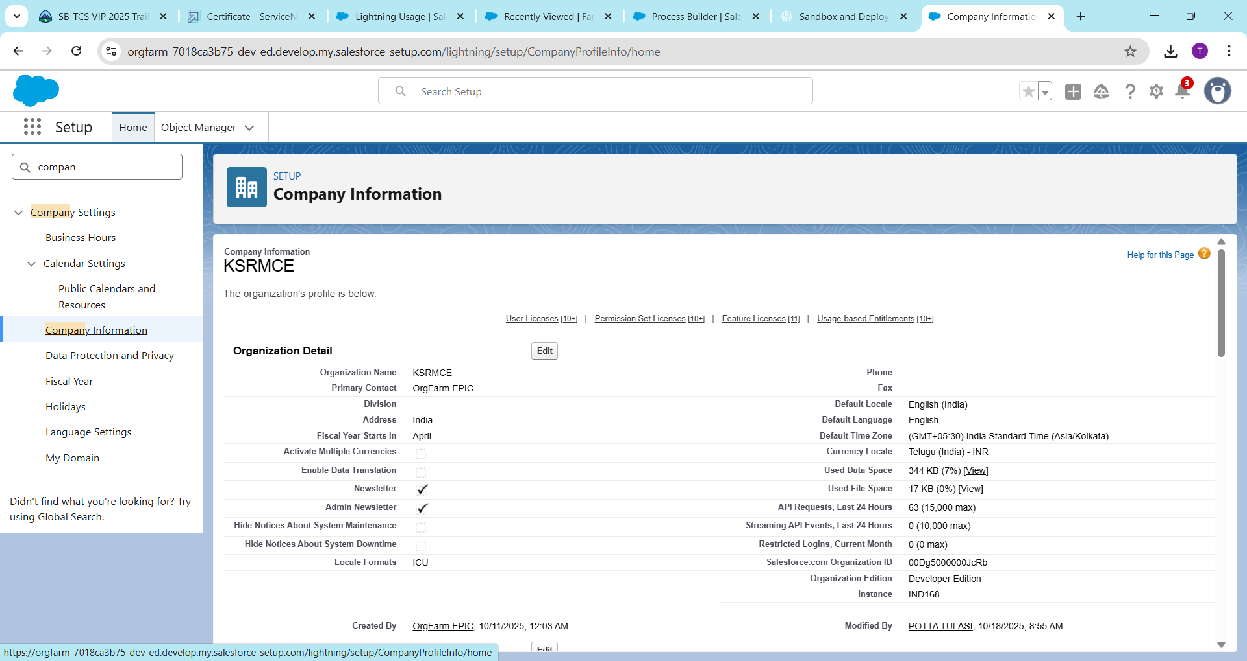

**3. Business Hours & Holidays**

* **Business Hours:** Setup → Business Hours → New
  + Working Days: Monday to Saturday
  + Working Hours: 9:00 AM – 6:00 PM
* **Holidays:** Setup → Holidays → New
  + Add important holidays like Independence Day and Diwali.
  + Ensures workflows and escalation rules respect non-working days.

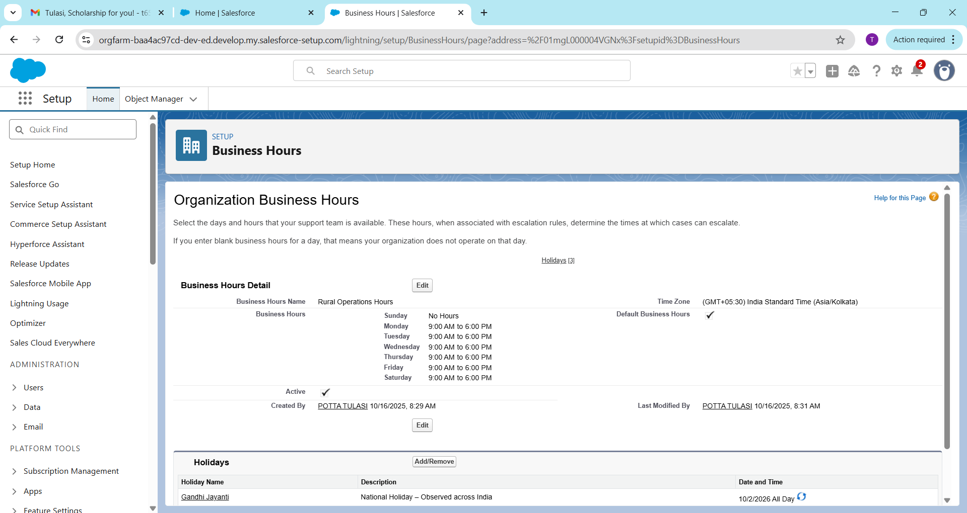

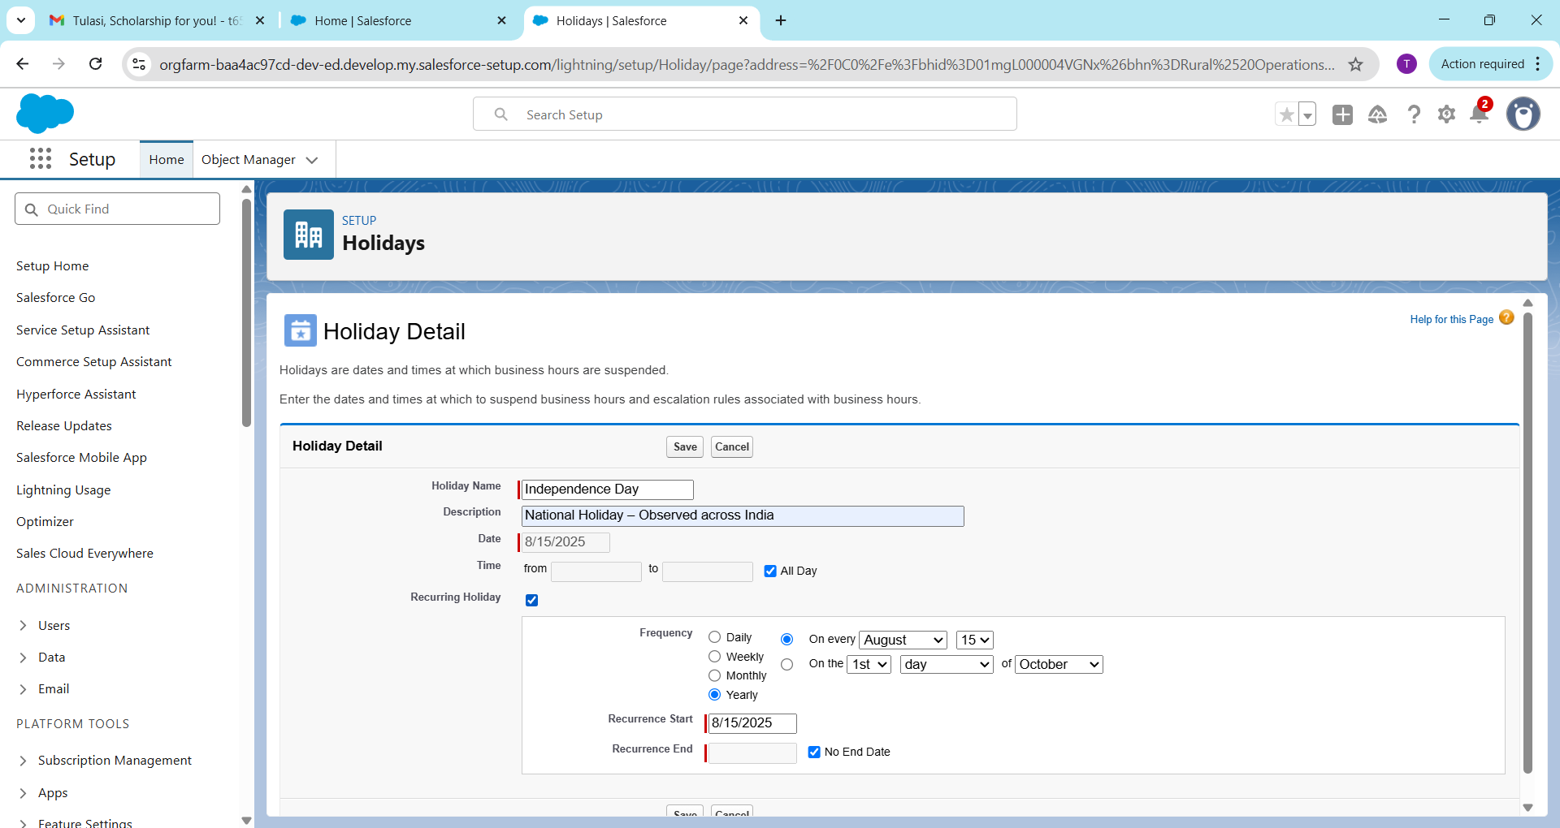

**4. Fiscal Year Settings**

* Navigate to **Setup → Fiscal Year**
* Select **Standard Fiscal Year**
* Set **Start Month:** April, **End Month:** March
* Matches the Indian government’s financial reporting cycle.

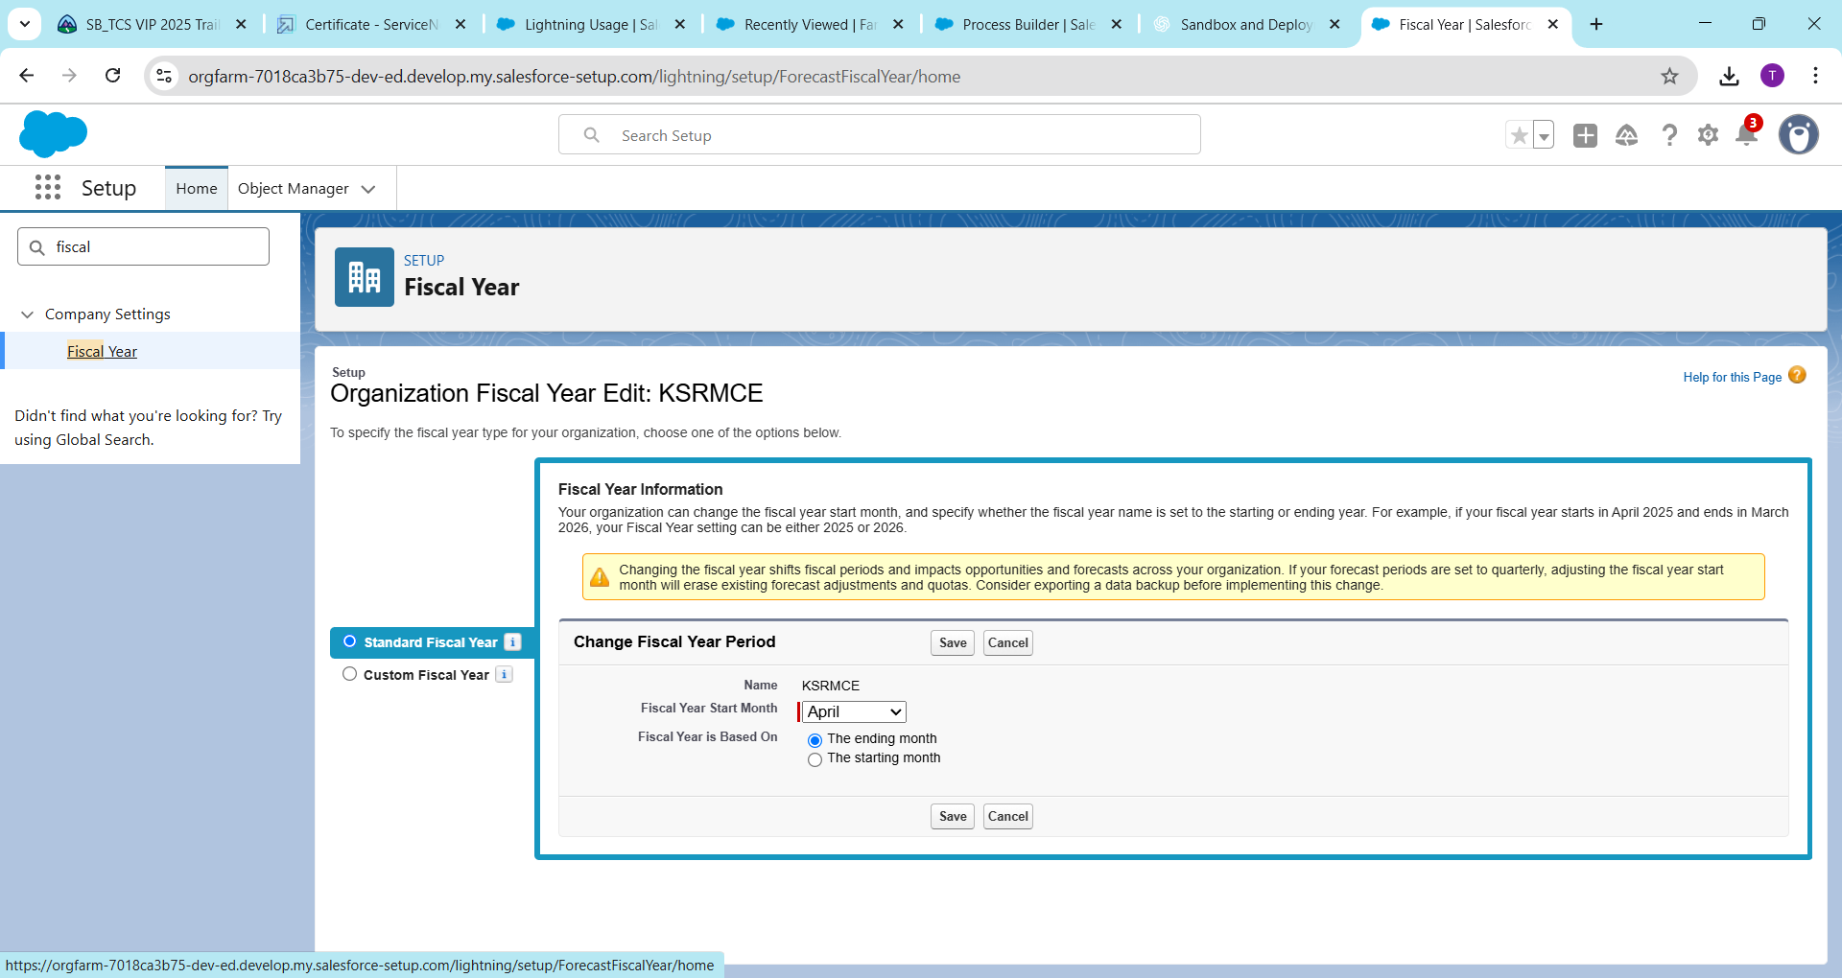

**5. User Setup & Licenses**

* Go to **Setup → Users → New User**
* Create accounts for:
  + **System Admin**
  + **Government Officer**
  + **Buyer**
  + **Farmer**
* Assign appropriate **Salesforce licenses** and **roles** to each user.

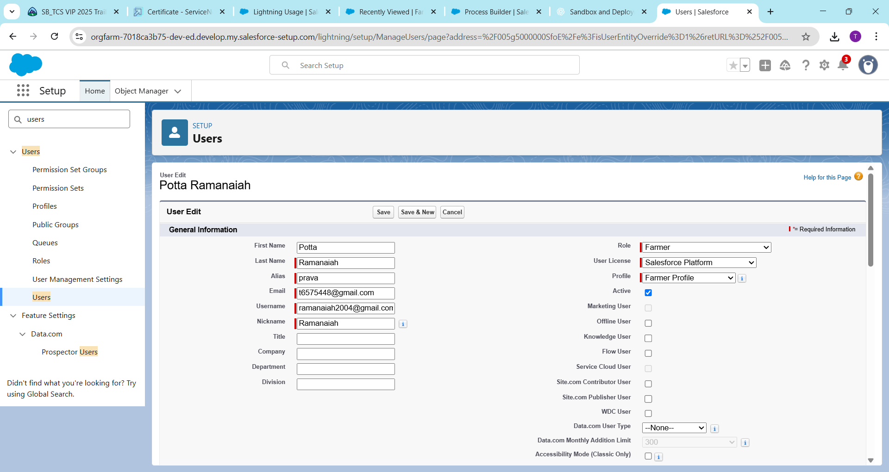

**6. Profiles**

* Navigate to **Setup → Profiles**
* Clone the **Standard User** profile and rename it.
* Create profiles such as:
  + Farmer Profile
  + Buyer Profile
  + Officer Profile
* Assign **object-level** and **field-level permissions** according to user responsibilities.

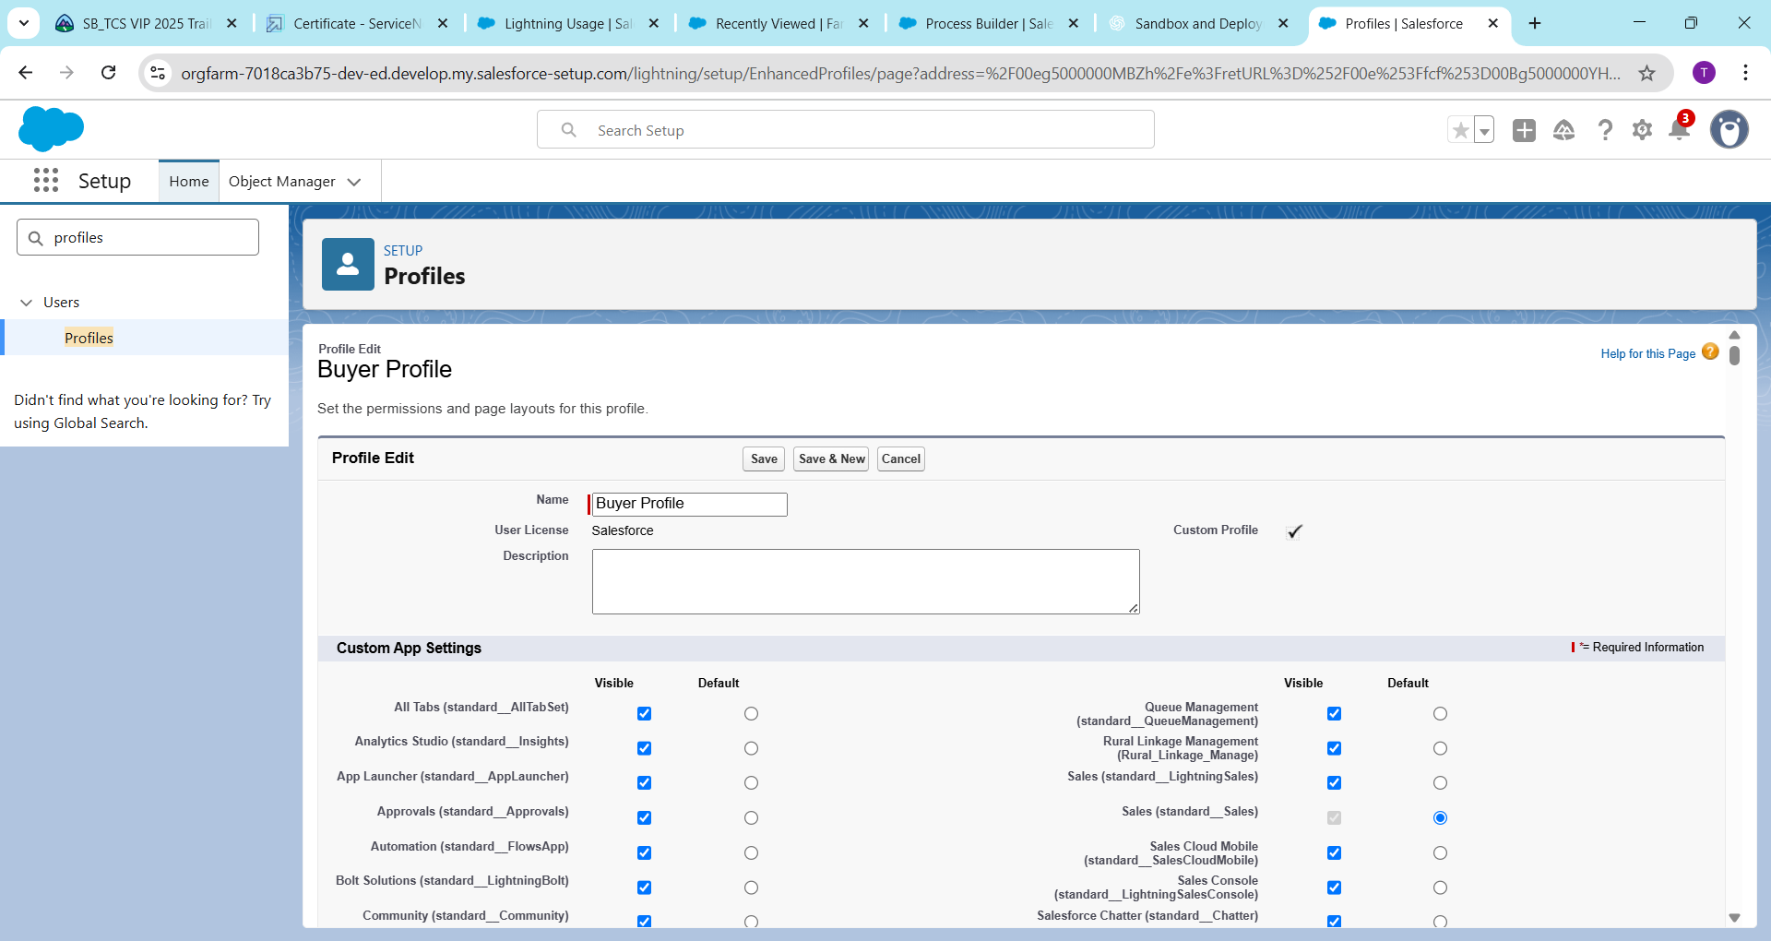

**7. Roles**

* Go to **Setup → Roles → Set Up Roles**
* Define a data visibility hierarchy:

System Admin

→ Government Officer

→ Buyer

→ Farmer

* Ensures data flows securely upward through the organization.

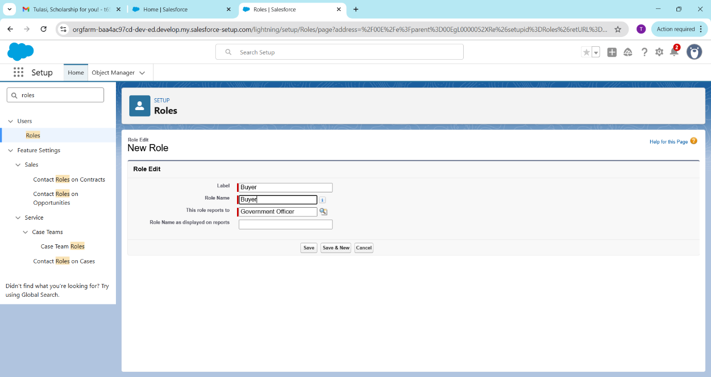

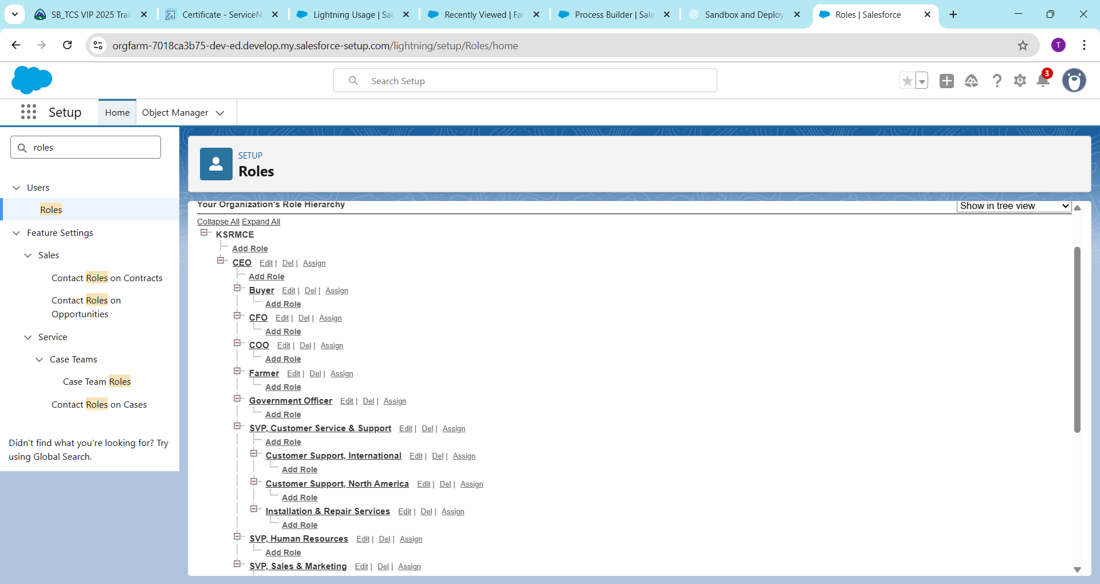

**8. Permission Sets**

* Navigate to **Setup → Permission Sets → New**
* Create additional privileges such as:
  + Opportunity Access
  + Data Export Access
* Assign permission sets to users who require extra access without changing their profiles.

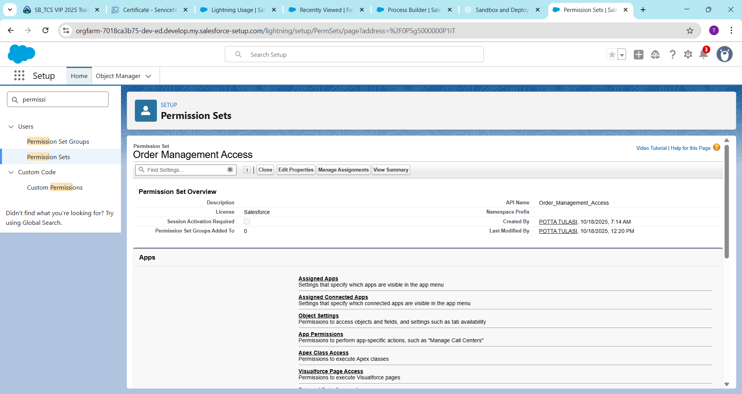

**9. Organization-Wide Defaults (OWD)**

* Go to **Setup → Sharing Settings → Edit**
* Configure default record access:
  + Farmer: **Private**
  + Buyer: **Private**
  + Product: **Public Read-Only**
  + Market Transaction: **Controlled by Parent**
* Ensures data security and proper sharing control.

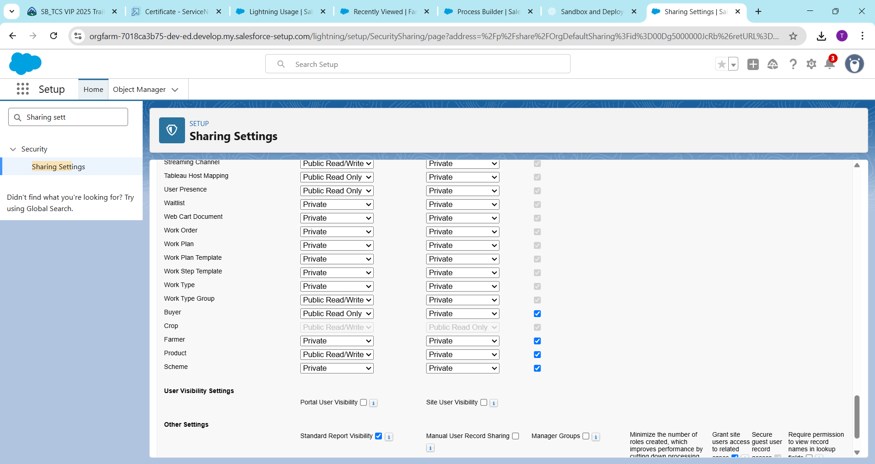

**10. Sharing Rules**

* Navigate to **Setup → Sharing Settings → New Rule**
* Create sharing rules for collaboration:
  + Share **Farmer** records with Buyers (Read Only)
  + Share **Opportunities** with Government Officers (Read/Write)
* Allows teamwork without compromising data security.

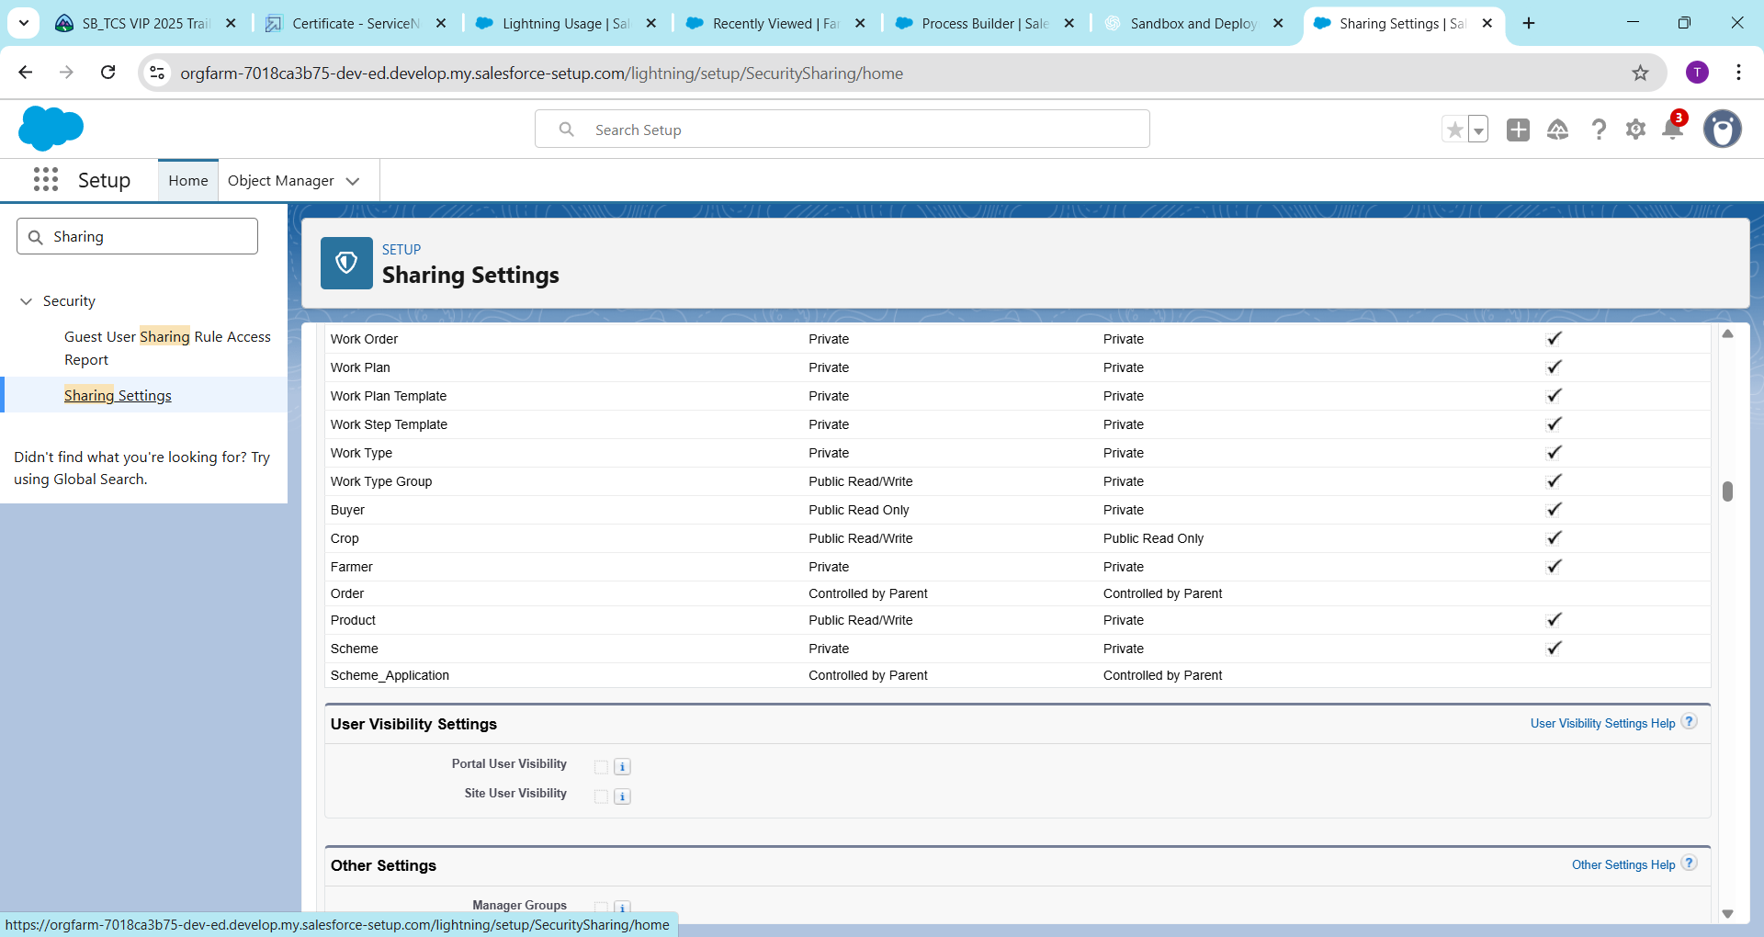

**11. Login Access Policies**

* Go to **Setup → Login Access Policies**
* Enable **Grant Login Access to Administrators**
* Helps administrators troubleshoot login or data issues while maintaining transparency.

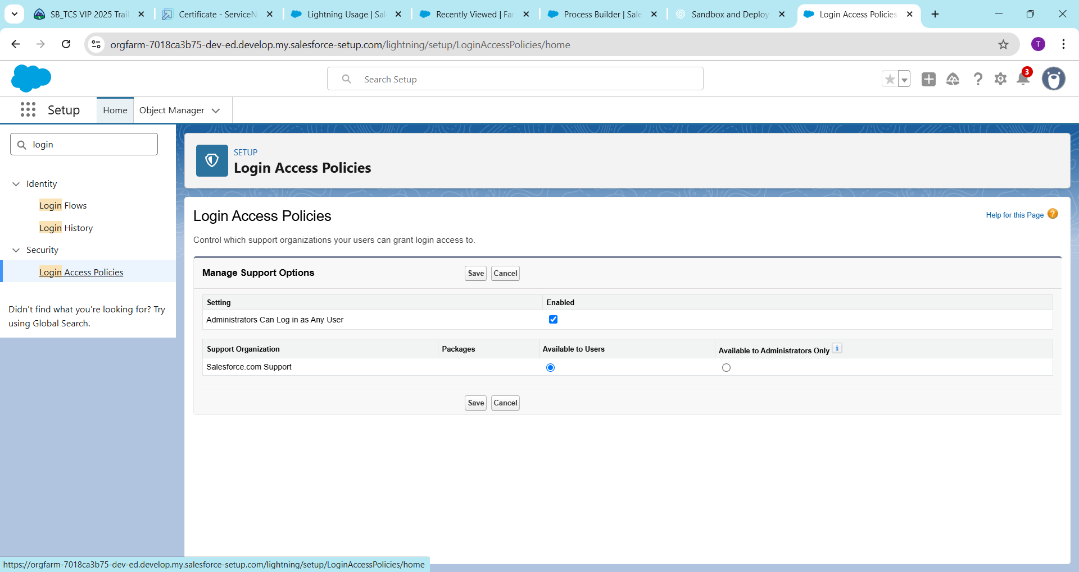

**12. Developer Org Setup**

* Sign up for a free **Salesforce Developer Org** at [developer.salesforce.com](https://developer.salesforce.com)
* Navigate to **Setup → App Manager → New Lightning App**
* Create your app named **Rural Market Linkage CRM**
* This serves as the main environment for customization and testing.



