# **PHASE 3: DATA MODELING & RELATIONSHIPS**

**1️⃣ Standard & Custom Objects**

**Standard Objects**

These are Salesforce’s built-in objects.  
Examples:

* **Account** → Can represent “Cooperatives” or “Organizations.”
* **Contact** → Can represent “Farmer Contacts.”
* **Opportunity** → Can represent “Orders.”
* **Case** → Can represent “Complaints or Service Requests.”

**Custom Objects**

You create these for your project-specific needs.  
**Path:**  
👉 Setup → Object Manager → **Create → Custom Object**

| **Object Name** | **API Name** | **Purpose** |
| --- | --- | --- |
| Farmer | Farmer__c | Stores farmer details |
| Buyer | Buyer__c | Stores buyer details |
| Crop | Crop__c | Details of crops |
| Order | Order__c | Links farmers and buyers |
| Subsidy Application | Subsidy_Application__c | Government subsidy tracking |

✅ After creating each, check:

* Allow Reports
* Allow Activities
* Track Field History (important for auditing)

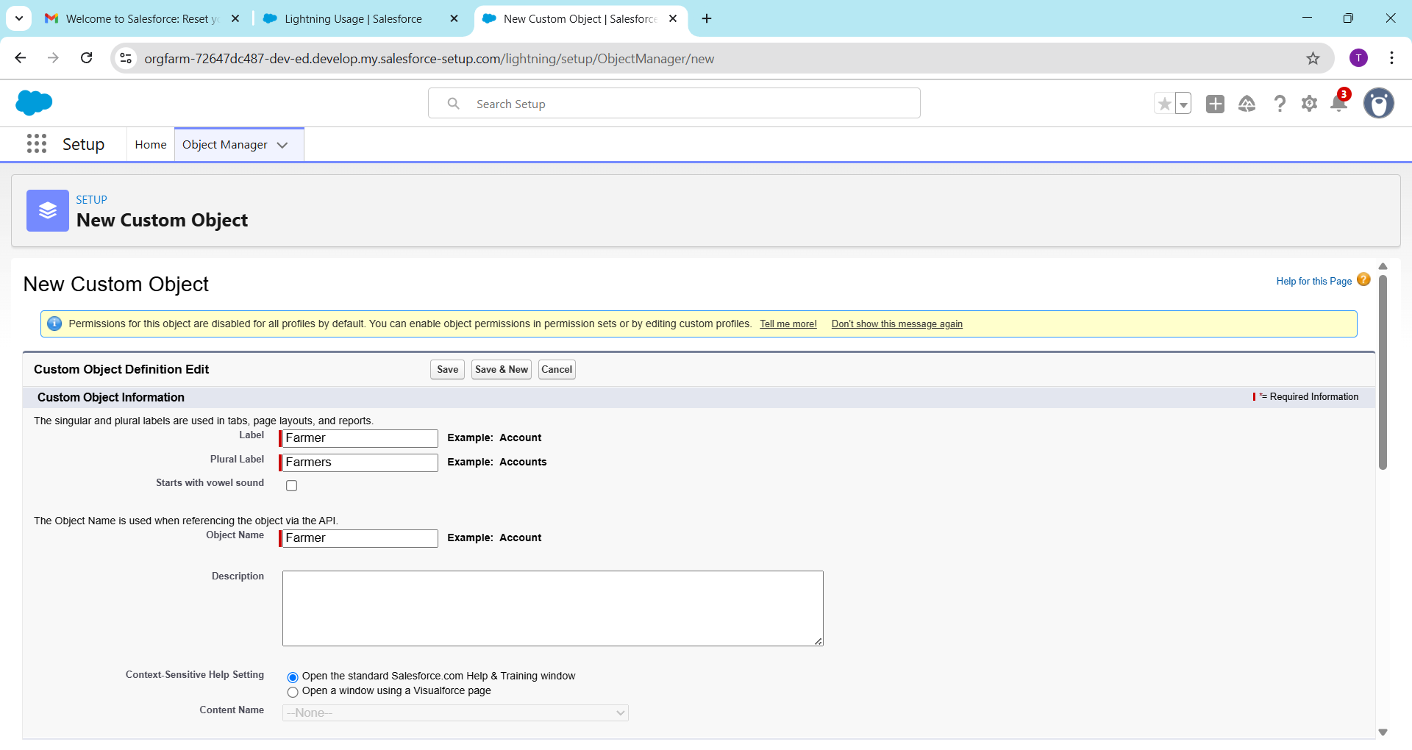

**2️⃣ Fields**

Each object has **fields** that store data.  
**Path:** Object Manager → [Object Name] → Fields & Relationships → New

| **Field Label** | **Data Type** | **Example / Notes** |
| --- | --- | --- |
| Farmer Name | Text | Full name |
| Mobile Number | Phone | Farmer’s contact |
| Crop Type | Picklist | Rice, Wheat, Maize |
| Quantity | Number | Kg or Quintals |
| Price | Currency | Selling price |
| Order Date | Date | Date of sale |
| Cooperative | Lookup(Cooperative) | Connects farmer with cooperative |

✅ Use **Formula Fields** for calculations  
Example: Total_Amount__c = Quantity__c * Price__c

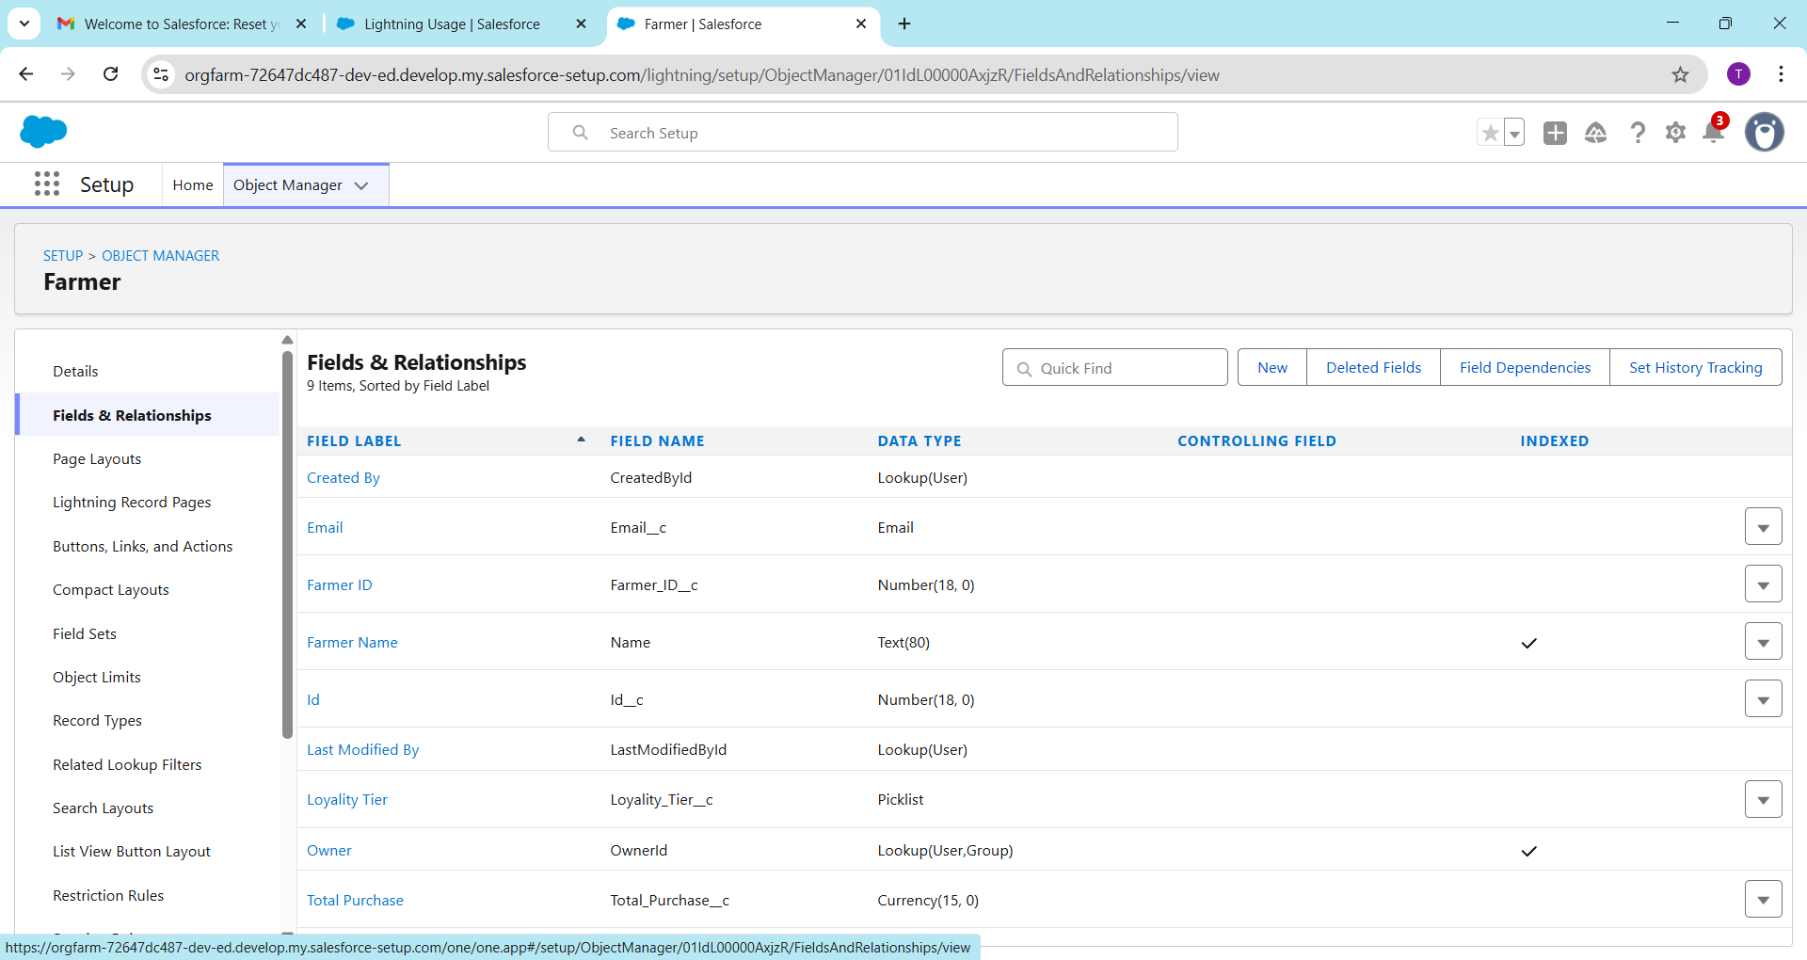

**3️⃣ Record Types**

Used when you need **different views or processes** for the same object.  
Example:

* **Order__c**
  + Record Type 1: *Farmer Order*
  + Record Type 2: *Buyer Purchase*

**Path:** Object Manager → [Object] → Record Types → New

✅ Assign to profiles as needed.

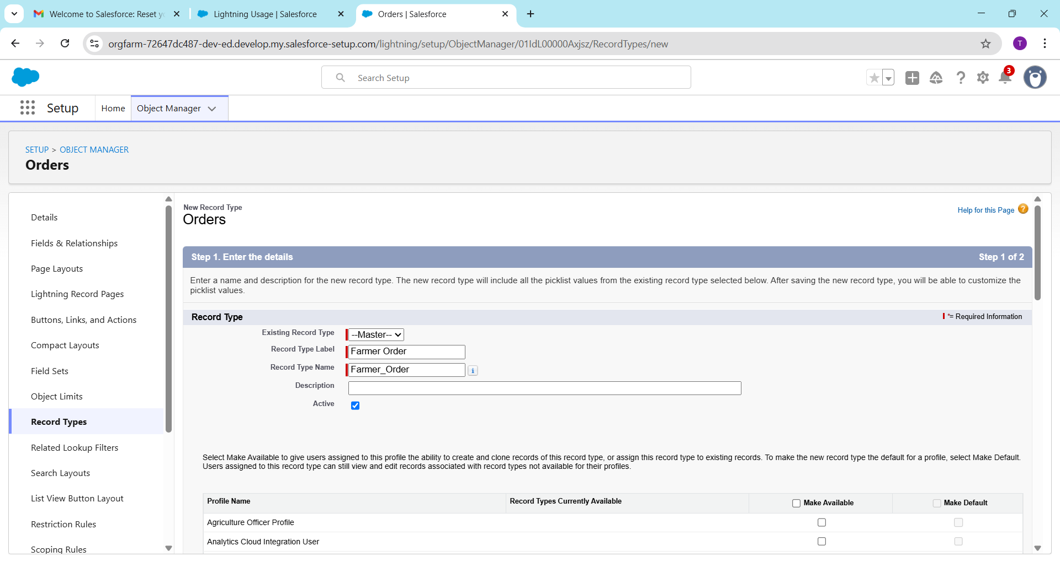

**4️⃣ Page Layouts**

Controls what users **see and edit** on a record page.  
Example:

* Farmer Page Layout → shows personal, crop, and cooperative fields
* Buyer Page Layout → shows order and payment details

**Path:** Object Manager → [Object] → Page Layouts → Edit

✅ You can:

* Drag & drop fields
* Add related lists (Orders, Crops)
* Assign layouts by profile

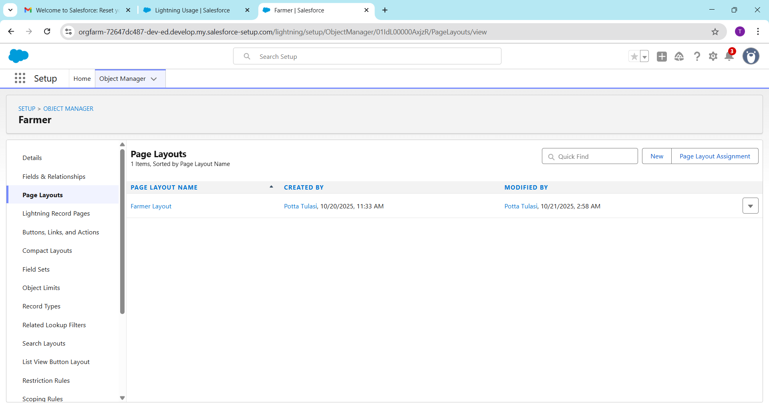

**5️⃣ Compact Layouts**

Controls which **fields show in highlights panel** (top area of record page).  
Example:  
For **Farmer__c**, include:

* Farmer Name
* Mobile Number
* Cooperative

**Path:** Object Manager → [Object] → Compact Layouts → New → Assign as Primary

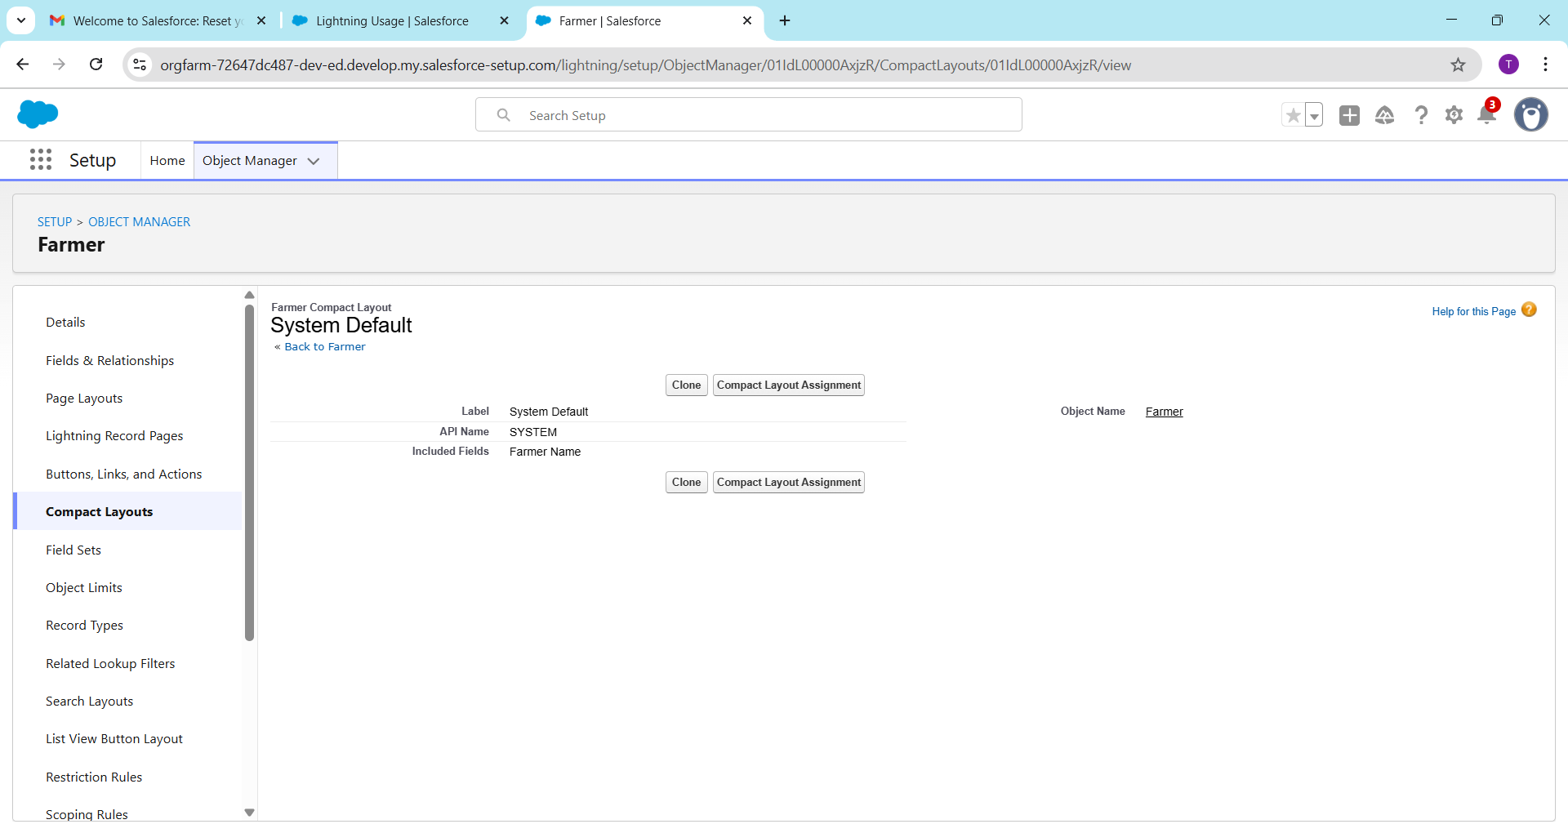

**6️⃣ Schema Builder**

Visual tool to see **objects + fields + relationships** in one diagram.  
**Path:** Setup → Schema Builder

✅ Select your custom objects (Farmer, Buyer, Crop, Order)  
You can drag to create relationships directly here.

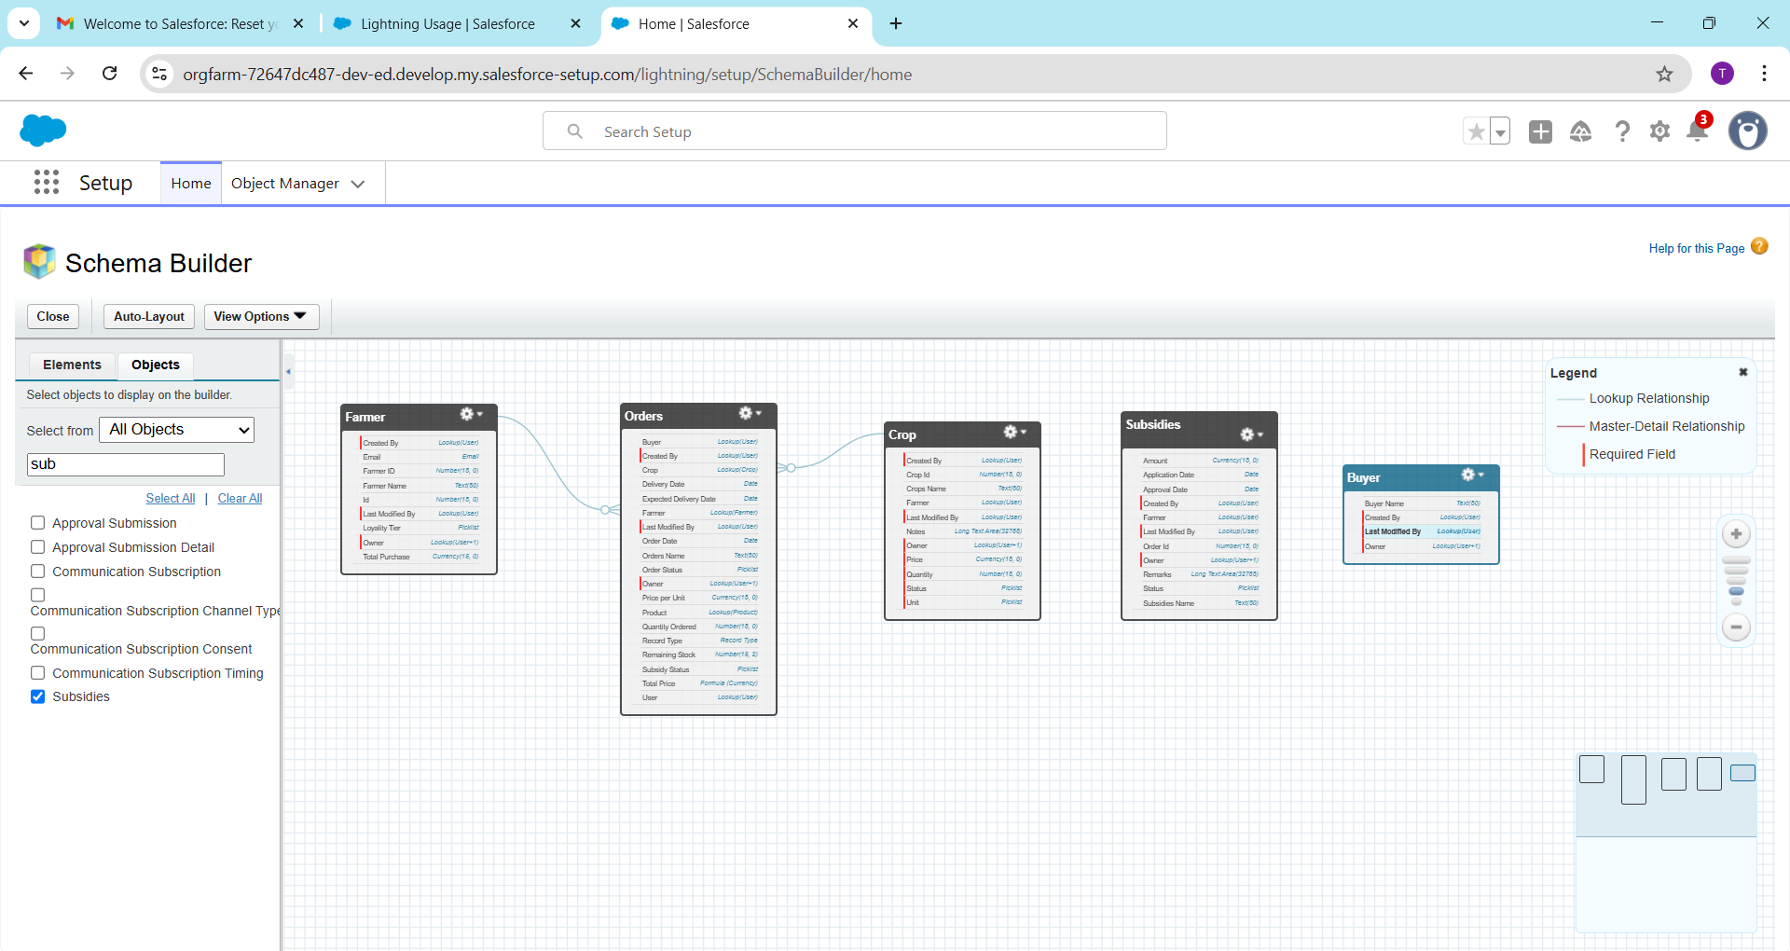

**7️⃣ Relationships**

Relationships connect data between objects.

| **Type** | **Description** | **Example** |
| --- | --- | --- |
| **Lookup** | Loose link between two objects | Order → Farmer |
| **Master-Detail** | Strong link (child depends on parent) | Crop → Cooperative |
| **Hierarchical** | Only for User object (managers) | User → Manager |

**How to Create:**  
👉 Object Manager → [Child Object] → Fields & Relationships → New → Relationship Type

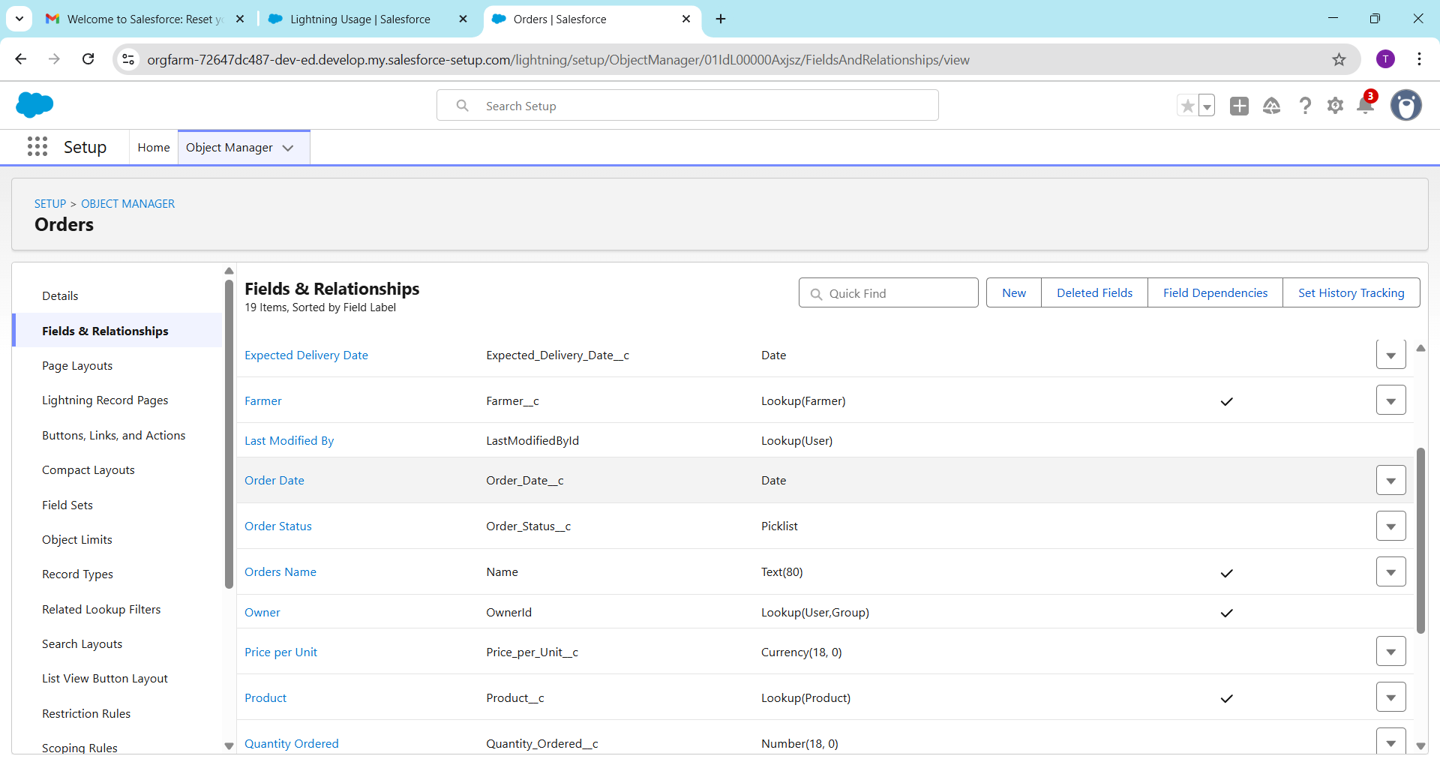

**8️⃣ Junction Objects (Many-to-Many)**

Used when **one record relates to many records** on both sides.

Example:

* A **Farmer** can grow many **Crops**
* A **Crop** can be grown by many **Farmers**

Create **Junction Object:**  
→ Name: *FarmerCrop__c*  
→ Add two Master-Detail fields:

* Farmer (to Farmer__c)
* Crop (to Crop__c)

This forms **Many-to-Many Relationship** ✅

**9️⃣ External Objects (for External Data)**

Used when data is **stored outside Salesforce** (e.g., government subsidy API or external database).

* Use **Salesforce Connect** to link external data.
* Appears like a normal object but data is fetched real-time.

**Path:** Setup → External Data Source → New → Define connection → Validate & Sync

Example:

* **External Object Name:** Government_Subsidy__x  
  → Fields: Farmer_ID, Status, Amount

