**📘 Rural Market Linkage – Phase 4: Process Automation (Admin)**

**🔶 1. Phase Overview**

**Objective:**  
Automate manual tasks and ensure data consistency using Salesforce automation tools such as Validation Rules, Process Builder, Approval Processes, and Flows.

**Scope:**  
This phase focuses on automating processes for:

* Farmer registration
* Order confirmation and tracking
* Subsidy approvals
* Buyer communication

**🔶 2. Tools Used**

| **Tool** | **Purpose** |
| --- | --- |
| Validation Rules | Data entry control |
| Workflow Rules | Simple automation |
| Process Builder | Multi-step automation |
| Approval Process | Manager approval logic |
| Flow Builder | Complex automation & screen flows |
| Email Alerts | Automated email communication |
| Field Updates | Automatic record changes |
| Tasks | Follow-up reminders |
| Custom Notifications | In-app alerts for users |

**🔶 3. Validation Rules**

**Object:** Farmer__c

**Purpose:** Ensure mandatory data entry

**Rule Name:** Phone_Required

**Formula:**

ISBLANK(Phone__c)**Error Message:** “Please enter a valid phone number.”  
**Error Location:** Field → Phone__c

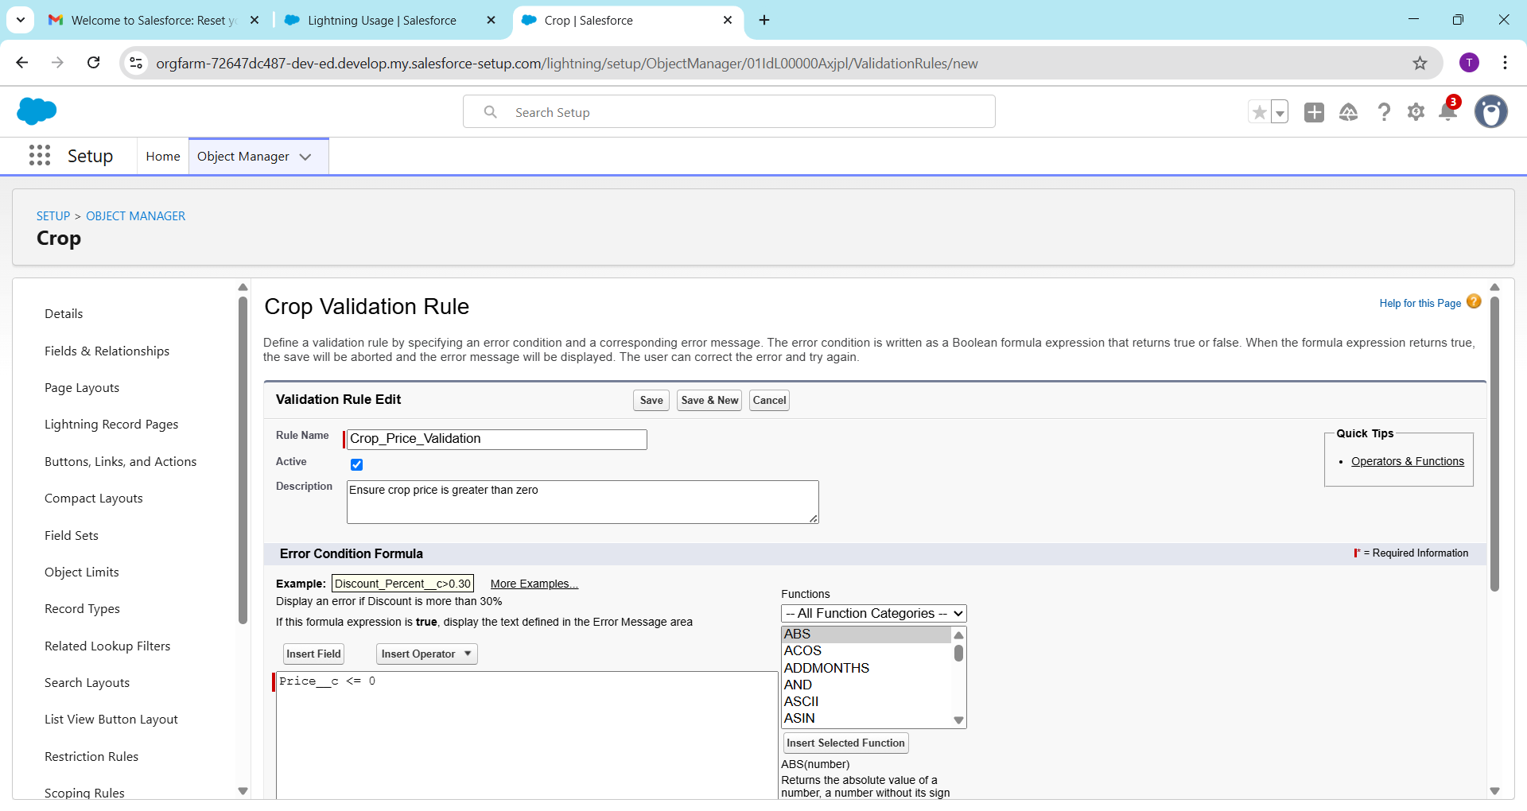

**🔶 4. Workflow Rule (Optional)**

**Object:** Order__c  
**Rule Criteria:**  
When Status__c = "Completed"

**Actions:**

* Send email to Farmer confirming order completion.
* Update Buyer’s “Last Order Date.”

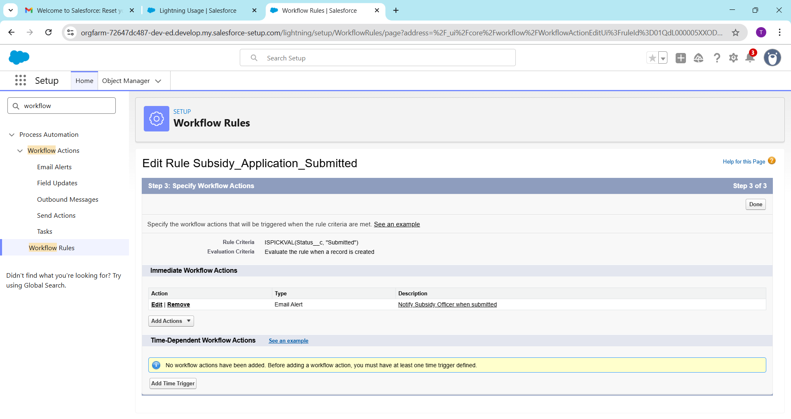

**🔶 5. Process Builder**

**Object:** Order__c

**Trigger:** Record Created or Updated  
**Criteria:** Status__c = 'Confirmed'

**Actions:**

1. Update Buyer__c.Last_Order_Date__c = TODAY()
2. Send email to Buyer
3. Post to Chatter: “New order confirmed for {Crop_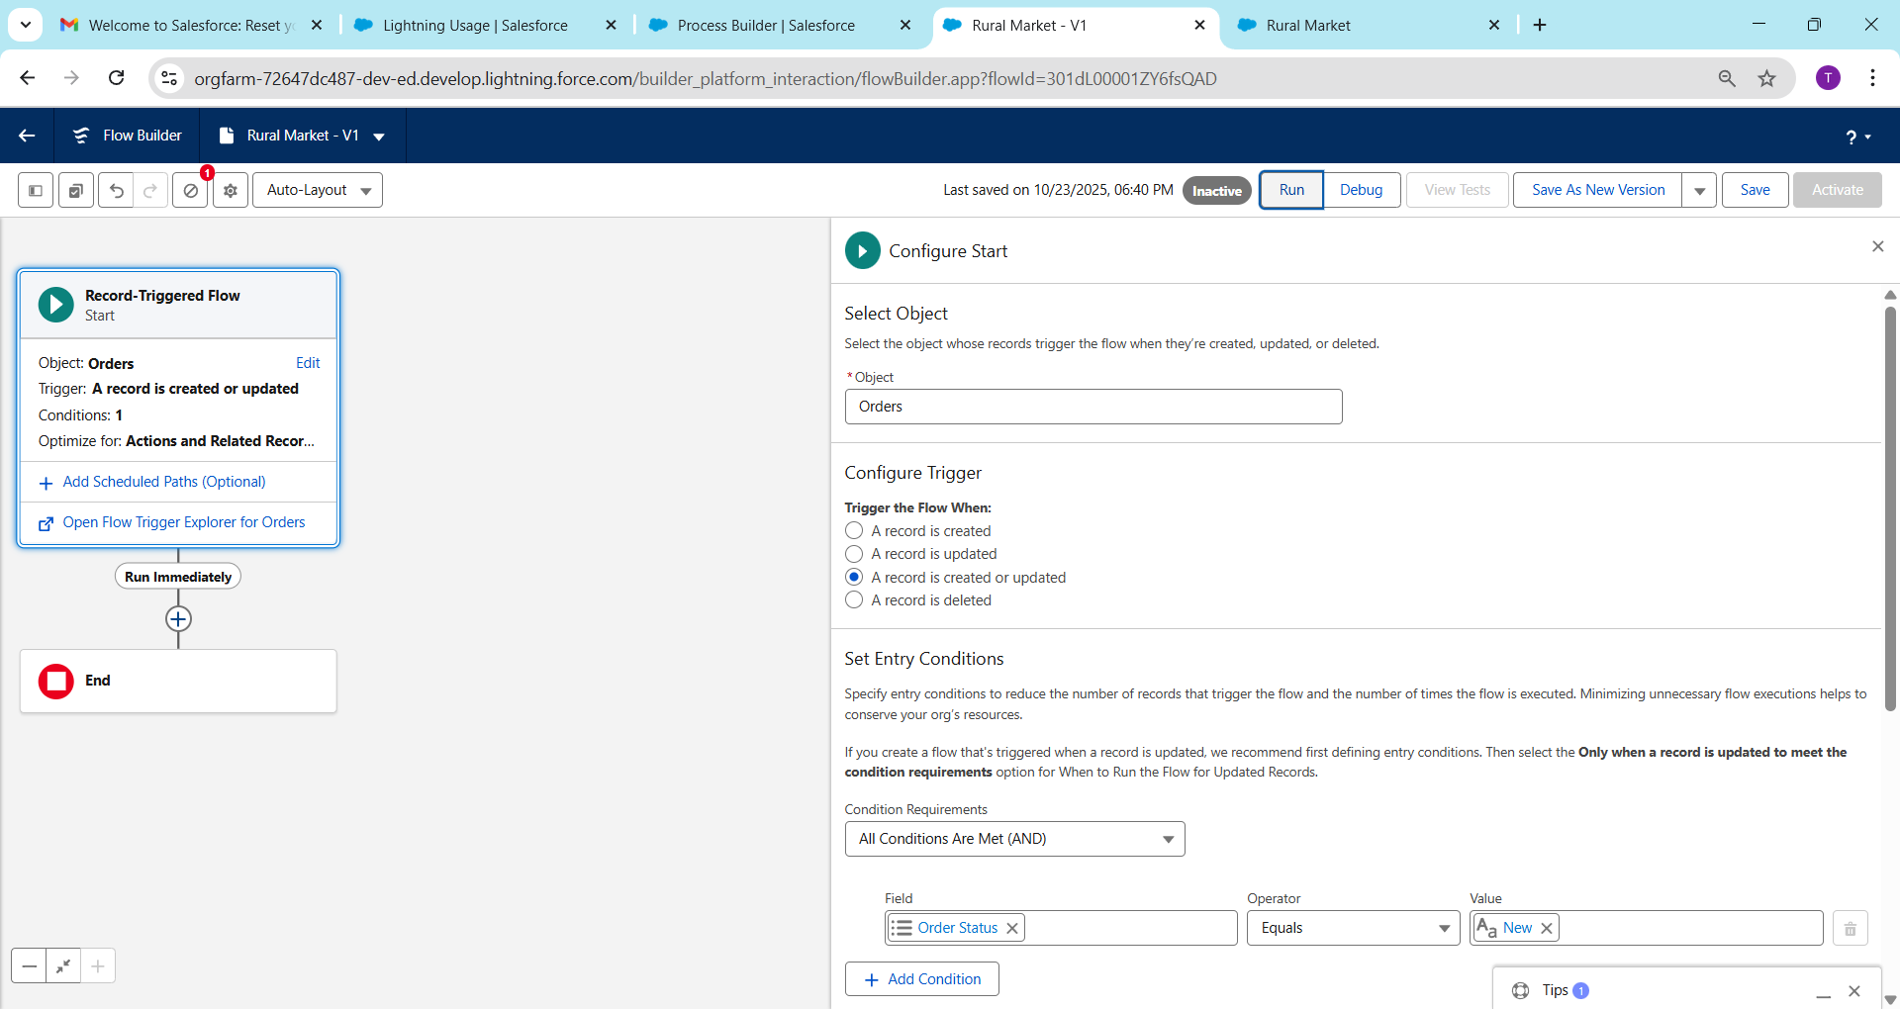

**🔶 6. Approval Process**

**Object:** Subsidy_Application__c  
**Entry Criteria:** Amount__c > 5000

**Steps:**

1. Manager approval required
2. On approval → Status = "Approved"
3. On rejection → Status = "Rejected"

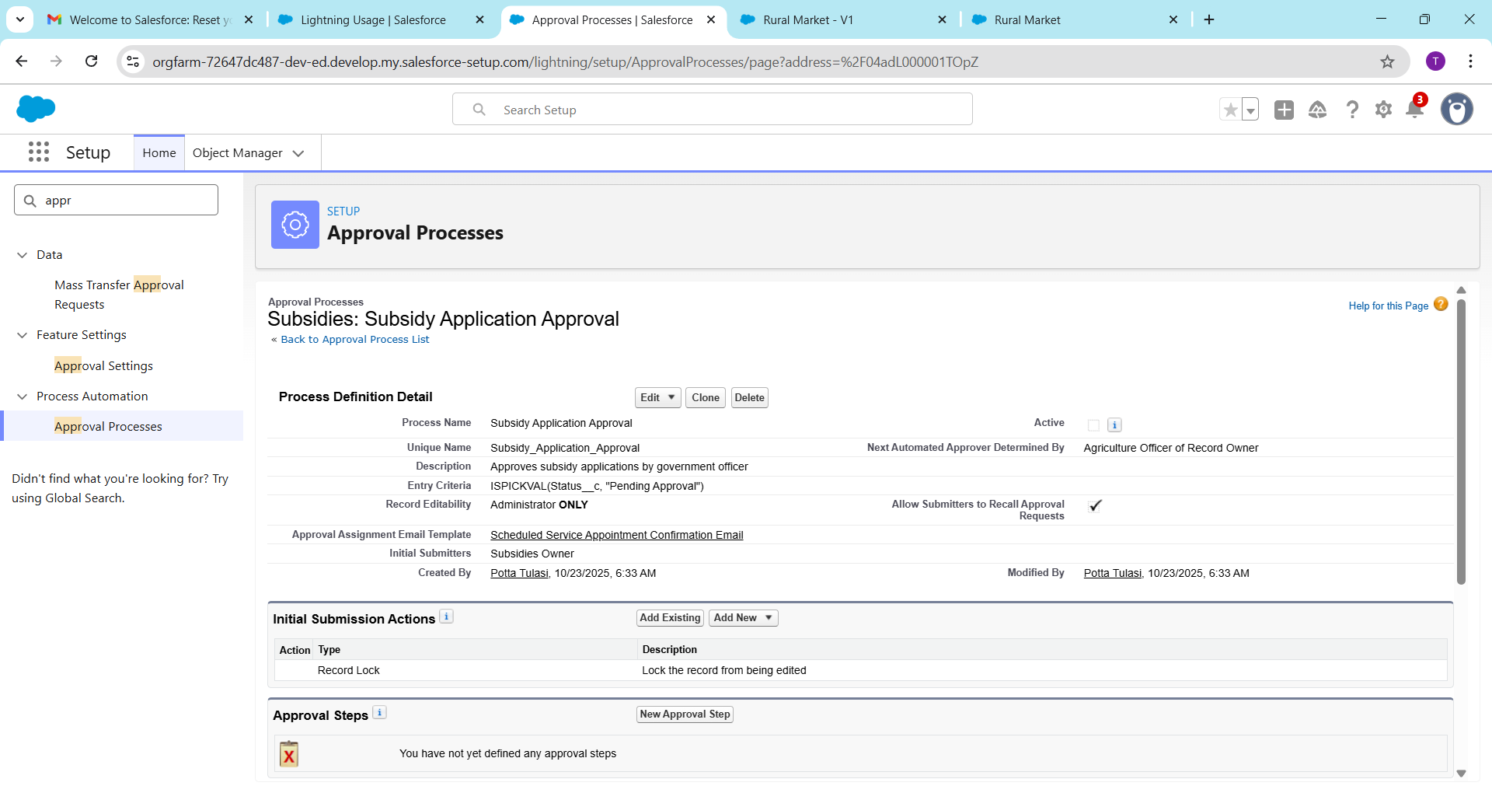

**🔶 7. Flow Builder Automations**

**a. Screen Flow – Farmer Registration**

**Purpose:** Allow farmers to register through the portal.  
**Steps:**

1. Screen → Enter Name, Phone, Crop
2. Create Record → Farmer__c
3. Display “Registration Successful” message

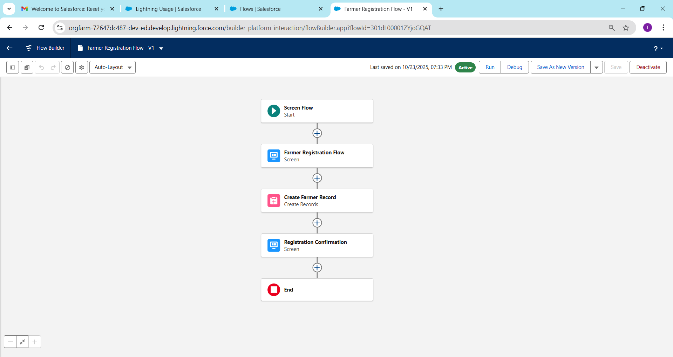

**b. Record-Triggered Flow – Order Automation**

**Trigger:** When Order is created.  
**Actions:**

* Update Buyer’s Last Order Date
* Send Order Confirmation Email

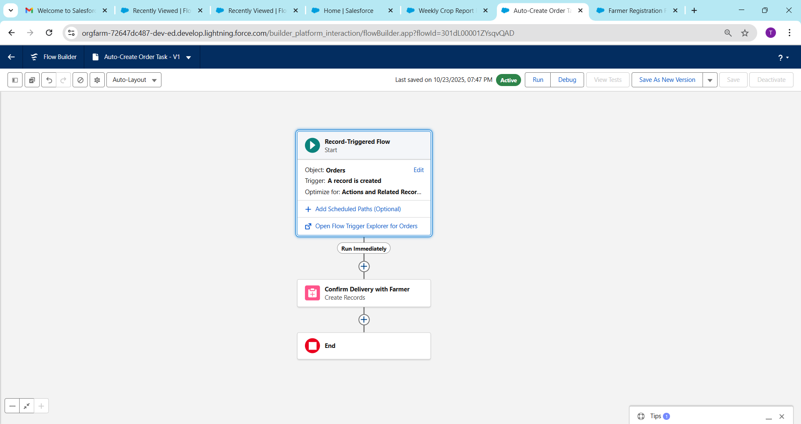

**c. Scheduled Flow – Monthly Reminder**

**Schedule:** 1st of every month  
**Action:** Send reminder email to inactive Buyers.

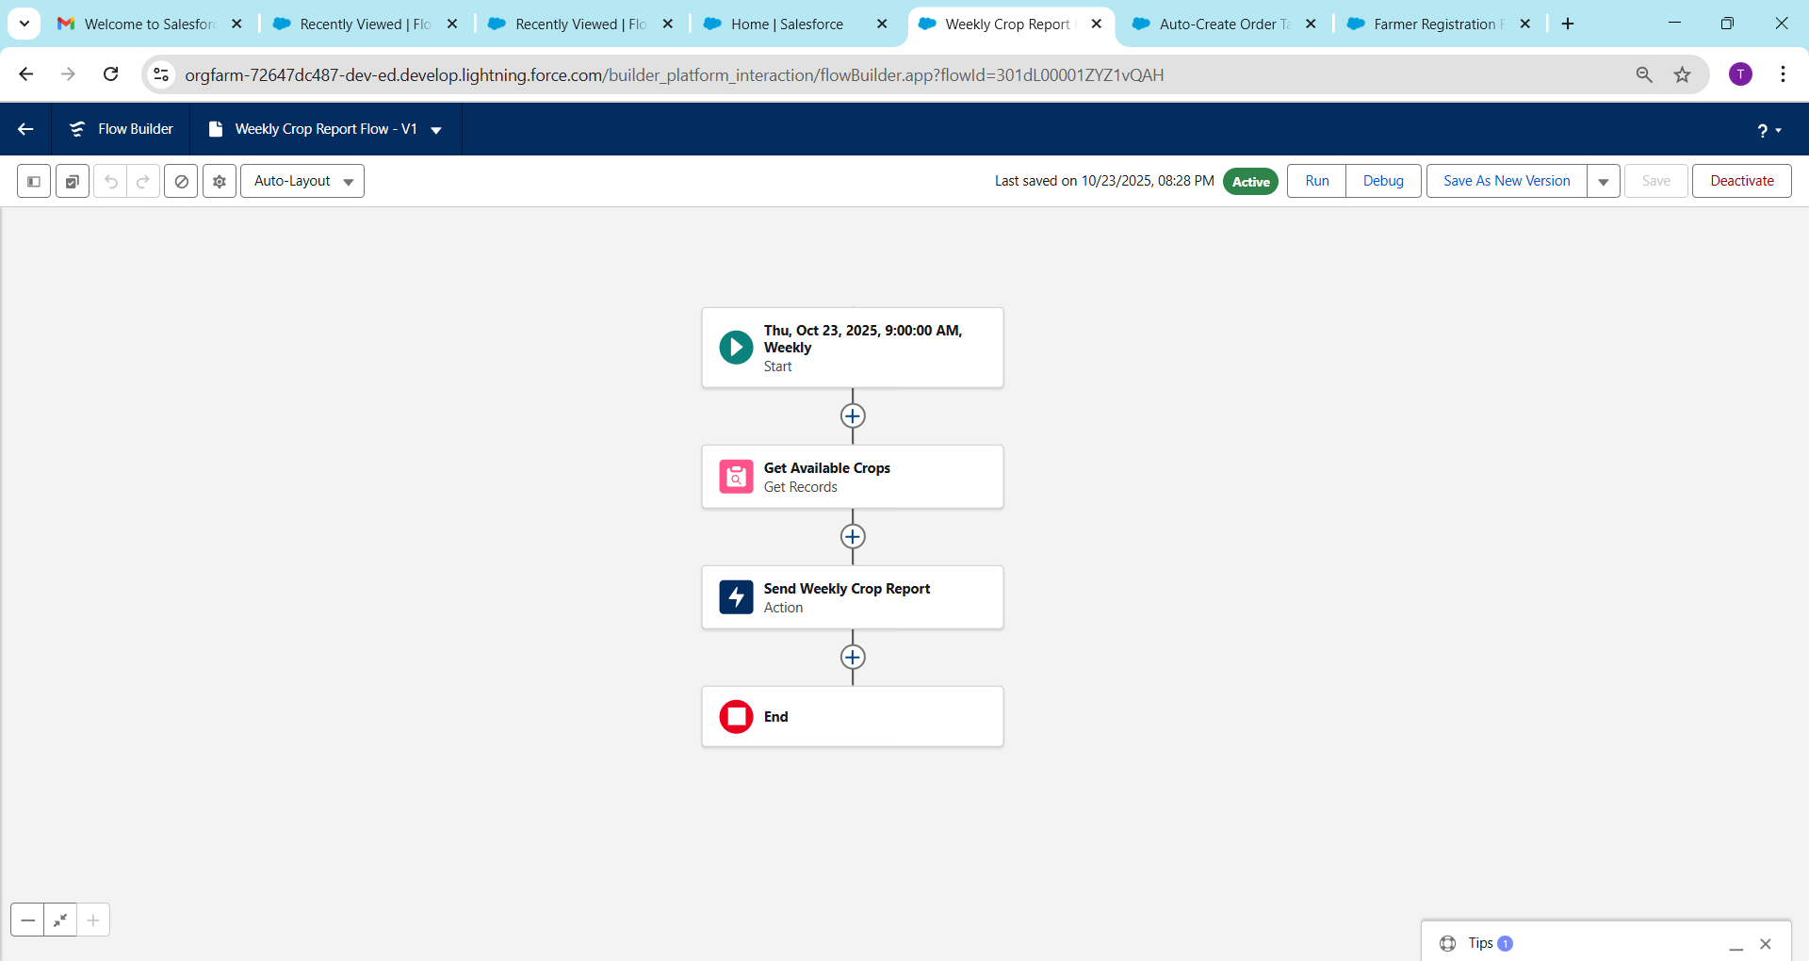**d. Auto-Launched Flow – Internal Updates**

**Purpose:** Update internal metrics (e.g., total orders by Farmer).

**Trigger:** Called by another Flow.

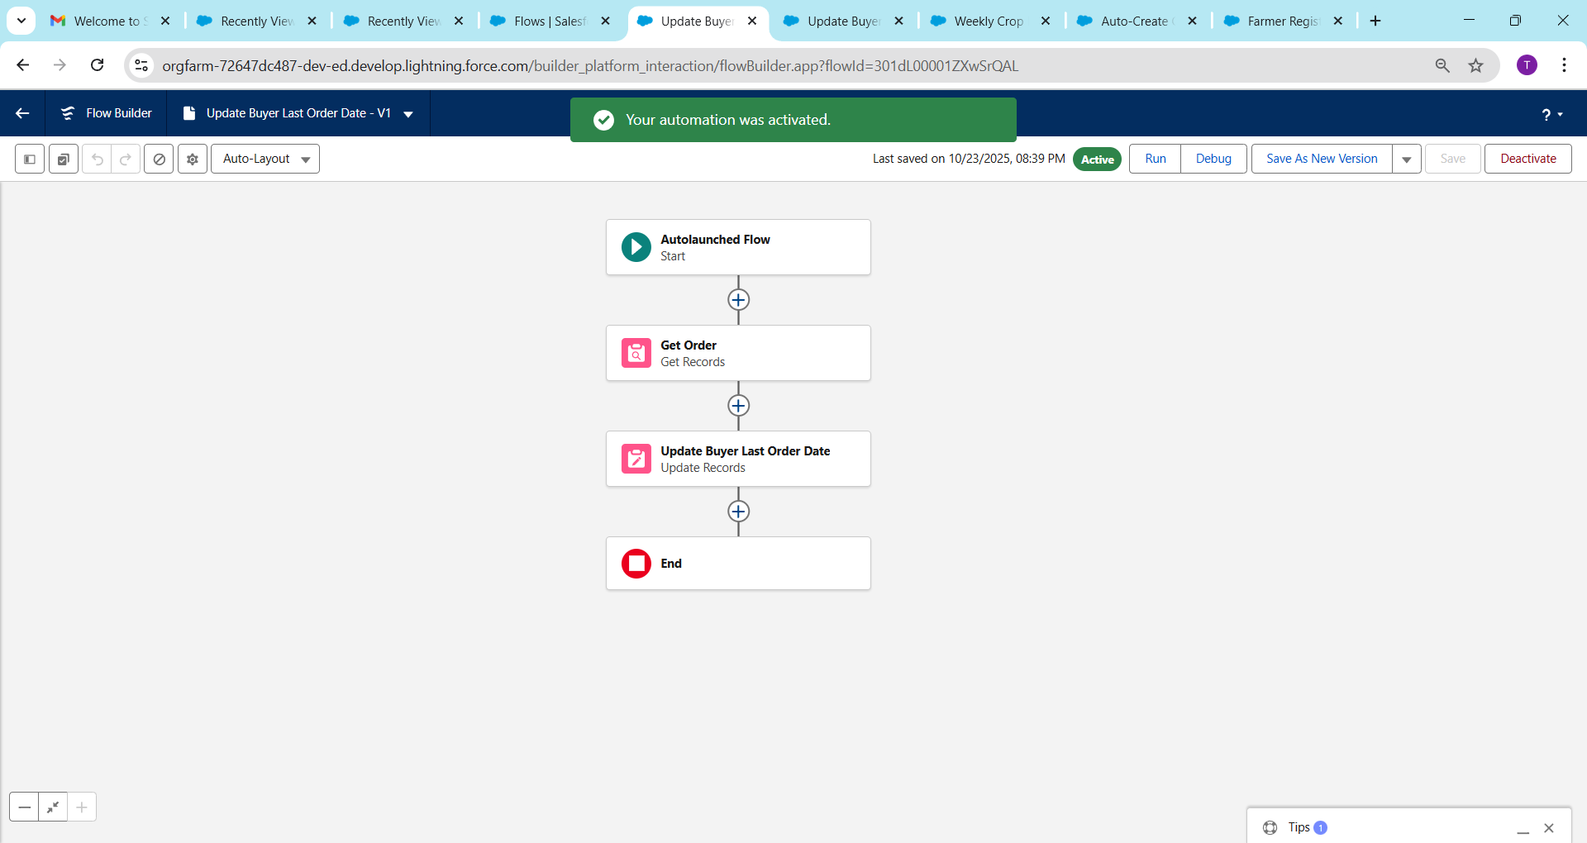

**🔶 8. Email Alerts**

**Object:** Order__c  
**Action:** Send “Order Confirmation” Email to Buyer.

**Setup Steps:**

1. Create Email Template → “Order Confirmation”
2. Create Email Alert → Link Template
3. Trigger via Flow / Process Builder

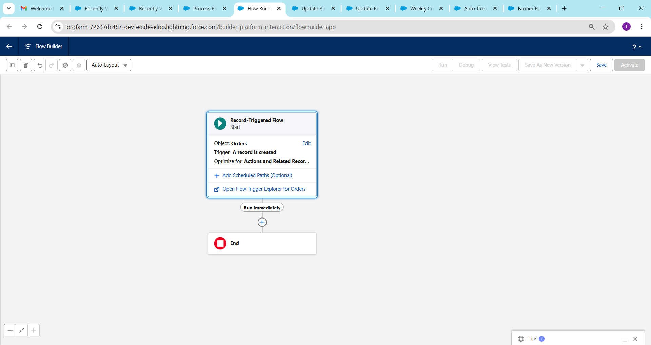

**🔶 9. Field Updates**

**Rule:**  
If Order__c.Status__c = 'Delivered' →  
Update Farmer__c.Last_Order_Status__c = 'Delivered'

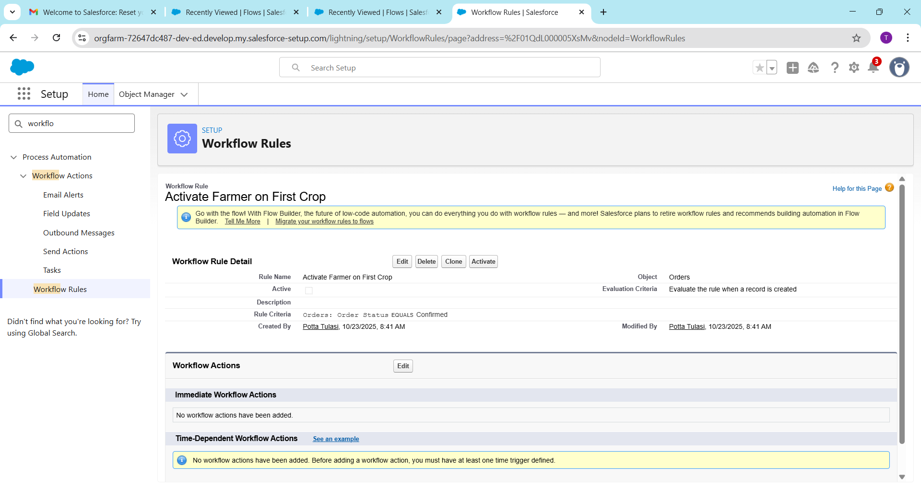

**🔶 10. Tasks**

**Automation:**  
When a Subsidy Application is approved →  
Create Task for Finance Officer: *“Release Payment*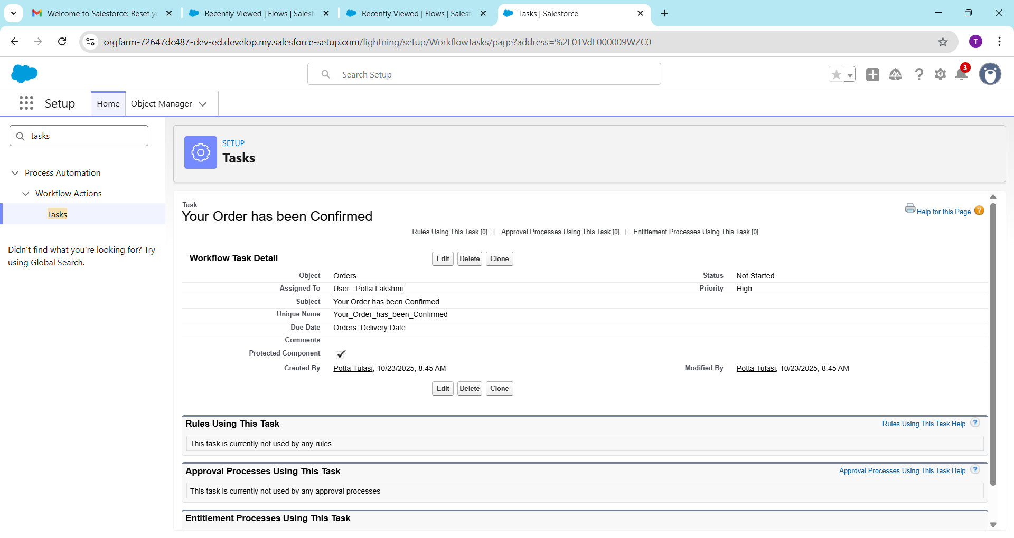

**🔶 11. Custom Notifications**

**Scenario:**  
When a new order is placed → Send in-app alert to Farmer:

“New order received for your crop!”

**Setup:**

1. Setup → Notification Builder → Custom Notification
2. Trigger via Flow

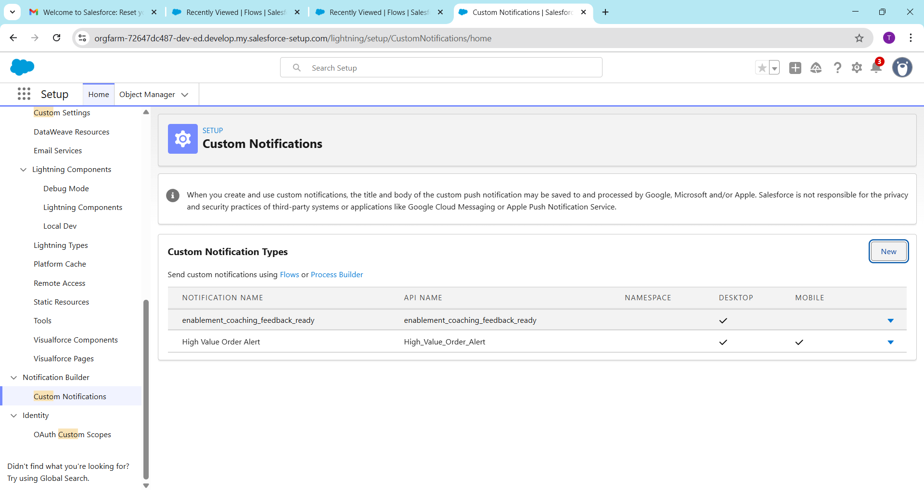

**🔶 12. Final Automation Workflow (Summary)**

**Process Flow Diagram:**

Order Created

↓

Record-Triggered Flow

↓

Update Buyer → Send Email → Notify Farmer → Update Records

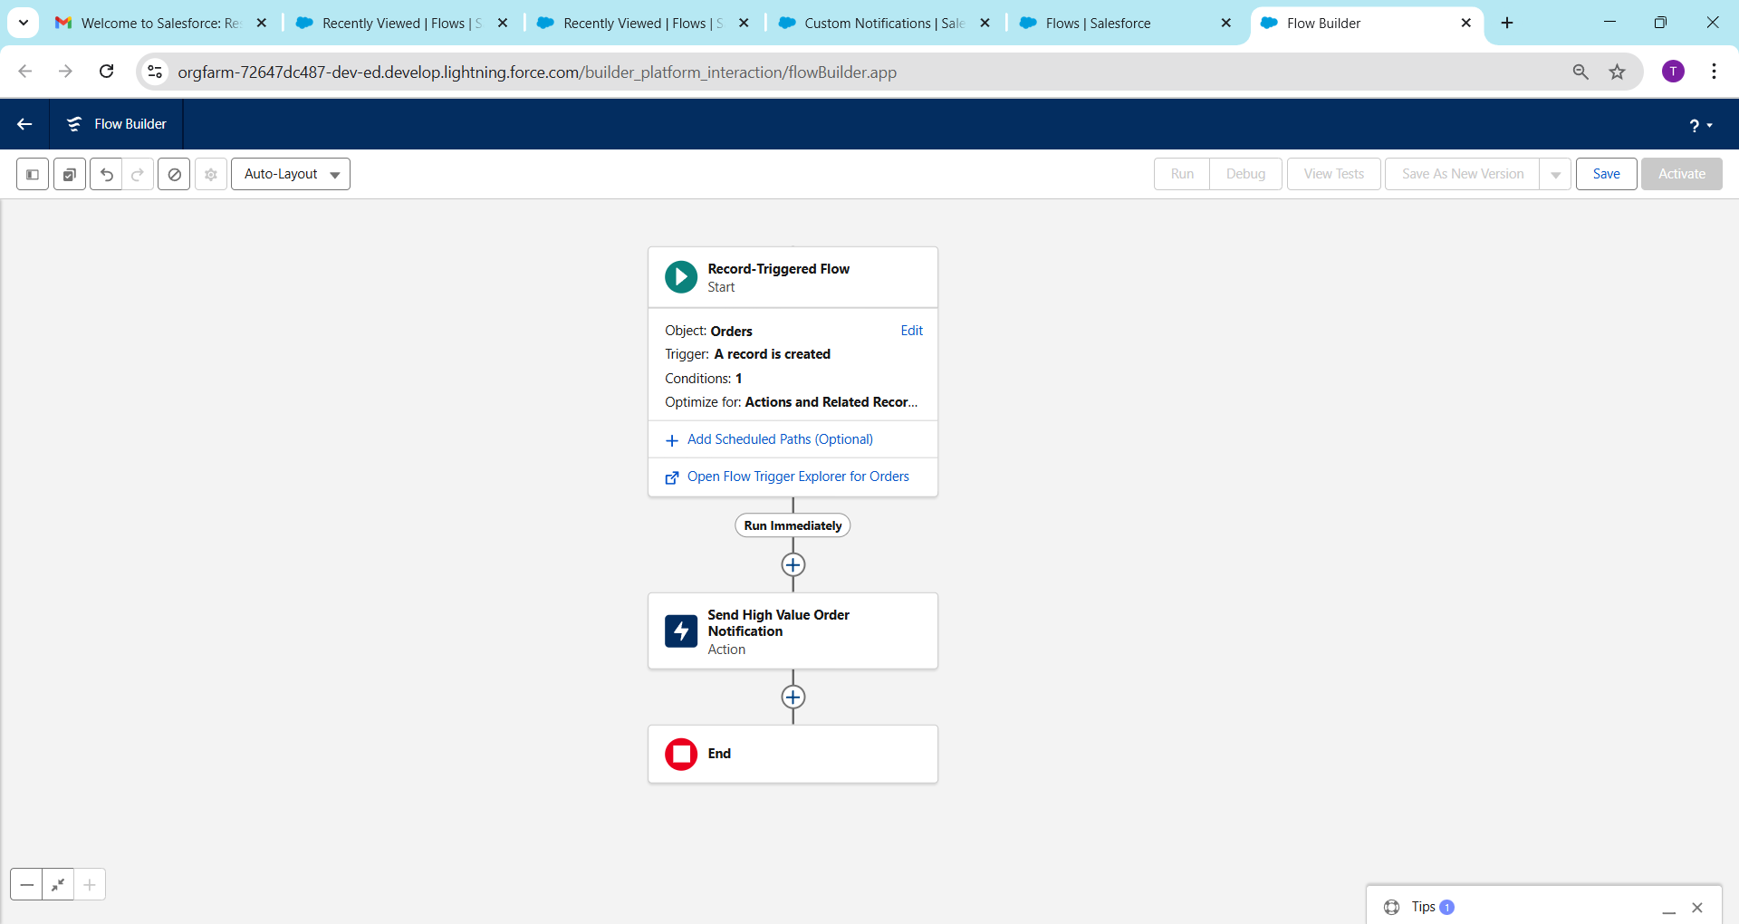

**🔶 13. Testing & Verification**

| **Test Case** | **Trigger** | **Expected Outcome** |
| --- | --- | --- |
| New Farmer Registered | Screen Flow | Farmer record created |
| Order Confirmed | Process Builder | Email sent, field updated |
| Subsidy Request > ₹5000 | Approval Process | Manager approval required |
| Monthly Reminder | Scheduled Flow | Email sent to inactive buyers |

**🔶 14. Output / Result**

✅ Automated all key business processes for Farmers, Buyers, and Government Subsidy Approvals.  
✅ Reduced manual work and ensured data accuracy.  
✅ Enhanced transparency in the Rural Market Linkage ecosystem.

**🔶 15. Conclusion**

This phase integrates automation tools to streamline data validation, communication, and approvals — making the CRM more intelligent, efficient, and farmer-friendly.