# Phase 7: Integration & External Access – Salesforce

**Overview**:  
Phase 7 focuses on connecting Salesforce to external systems, APIs, and databases, while ensuring secure access and real-time updates.

1. **Named Credentials**

* Store login credentials (username, password, OAuth token) for external systems securely.
* Steps:
  1. Go to Setup → Named Credentials → New.
  2. Enter the external system URL.
  3. Choose authentication method.
  4. Use the Named Credential in Apex or Flow.
* Example: Fetch crop prices from a government API.
* Analogy: A safe holding keys for external offices.

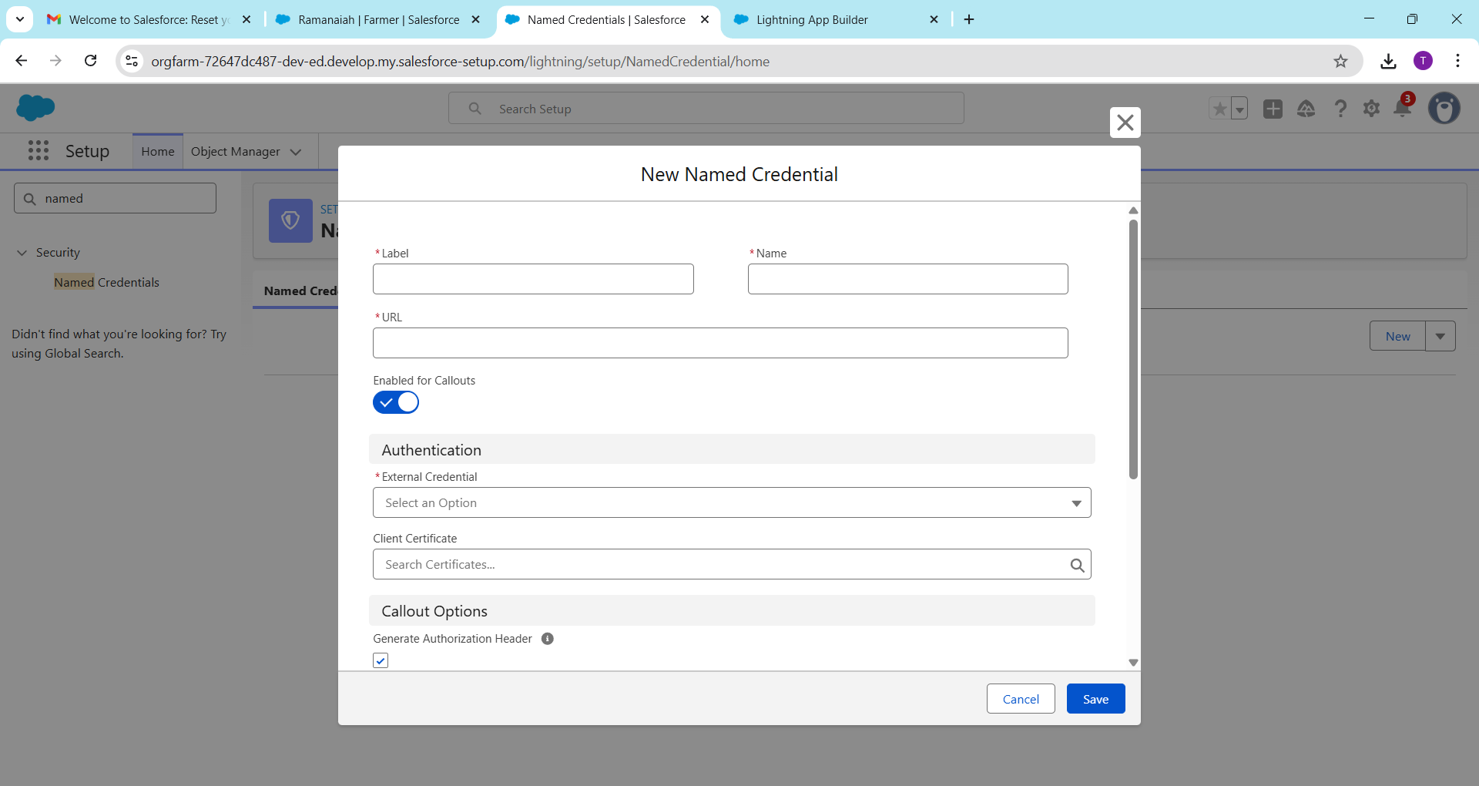

1. **External Services**

* Allows Salesforce to use external API functions without coding.
* Steps:
  1. Import the API definition (OpenAPI/Swagger).
  2. Salesforce generates actions for Flows or LWCs.
* Example: Get rainfall data for farmers’ regions.
* Analogy: Ordering from a pre-made menu.

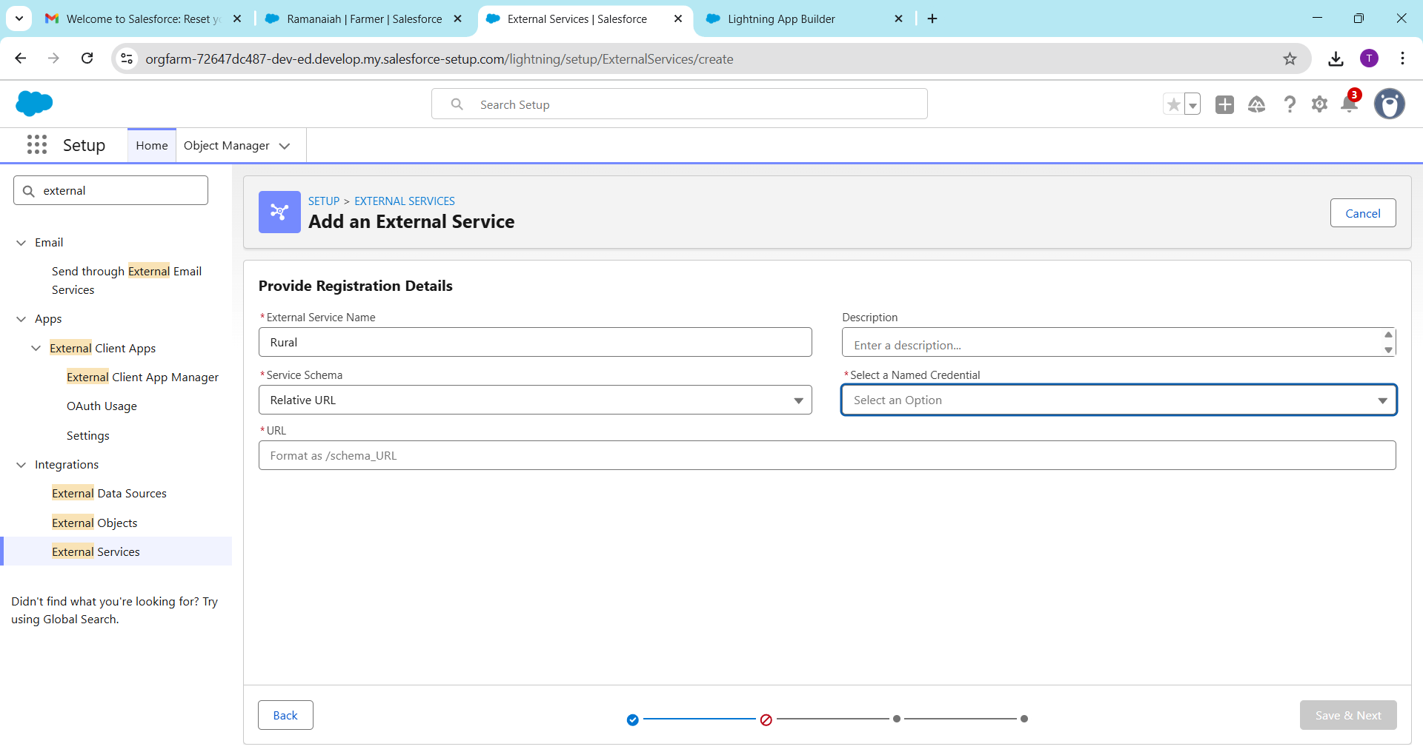

1. **Web Services (REST/SOAP)**

* REST: Modern, uses JSON. Good for lightweight calls.
* SOAP: Older, uses XML. Structured and formal.
* Steps:
  1. Create an Apex callout or configure external system connection.
  2. Send GET/POST requests.
* Example: Pull crop prices using REST, submit subsidy via SOAP.
* Analogy: WhatsApp message (REST) vs. formal letter (SOAP).

1. **Callouts**

* Salesforce sends HTTP requests to external systems.
* Steps:
  1. Create an Apex class.
  2. Use HttpRequest and HttpResponse.
* Example Code:

HttpRequest req = new HttpRequest();

req.setEndpoint('https://api.crops.com/wheat');

req.setMethod('GET');

HttpResponse res = new Http().send(req);

System.debug(res.getBody());

Analogy: Making a phone call to request information.

1. **Platform Events**

* Real-time messaging system inside Salesforce.
* Steps:
  1. Create Platform Event object.
  2. Publish event from Apex, Flow, or LWC.
  3. Subscribe using Process Builder, Flow, or external apps.
* Example: New order triggers buyer notification instantly.
* Analogy: Bell rings to alert everyone in the office.

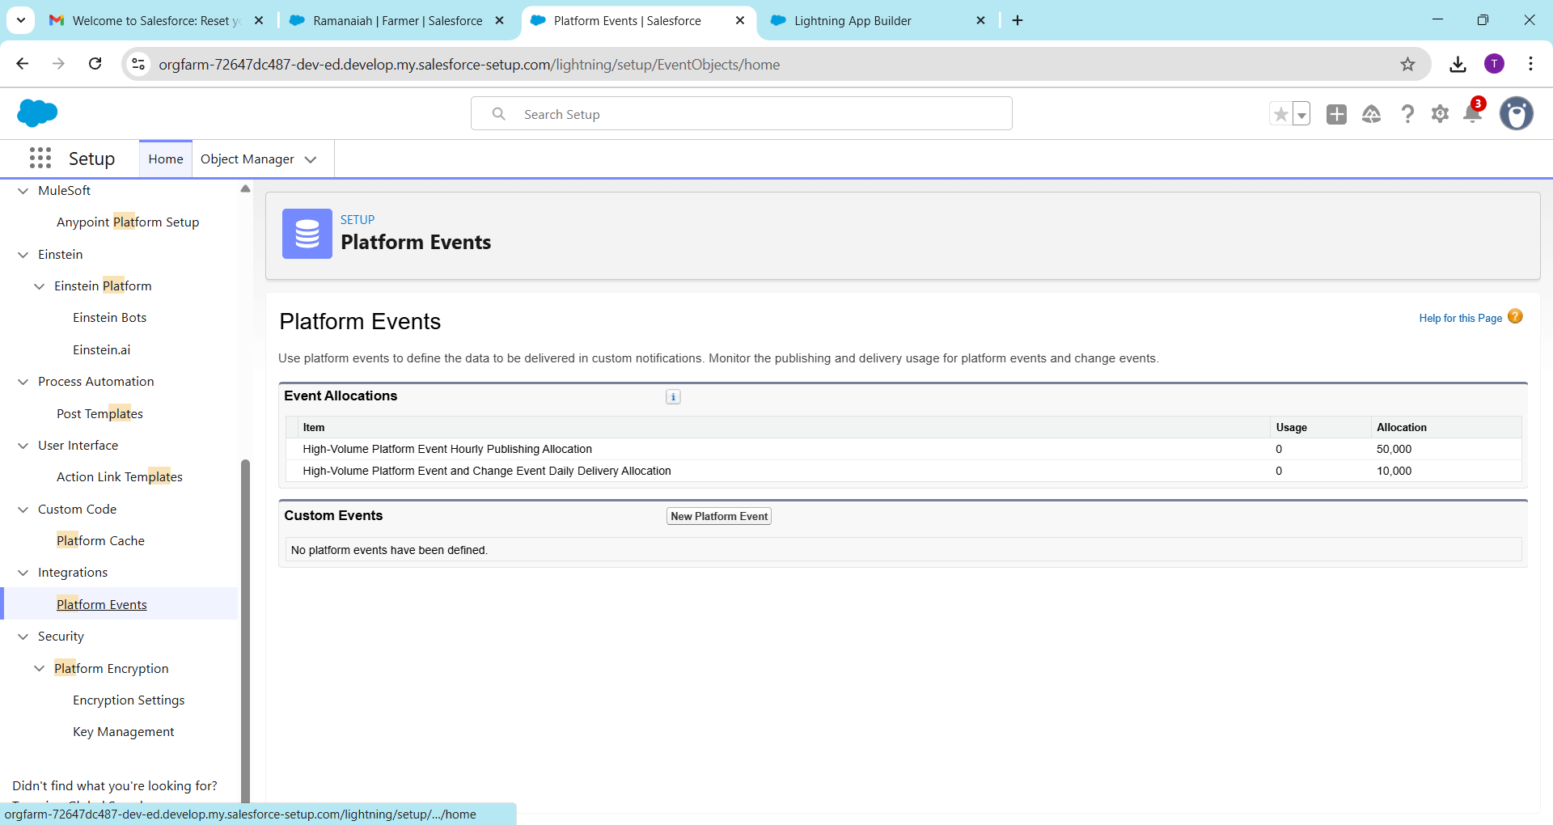

1. **Change Data Capture (CDC)**

* Tracks changes to Salesforce records in real-time.
* Steps:
  1. Enable CDC for objects.
  2. Subscribe to events in external systems or Salesforce.
* Example: Update in order quantity automatically notifies warehouse system.
* Analogy: Security camera sends alerts when changes occur.

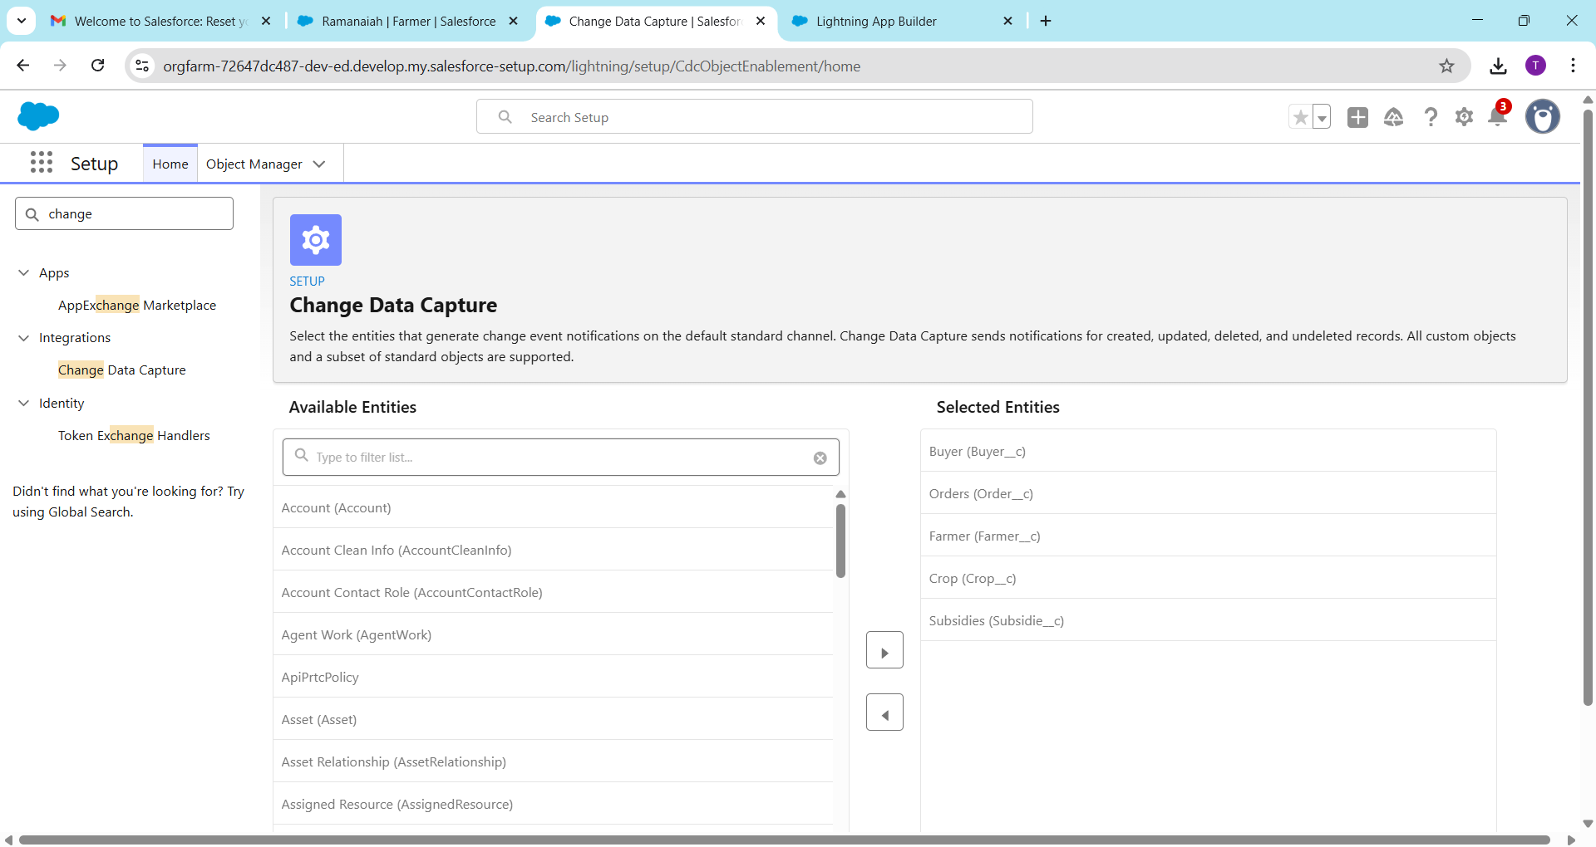

1. **Salesforce Connect**

* Access external database data without storing it in Salesforce.
* Steps:
  1. Configure External Data Source.
  2. Create External Objects mapped to the external database.
* Example: View warehouse inventory stored in Oracle DB.
* Analogy: Looking through a window without moving items.

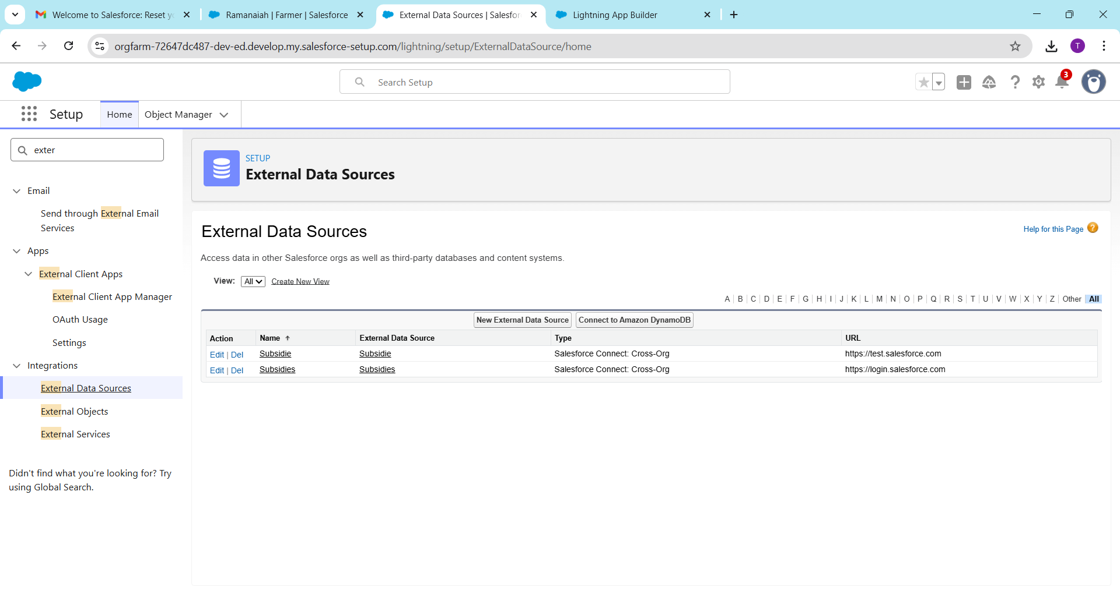**API Limits**

* Salesforce restricts the number of API calls per 24 hours.
* Steps:
  1. Check API usage in Setup → System Overview.
  2. Optimize callouts to avoid exceeding limits.
* Example: Free org has 15,000 API calls/day.
* Analogy: Water tank with maximum daily capacity.

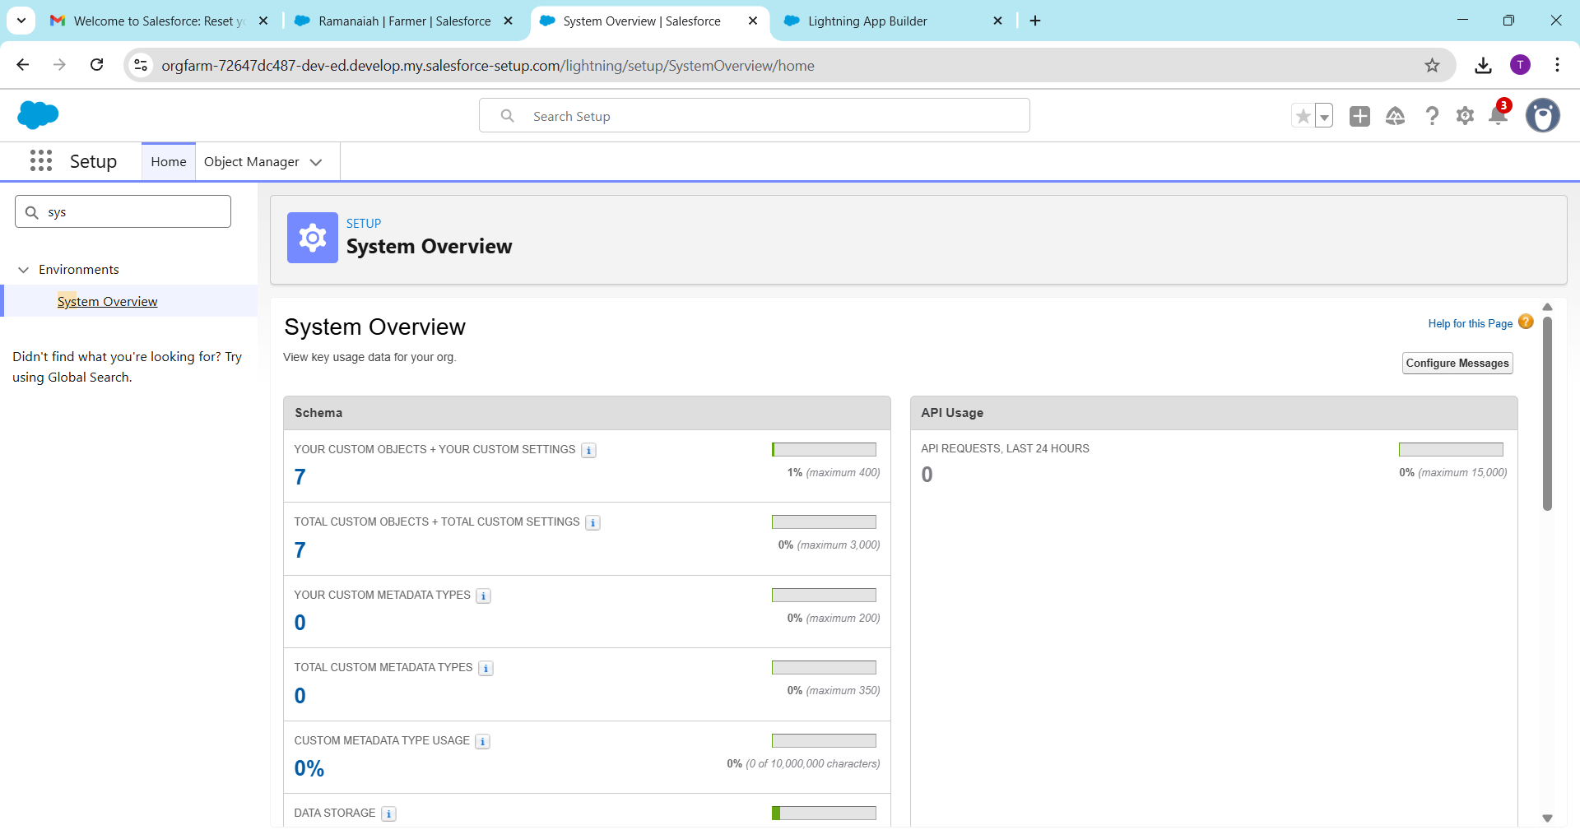

1. **OAuth & Authentication**

* Secure way to connect Salesforce to other apps using tokens.
* Steps:
  1. Create Connected App.
  2. Configure OAuth scopes.
  3. Use token in Apex or external system.
* Example: Salesforce connects to Google Sheets without sharing passwords.
* Analogy: Temporary access card for secure login.

1. **Remote Site Settings**

* Salesforce allows callouts only to whitelisted URLs.
* Steps:
  1. Setup → Remote Site Settings → New.
  2. Enter external system URL.
* Example: Must whitelist [https://api.crops.com](https://api.crops.com/).
* Analogy: Approved websites your office is allowed to communicate with.

Example Workflow for Rural Market Linkage:

1. Farmer places an order → Platform Event triggers buyer notification.
2. Salesforce fetches live crop price → Callout using Named Credentials.
3. Order quantity changes → CDC notifies warehouse system.
4. Inventory data lives in external DB → Salesforce Connect displays it.

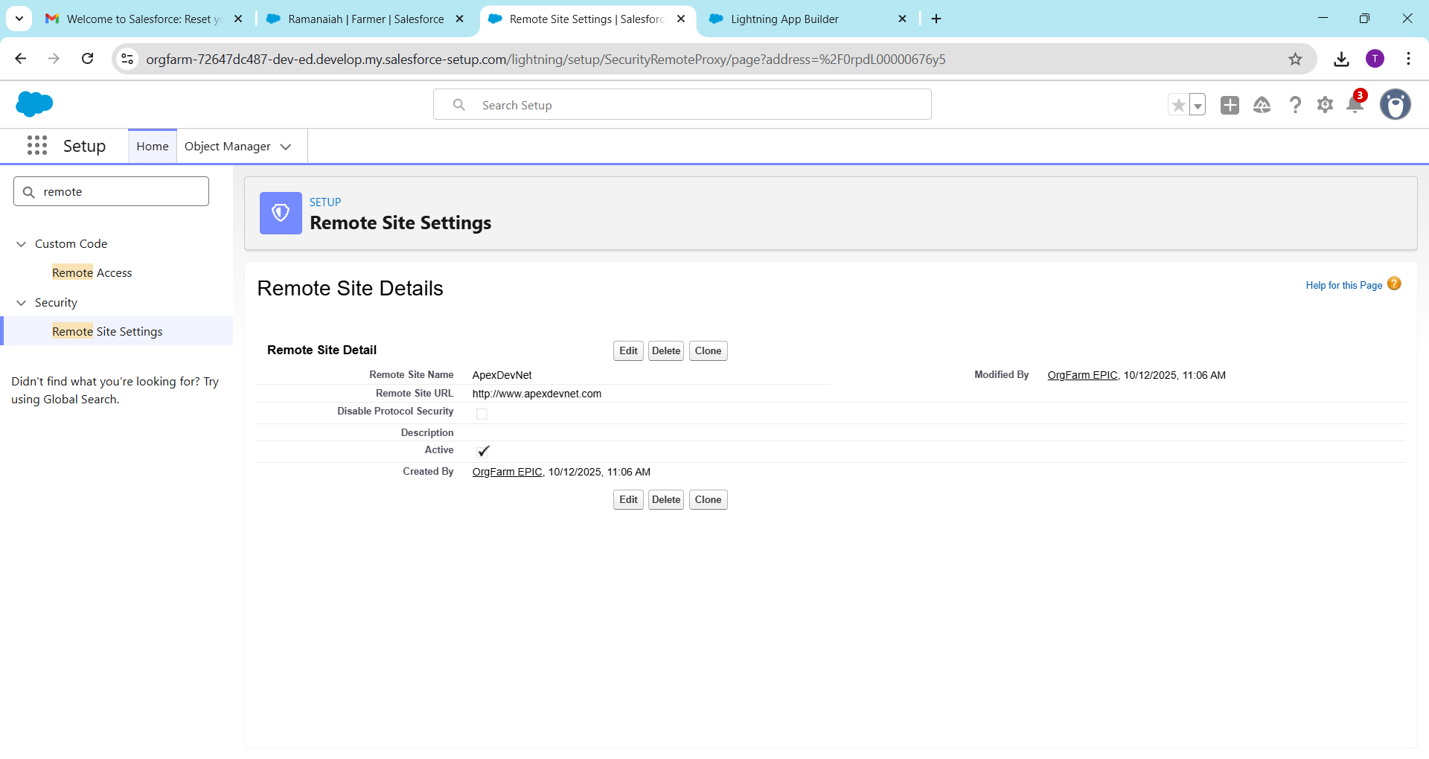

Summary:  
Phase 7 enables Salesforce to securely fetch/send data, integrate with external apps and databases, react in real-time, and follow security rules while respecting API limits.