## Phase 9: Reporting, Dashboards & Security Review – Explained

**1. Reports**

**Purpose:** Summarize, analyze, and present Salesforce data.

**Types of Reports:**

| **Type** | **Description** | **Example** |
| --- | --- | --- |
| **Tabular** | Simple table, like Excel sheet | List all farmers with phone numbers |
| **Summary** | Tabular + grouped data | Total orders per farmer |
| **Matrix** | Grouped by rows & columns | Crop quantity per village per buyer |
| **Joined** | Combine multiple related reports | Farmer info + Subsidy applications |

**Steps to Create a Report:**

1. Go to **Reports → New Report**
2. Choose **Report Type** (Farmer, Order, Crop, etc.)
3. Filter the data (e.g., only active farmers)
4. Group or summarize data as needed
5. Save & run the report

✅ **Tip:** Use **summary or matrix reports** for deeper insights.

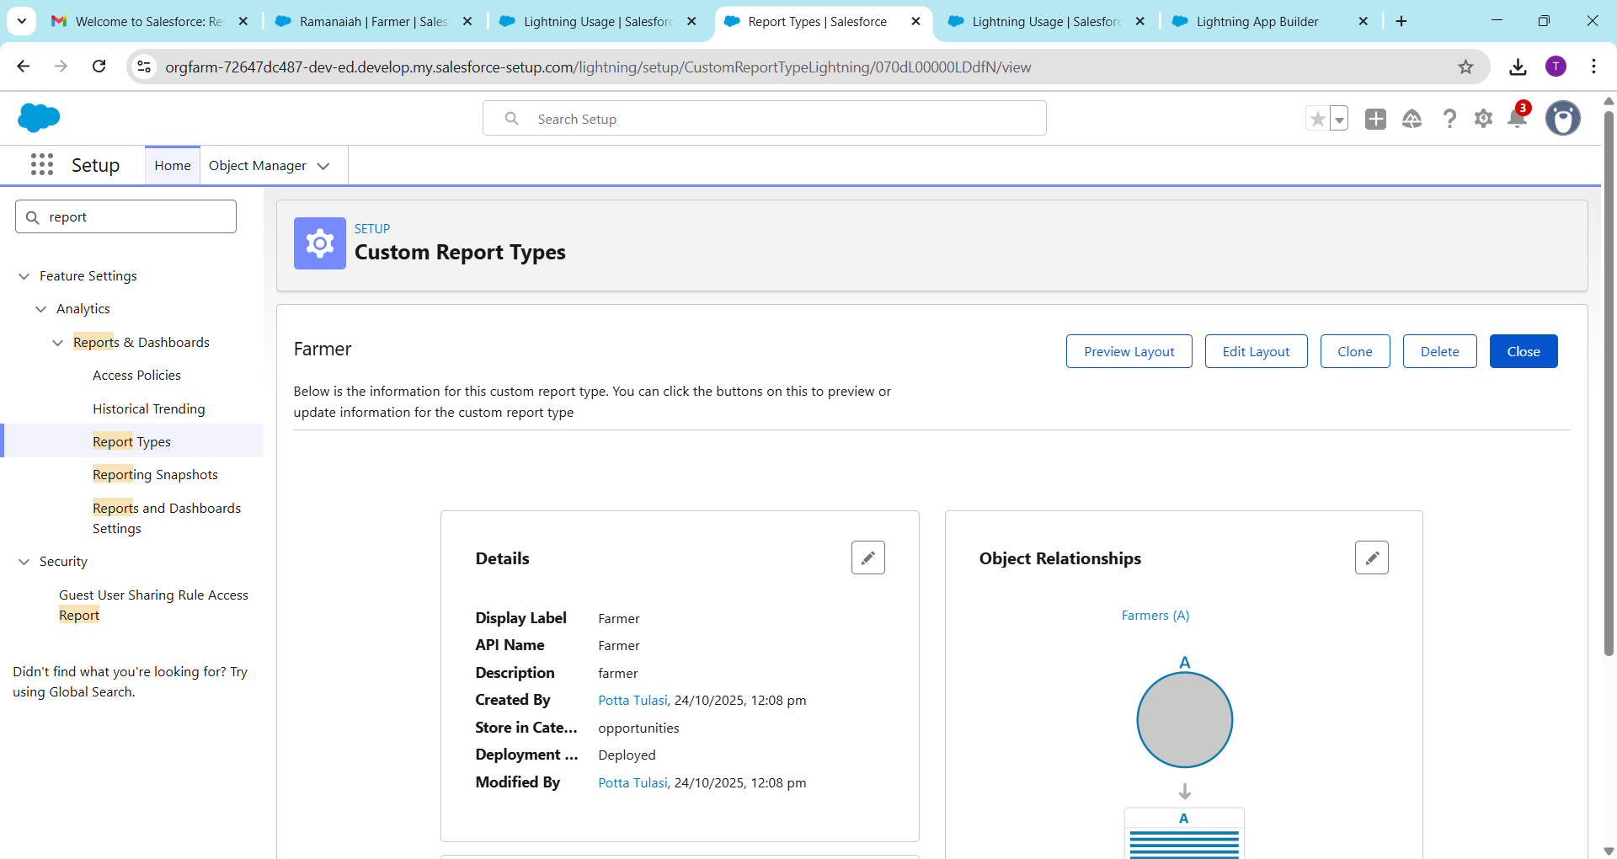

**2. Report Types**

* **What it is:** Defines **which objects and fields are available** in a report.
* **Standard Report Types:** Prebuilt by Salesforce (Accounts, Contacts, Orders)
* **Custom Report Types:** You can create for custom objects or relationships.

**Steps to create a Custom Report Type:**

1. Setup → Report Types → New Custom Report Type
2. Choose **Primary Object** (e.g., Farmer__c)
3. Add **related objects** if needed (Orders, Subsidies)
4. Select fields to include



**3. Dashboards**

**Purpose:** Visual representation of reports.

* Show charts, graphs, and metrics in **one place**.

**Steps to create a Dashboard:**

1. Go to **Dashboards → New Dashboard**
2. Give a name, folder, and source report(s)
3. Add **components** (charts, gauges, tables)
4. Customize layout and filters
5. Save & refresh

**4. Dynamic Dashboards**

* **What it is:** Dashboards that **show data according to the logged-in user**.
* Example: Sales manager sees only their region’s farmers; CEO sees all regions.
* Steps:
  1. Create a dashboard
  2. Check **“Run as Logged-in User”**
  3. Assign permissions

**5. Sharing Settings**

* **Purpose:** Control **who can see or edit records** in Salesforce.
* Types:
  + **Public Read/Write** → Everyone can view and edit
  + **Public Read Only** → Everyone can view, only owners edit
  + **Private** → Only record owner and above can see

**Steps:**

1. Setup → Sharing Settings → Edit
2. Adjust **Organization-Wide Defaults (OWD)**
3. Set sharing rules for exceptions

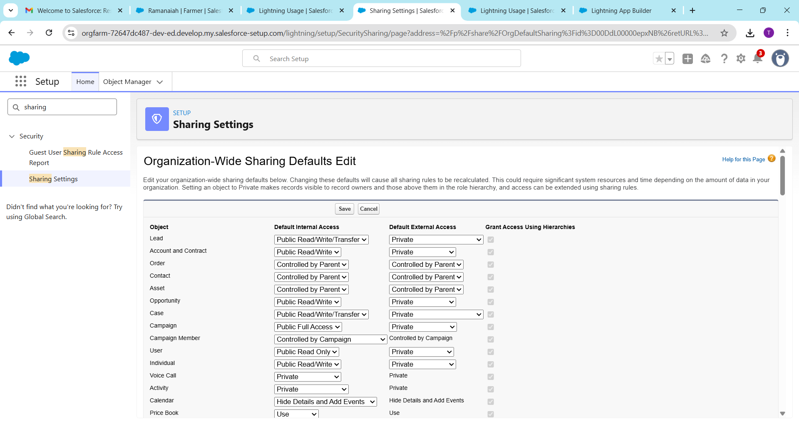

**6. Field Level Security (FLS)**

* **Purpose:** Control **who can see or edit specific fields** on a record.
* Steps:
  1. Setup → Object Manager → Object → Fields & Relationships
  2. Click field → Set Field-Level Security
  3. Choose which profiles can view or edit

**Example:** Only managers can see subsidy amounts.

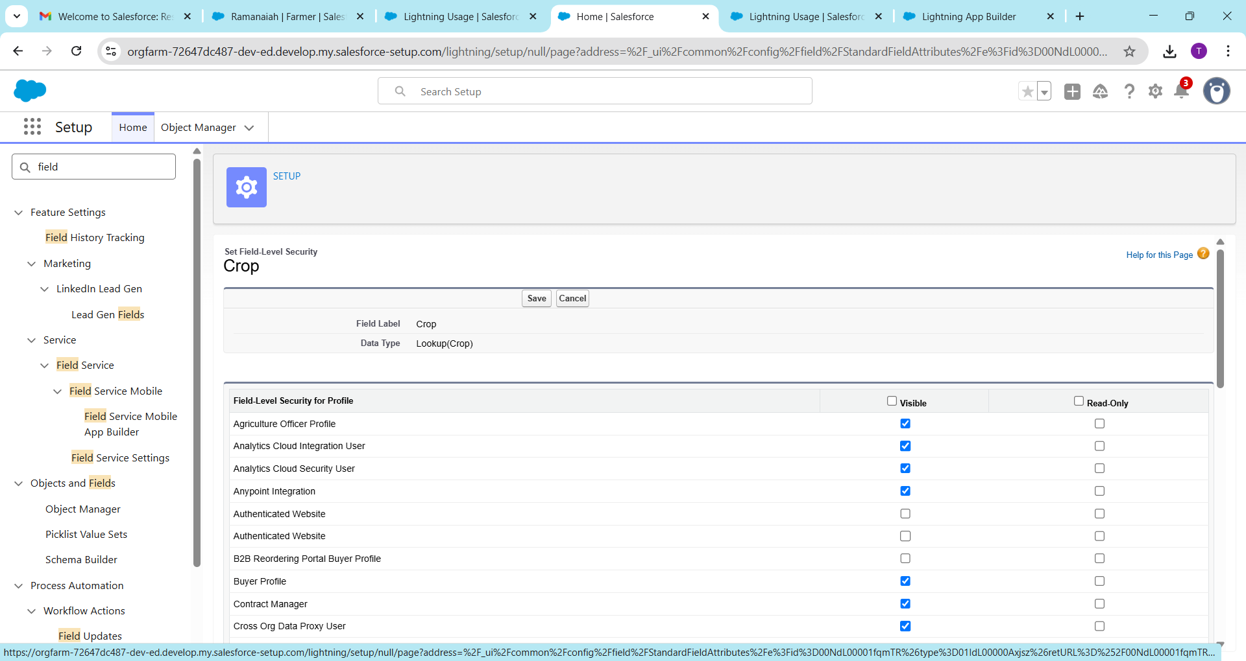

**7. Session Settings**

* **Purpose:** Control **user session behavior** for security.
* Can set:
  + Session timeout (e.g., 30 mins inactivity)
  + IP address restrictions
* Steps: Setup → Security → Session Settings → Adjust

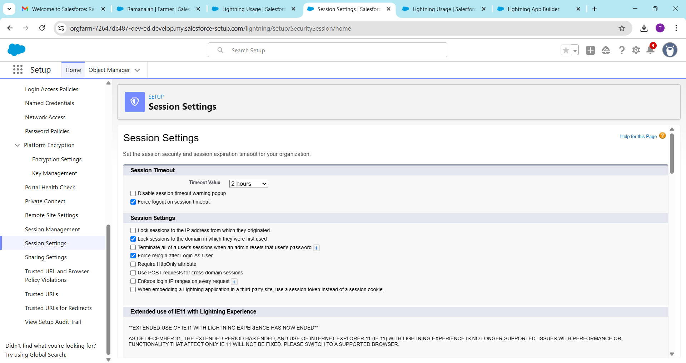

**8. Login IP Ranges**

* **Purpose:** Restrict Salesforce access to specific IPs.
* Steps:
  1. Setup → Profiles → Choose Profile
  2. Set **Login IP Range** (start IP → end IP)
* Example: Only allow office network to login

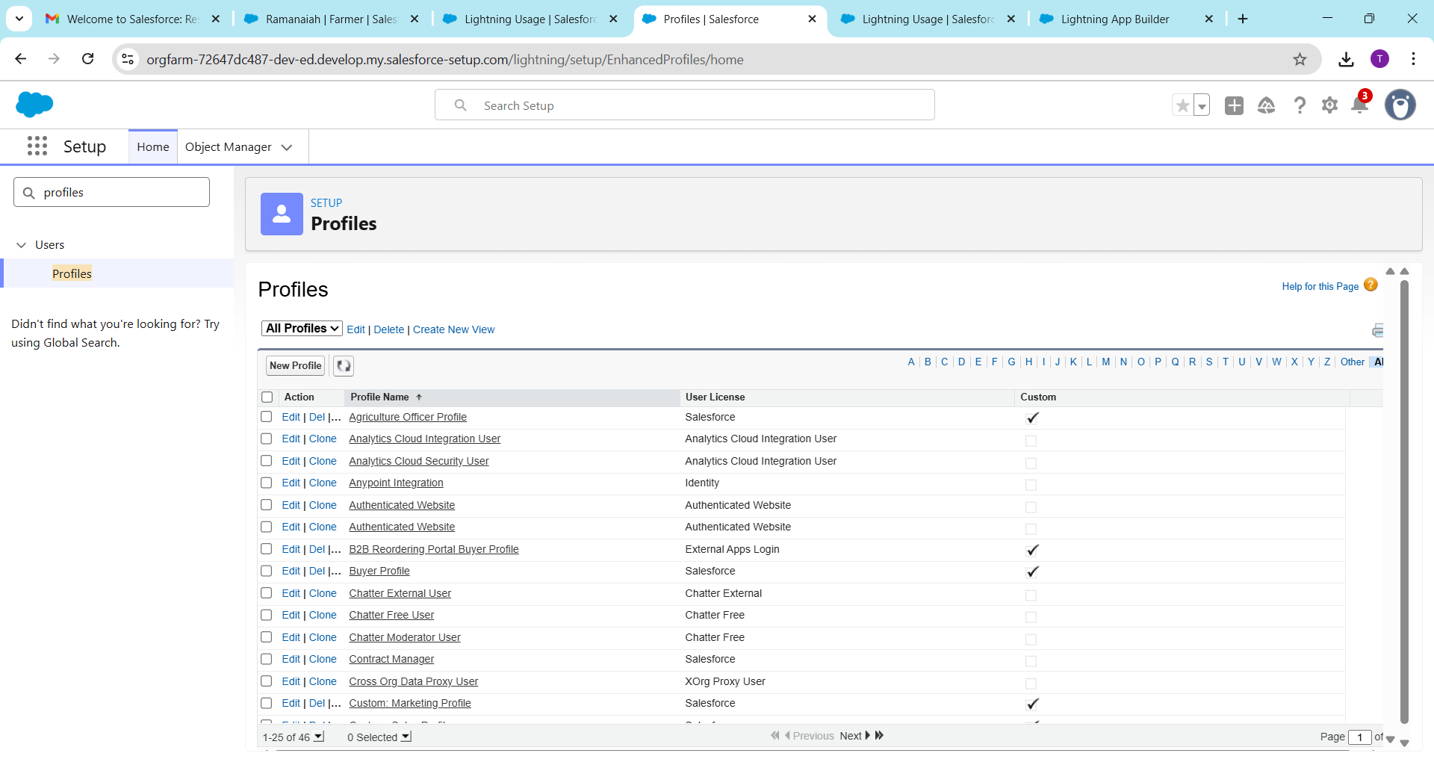

**9. Audit Trail**

* **Purpose:** Track **changes in Salesforce setup** (who changed what and when).
* Steps: Setup → Security → View Setup Audit Trail
* Example: See when a new user was added, or a field was updated

