Temperature Sensor

Parts

Raspberry Pi
Micro SD Card
DS18B20 Temperature Sensors
4.7 kΩ Resistor
Breadboard
Breadboard Wire
Jumper Cables

Protocol

DS18B20 sensors communicates with the “One-Wire” communication protocol, means that only one wire is used to transmit the temperature readings to the micro-controller and two other wires are required for operation :
V CC (Red Wire)
Ground (Black Wire)
Data Wire (Yellow Wire)

A 4.7 kΩ pull-up resistor is placed on the breadboard between the V CC(Red) and, the Data Wire (Yellow).

Then,using jumper cables, the RPi pins are connected as below:

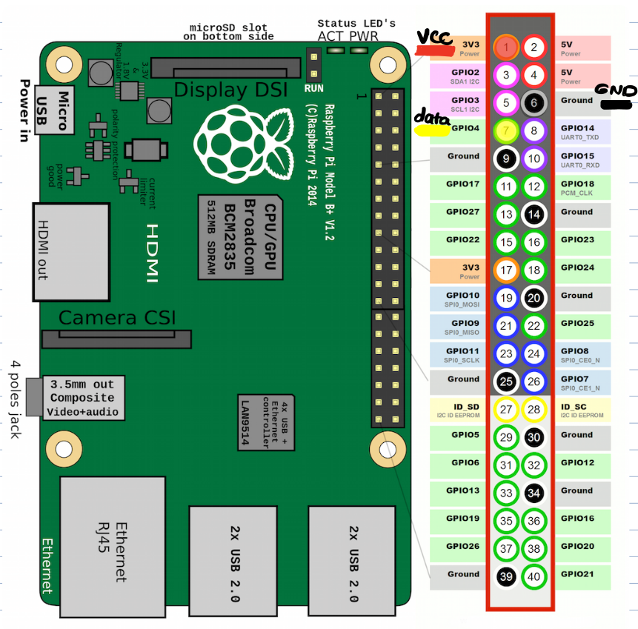
V CC ==> Pin 1
Ground ==> Pin 6
Data Wire ==> Pin 7

The rest of the sensors can be parallelly connected to the first sensor and the same GPIO pin of Rpi. Because each sensor has a specific wire address to communicate with RPi.

Rpi is already configured. So, after connecting the sensors as mentioned, we can move forward to run the codes. Directory for codes are :

/home/pi/Desktop/Documents

Temp-Script.py is the German code file, TemperatureMeasurement.py is the English one and, finally, the MultipleSensors.py contains codes for of all 5 sensors.
In case of any error regarding the wire addresses, it can be solved by opening a terminal and entering this command:

$ ls -l /sys/bus/w1/devices/

We can see the list of wire addresses for all connected sensors. Then the number appeared as 28-XXXX should be replaced in the respective code line of the sensor.
For the sensors we used, the addresses for each are labeled on the cable and you can find it in this table, as well:

Sensor.1 | 28-03049779dae9
Sensor.2 | 28-03049779da5b
Sensor.3 | 28-031197796d7c
Sensor.4 | 28-031197796aa1
Sensor.5 | 28-030297792649

