**MY SQL QUERIES**

**COFFEE SHOP SALES PROJECT**

**DATA given**

SELECT * FROM coffeeshopsales;

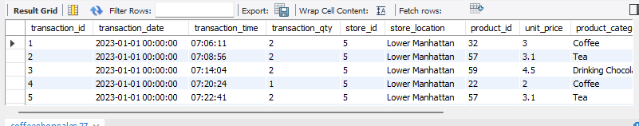

**DATA TYPES OF DIFFERENT COLUMNS**

describe coffeeshopsales;

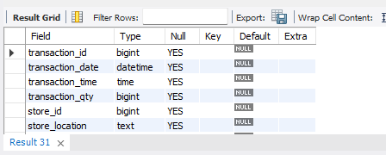

**TOTAL SALES KPI - MOM DIFFERENCE AND MOM GROWTH**

select round(sum(unit_price* transaction_qty),2) as 'Sales', monthname(transaction_date) as 'Month' from coffeeshopsales

group by monthname(transaction_date);

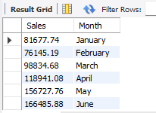

**TOTAL SALES KPI - MOM DIFFERENCE AND MOM GROWTH**

with TBL AS (

with tbl as (

select round(sum(unit_price* transaction_qty),2) as 'Sales',

monthname(transaction_date) as 'Month'

from coffeeshopsales

group by monthname(transaction_date)

)

select Month, Sales,

LAG(Sales) over() AS previous_value,

CASE

WHEN Sales > LAG(Sales) over() THEN 'greater'

WHEN Sales = LAG(Sales) over() THEN 'equal'

ELSE 'less'

END AS comparison_result

from tbl )

SELECT Month,

Sales,

previous_value,

CASE

WHEN Sales is not null and previous_value is not null THEN ((Sales-previous_value)/previous_value)*100

ELSE 0

END as "Month_on_Month_percentage"

FROM TBL;

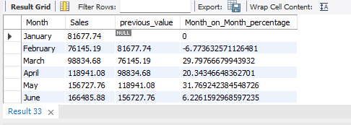

**TOTAL ORDERS**

with TBL AS (

with tbl as (

select monthname(transaction_date) as 'Month',count(transaction_id) as 'Total_no_Orders' from coffeeshopsales

group by monthname(transaction_date)

)

select Month, Total_no_Orders,

LAG(Total_no_Orders) over() AS previous_value,

CASE

WHEN Total_no_Orders > LAG(Total_no_Orders) over() THEN 'greater'

WHEN Total_no_Orders = LAG(Total_no_Orders) over() THEN 'equal'

ELSE 'less'

END AS comparison_result

from tbl )

SELECT Month,

Total_no_Orders,

previous_value,

CASE

WHEN Total_no_Orders is not null and previous_value is not null THEN ((Total_no_Orders-previous_value)/previous_value)*100

ELSE 0

END as "Month_on_Month_percentage"

FROM TBL;

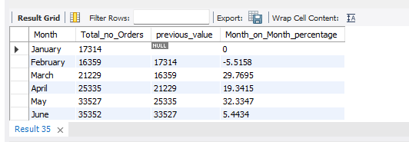

**TOTAL QUANTITY SOLD KPI - MOM DIFFERENCE AND MOM GROWTH**

with TBL AS (

with tbl as (

select monthname(transaction_date) as 'Month',sum(transaction_qty) as 'Total_no_qty' from coffeeshopsales

group by monthname(transaction_date)

)

select Month, Total_no_qty,

LAG(Total_no_qty) over() AS previous_value,

CASE

WHEN Total_no_qty > LAG(Total_no_qty) over() THEN 'greater'

WHEN Total_no_qty = LAG(Total_no_qty) over() THEN 'equal'

ELSE 'less'

END AS comparison_result

from tbl )

SELECT Month,

Total_no_qty,

previous_value,

CASE

WHEN Total_no_qty is not null and previous_value is not null THEN ((Total_no_qty-previous_value)/previous_value)*100

ELSE 0

END as "Month_on_Month_percentage"

FROM TBL;

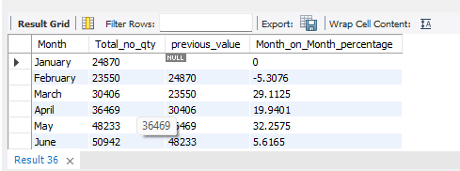

**CALENDAR TABLE – DAILY SALES, QUANTITY and TOTAL ORDERS**

select transaction_date,concat(round(sum(unit_price * transaction_qty)/100,1), "k") as "Total_sales",

concat(round(sum(transaction_qty)/100,1), "k") as "Total_Qty_sold",

concat(round(count(transaction_id)/100,1), "k") as "Total_Orders"

from coffeeshopsales

group by transaction_date;

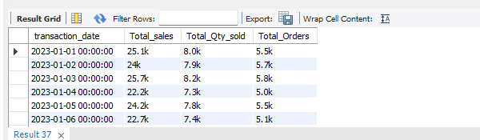

**Sales made over the weekdays and weekends**

select distinct(dayname(transaction_date)) as 'Day', round(sum((unit_price * transaction_qty)),2) as 'Sales' from coffeeshopsales

group by Day;

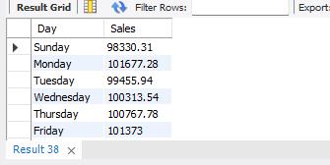

**Weekends sales**

with tbl as (

with tbl as (

select distinct(dayname(transaction_date)) as 'Day', round(sum((unit_price * transaction_qty)),2) as 'Sales' from coffeeshopsales

group by Day)

select * from tbl

where Day not in ('Sunday','Saturday'))

select round(sum(Sales),2) as 'weekdays_sales' from tbl;

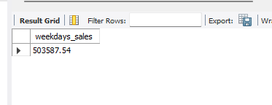

**Weekends sales per month**

with tbl as (

with tbl as (

select distinct(dayname(transaction_date)) as 'Day',monthname(transaction_date) as "Months", round(sum((unit_price * transaction_qty)),2) as 'Sales' from coffeeshopsales

group by Day, monthname(transaction_date))

select * from tbl

where Day in ('Sunday','Saturday'))

select Months,round(sum(Sales),2) as 'weekend_sales' from tbl

group by Months;

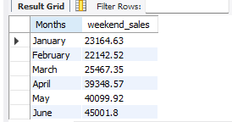

**weekdays sales per month**

with tbl as (

with tbl as (

select distinct(dayname(transaction_date)) as 'Day',monthname(transaction_date) as "Months", round(sum((unit_price * transaction_qty)),2) as 'Sales' from coffeeshopsales

group by Day, monthname(transaction_date))

select * from tbl

where Day not in ('Sunday','Saturday'))

select Months,round(sum(Sales),2) as 'weekdays_sales' from tbl

group by Months;

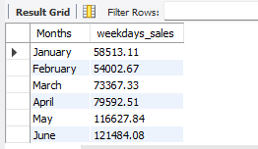

**SALES TREND OVER PERIOD**

SELECT AVG(total_sales) AS average_sales

FROM (

SELECT

SUM(unit_price * transaction_qty) AS total_sales

FROM

coffee_shop_sales

WHERE

MONTH(transaction_date) = 5 -- Filter for May

GROUP BY

transaction_date

) AS internal_query;

***Query Explanation:***

* This inner subquery calculates the total sales (unit_price * transaction_qty) for each date in May. It filters the data to include only transactions that occurred in May by using the MONTH() function to extract the month from the transaction_date column and filtering for May (month number 5).
* The GROUP BY clause groups the data by transaction_date, ensuring that the total sales are aggregated for each individual date in May.
* The outer query calculates the average of the total sales over all dates in May. It references the result of the inner subquery as a derived table named internal_query.
* The AVG() function calculates the average of the total_sales column from the derived table, giving us the average sales for May.

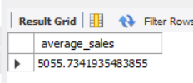

**DAILY SALES FOR MONTH SELECTED**

SELECT

DAY(transaction_date) AS day_of_month,

ROUND(SUM(unit_price * transaction_qty),1) AS total_sales

FROM

coffee_shop_sales

WHERE

MONTH(transaction_date) = 5 -- Filter for May

GROUP BY

DAY(transaction_date)

ORDER BY

DAY(transaction_date);

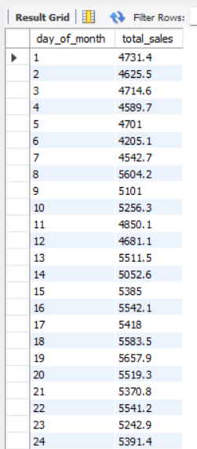 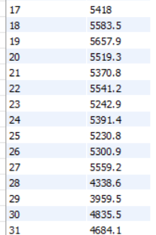

***COMPARING DAILY SALES WITH AVERAGE SALES – IF GREATER THAN “ABOVE AVERAGE” and LESSER THAN “BELOW AVERAGE”***

SELECT

day_of_month,

CASE

WHEN total_sales > avg_sales THEN 'Above Average'

WHEN total_sales < avg_sales THEN 'Below Average'

ELSE 'Average'

END AS sales_status,

total_sales

FROM (

SELECT

DAY(transaction_date) AS day_of_month,

SUM(unit_price * transaction_qty) AS total_sales,

AVG(SUM(unit_price * transaction_qty)) OVER () AS avg_sales

FROM

coffee_shop_sales

WHERE

MONTH(transaction_date) = 5 -- Filter for May

GROUP BY

DAY(transaction_date)

) AS sales_data

ORDER BY

day_of_month;

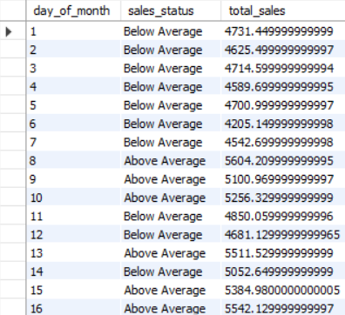 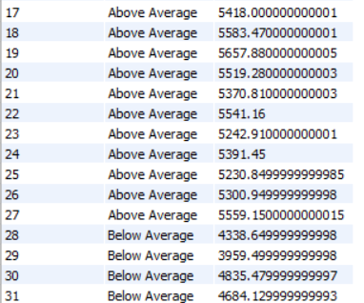

**SALES BY WEEKDAY / WEEKEND:**

SELECT

CASE

WHEN DAYOFWEEK(transaction_date) IN (1, 7) THEN 'Weekends'

ELSE 'Weekdays'

END AS day_type,

ROUND(SUM(unit_price * transaction_qty),2) AS total_sales

FROM

coffee_shop_sales

WHERE

MONTH(transaction_date) = 5 -- Filter for May

GROUP BY

CASE

WHEN DAYOFWEEK(transaction_date) IN (1, 7) THEN 'Weekends'

ELSE 'Weekdays'

END;

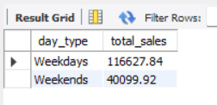

**SALES BY STORE LOCATION**

SELECT

store_location,

SUM(unit_price * transaction_qty) as Total_Sales

FROM coffee_shop_sales

WHERE

MONTH(transaction_date) =5

GROUP BY store_location

ORDER BY SUM(unit_price * transaction_qty) DESC

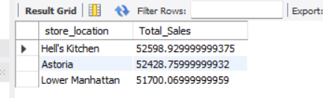

**SALES BY PRODUCT CATEGORY**

SELECT

product_category,

ROUND(SUM(unit_price * transaction_qty),1) as Total_Sales

FROM coffee_shop_sales

WHERE

MONTH(transaction_date) = 5

GROUP BY product_category

ORDER BY SUM(unit_price * transaction_qty) DESC

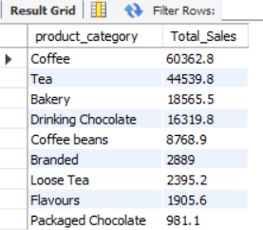

**SALES BY PRODUCTS (TOP 10)**

SELECT

product_type,

ROUND(SUM(unit_price * transaction_qty),1) as Total_Sales

FROM coffee_shop_sales

WHERE

MONTH(transaction_date) = 5

GROUP BY product_type

ORDER BY SUM(unit_price * transaction_qty) DESC

LIMIT 10

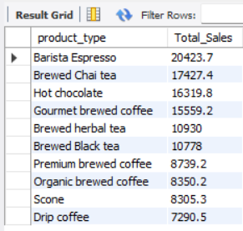

**SALES BY DAY | HOUR**

SELECT

ROUND(SUM(unit_price * transaction_qty)) AS Total_Sales,

SUM(transaction_qty) AS Total_Quantity,

COUNT(*) AS Total_Orders

FROM

coffee_shop_sales

WHERE

DAYOFWEEK(transaction_date) = 3 -- Filter for Tuesday (1 is Sunday, 2 is Monday, ..., 7 is Saturday)

AND HOUR(transaction_time) = 8 -- Filter for hour number 8

AND MONTH(transaction_date) = 5; -- Filter for May (month number 5)

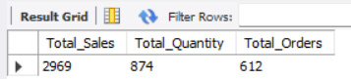

***TO GET SALES FROM MONDAY TO SUNDAY FOR MONTH OF MAY***

SELECT

CASE

WHEN DAYOFWEEK(transaction_date) = 2 THEN 'Monday'

WHEN DAYOFWEEK(transaction_date) = 3 THEN 'Tuesday'

WHEN DAYOFWEEK(transaction_date) = 4 THEN 'Wednesday'

WHEN DAYOFWEEK(transaction_date) = 5 THEN 'Thursday'

WHEN DAYOFWEEK(transaction_date) = 6 THEN 'Friday'

WHEN DAYOFWEEK(transaction_date) = 7 THEN 'Saturday'

ELSE 'Sunday'

END AS Day_of_Week,

ROUND(SUM(unit_price * transaction_qty)) AS Total_Sales

FROM

coffee_shop_sales

WHERE

MONTH(transaction_date) = 5 -- Filter for May (month number 5)

GROUP BY

CASE

WHEN DAYOFWEEK(transaction_date) = 2 THEN 'Monday'

WHEN DAYOFWEEK(transaction_date) = 3 THEN 'Tuesday'

WHEN DAYOFWEEK(transaction_date) = 4 THEN 'Wednesday'

WHEN DAYOFWEEK(transaction_date) = 5 THEN 'Thursday'

WHEN DAYOFWEEK(transaction_date) = 6 THEN 'Friday'

WHEN DAYOFWEEK(transaction_date) = 7 THEN 'Saturday'

ELSE 'Sunday'

END;

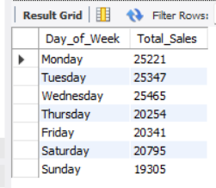

***TO GET SALES FOR ALL HOURS FOR MONTH OF MAY***

SELECT

HOUR(transaction_time) AS Hour_of_Day,

ROUND(SUM(unit_price * transaction_qty)) AS Total_Sales

FROM

coffee_shop_sales

WHERE

MONTH(transaction_date) = 5 -- Filter for May (month number 5)

GROUP BY

HOUR(transaction_time)

ORDER BY

HOUR(transaction_time);

