**I.** **Modeling of Vehicle kinematics & Dynamics**

**1. Kinematics modeling**

Kinematics is the study of a system's motion without taking into account the forces and torques that regulate it. When kinematic relations are able to sufficiently represent the actual system dynamics, kinematic models can be used. It's worth noting, though, that this approximation only applies to systems that undertake non-aggressive movements at lower speeds.

In this section we present firstly, “the kinematic bicycle model”, one of the most extensively used kinematic models for autonomous vehicles, then the vehicle 2D controller will be developed on this model.

**1.1 Bicycle Kinematic Model**

The goal is to define the vehicle state and observe how it evolves over time based on the previous state and the vehicle's current control inputs.

Allow the vehicle state to be composed of the x and y components of position, heading angle or orientation θ, and velocity (in the direction of heading) v.

Ego vehicle state vector q is defined as follows

q = [x, y, θ, v] T  (1)

We must consider both longitudinal (throttle and brake) and lateral (steering) commands for control inputs. The brake and throttle commands contribute to longitudinal accelerations in the range [-𝛂’max, 𝛂max], where negative values represent braking deceleration and positive values represent throttle acceleration (forward or reverse depending upon the transmission state)

[-𝛂’max, 𝛂max] are purposefully denoted to distinguish between the physical limits of acceleration due to throttle and deceleration due to braking. The steering command changes the vehicle's steering angle, where δ ∈ [−δmax, δmax] such that negative steering angles dictate left turns and positive steering angles otherwise. It is worth noting that, in general, control inputs are clamped in the range [1, 1] based on the actuators to ensure proper scaling of control commands in terms of actuation limits. To summarize, the ego vehicle control vector u is defined as follows

u = [a, δ] T (2)

We will now derive the kinematic model of the ego vehicle.

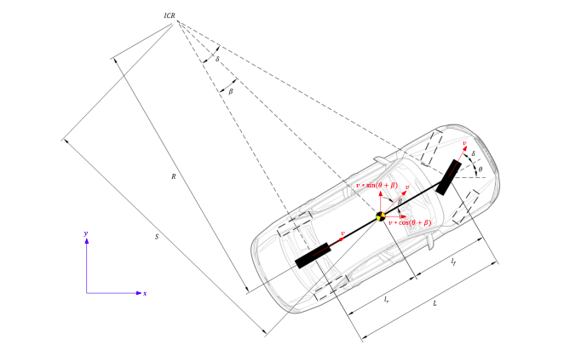

Figure 1. Vehicle kinematics [1]

The slip angle can be calculated using the distance between the rear wheel axle and the vehicle's center of gravity, as shown below.

tan (β) = lr /S = lr/ (L/ tan(δ)) = lr/ L ∗ tan (δ) (3)

Using the equations of trigonometry, we can decompose the velocity vector v into its x and y components.

x˙ = v ∗ cos (θ + β) (4)

y˙ = v ∗ sin (θ + β) (5)

To compute θ˙, we must first compute S using the following relationship.

S = L/ tan (δ) (6)

We can compute R using S from equation 5 as shown below.

R = S /cos (β) = L/ (tan (δ) ∗ cos (β)) (7)

we calculate now θ˙

θ = v/ R = (v ∗ tan (δ) ∗ cos (β))/ L (8)

Finally, we can compute v˙ using the rudimentary differential relation.

v˙ = a (9)

**2 Dynamic Modeling**

Dynamic is the study of a system's motion in relation to the forces and torques that regulate it is known as dynamics. Dynamic models, in other words, are motion models of a system that closely reflect the system's actual dynamics. Such models are more complex and inefficient to solve in real-time (depending on computational hardware), but they are essential in high-performance settings like racing, where high speeds and aggressive maneuvers are typical.

**2.1 Longitudinal Vehicle Dynamics**

Figure 2 shows the free-body diagram of an autonomous vehicle in the longitudinal direction (denoted as x). Vehicle inertial term m∗ $ẍ$, front and rear tire forces Fxf and Fxr, aerodynamic resistance Faero, front and rear rolling resistance Rxf and Rxr, and x component of gravitational force m∗g∗ sin (α) (since y component of gravitational force m∗g∗ cos (α)and normal force FN cancel each other) are among the longitudinal forces considered. It's worth noting that tire forces help the car go ahead, whereas all other forces work against it.

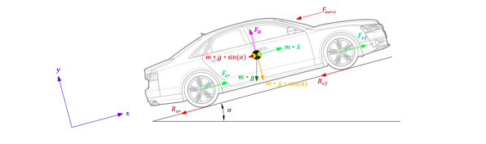

**figure 2. longitudinal vehicle Dynamics [1]**

After applying Newton’s second law of motion to the free-body we get

m ∗ $ẍ$ = Fxf + Fxr − Faero − Rxf − Rxr − m ∗ g ∗ sin (α) (10)

sin (α) ≈ α we have

m ∗ $ẍ$ = Fxf + Fxr − Faero − Rxf − Rxr − m∗g∗α (11)

The force of traction Fx is determined by the vehicle mass m, the radius of the wheel rwheel, and the angular acceleration of the wheel θ¨ wheel . We have F = m∗ a and a =θ¨.

Fx= m∗rwheel ∗ θ ¨wheel (12)

Aerodynamic resistance Faero depends upon air density ρ, frontal surface area of the vehicle A and velocity of the vehicle v. Using proportionality constant Cα we have,

Faero = 1/ 2 ∗ Cα ∗ ρ ∗ A ∗ v2 ≈ Cα ∗ v 2  (13)

Rolling resistance Rx depends upon tire normal force N, tire pressure P and velocity of the vehicle v. Note that tire pressure is a function of vehicle velocity.

Rx = N ∗ P (v) (14)

Where, P (v) = Cˆ r,0 + Cˆ r,1 ∗ |v| + Cˆ r,2 ∗ v 2

Substituting equations 13, 14 we get

x¨ = rwheel ∗ ¨θwheel −[ (Cα ∗ v 2) / m ]−[( Cˆ r,1 ∗ |v|)/ m] −[ g ∗ α] (15)

**2.2 Lateral Vehicle Dynamics**

Figure 3 shows the free-body diagram of an autonomous vehicle in the lateral direction (denoted as y). The inertial term m*ay, as well as the front and rear tire forces Fyf and Fyr, are all considered lateral forces. Vehicle torque about instantaneous center of rotation Iz, as well as moments of front and rear tire forces lf *Fyf and lr*Fyr (acting in opposing directions), are all taken into account. As a result, when Newton's second law of motion is applied to the free-body diagram, we get:

m ∗ ay = Fyf + Fyr  (16)

Iz ∗ ¨θ = lf ∗ Fyf − lr ∗ Fyr  (17)

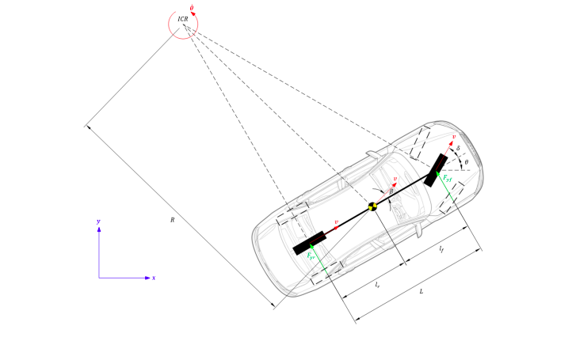

**Figure 3 Lateral Vehicle Dynamics[1]**

The overall lateral acceleration ay of the ego vehicle is made up of the linear lateral acceleration $Ÿ$ and the centripetal acceleration R*˙θ2. As a result, we have,

ay= +R*˙θ 2= y + v ∗ ˙θ (18)

1. **Autonomous 2D Control**

**2.1 Longitudinale speed control with PID**

Longitudinale speed consists of maintaining the required speed by regulating the throttle and brake while following the reference path. The controller tries to keep the discrepancy between the vehicle's heading angle and the reference path's orientation to a minimum.

The vehicle's speed will be controlled via throttling and braking to maintain a reference speed. The graphic in Figure 4 illustrates how to use control.[2]

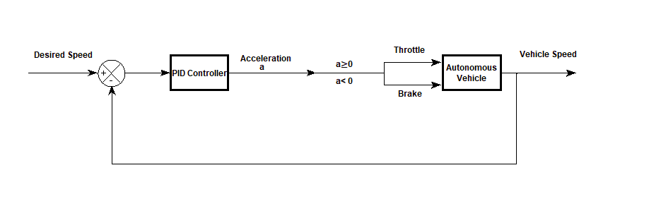

**Figure 4 The Longitudinal Controller Design**

**2.2 Lateral Control with MPC**

Lateral control is adjusting the steering angle such that the vehicle follows the reference path. The controller minimizes the distance between the current vehicle position and the reference path.

The primary idea behind MPC is to utilize a plant model to anticipate how the system will evolve in the future.



In our case, we will use the simple kinematic bicycle model as follows figure 1

x= v * cos(𝛿 + 𝜃)

yt = v * sin(𝛿 + 𝜃)

𝜃t = v / R = v / (L/sin(𝛿)) = v * sin(𝛿)/L

𝛿 = 𝜑

x_(t+1) = x_t + x_dot * ∆𝑡

y_(t+1) = y_t + y_dot * ∆𝑡

𝜃_(t+1) = 𝜃_t + 𝜃_dot * ∆𝑡

𝛿_(t+1) = 𝛿_t + 𝛿_dot * ∆𝑡

**Refrences**

**[1] Chinmay Samak, Tanmay Samak, Sivanathan Kandhasamy “CONTROL STRATEGIES FOR AUTONOMOUS VEHICLES”, cs.RO,10 Sep 2021**

**[2] https://www.mathworks.com/help/driving/ug/lateral-control-tutorial.html**