E. State estimation and real-time localization:

State estimation and real time localization is very important step in driven simulation robotaxis. There is a fundamental function of an autonomous driving system. The localization is of crucial importance for autonomous robotaxis driving tasks. The high precision localization relies on high precision sensors and High-Definition maps (HD Map). Many research and society focalize your search in this field, because is very interested to optimize and estimate the target of the robot. Then, obtaining effective vehicle analysis is critical for urban autonomous driving, tracking, detection and computing of the expected trajectory must be conducted. For better estimation of the trajectory of vehicle movement, the performance of the state of estimation algorithm is important factors. We are interested in determining the position exact of the robotaxis on the trajectory-rail as a function of time. Since our robotaxis is a data-logging sentinel, we are not particularly interested in online estimates of the state.

Robotaxis navigation in an unknown environment is a well-known problem that involves:

• Building a (possibly partial) map of the workspace;

• Localizing the robot within such map.

Many solutions to the navigation problem of Robotaxis in a known environment are based on the use of the Extended Kalman Filter (EKF). When not existence of information on the robotaxis workspace is given, the filter must be complemented with a suitable model for the measurement devices in system. The robotaxis are equipped with onboard ultrasonic sensors, battery-powered, that measure the distance from the boundaries of the surroundings.

1. Options assessment:
   1. Extended Kalman Filter (EKF):

The state estimation of robotaxis update problems can be solved using an Extended Kalman filter (EKF). The EKF has been used for many researchs to estimate the state of nonlinear systems from noisy measurements for robotaxis. It is based on the linearization of the nonlinear maps (f, h) of around the estimated trajectory, and on the assumption. The different equation of Extended Kalman Filter (EKF) are presented in the following equations:

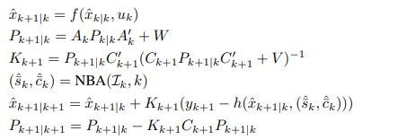

There xˆk+1|k represents the estimate of xk+1 before getting the observation yk+1, xˆk+1|k+1 represents the estimate after getting that observation, and (ˆsk, ˆck) represent the output of NBA at time k and for each sensor Si , i ∈ Ik.

* 1. Error State Extended Kalman Filter (ES-EKF):

The basic idea of Error State Extended Kalman Filter (ES-EKF) is presented in the following figure.

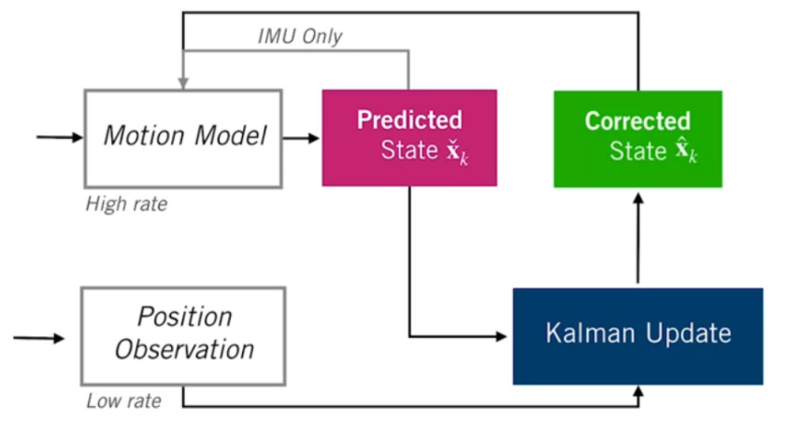

The robotaxis state at each time steps consist of position, velocity and orientation. The inputs of motion model are illustrated in following equations:

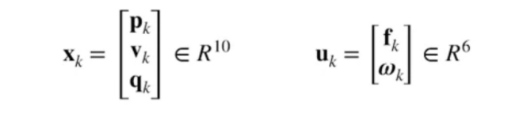

We present now the different equations for ES-EKF:

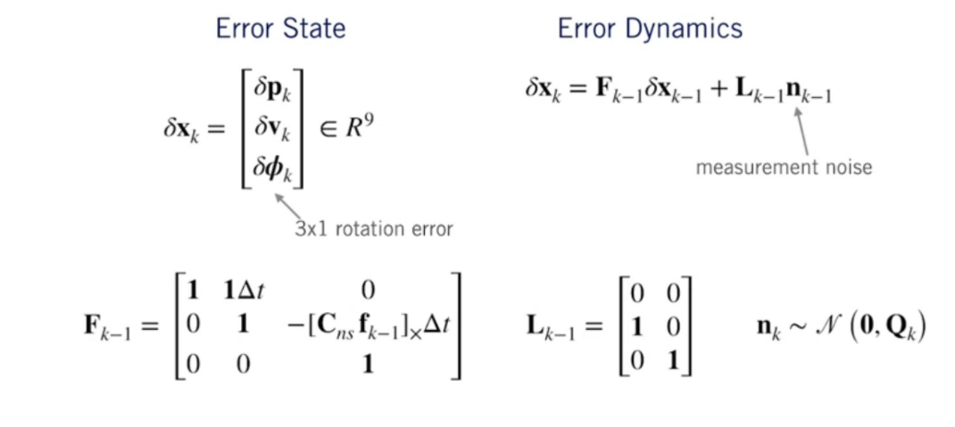

* 1. Unscented Kalman Filter (UKF):

The Unscented Kalman Filter (UKF) has been implemented in recent years to overcome two main problems of the EKF. The UKF is that of finding a transformation that allows to approximate and optimize the mean and covariance of a random vector of length n when it is transformed by a nonlinear map. The UKF estimate is accurate to the third order in the case of Gaussian noises.

1. Implementation of the UKF:

We described the different steps of implementation of the UKF in matlab.

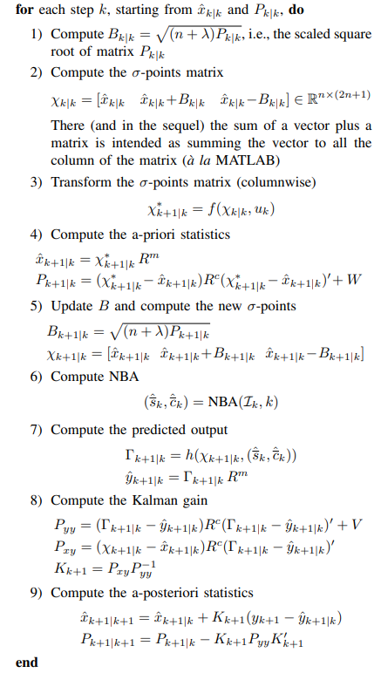

H. Sensor Fusion:

The sensor fusion is the process of combination information from a number of different sources in robotaxis to provide a robust and complete description of an environment. The sensor fusion techniques are used to obtain a better process description, less influenced by noise w.r.t. the starting one. In a control robotaxis various sensors types are used to provide as more information as possible and to ensure application robustness. The sensors are used to monitor various aspects of the same robotaxis (e.g. speed, position, power, temperature, etc. . . ). This information is influenced by noise due to the sensors’ characteristics or to working environment features.

1. Sensor Synchronization:

The Sensor synchronization in robotaxis is vastly under-studied and public information is scarce. Most prior work in the literature with many researchs either assumes that the sensors are perfectly synchronized, which is unrealistic in realworld scenario, or targets a specific application with a specific sensor setup. Many authors design an effective intra-machine synchronization system for cameras and IMUs and demonstrate its effectiveness in real-time SLAM tasks in robotaxis and Micro Vehicles. This system practices our Design Principle 4, i.e., obtaining sensor timestamps closer to the sensor source.

1. Sensor Raw Data Processing:

We choose a two cameras for sensor data because a LIDAR is very expensive. The camera data is encoded in this dataset as range images, one for each Camera return; data for the first two returns is provided. The range image format is similar to the rolling shutter camera image in that it is filled in column-by-column from left to right. Each range image pixel corresponds to a Camera return. The height and width are determined by the resolution of the inclination and azimuth in the Cameras sensor frame. Each inclination for each range image row is provided.

3. Sensor Fusion Algorithm:

In the following, we present a flow chart of sensor fusion algorithm:

Initial object detection

Determine the location of detected object

Get distance and orientation of object with range laser sensor

Use the laser scan data for motion planning

Non

Oui

Push the button with the level of procession

Activate a Button