MOTOR :

**2kw 20kw 48v 72v brushless dc motor :**

Brushless DC motor has simple structure, great power density, torque output and high efficiency. It has a broad application prospect for electric vehicle.

<https://www.alibaba.com/product-detail/2kw-20kw-48v-72v-brushless-dc_60778503928.html?spm=a2700.pc_countrysearch.main07.29.68a35916E4TbXf&fbclid=IwAR0uGR4VCxPOuUwYkN-bMUzrEAq9Fl2hplGbWATaL6OE1jnI0DKE8DoSekk>

**Li Ion Battery :** 18650 cells

The design of Li-ion battery is composed of 20 cells in series Each cell provides a nominal voltage of 3.6V so my final pack voltage will be 72v And 12 cells in parallel  so the final capacity of my pack is going to be 72 volts times 40 amp hours equals 2880 watt hours or 2.88 kilowatt hours

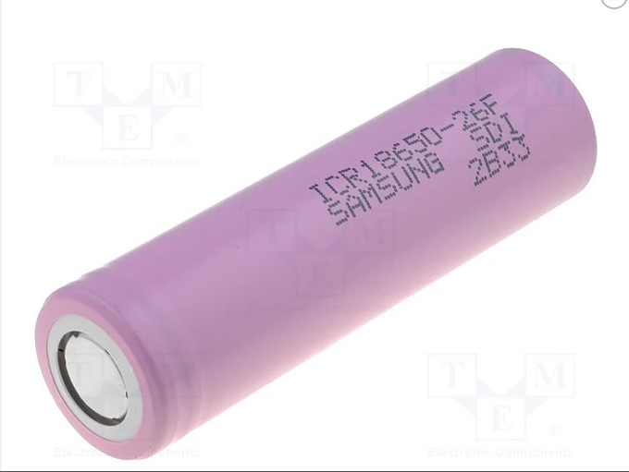

B. Battery Management System (BMS) :

Automotive Battery Management Systems (BMS) must be able to meet critical features such as voltage, temperature and current monitoring, battery state of charge (SoC) and cell balancing of l batteries.

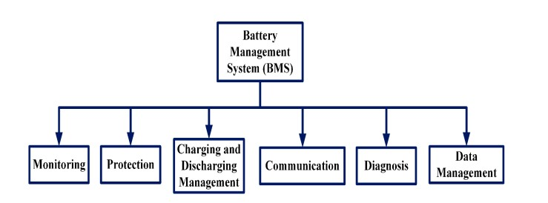

# Choice : NCM Li Ion Battery BMS 20S 72V 70A Lithium Battery Management System

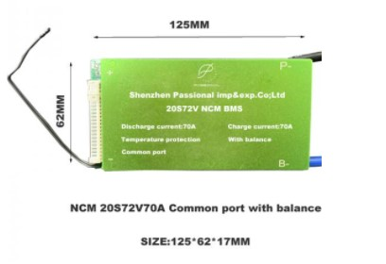

1. Voltage and current Monitoring :

The BMS must manage the system over the entire operating cycle of the EV , and has to ensure the function of Collecting information from sensors in the battery: current, voltage,

The information is processed by the BMS to ensure correct battery operation.

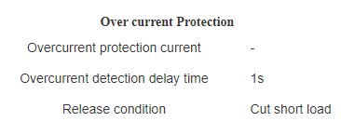

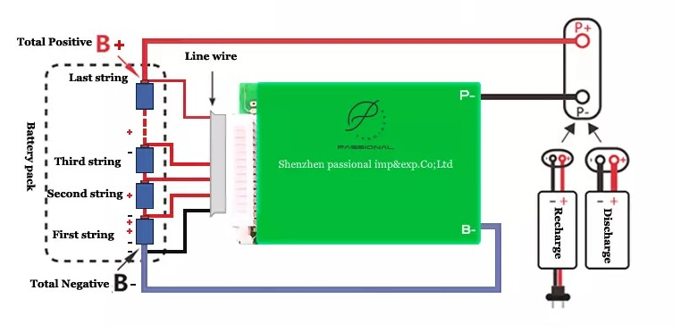

3. Temperature Monitoring :

One of the functions of the BMS (Battery Management System) is the continuous monitoring the temperature of the accumulators

Too low battery temperature will slow the charging rate while too high battery temperature will create a hazard so Maintaining the correct charging temperature range has the added benefit of increasing battery life expectancy.

Solution :

Ametherm NTC Thermistor Temperature Sensors are a key component in Li-Ion battery charging and safety

Choice : NTC THERMISTORS – GLASS ENCAPSULATED

**Characteristics :**

* High precision resistance and β value with an operating temperature range of -40~ +250 °C.
* Greater accuracy and a faster response makes them an efficient and cost effective alternative to RTD probes and thermocouples.

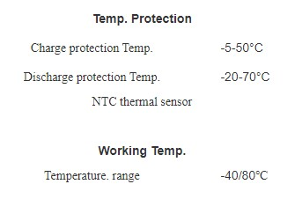 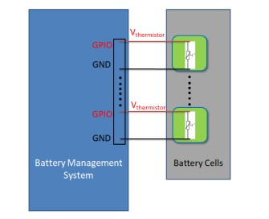

4. State of Charge (SOC) :

Each battery has a specific number of charging and discharging cycles so The BMS estimates the state of charge (SOC) of the battery

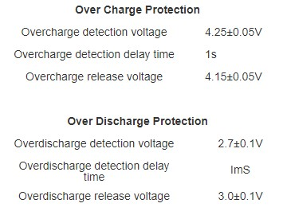

5. State of Health (SOH) :

The SOH is an indicator of overall health of the battery and gives an insight into the operating conditions of the battery. Based on this information, battery lifespan and maintenance schedule can be projected.

The accurate state-of-health battery estimation can give early warning of deterioration and the need for battery replacement. Once you know the SOH, you gain access to useful information regarding the performance of your battery and the entire energy storage system, including their efficiency and reliability.

calculating the SOH can rely on:

* **Age**
* **Cycle life (number of charge/discharge cycles)**
* **Capacity**
* **Internal resistance**
* **Energy throughput**
* **Temperature**
* **Self-discharge rate**
* **Voltage**

6. Balancing System :

The working principle and function are as followings, when your one cell voltage is upto alarm voltage, then the cell Balance starts to work, balance resistance starts discharge with 35ma(when balance discharge starts to work, BMS will starts a little heat up, which is the normal reflection), the cell is in both charging and discharging status, and others which are not reached to alarm voltageare only in charging status, no discharging, when the fast cell voltage is reached to alarm voltage BMS starts off power protection, all the other cells are all in stop of charging, this process will enable your battery charging in balance current, and your battery voltage are in balance status, but when your cell voltage difference are in a big range, then balance can not be functioning.well

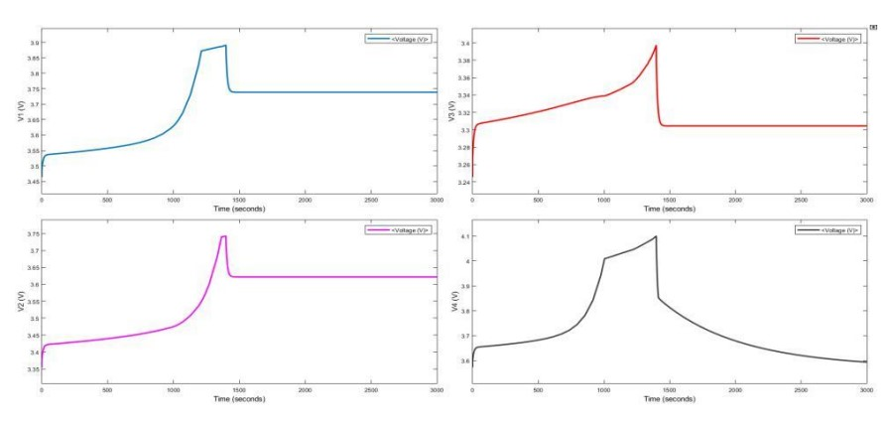 Voltage graph of passive balancing of 4 cells  
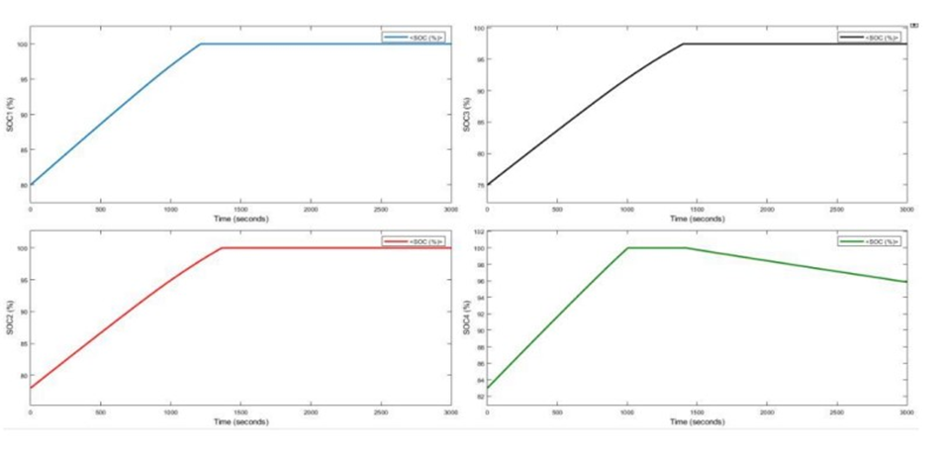

SoC graph of passive balancing of single cell