***Sensors***

Battery sensor:

electronic battery sensor (EBS):

The electronic battery sensor is an important part of the vehicle energy management. The sensor informs the car of the exact battery status, **measures the temperature** and **controls the charging** **voltage** and **charging current accordingly**.

Specifications:

The electronic battery sensor (EBS) provides reliable and precise information on the status of 12V lead-acid batteries while taking battery aging effects into account. By providing this relevant information, the sensor allows for the implementation of an optimized electrical energy management (EEM) system in the vehicle and supports fuel- and CO2-saving technologies. It is also a key component in electrified and automated vehicles as well as supporting other applications, such as firmware over-the-air, predictive diagnostics, and predictive maintenance.

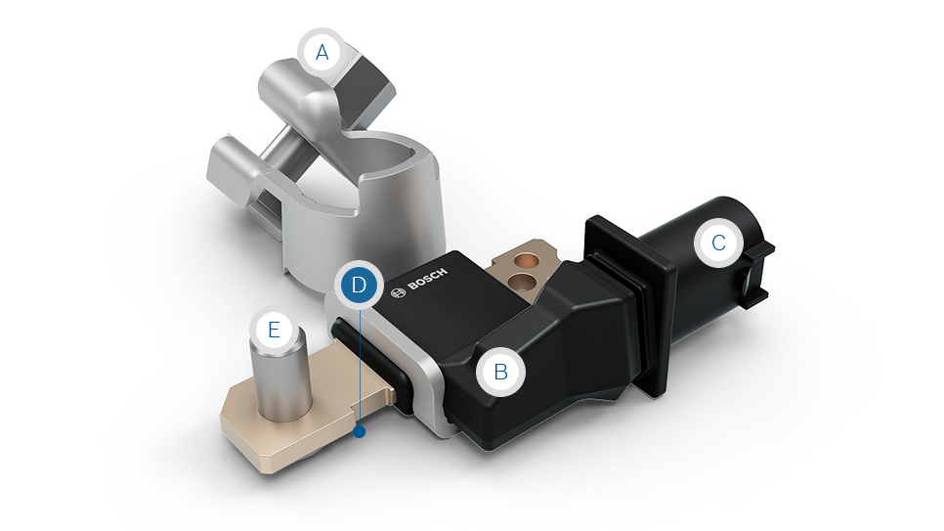

Features:

The electronic battery sensor (EBS) measures the current, voltage and temperature of 12V lead-acid batteries with great precision. The battery state detection algorithm (BSD) integrated into the EBS calculates the current and predicted state of charge and function of the battery from these base parameters and indicates battery aging effects. This information is passed on to a higher-level control unit, e.g. the electrical energy management (EEM) system. If needed, that system implements suitable measures to ensure the power supply to ancillaries that are important or critical to safety.

Moreover, it serves other purposes like maximizing battery life by avoiding deep discharge or supporting fuel- and CO2-saving technologies such as smart generator control, start/stop or recuperation.

The sensor is also a key component in the design of safe and reliable vehicle electrical system topologies, thereby supporting the continuously increasing electrification and automation of vehicles as well as other applications, such as firmware over-the-air, predictive diagnostics, and predictive maintenance.

Technical specification:

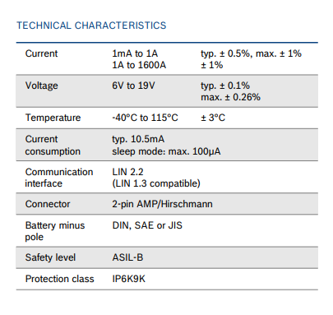

PRODUCT BENEFITS:

PRODUCT BENEFITS FOR MANUFACTURERS

* Scalable and programmable data output based on customer needs
* Cost-efficient design thanks to a platform concept
* Advanced diagnostic functions during manufacture, transport and operation
* Supports safety-relevant functions like automated driving (ASIL-B conformity)

PRODUCT BENEFITS FOR DRIVERS:

* Prevention of breakdowns resulting from a discharged battery
* Fuel savings thanks to the support of technologies such as smart generator control, start/stop und recuperation
* Extended battery life
* Supports automated driving functions

Notes:

For a better performance, we can use a smart electronic battery sensor( SSVT model )

**temperature sensor**

The temperature sensor measures the temperature of various fluid media, such as water, fuel, or oil, over a wide temperature range. It is specially designed for automotive applications. Temperature measurement is via an NTC (Negative Temperature Coefficient) resistor. The signal of the temperature sensor, transmitted in an analog format, is a key input parameter with respect to intelligent engine and gearbox control, for instance in the regulation of engine cold starts and warm operation.

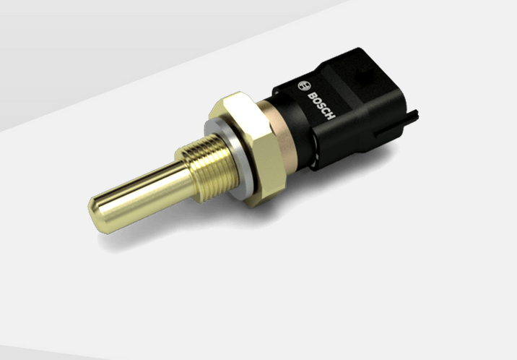

The temperature sensor has an NTC sensor element with brass housing and a 2-pin connector.

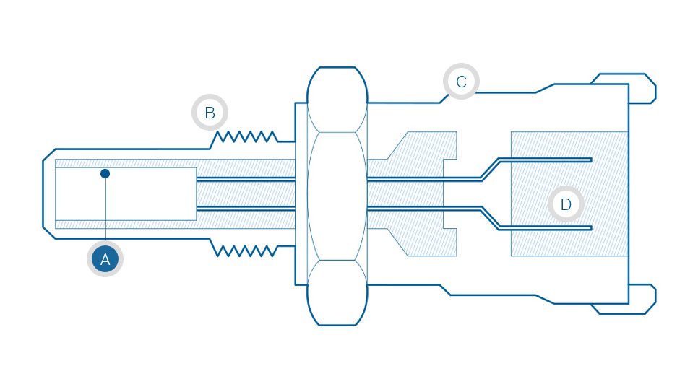



Technical specification:

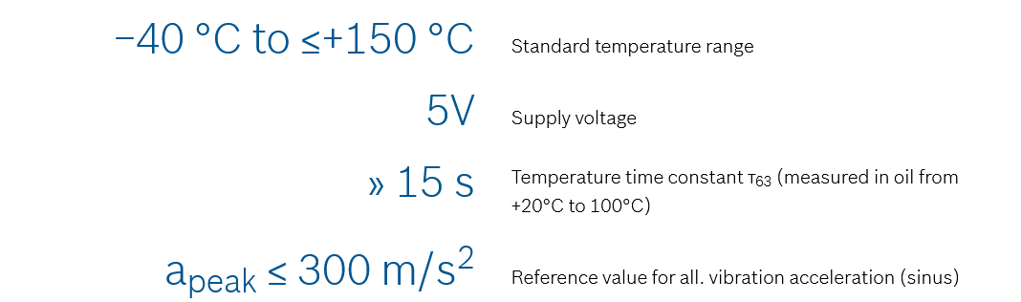

PRODUCT BENEFITS

* Control during cold starts, warm operation, fan actuation, etc.
* High resistance against various media (water, fuels, oil, etc.)
* Broad temperature range

**Transmission sensors**

Transmission speed sensors detect the input, output or intermediate speed of the transmission and transmit this information to the transmission control unit (TCU). The TCU uses this signal to regulate the shifting pressure and to decide on the gear to be engaged. The transmission pressure sensor measures the hydraulic oil pressure in different transmission applications and helps to determine the shifting pressure precisely and reliably.

**flexible design** of the transmission speed sensor for various installation-space requirements and **increased driving comfort** due to improved gearshift operations and clutch reaction thanks to the transmission pressure sensor.

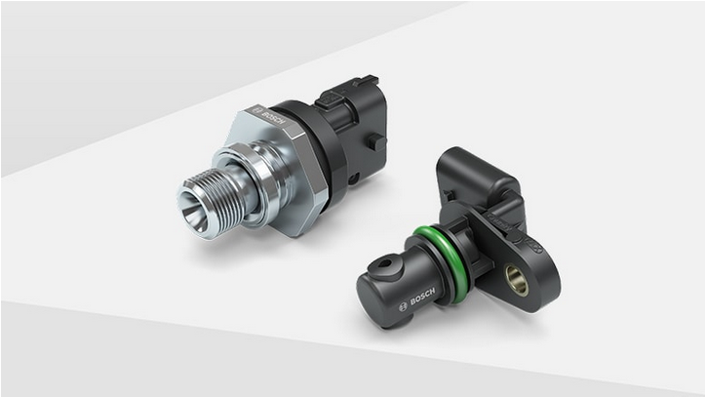

The transmission speed sensor is designed as a hall or inductive sensor. The transmission sensor performs contactless scanning of the steel or multipole trigger wheels. The sensing element of the transmission pressure sensor consists of a membrane that is deformed by the applied pressure.

The deformation is converted into a voltage proportional to the pressure. An electronic evaluation circuit then amplifies and digitizes the voltage.

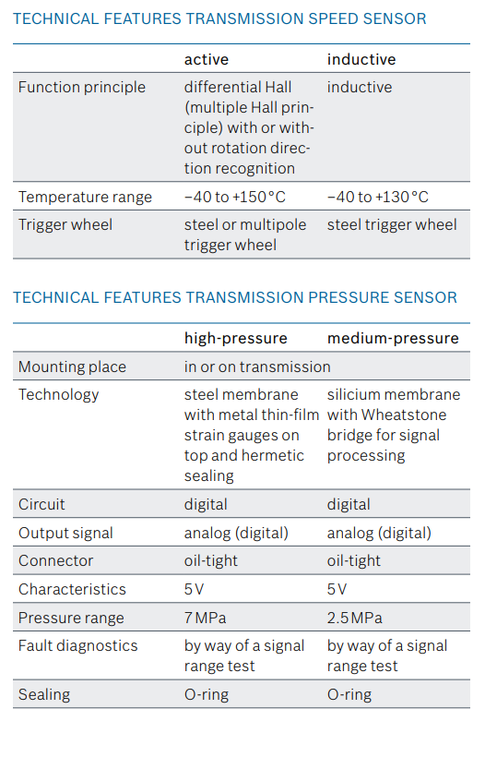

PRODUCT BENEFITS

* Durable design
* High measuring precision and reliability
* For flexible use with different transmission types
* High media resistance

**Differential pressure sensor**

The differential pressure sensor measures the pressure drop between two points in the flow pattern and is used at two different points in the exhaust manifold. At one point it reports the charge status of the particle filter and monitors its function. At the other point it is used to control the low-pressure exhaust gas recirculation.

**Economical** precise sensor measurement allows demand-controlled regeneration of the diesel particulate filter to save fuel, **safe** monitoring of the particulate filter charge and **precise** control of the low-pressure exhaust gas recirculation rate.

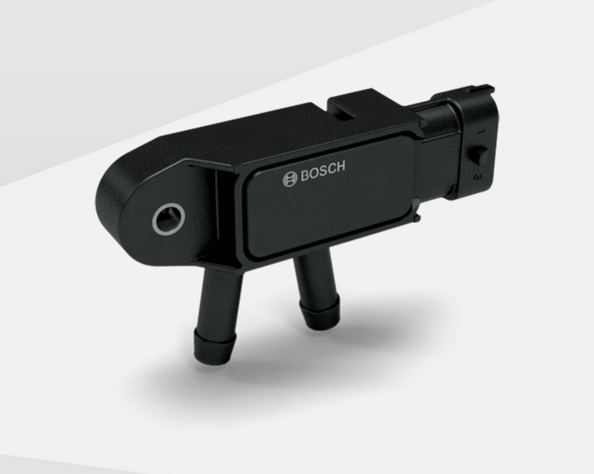

The differential pressure sensor can be used for exhaust-gas treatment as well as low-pressure exhaust gas recirculation. The variant for exhaust gas recirculation is only slightly different from the particulate filter variant. It generally uses a smaller pressure measuring range. The connectors and the housing of both variants can be adapted to the specific requirements of the vehicle manufacturer.

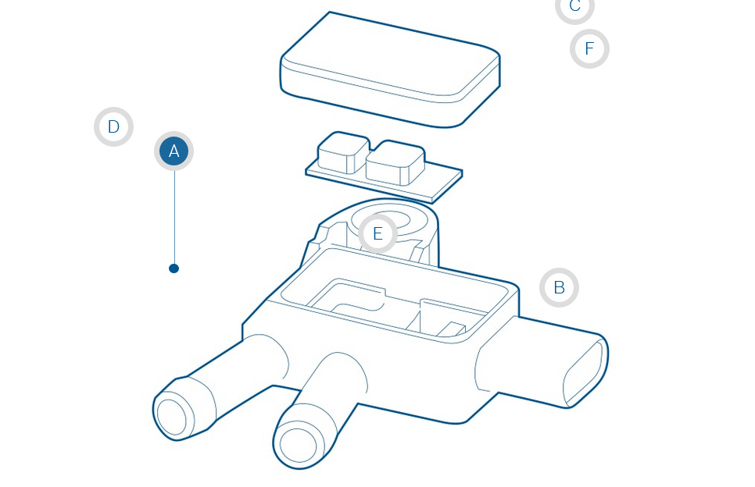

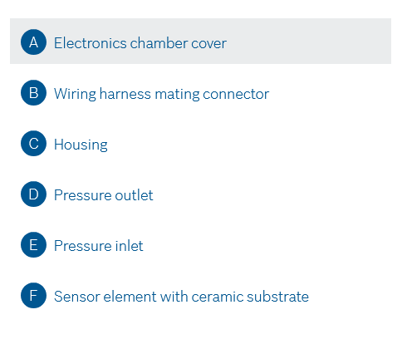

### Technical specifications

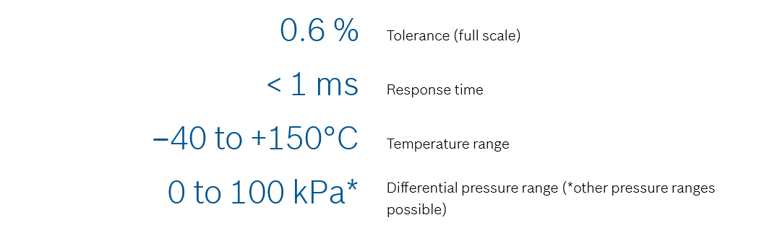

PRODUCT BENEFITS

* High sensor accuracy of 0.6 % F.S. on a 100 kPa sensor for demand-based control
* High media resistance in the demanding area around the exhaust tract
* Temperature resistance up to 150 °C
* Customer-specific solutions for connection geometry and connectors

**wheel-speed sensors**

Active wheel-speed sensors are an integral part of brake control systems. They detect the rotational wheel speed of vehicles using a non-contacting measurement principle. It is **tailor-made** For its wheel-speed sensors, Bosch offers different standard sensor heads suitable for various customer applications. **signal redundancy** -The wheel-speed sensor complies with the requirements of highly automated driving-, and **key component** Wheel-speed sensors are an integral part of modern brake control and driving management systems. **sensor variants** are with cable or directly plugged in.

**Sensor design and measuring principle of the wheel-speed sensor**

A wheel-speed sensor consists of a silicon integrated circuit in the sensor head, which is hermetically sealed with overmolded plastic. Bosch wheel-speed sensor circuits use Hall technology, which incorporates the Hall-sensing element, signal amplifier and signal processing all on a single chip. The circuit is exposed to the changing magnetic field of the rotating encoder, which is either a multipole or a steel wheel. In case of a steel wheel application, a magnet placed inside the sensor is needed.

The Hall element generates an alternating voltage that is proportional to the changing magnetic field. The sinusodial voltage is processed by the circuit into an alternating digital output signal, and the wheel-speed information is transferred into load-independent rectangle current impulses. The frequency of the current pulses are directly proportional to the wheel speed. A detection of very low speed nearly up to stand-still (0.1 km/h) is possible.

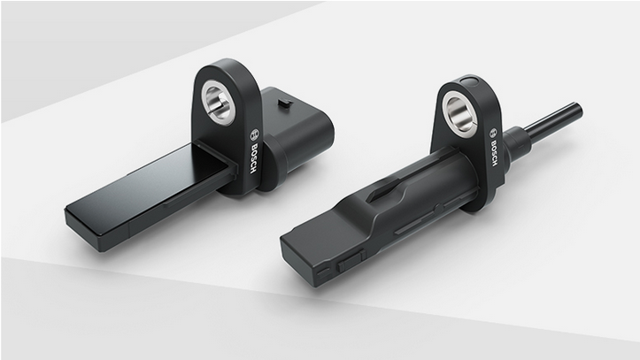

PRODUCT BENEFITS FOR MANUFACTURER

* Small size
* Internationally standardized two-wire-current interface
* Speed detection close to 0.1 km/h
* Standard sensor heads suitable for various customer applications

**https://www.bosch-mobility-solutions.com/en/solutions/sensors/wheel-speed-sensor/**