1. **COMPETITION DUTIES**

Robotaxi will serve on a track that reflects the state of full-scale city traffic. The vehicle's task is to travel on an inner-city route, starting from a fixed point (BN: starting point) and ending at an end/stopping point (DN: ending/stopping point), similar to a typical urban taxi. During this trip, robotaxi will stop when it sees the first passenger pick- up sign (or: passenger pick-up point), pick up the passenger and continue its journey. Robotaxi will drop the received passenger at a marked point (YB: passenger drop-off/drop-off point) on its route. Robotaxi will follow traffic rules throughout the trip and stop when it reaches the end point. Robotaxi, which parks in the first empty space in the parking areas at the end of the endpoint, will have successfully completed its task.

1. **VEHICLE GENERAL SPECIFICATIONS,**

**4.1. Physical Properties**

It is expected that the vehicles will be passenger vehicles suitable for urban driving. For this purpose, vehicles (within the specified dimensions) are required to have at least one seat or more seats, 4 wheels (for the driver with a height of about 1.70 m and a weight of 70 kg).

**4.1.1. Vehicle Dimensions**

1. the height of the vehicle must be at least 100 cm and less than 1.25 times the width of the vehicle. (100 cm < vehicle height < vehicle width x 1.25 (150-225cm)).
2. the distance between the mutual wheels must be more than half the width of thevehicle.
3. vehicle width should not be less than 120 cm, not greater than 180 cm (119 cm < vehicle width <181 cm).
4. the vehicle length must be at least 200 cm and at most 425 cm.
5. the opening of the front wheels must be at least 100 cm, and the opening of the rear wheels must be at least 80 cm.
6. the distance between the front and rear wheels must be at least 130 cm.
7. the vehicle's ground clearance must be at least 45 mm.
8. vehicles whose doors and other components it believes will be damaged in the wind will be exported due to a security violation.
9. during technical checks, the vehicle will be checked to see if it is in the lines drawn in the control area.

**4.1.2. Car Body**

* 1. The vehicle body must be fixed to accommodate all mechanical and electrical parts. When looking at the car from the front, back and top, all parts must be completely inside the body, the wheels can move out of the shell (e.g. Formula cars). The Shell must not contact the road, wheel or any other hitch.

1. in cases that require the installation of brake wires, pipes, hoses, electrical cables and electrical equipment outside the vehicle, these components should be protected from the risks of damage such as Stone impact, rust, mechanical failure. All components to be installed in the vehicle Shell must be protected from risks such as combustion and short circuit.
2. the body of the car should not have sharp and sharp protrusions that may damage the track during the race.

During technical checks, all elements that pose a risk to the track or other vehicles will be checked.

1 TUBITAK Efficiency Challenge electric vehicle racing activity booklet was used in the preparation of this title.

**4.1.3. Weight**

There is no lower limit on vehicle weight. However, if the car is not suitable for safety equipment, it may be expelled from the race by the Advisory Board and the Arbitration Committee.

**4.1.4. Wheels**

1. the wheel to be used in vehicles should consist of hub, rim and tire. It is mandatory to use air tires on wheels.
2. heating or chemical treatment of wheel tires by any method is prohibited.
3. there are no restrictions on the wheel dimensions of the wheels and the material in which they are made.
4. the wheel width must be at least 70 mm.

**4.2. Sensor / Sensing System**

The geometry of the road (lanes) and recognition of obstacles can be done by means of cameras or other sensors. One or more sensors can be used to detect the position and environment of the vehicle and help perform the given autonomous task.

The sensor must be securely mounted in the vehicle. The area should not exceed the envelope that determines the surface of the vehicle. This area is limited by the outer edges of the 4 wheels horizontally and by the front rear end points. Except for the sensor, it can exceed the vehicle height by maximum 30 cm.

There will be a "Sudden Brake Duty" at a determined point on the competition track. Within the scope of this task, it will be requested to stop without hitting during movement against pedestrians and similar situations that may unexpectedly set off/jump in urban traffic.

**4.3. Security Hardware**

Your vehicle must have brake, right and left turn signal lights. The diameter of the reflection surface of these lights cannot be less than 7 cm and the amount of light cannot be less than 500 lumens.

There is no limitation in the selection of motor and motor driver. The battery pack must be

placed inside the vehicle and protected from short circuit and leakage by a protection container. The battery protection cup should be fixed to a solid point on the floor of the vehicle. Fixing should be done in such a way that the fixing apparatus and fixing points do not move out of place even in the event of an accident. The Battery Management System (BMS) is an electronic system that enables rechargeable battery cells and packs to operate within safe operating limits and its use is mandatory. For this purpose, BMS should monitor the voltage, current, temperature, State of Charge (SOC), State Of Health (SOH) of each battery cell and package and take necessary safety measures when exceeding safe operating limits. BMS should also include passive or active balancing system in order to eliminate voltage imbalances that may occur in battery cells.

In terms of Electrical Safety; All vehicles must comply with the rules set by the national authorities regarding the standardization and use of low voltage electrical components. Although all parts of the electrical equipment should be protected with at least IP 44 type (safe against dust and splashing water), IP 55 type protection is recommended. Any electrical connection between energy generating equipment and energy consuming units must be able to be interrupted by at least one non-sparking circuit breaker (top push emergency power cut-off switch / emergency stop). It is sufficient to have an emergency button. (See Figure 11.a, b, c).

Over

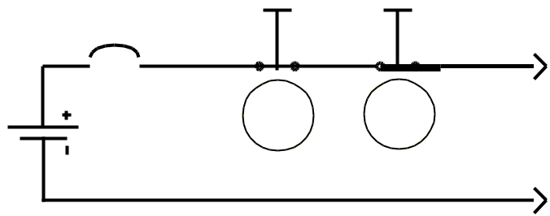

Battery, Fuel

Cell

*Figure 11-a. Example of de-energization circuit with high current emergency disconnect switch*

Over Current Breaker

Contactor

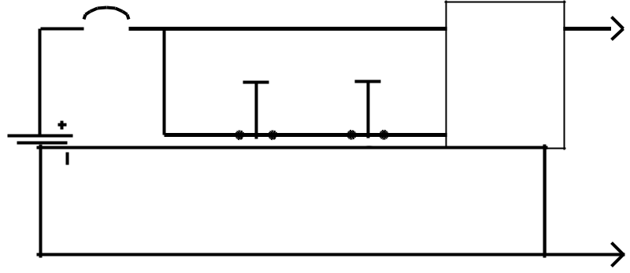

Normally Closed

Switches

Battery,

Fuel Cell

*Figure 11-b. Example of de-energization circuit with low current emergency disconnect switch*

20

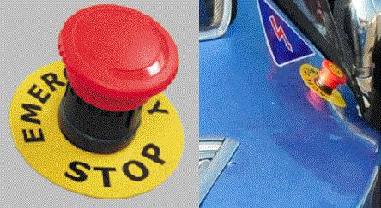

*Figure 11-c. Exapmles of Emergency Power Off (EPO) button*

The emergency disconnect switch should be in a place that can be easily accessed from outside when necessary. In technical inspections, after the other controls of the vehicle are completed, it will be tested whether the emergency stop button works functionally or not by pressing it while the vehicle is running and moving. All electrical cables in the vehicle must be protected by an overcurrent breaker (fuse, etc.) rated for the diameter of each conductor. Overcurrent breakers can in no way replace the circuit breaker (emergency stop button) . Cables must be in a suitable cable sheath and bare cables must not be used. Harnesses should be properly clamped. In addition, the value of the maximum RMS current carried by the cables used in the vehicle should not exceed 5 times the cross-section of the cable used in mm2. (For example, the maximum current that can pass through the 16mm2 cable used in the vehicle should be 80A RMS.) . The braking performance of the vehicle will be controlled by applying the brakes. The test will be done on the brake ramp (slope is about 10 degrees) or the 650 Newton thrust test will be provided by two people pushing the vehicle. The wheels of the pushed vehicle should not turn. The brakes of the vehicle whose wheels turn while being pushed are not suitable. A stop lamp should be placed at the rear of the vehicle so that it can be seen from a distance of at least 25 meters during the day, giving a red light and activating in the event of full or half pressing the brake. It will be checked whether the stop lights are easily visible from a distance of 25 meters in technicalcontrols.

**4.3.1. Remote Emergency Response System (RERS)**

Autonomous vehicle must have RERS. RERS should have two functions:

1. RERS-1: When the remote emergency stop button is pressed, the vehicle must perform an emergency shutdown.
2. RERS-2: When the "Go" button is clicked, the vehicle should start its mission. This button will replace the starting flag in other races.

RERS circuit on vehicle will be directly connected to the vehicle by cable. In technical controls, it will be tested that RERS-1 and RERS-2 functions are working

**4.3.2. Control System**

The entire movement of the vehicle (road tracking, brake and steering maneuvers) will be carried out by the control system on the vehicle or the computer. This control will be provided by electromechanical systems.

It is recommended that teams use regenerative electric brakes in braking. In addition, it is

21

recommended that the hydraulic brake system be working against possible electrical problems of the vehicle and it should be controlled by the vehicle control computer.

*An electromechanical system attached to the brake pedal can activate the hydraulic brake.*

The correct operation of the software that performs the control algorithms should be demonstrated in technical controls.

*(When showing the software, the functions should be displayed* ***in Medium and High level languages*** *for easy understanding.)*

**4.3.3. Wireless Communication System**

Mission start is given to the vehicle remotely via wireless communication. This system should also fulfill the emergency shutdown function. Team is responsible for showing that wireless communication is not involved in the autonomous driving of the vehicle during the mission. Any changes in the vehicle (changing parameters, updating software, sending commands, etc.) will not be permitted at the time of duty by wireless or other communication.

It is strictly forbidden to communicate in any way with the vehicle, except for the systems mentioned above. The vehicle will never be remotely controlled.

Technical controls of autonomous vehicles will be made according to the following:

1. It will be checked whether the vehicle complies with the rules regardingcommunication.
2. Participants must prove that their vehicles perform the autonomous task. This will be checked by the competition evaluation report and presentation, and by the Advisory Board and the Ground Jury.

**4.3.4. Assembly and Wiring Elements**

Autonomous in-vehicle transmission organs must be structurally and chemically appropriate to their task and reliable in terms of environment.

For this, various issues should be taken into consideration while making assembly and cabling.

**4.3.4.1. Assembly**

* In screw connections, make sure that the nut is fully tightened.
* For fixing the parts that are a certain force or that will be exposed to force in the process and that may rupture / detach as a result of these forces, silicon etc. glue cannot be used

. *(It is not a problem to use it for simple bonding.)*

* Fixing / connecting the sections in critical parts should be done with appropriate connection equipmen bolts, rivets, etc.).
* While the car is ready, no parts should make abnormal movements..
* Unsuitable connection equipment cannot be used.
* Electronic components cannot be installed in two potential moving parts.

**4.3.4.2. Wiring**

* Cables should be chosen according to thetask.

22

* + Cables in contact with hot areas should be insulated from heat.
  + The cable should be protected in cases such as puncture, cut and chipped.
  + Measures should be taken to prevent the cable from being damaged in cases such as compression or pulling (plastic inside copper break, plastic breakage, coming out of connectors or connector breaking, etc.).
  + Harnesses should not be kept free. Strapping equipment such as cable socks should be used.
  + Cables need to be labeled. *(To save time and prevent possible accidents during the competition.)*
  + Power cables should be selected properly, installed in the vehicle, protected and insulated.
  + The color selection of the cables should be in accordance with the standards as possible.
  + For color selection of power cables, the color of (+, plus) line should be **Red** (-,minus) line should be **Black**
  + When using cable ties, care should be taken not to cross the cable and take precautions..
  + Power transmission organs should not be transferred directly and aconnector should be used*. (Direct soldering from card to card etc.)*
  + Data and signal cables should be easy to understand.
  + Areas with the possibility of arcing should be designed against burning.
  + No active conductor should be exposed in a ready-made vehicle.
  + Cables, cable harnesses and any transferring equipment must not touch a moving surface (wheel, etc)