**COMPETITION DUTIES**

* 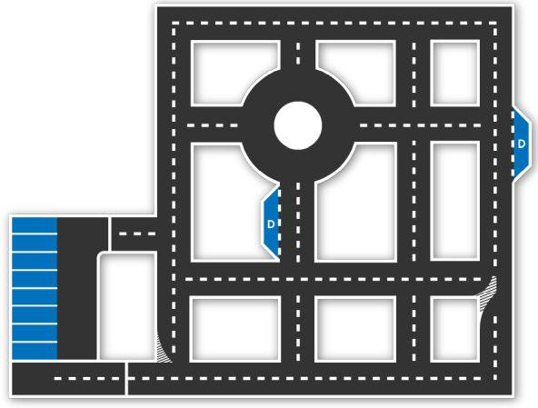The vehicle's task is to travel on an inner-city route, starting from a fixed point and ending at an end/stopping point, similar to a typical urban taxi.
* During this trip, the robotaxi will stop when it sees the first passenger pick- up sign (or: passenger pick-up point), pick up the passenger and continue its journey. It will drop the received passenger at a marked point on its route
* It will follow traffic rules throughout the trip and stop when it reaches the end point.
* Robotaxi, which parks in the first empty space in the parking areas at the end of the endpoint, will have successfully completed its task.

**Physical Properties**

- It is expected that the vehicles will be passenger vehicles suitable for urban driving. For this purpose, vehicles are required to have at least one seat or more seats, 4 wheels (for a driver with a height of about 1.70 m and a weight of 70 kg).

**Vehicle Dimensions**

1. the height of the vehicle must be at least 100 cm and less than 1.25 times the width of the vehicle. (100 cm < vehicle height < vehicle width x 1.25 (150-225cm)).
2. the distance between the mutual wheels must be more than half the width of thevehicle.
3. vehicle width should not be less than 120 cm, not greater than 180 cm (119 cm < vehicle width <181 cm).
4. the vehicle length must be at least 200 cm and at most 425 cm.
5. the opening of the front wheels must be at least 100 cm, and the opening of the rear wheels must be at least 80 cm.
6. the distance between the front and rear wheels must be at least 130 cm.
7. the vehicle's ground clearance must be at least 45 mm.

**Car Body**

1. When looking at the car from the front, back and top, all parts must be completely inside the body,
2. in cases that require the installation of brake wires, pipes, hoses, electrical cables and electrical equipment outside the vehicle, these components should be protected from the risks of damage such as Stone impact, rust, mechanical failure. All components to be installed in the vehicle Shell must be protected from risks such as combustion and short circuit.
3. the body of the car should not have sharp and sharp protrusions that may damage the track during the race.

**Weight**

There is no lower limit on vehicle weight.

**Wheels**

1. the wheel to be used in vehicles should consist of hub, rim and tire. It is mandatory to use air tires on wheels.
2. there are no restrictions the material in which the wheels are made.
3. the wheel width must be at least 70 mm.
4. the wheels can move out of the shell (e.g. Formula cars). The Shell must not contact the road, wheel or any other hitch.

**Sensor / Sensing System**

* The sensor must be securely mounted in the vehicle.
* The area should not exceed the envelope that determines the surface of the vehicle. This area is limited by the outer edges of the 4 wheels horizontally and by the front rear end points. Except for the sensor, it can exceed the vehicle height by maximum 30 cm.

**Security Hardware**

* Your vehicle must have brake, right and left turn signal lights. The diameter of the reflection surface of these lights cannot be less than 7 cm and the amount of light cannot be less than 500 lumens.
* A stop lamp should be placed at the rear of the vehicle so that it can be seen from a distance of at least 25 meters during the day, giving a red light and activating in the event of full or half pressing the brake.
* There is no limitation in the selection of motor and motor driver.
* The battery pack must be placed inside the vehicle and protected from short circuit and leakage by a protection container. The battery protection cup should be fixed to a solid point on the floor of the vehicle. Fixing should be done in such a way that the fixing apparatus and fixing points do not move out of place even in the event of an accident.
* 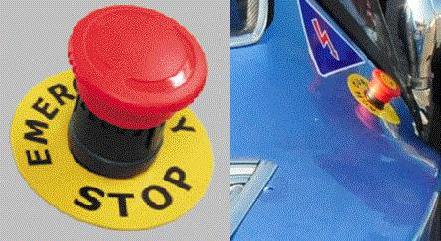Any electrical connection between energy generating equipment and energy consuming units must be able to be interrupted by at least one non-sparking circuit breaker (top push emergency power cut-off switch / emergency stop). It is sufficient to have an emergency button.
* The emergency disconnect switch should be in a place that can be easily accessed from outside when necessary

*Examples of Emergency Power Off (EPO) button*

**Assembly**

* Fixing / connecting the sections in critical parts should be done with appropriate connection equipmen bolts, rivets, etc.).
* While the car is ready, no parts should make abnormal movements..

**Wiring**

* + The color selection of the cables should be in accordance with the standards as possible.
  + For color selection of power cables, the color of (+, plus) line should be **Red** (-,minus) line should be **Black**