### Goals:

The Fish-Tastic website is intended to increase the revenue for this aquarium supplier by promoting the existing and new business that developed. It intends to see an increase in the number of residential and corporate customers attending the classes for setting up landscapes and koi ponds and also the number of fish and puppies sold every week.

### Success Evaluation:

As well as conducting other promotional activities and keep profits, online feedback form and FAQ are our way to evaluate whether the increase in sales are attributed to the new website. After 3 months, we count the profits and increase number of fish and puppies sold to the previous months.

### Target Audience:

### 

The website mainly target at young families with child who emphasis on relax values of life. They are from high to middle class and intend to both online shopping and physical stores. The site will be specifically designed towards children. It boots the appeal to this age group by using imagery and colorful fonts.

### Content:

**Home Page**

* information about the organisation

**Online order form:**

* customers can place orders online

**Products**:

* short descriptions of company products

**Services page:**

* information on delivery details and free delivery
* value-added services
* exchanges and returns

**Events (landscaping):**

* events list descriptions
* Pet shop & veterinary information

**Contact us:**

* Online feedback form:
* FAQ

**References:**

* References used

### Site Flowchart:

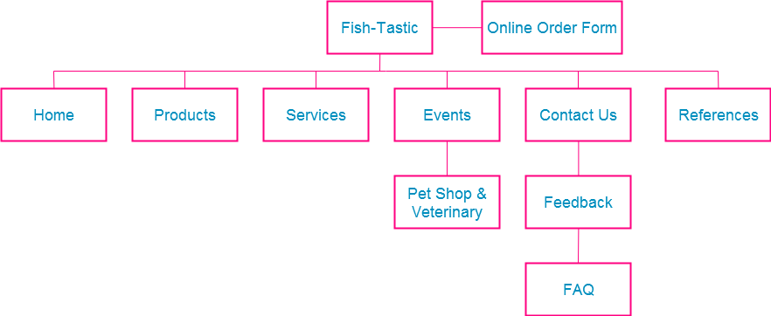

### GitHub Repository Link and links to comps and pages