**RAE VS. REF**

|  |  |  |
| --- | --- | --- |
|  | RAE | REF |
| Number of panels | 15 main panels + 67 sub-panels + 800 advisors | 4 main panles + 36 sub-panels + advisors |
| What was assesed | Output, esteem indicators, environment | Output, **impact*,** environment,  *case study approach in order to assess ‘user value’ of a research |
| Weights | Depending on panel decission (min. 50% for output, 20% for enivioronment, 5%) | Strict: Output – 65%, Input- 20%, Environment – 15% |
| Number of submission | 2363 submission form 159 HEIs | 1911 submissions by 154 HEIs |
| Usage of biblimetrics (citation indicators) | No | Yes |
| Staff elibillitty cateories) | A,B,C,D | A, C (more restricted) |

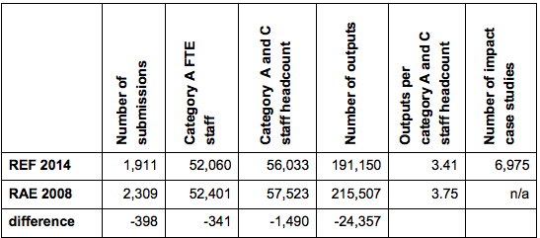

**Similarities:**

* metrics-based system for assessing and funding research
* similar information about submission - staff, resarchers, outcome, income
* the same scale and definitions – from 1* to 4*
* Type of an output and distribution (75/80% of journals)
* The total budget for conducting a REF -£14.4 million, for RAE a bit less - £12 million

Things that have **changed** with **RAE 2008:**

* system involving expert advice
* indicators or metrics focused on research quality
* including in the assesment a disciplinary differences

Things that have **changed** with **REF 2014:**

* Guidline for environment and impact studies (developing structured template)
* Guidelines on submissions and the panel criteria standarised across the whole exercise
* More attention paid to staff equality, privacy and diversity