SineReserve

**Project Manager**

Pura, Walter Jann

**Back-end Programmers**

Mendoza, Michelle Ann

Falcon, Dan Kristopher

**Front-end Programmers**

Pua, Renzo Ralph

Digman, Jan Renzo

**Quality Assurance Tester**

Monte, Raymar

SineReserve

A Movie Reservation System

Website Objectives:

* Offer membership buying/reserving seats for a film showing in a branch of a theater house
* Offer members to give reviews and ratings for movies that they had already watched
* Offers information for movies that had been shown, currently showing, and to be shown to help users in picking the movie they want to watch
* Track member activities such as past watched films and reviews made

Components:

**Front-End:**

* HTML5
* CSS3 with Materialize as main framework
* Javascript with JQuery as plugin

**Back-End:**

* PHP with CodeIgniter as main Framework

Structure:

**Home Page:**

* Landing page for users going to the website
* Offers quick glance of what the website offers through its banner
* Lists all showing and incoming movies in a grid list categorized by Now Showing, Next Attraction, and Coming Soon

**Search Results by Date //Danny Boy**

* Lists all movies and their corresponding showing times on a particular date sorted by branch

**Search Results by Movie //Danny Boy**

* Lists all possible movie match according to user’s search term

**Movie Page //Pua w/ co-pilot Digman**

* Page dedicated to a movie displaying all related information such as synopsis, trailers, and photos. Also shows schedules for the movie’s showing if any exists at the moment
* Logged in users will also be able to review the movie if they already watched it

**Reservation Page/Form //Digman**

* A page dedicated as a form which states the formal transaction between the user and the website for buying/reserving a particular movie

**Events page //Walter**

* A page displaying all the events that the website and its corresponding theater house are hosting

**Promos Page //Walter**

* A page displaying all the promos that the website and its corresponding theater house are hosting

**User Page //TBA**

* Page dedicated to view user information such as past reservations and movies reviewed

**Admin Page //Michelle w/ co-pilot Raymar**

* Management.

**Navigation and Footer (Login and Signup included) //Walter & Dan**

Data Dictionary:

**branch**

|  |  |  |  |  |  |
| --- | --- | --- | --- | --- | --- |
| **Column** | **Type** | **Null** | **Default** | **Links to** | **Comments** |
| bran_id *(Primary)* | int(11) | No |  |  | Primary Key for the “branch” table  Ex: 1 |
| bran_name | varchar(20) | No |  |  | Name of the Branch of the Cinema  Ex: SM Manila |
| bran_add | varchar(30) | No |  |  | Address of the Branch of the Cinema  Ex: San Marcelino, Ermita, Manila |

**cinema**

|  |  |  |  |  |  |
| --- | --- | --- | --- | --- | --- |
| **Column** | **Type** | **Null** | **Default** | **Links to** | **Comments** |
| cine_id *(Primary)* | int(11) | No |  |  | Primary key for the “cinema” table  Ex: 1 |
| cine_name | varchar(10) | Yes | *NULL* |  | Name of the Cinema Ex: Cinema 1 |
| lb_slots | int(11) | Yes | *NULL* |  | No. of Seats in the Lower Block of the Cinema  Ex. 250 |
| ub_slots | int(11) | Yes | *NULL* |  | No. of Seats in the Upper Block of the Cinema  Ex. 200 |
| bran_id *(Foreign)* | int(11) | Yes | *NULL* | branch -> bran_id | Foreign Key references to bran_id of the table branch  Ex: 1 |

**movie**

|  |  |  |  |  |  |
| --- | --- | --- | --- | --- | --- |
| **Column** | **Type** | **Null** | **Default** | **Links to** | **Comments** |
| mov_id *(Primary)* | int(11) | No |  |  | Primary key for the “movie” table  Ex. 1 |
| mov_name | varchar(20) | Yes | *NULL* |  | Name of the Movie  Ex: Pitch Perfect 2 |
| mov_desc | text | Yes | *NULL* |  | Synopsis of the Movie  Ex: It's been three years since the Barden Bellas… |
| mov_rating | varchar(4) | Yes | *NULL* |  | Rating of the Movie  Ex: PG-13 |

**reserved_by**

|  |  |  |  |  |  |
| --- | --- | --- | --- | --- | --- |
| **Column** | **Type** | **Null** | **Default** | **Links to** | **Comments** |
| or_no *(Primary)* | varchar(10) | No |  |  | Official Receipt Number of the reserve  Ex. 01021 |
| or_date | date | Yes | *NULL* |  | Official Receipt Date of the reserve  Ex: 2015-01-01 |
| type_reserved | varchar(10) | Yes | *NULL* |  | Type of Seating of the Show  Ex: Free Seat |
| sched_id  *(Foreign)* | varchar(10) | Yes | *NULL* | shows -> sched_id | Foreign key reference to sched_id of shows table  Ex: 010101 |
| Username  *(Foreign)* | varchar(15) | Yes | *NULL* | user -> username | Foreign key reference to username of user table  Ex: derpina07 |

**review**

|  |  |  |  |  |  |
| --- | --- | --- | --- | --- | --- |
| **Column** | **Type** | **Null** | **Default** | **Links to** | **Comments** |
| rev_id *(Primary)* | int(11) | No |  |  | Primary key for the table “review”  Ex: 1 |
| review | text | Yes | *NULL* |  | Review of the User  Ex: I love the musics involved…. |
| user_rating | int(11) | Yes | *NULL* |  | Rating score of the User  Ex: 5 |
| mov_id  *(Foreign)* | int(11) | Yes | *NULL* | movie -> mov_id | Foreign key reference to mov_id of movie table  Ex: 1 |
| Username  *(Foreign)* | varchar(15) | Yes | *NULL* | user -> username | Foreign key reference to username of user table  Ex: derpina07 |

**shows**

|  |  |  |  |  |  |
| --- | --- | --- | --- | --- | --- |
| **Column** | **Type** | **Null** | **Default** | **Links to** | **Comments** |
| sched_id *(Primary)* | varchar(10) | No |  |  | Primary key for the table “shows”  Ex: 010102 |
| start_time | time | Yes | *NULL* |  | Time when the show starts  Ex: 08-22-00 |
| end_time | time | Yes | *NULL* |  | Time when show ends  Ex: 08-40-00 |
| date | date | Yes | *NULL* |  | Date when the movie will be showed  Ex: 2015-08-22 |
| seat_type | varchar(10) | Yes | *NULL* |  | Type of Seating of the Show  Ex: Free Seat |
| lb_slots_avail | int(11) | Yes | *NULL* |  | No. of Seats available for the show in lower block  Ex: 100 |
| ub_slots_avail | int(11) | Yes | *NULL* |  | No. of Seats available for the show in upper block  Ex: 101 |
| cine_id  *(Foreign)* | int(11) | Yes | *NULL* | cinema -> cine_id | Foreign key reference to cine_id in cinema table  Ex: 1 |
| mov_id  *(Foreign)* | int(11) | Yes | *NULL* | movie -> mov_id | Foreign key reference to mov_id of movie table  Ex: 1 |

**user**

|  |  |  |  |  |  |
| --- | --- | --- | --- | --- | --- |
| **Column** | **Type** | **Null** | **Default** | **Links to** | **Comments** |
| username *(Primary)* | varchar(15) | No |  |  | Primary key of the table “user”  Ex: derpina07 |
| password | varchar(15) | Yes | *NULL* |  | Password of the user  Ex: bechloe |
| email | varchar(15) | Yes | *NULL* |  | Email of the user  Ex: [Derpina07@googly.com](mailto:Derpina07@googly.com) |
| lname | varchar(15) | Yes | *NULL* |  | Last name of the user  Ex: Doe |
| fname | varchar(15) | Yes | *NULL* |  | First name of the user  Ex: Jane |
| minit | varchar(5) | Yes | *NULL* |  | Middle Initial of the user  Ex: B. |
| sex | varchar(6) | Yes | *NULL* |  | Sex of the user  Ex: Female |
| birthdate | date | Yes | *NULL* |  | Birthdate of the user  Ex: 1995-10-04 |
| address | varchar(50) | Yes | *NULL* |  | Address of the user  Ex: 528 Baltazar st., Tondo, Manila |

Designs:

Current Home Page Design:

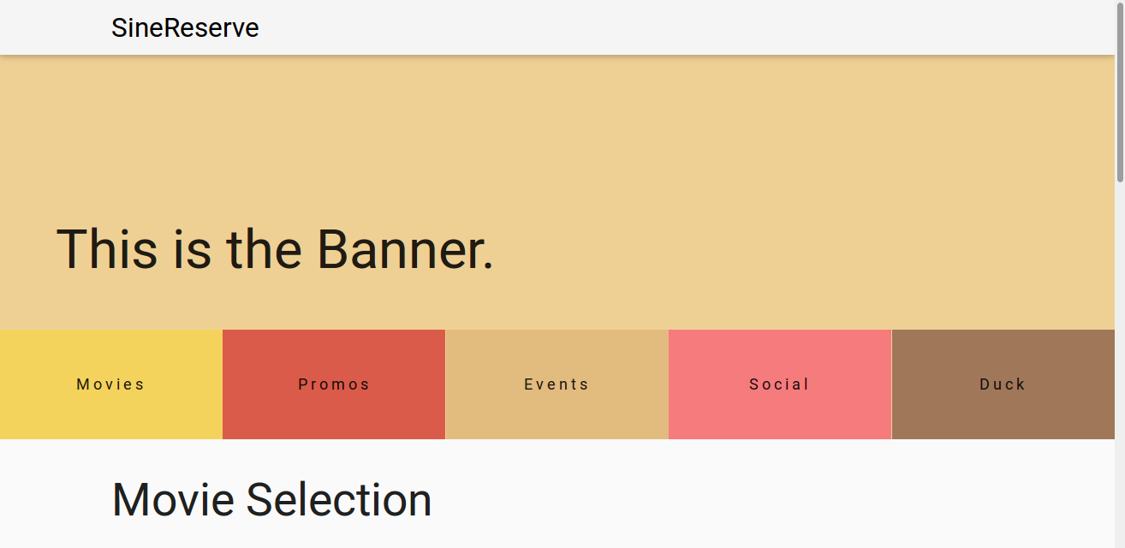

Figure Top Part of Home Page. Contains the fixed navbar and banner.

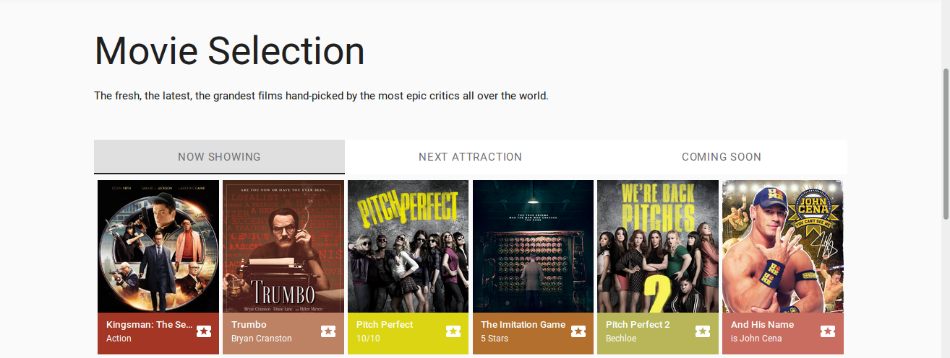

Figure Bottom Part of Home Page. Contains the Movie Selection.

Current Movie Page Design:

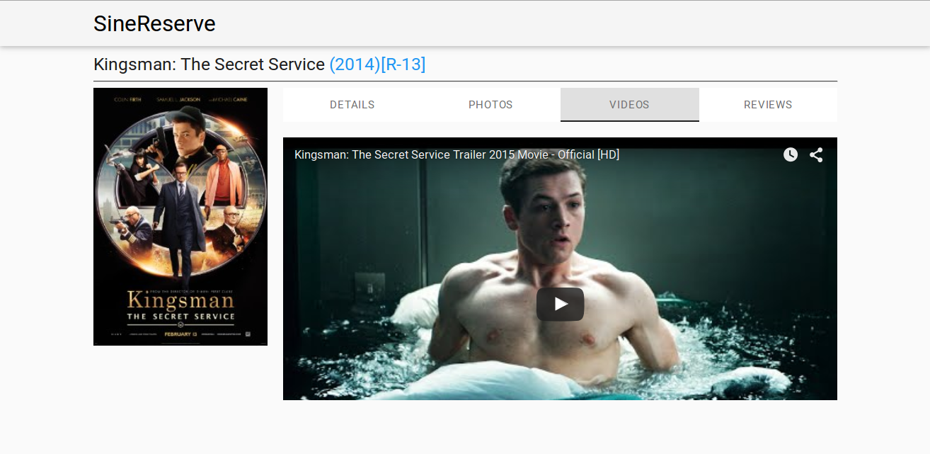

Figure Movie Page with Videos tab selected.

ER Diagram:

