ece-spv MANUAL

Optimized Scheduling System for Electronics Engineering Department with Student Population Predictive Analysis Via Genetic Algorithm

BAGUNA DEL MUNDO LADAGA PABILONA TUVILLEJA

**INSTALLATION**

1. Assuming Drive C is where the operating system drive installed. Copy or extract the 'ECE-SPV' folder to this directory, C:\Program Files. This application will not work properly if the directory of the ECE-SPV.exe is not on C:\Program Files\ECE-SPV.

2. Check if the Data Base File called ARADB.db and ARIMADB.db are at the C:\Program Files\ECE-SPV directory. ARADB.db is the main database and where the non-configurable time tables are saved, *see Table a.2 for the list of tables inside the database and their descriptions.*

3. Edit permission of the folder for the ECE-SPV.exe to work properly. The computer needs to edit files while running the system. *See Figure a.1 for applying full control permission.*

a. Right click the ECE-SPV folder, access the ‘properties’ and go to ‘Security’.  
b. Click ‘Edit’ to change the permissions.  
c. Tick ‘Allow’ on ‘full control’ permission to all members of ‘Group or usernames’ and apply it one by one.  
d. If there is still some problem on the application, try to set ‘full control’ permission of all the files inside the ECE-SPV folder, one by one.

**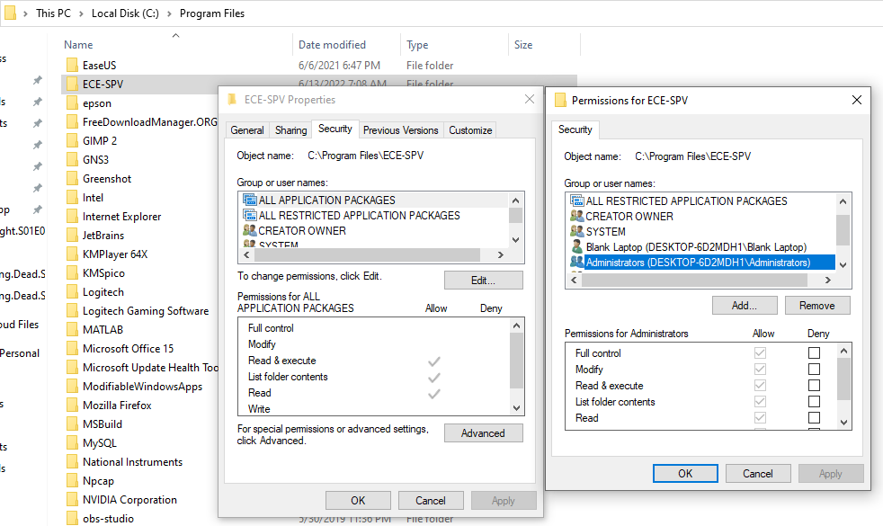  
Figure a.1.** Applying Permission

|  |  |
| --- | --- |
| Tables | Description |
| Add Section | List of Sections. Add only the sections that will later use for class creation. |
| Section Availability | List of availabilities of the sections. This must be fill if the ‘Limit Section Availability’ is set to ‘Yes’ on Settings. |
| Department | List of departments. |
| Class Creation | List of classes that the scheduling system will later schedule to a room. |
| Instructor | List of instructors. |
| Instructor Availability | List of availabilities of the instructors. This must be fill if the ‘Limit Instructor Availability’ is set to ‘Yes’ on Settings. |
| Instructor Overtime | List of specified overtime of the instructors. The classes that dwell between official availability and overtime or within overtime range will be plot in different color in spreadsheet. |
| Instructor’s Subject | List of instructor’s subjects that they will teach. |
| Subject | List of subjects. |
| Curriculum | List of different curriculums. |
| Room | List of rooms. |
| Room Availability | List of availabilities of the rooms. This must be fill if the ‘Limit Room Availability’ is set to ‘Yes’ on Settings. |
| Population | Data needed for student population forecasting system. |
| meeting_time  (non-configurable) | List of all time blocks from 1-hour to 4-hour between 7:00AM and 9:00PM for Monday to Sunday with corresponding position on spreadsheet to be used for plotting the schedules.  (e.g. Mo/7-8AM, ‘7:00AM-8:00AM’, ‘Monday’, 1, ‘B13:B14’) |
| rest_time  (non-configurable) | List of time blocks that are overlaps to a certain time block. This is used to identify which time blocks should not be use when there is already class scheduled to that time. |
| break_time  (non-configurable) | List of time blocks before the schedule’s time block. This is used to remove schedule when the instructor reaches consecutive teaching hours and need a break time for at least 30 minutes. |
| point_block  (non-configurable) | Combination of time_point and time (blocks) to list down all time blocks below the time_point. This technique is used on the ‘combobox’ when filling-up the time range from ‘Start’ to ‘End’. Later the system will pick out the list of meeting_time in that time range and automatically input it in the database one by one together with the instructor_id, room_id, or section_id. |
| time  (non-configurable) | List of all time blocks from 1-hour to 4-hour between 7:00AM and 9:00PM.  (e.g. 7:00AM-8:00AM, 7:30AM-8:30AM, 7:00AM-10:00AM, and so on) |
| time_point  (non-configurable) | List of a point of time.  (e.g. 7:00AM, 7:30AM, 8:00AM, 8:30AM, 9:00AM, 9:30AM, and so on) |
| phantom_time  (non-configurable) | List of time blocks that cross within the official availability time range and overtime time range. |

**Table a.2.** Database Tables

**SETTING UP**

1. Set the settings to make a various constraint to modify the characteristic of the scheduling system. The proponents suggest that do not change the values in Population Size and Mutation Rate, because based on the proponents' trials these values can process the algorithm faster and produce lesser conflicts. These are the two of the main values needed for the genetic algorithm to work. The default setting is recommended for when the physical classes are allowed. *See Figure b.1.1 for what the Default Settings look like. As for the full online classes, see Figure b.1.2. Suggested Setting for Full-Online Class.*

|  |  |  |
| --- | --- | --- |
| Setting | Description | Default Value |
| Population Size | A variable of Genetic Algorithm. This variable indicates the number of different sets of schedules the system will make per generation. | 23 |
| Mutation Rate | A variable of Genetic Algorithm. This variable indicates the rate of mutation of the conflicted schedules. By mutation, it will copy and replace some schedules from the fittest one until it found no conflict. | 0.005 |
| Number of Trials | The Number of trials specify how many times the system will run. If the system's Scheduling Time Limit is set to 12 hours and the value of the Number of trials are set to 2, the system will produce 2 sets of result after 24 hours. This is made for the scheduler can choose between different sets of schedules. (There is a bug on this feature so the proponents disabled the entry box here. The bug will not affect the scheduling process.) | 1 |
| Allowable Room Conflicts | This is the rate of allowable room-related conflicts. If the results produced more than the allowable amount, the system will add 1 virtual room in the Database for the next run of the system. If the number of trials is set to 2, after the first run, the system will add a virtual room before the second run. | 0.1 |
| Scheduling Time Limit | This is how long the scheduling system will run in hours. After this time the system will halt and will give a result. The scheduler can increase this to 24.0 to give the system more time to schedule to add a few more fit schedules. Doubling the time does not mean that it will double the effect of optimization. | 12.0 |
| Recurring Update Time | Number of hours when the text box will update to display recent progress of the system. | 1.0 |
| Enable Verbose Flag? | If this enabled, the text box will update real-time and consume a lot of computer’s resources. This is helpful for the developers to see real-time result and to see how the scheduling progress. | No |
| Enable Number of Student Constraint? | If this enabled, it will create a constraint to the room if it can accommodate the number of students stated per subject in the Subject Table. | No |
| Disable Casual Splitting Constraint? | If this is enabled, the system might schedule a class in 2 or more separate sessions in the same day. | No |
| Disable Unequal Split Constraint? | If this is enabled, the system might schedule a class in split-time with different time ranges. For example, there is a 3-hour subject, it might get a split-time schedule with 1-hour time block and 2-hour time block. If this is disabled, the system only allowed a split-time schedule for 3-hour subject to have a two 1.5-hour time block. | No |
| Disable Dual Class Type Constraint? | If this is enabled, the system might schedule physical classes and virtual classes at the same day. This is not ideal for students that does not have internet connection while in university since there are no facility for students to attend online class inside. | Yes |
| Allow Lab Subjects on Virtual Rooms Constraint? | If this sets ‘Yes’, the system might schedule a Lab Subjects in Virtual Classroom. Since Lab Subject sometimes requires physical equipment to study, it is good if the scheduler set it to ‘No’ when the physical classes are allowed. | No |
| Disable Cross-Department Room Utility Constraint? | If this is enabled, the system might schedule a subject in different department’s rooms but scheduler must set the availability of every room in the database and enable the Room Availability Constraint in the Settings. If no availability set while the enabling the Room Availability Constraint, the system will assume that the room is not available. | Yes |
| Disable Instructor Overload Constraint? | If this disabled, overloading of units is allowed. Enabling this will raise a conflict to all instructor’s class schedules if the instructor’s load exceeded on their allowable load for the semester and it will not plot a schedule on spreadsheet. | No |
| Limit Instructor Availability Constraint? | If this is ‘Yes’, the scheduler must fill the Instructor Availability table for each instructor. The scheduler must ‘No’ this if there are no constraints in instructor’s availability. | Yes |
| Limit Room Availability Constraint? | If this is ‘Yes’, the scheduler must fill the Room Availability table for each room. The scheduler must ‘No’ this if there are no constraints in room’s availability. | No |
| Limit Section Availability Constraint? | If this is ’Yes’, the scheduler must fill the Section Availability table for each section. The scheduler must ‘No’ this if there are no constraints in section’s availability. | No |

**Table b.1.** Settings and their Descriptions.

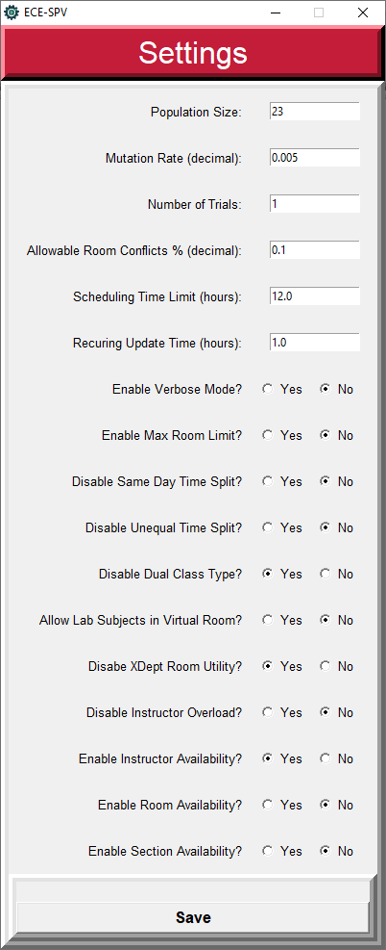

**Figure b.1.1.** Default Settings

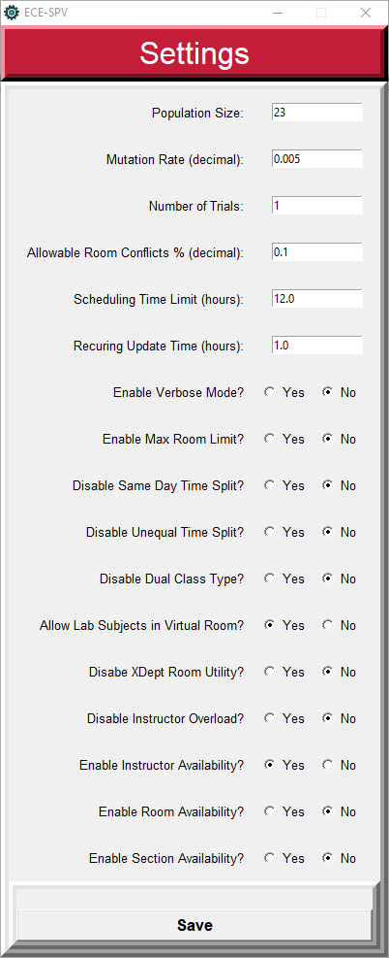

**Figure b.1.2.** Recommended Setting for Full-Online Class

2. Set the text in Outputs. *See Figure b.2 below to identify the location of each label.*

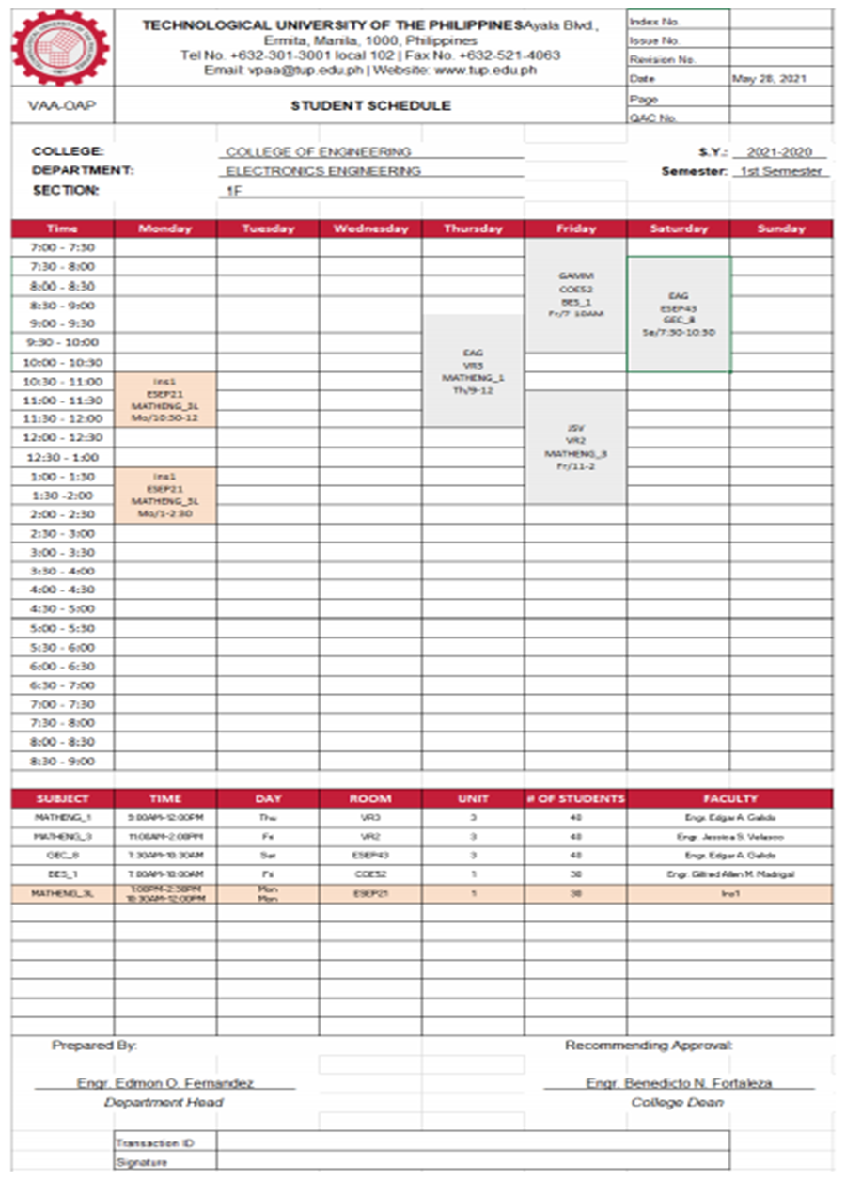

**Figure b.2.** Sample Schedules of a Section

|  |  |
| --- | --- |
| Output Label | Sample Text on Figure b.2 |
| School Name | TECHNOLOGICAL UNIVERSITY OF THE PHILIPPINES |
| Top Header | Ayala Blvd., Ermita, Manila, 1000, Philippines |
| Mid Header | Tel No. +632-301-3001 local 102 | Fax No. +632-521-4063 |
| Bot Header | Email: vpaa@tup.edu.ph | Website: www.tup.edu.ph |
| Underlogo Text | VAA-OAP |
| College | COLLEGE OF ENGINEERING |
| Department Head | Engr. Edmon O. Fernandez |
| Dean | Engr. Benedicto N. Fortaleza |
| Index Number |  |
| Issue Number |  |
| Revision Number |  |
| Page Number |  |
| QAC Number |  |
| Date | May 28, 2021 |
| School Year | 2021-2020 |
| Semester | 1st Semester |

**Figure b.2.1.** Setted Value of Spreadsheet’s Header on Figure b.2

3. Identify and set the teaching days to reduce the list of meeting time on the database. The genetic algorithm tends to pick the meeting time randomly so reducing the time tables that will not in-use can reduce the system’s choices and become more efficient. The default time table on the database is from Monday to Saturday. There are 3 applications inside the ECE-SPV folder, the mon-fri_timetable.exe, mon-sat_timetable.exe, and mon-sun_timetable.exe. To change the time table, the scheduler must select and open the time table to be use first before using the main application, ECE-SPV.exe.

**HOW TO USE SCHEDULING SYSTEM**

1. Input the instructors in ‘Instructor’ Tab. The Seniority is the instructor’s ranks between colleagues, the higher the number the higher the rank. Scheduler can also treat this as the number of years working in the university. If the 2 schedules overlap or in conflict to each other, the higher seniority will prioritize first and drop the other. *See Figure c.1 for the GUI of Instructor Table.*

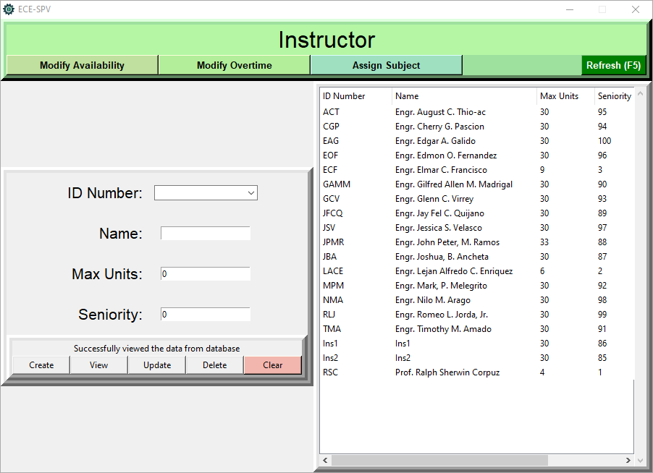

**Figure c.1.** Instructor Table

2. Input each of the instructor’s subjects in ‘Assign Subject’ Tab. Select the instructor and the subject then click create. Repeat this until all subjects assigned to the instructors are inputted. *See Figure c.2 for the GUI of Assign Subject Table.*

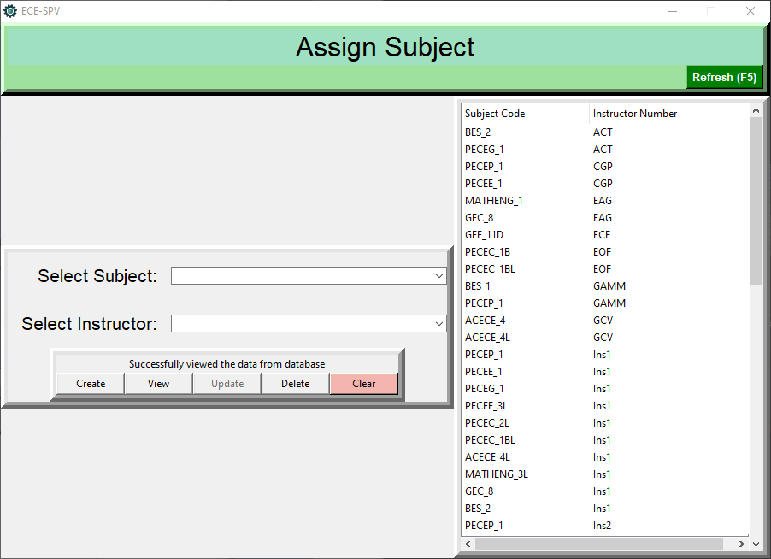

**Figure c.2.** Assign Subject Table

3. Input the instructor’s official time in ‘Modify Availability’ tab. Select the instructor and the time range of their daily availability, leave blank if not available for that day. If the scheduler wants to redo the time availability of the specific instructor, select the instructor and click ‘Delete’ button to clear the availability entered of that instructor. *See Figure c.3 for the GUI of Instructor Availability.*

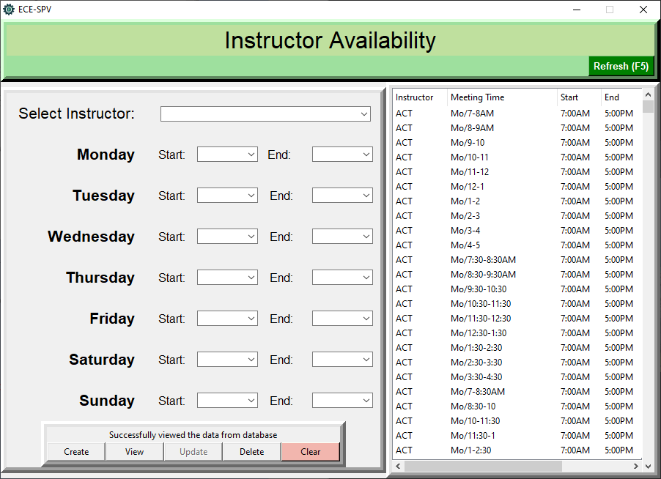

**Figure c.3.** Instructor Availability Table

4. Input the instructor’s overtime in ’Modify Overtime’ tab. This is like Instructor Availability Table but the subjects scheduled within the time range here is on different color in spreadsheet output. *See Figure c.4 for the GUI of Instructor Overtime Table.*

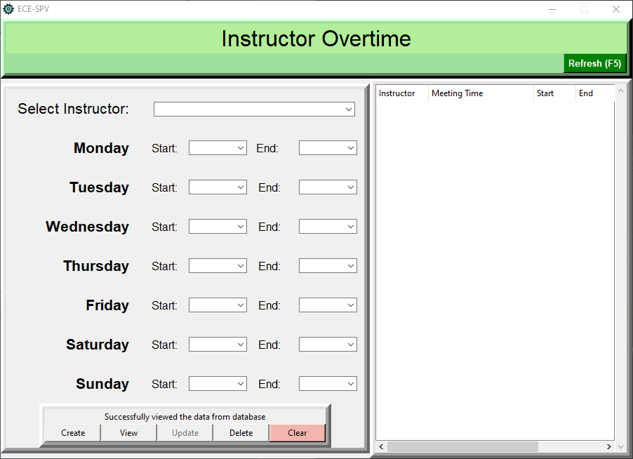

**Figure c.4.** Instructor Overtime

5. Input the physical room and virtual room in ‘Room’ tab. If the ‘Room Availability’ is enabled, the scheduler must assign its availability in ‘Modify Availability’ tab inside ‘Room’ tab just like instructor availability for Instructor or else the system will treat the room is not available. Always check the number of virtual rooms in the table and delete the auto-created by the system if virtual room is more than enough before proceeding. *See Figure c.5 for the GUI of Room Table.*

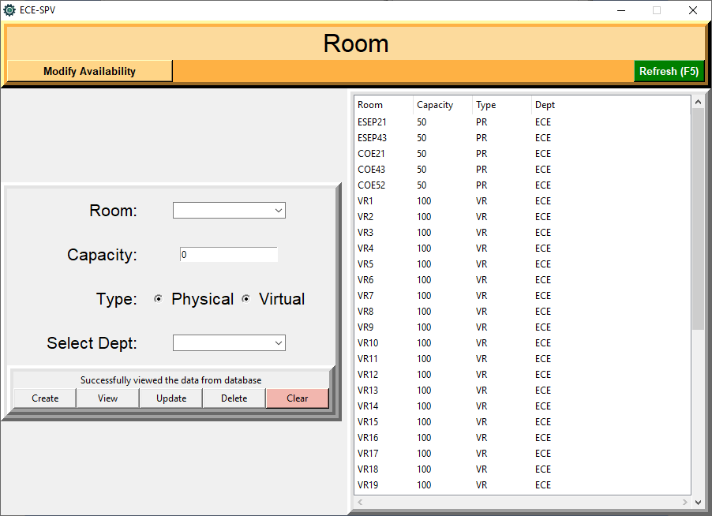

**Figure c.5.** Room Table

6. Scheduler must only add sections that later enter to ‘Class Creation’ table, delete any section will not pair by a subject in Class Creation tab. *See Figure c.6. for the GUI of ‘Add Section’ Table.*

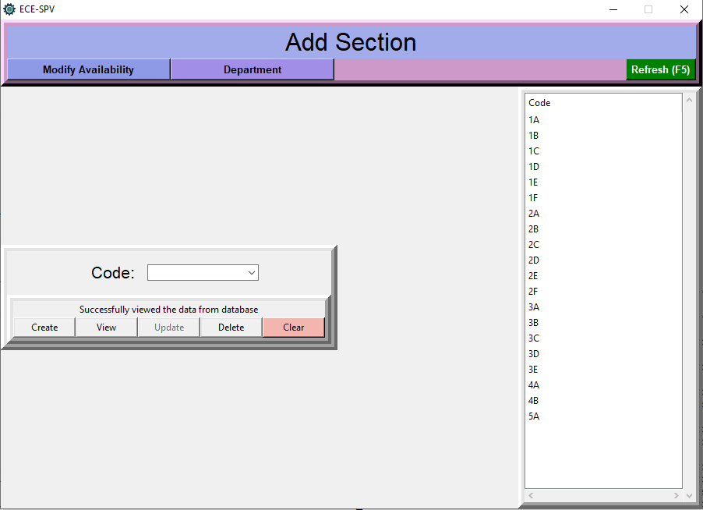

**Figure c.6.** Add Section Table

7. If the scheduler chose to limit the availability of the section, the scheduler must enable the ‘Section Availability’ in the ‘Settings’. Enabling this in the ‘Settings’, the scheduler must set a time availability in all sections listed in the Database or else the system will assume that the section is not available. Disabling it if there is no constraint or restriction regarding the availability of a section, the system will treat all sections are available all the time. *See Figure c.7 for the GUI of ‘Section Availability’ Table.*

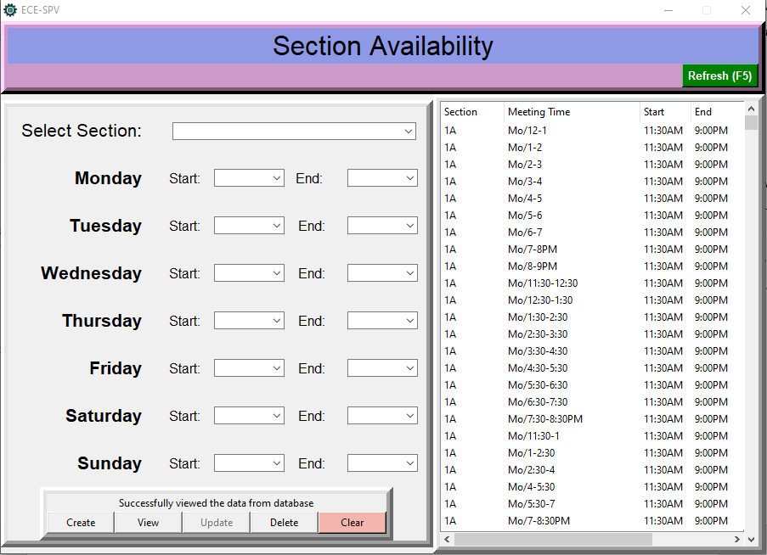

**Figure c.7.** Section Availability Table

8. In ‘Class Creation’ tab, scheduler can assign classes by inputting section and subject pair. This is where the system can see the list of classes that needing an instructor and room schedule. *See Figure c.8 for the GUI of ‘Class Creation’ Table.*

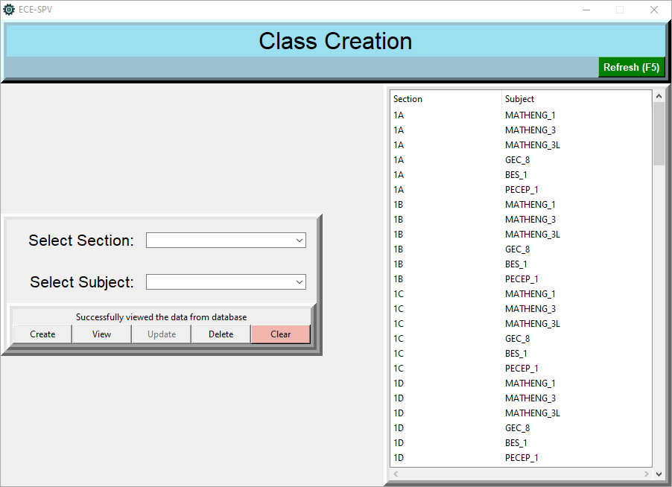

**Figure c.8.** Class Creation Table

9. To review the classes, subjects, rooms, and instructors entered in the database, click the ‘Show Initial Data’ button. *See Figure c.9.*

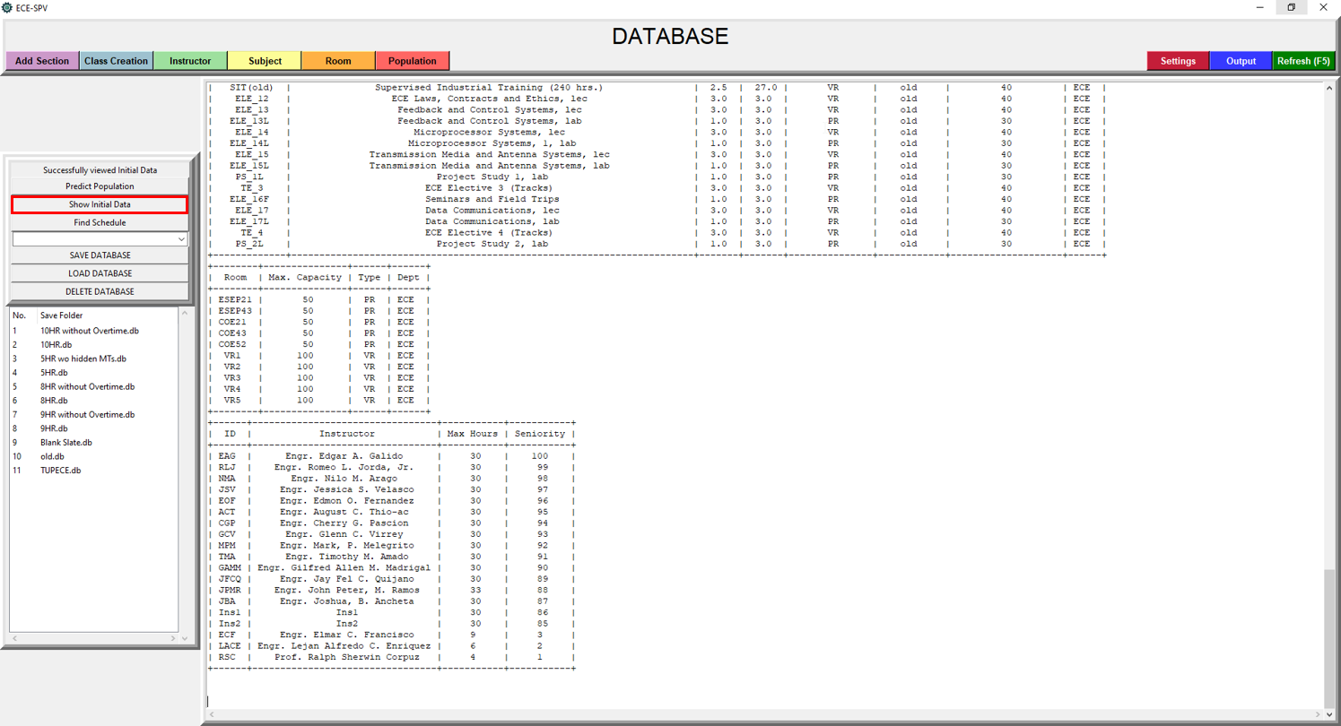

**Figure c.9.** ‘Show Initial Data’ Button

10. After filling-up the Database, initiate the scheduling system by clicking the "Find Schedule" Button at the main GUI. Wait until the scheduling is finish. *See Figure c.10 for where the button located. For more information about the tables in the database, see Table a.2 above.*

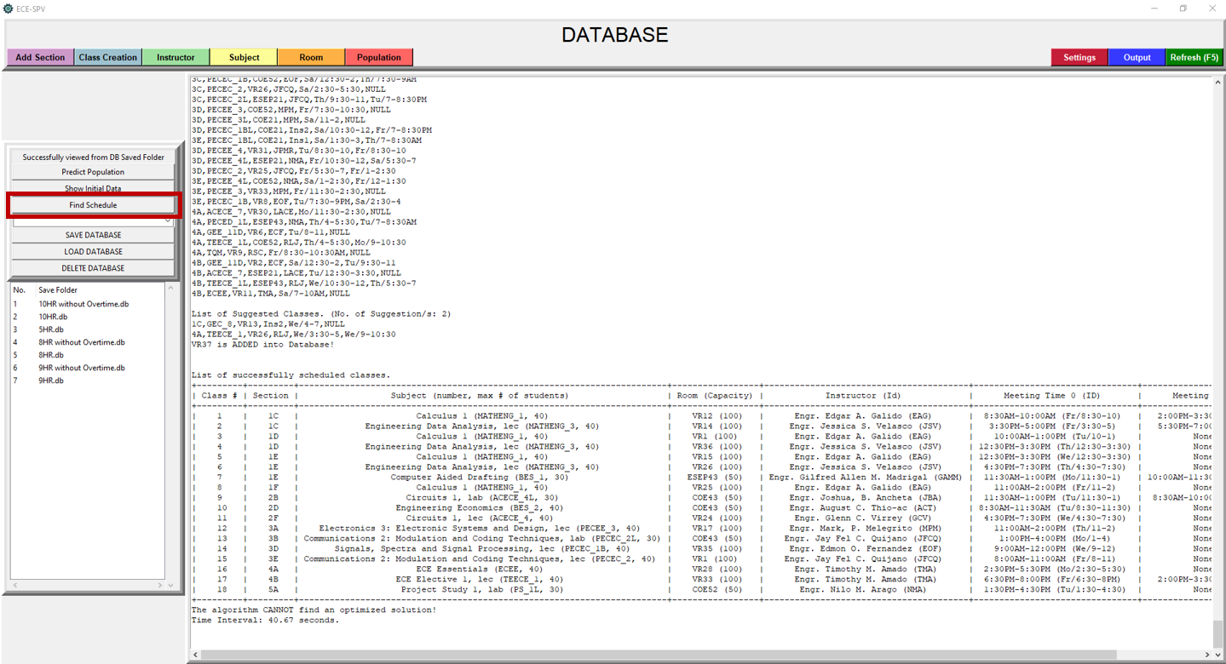

**Figure c.10.** “Find Schedule” Button

11. After the scheduling, name the results and save it. The scheduler will see the named folder where the spreadsheet outputs, the raw output, and setting config located in C:\Program Files\ECE-SPV\Result Saved\.

**RAW OUTPUT**

The raw output will be composed on 4 parts. The Conflict Box, list of classes that need to schedule manually or unfitted schedule, list of suggested classes, and list of successfully scheduled classes. *Please see Table d.1 for the brief description of the parts.*

|  |  |
| --- | --- |
| Raw Output | Description |
| Conflict Box | Compilation of all detected conflicts listed as the Conflict Type and its corresponding conflicted class schedule. Scheduler can use this to determine what is the conflict of the given class schedule and can manually modified the conflicted part and plot it directly to the spreadsheet. For example, if the conflicted part is the availability of the instructor, hence meeting time, the scheduler can consult the said time to the instructor to extend their availability or change the instructor that is available in the said time. A conflicted class schedule can have 2 or more conflicts so the scheduler must be aware of their conflicts before scheduling manually. *See Table d.2 for the list of Conflict Types and definition.* |
| List of classes that need to schedule manually | These are class schedules that accumulated conflicts. Since the Conflict Box might repeatedly shows the conflicted class when it had 2 or more conflicts, this list is just a list of conflicted classes that do not have a room schedule. |
| List of Suggested Classes | These are class schedules that has meeting time outside the Instructor Availability but within Instructor Overtime and plotted in a separate spreadsheet in different color together with the schedules that have no conflicts. |
| List of successfully scheduled classes | Class schedules that have no conflicts. |

**Table d.1.** Raw Output and their Description

|  |  |
| --- | --- |
| Conflict Type | Description |
| WRONG_MTHOUR | This conflict will transpire when the total meeting time of the scheduled class is not equal to the subject’s number of hours weekly. |
| UNEQUAL_SPLIT | This conflict will transpire when the class schedule is divided of unequal number of hours. (e.g. A 3-hour class is separated by a 1-hour time block and a 2-hour one) |
| CASUAL_SPLITTING | This conflict will transpire when a class schedule is separated by different time blocks at the same day. |
| SAME_MTS | This conflict will transpire when the 2 or more classes have the same meeting time at the same day. |
| OVERLAP_MTS | This conflict will transpire when the 2 or more classes have their meeting time overlaps each other. |
| NUMB_OF_STUDENTS | This conflict will transpire when the number of students of the class is greater than the maximum limit of the room. |
| ROOM_AVAILABILITY | This conflict will transpire when the class is scheduled outside the room’s availability. |
| ROOM_BOOKING | This conflict will transpire when the 2 classes are scheduled on the same room and their time blocks overlaps. |
| XDEPT_ROOM_UTILITY | This conflict will transpire when the room is from different department. |
| INSTRUCTOR_OVERTIME | This conflict will transpire when the class schedule is outside the instructor’s official availability but within their overtime. Class that had this conflict type will still be plotted on spreadsheet but in different color. |
| INSTRUCTOR_AVAILABILITY | This conflict will transpire when the class is scheduled outside the instructor’s availability. |
| INSTRUCTOR_BOOKING | This conflict will transpire when the 2 classes are scheduled with the same instructor and their time blocks overlaps. |
| INSTRUCTOR_OVERLOAD | This conflict will transpire when the total allowed units for this semester exceeded. |
| SECTION_AVAILABILITY | This conflict will transpire when the class is scheduled outside the section’s availability. |
| SECTION_BOOKING | This conflict will transpire when the 2 classes are scheduled with the same section and their time blocks overlaps. |
| LAB_ON_VR | This conflict will transpire when the scheduler is prohibiting the lab subjects in virtual room on ‘Settings’ and the system scheduled a lab subject to a virtual room. |
| MIXED_TYPE | There are 2 types of classes, the physical class and the virtual or online class. This conflict will transpire when the scheduler is prohibiting the Dual Class Type on ‘Settings’ and the system scheduled 2 different types of classes in a day. |

**Table d.2.** Conflict Types and their description

**HOW TO USE FORECASTING SYSTEM**

1. Add or update the Population table in the Database.

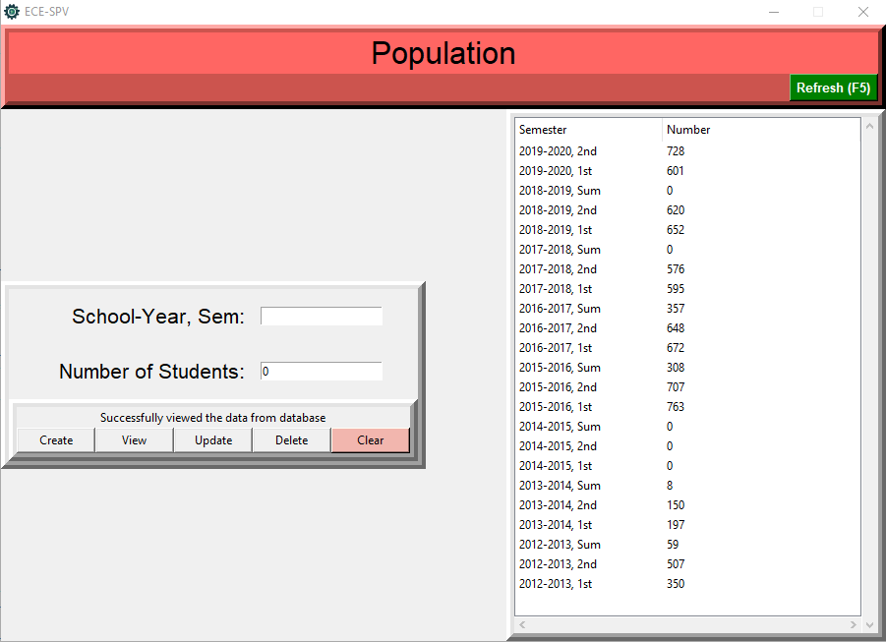

**Figure e.1.** Population Table

2. Click Predict Population button.

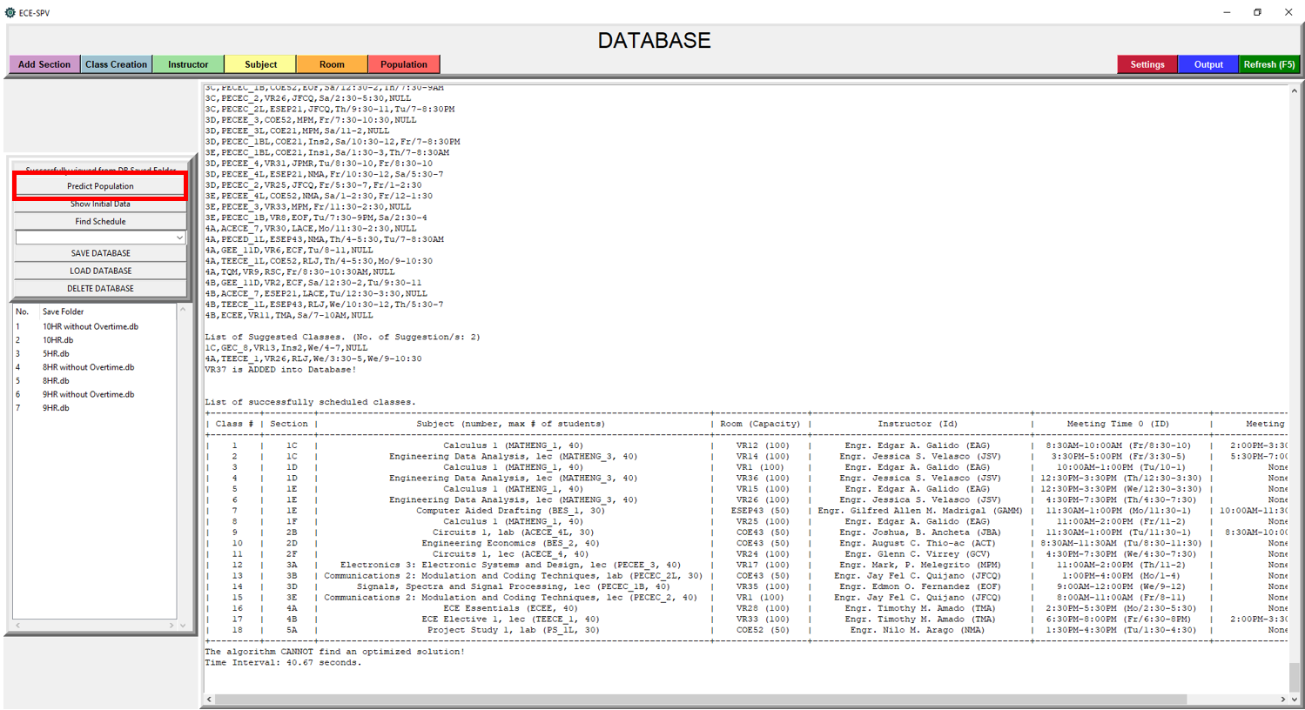

**Figure e.2.** “Predict Population” Button

3. After running, it will give a graphical output and raw text output on the big text box in the GUI. *Please see Figure e.2.1 and Figure e.2.2 for the sample outputs.*

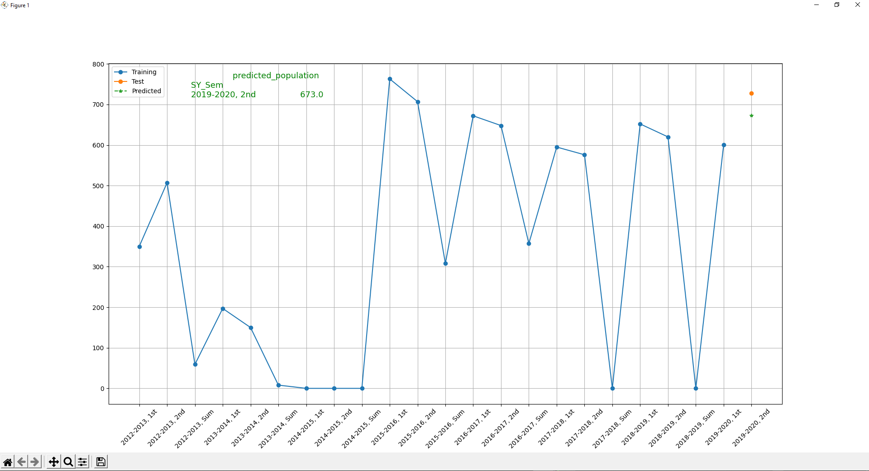

**Figure e.2.1.** Graphical Output of Forecasting System

In Figure e.2.1, graphical output has 3 parts, the trained value (blue), the test value (orange), and the predicted value (green). The train data is an actual data from the past years. The test value is the present actual value to be compared to the predicted value to calculate how precise the forecasting system is.

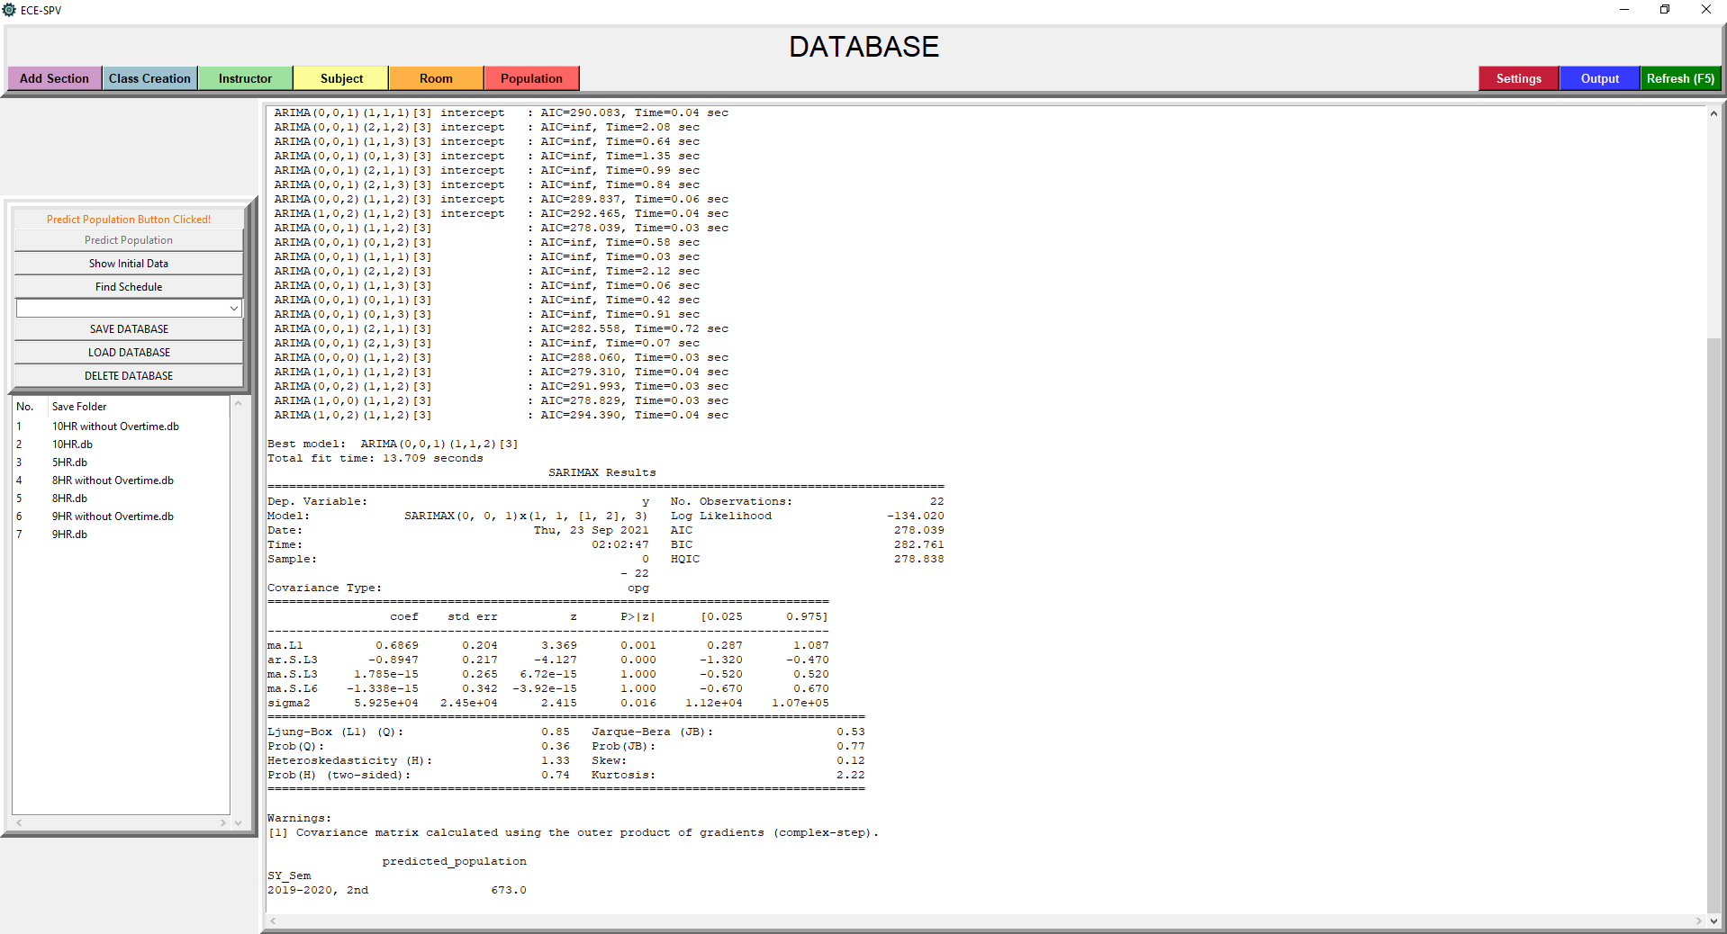

**Figure e.2.2.** Raw Text Output of Forecasting System

In Figure e.2.2, in the text box, it shows how the auto-arima calculate the arima model and its seasonality. The best model it detected in this example is ARIMA(0,0,1)(1,1,2)[3] which is the value of ARIMA(p,d,q)(P,D,Q). The P, D, Q are just a seasonal term. Seasonality refers to the presence of variations which occur at certain regular intervals. At the bottom, a numerical value of predicted population is printed also.

**HOW TO SAVE, LOAD, AND DELETE A DATABASE**

1. To save a database, click the “SAVE DATABASE” button and name it then click “Confirm”. The scheduler can view the saved database in the treeview below. *Please see Figure f.1 and Figure f.4.*

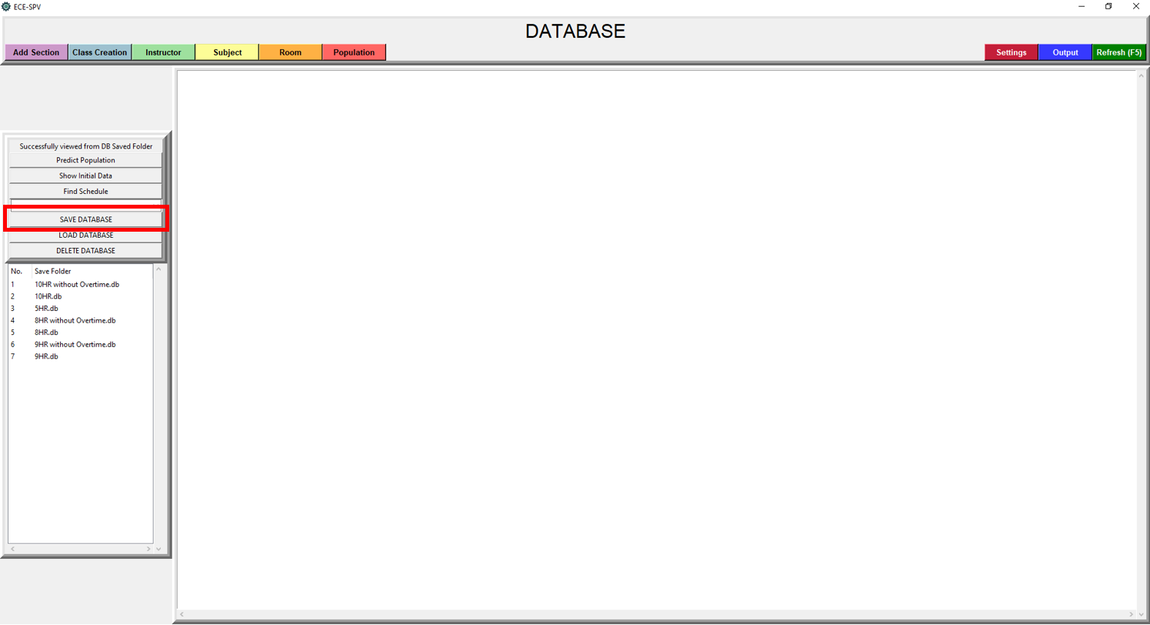

**Figure f.1.** “SAVE DATABASE” Button

2. To load a database, select a database in the treeview and click “LOAD DATABASE” button. Please be reminded to save the current database to avoid data loss. After clicking the button, it will automatically delete the current database and replace by the selected database. The scheduler has no way to edit any of the time tables at the application so any change of the time tables will affect the system. If deleted, restart the ECE-SPV.exe and load the ‘Blank Slate.db’ for blank database or ‘TUPECE.db’ that has been preset for the current ECE Department. *See Figure f.2 for the ‘LOAD DATABASE’ button*.

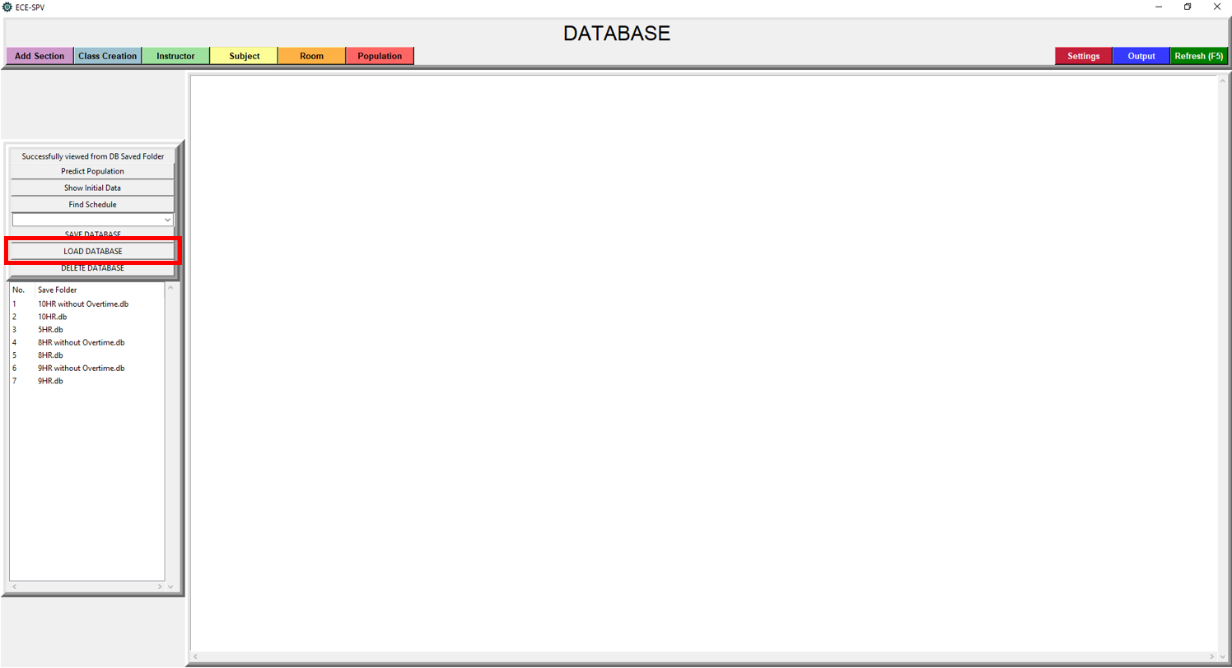

**Figure f.2.** “LOAD DATABASE” Button

3. To delete a database, select a database in the treeview and click “DELETE DATABASE” button.

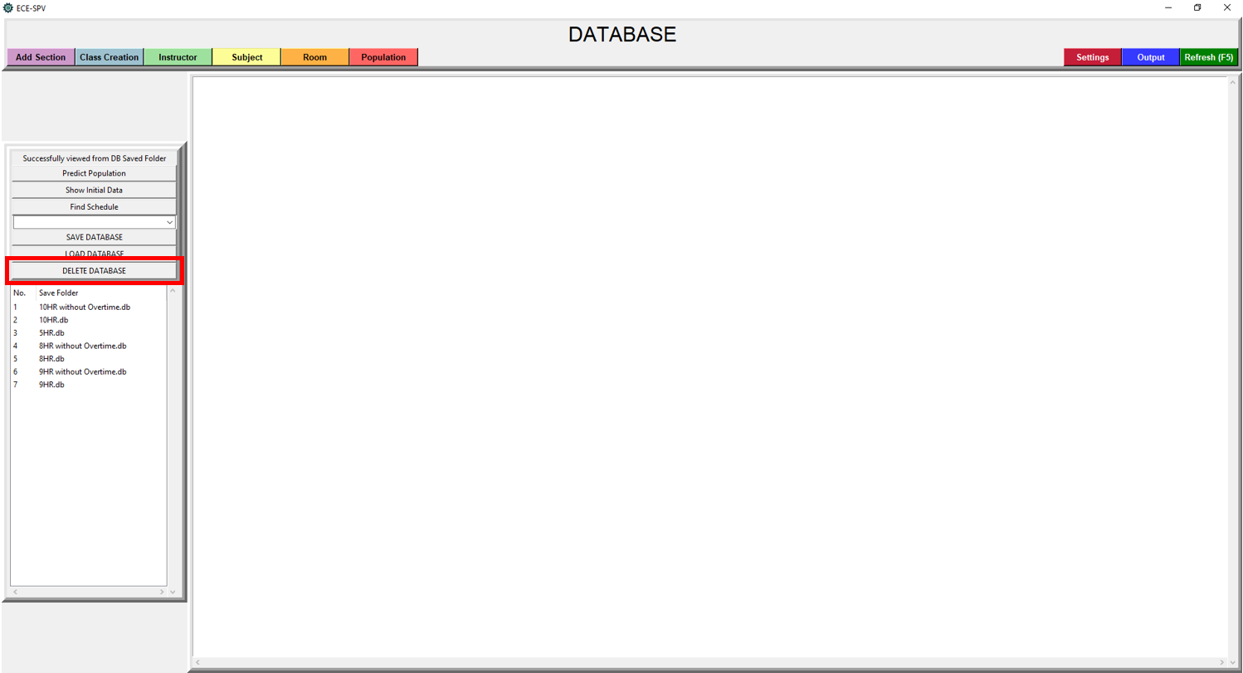

**Figure f.3.** “DELETE DABASE” Button

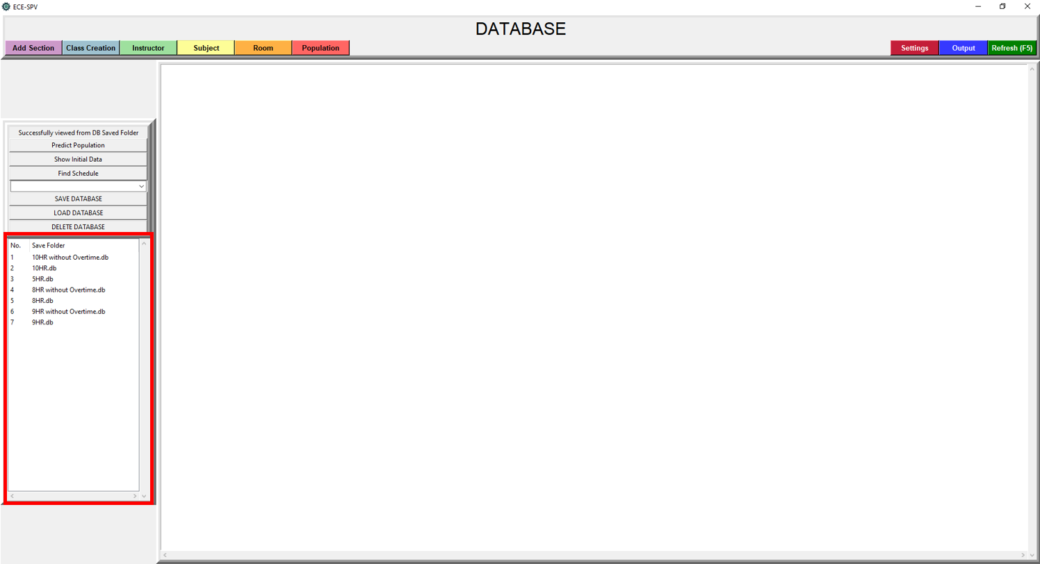

**Figure f.4.** Database Treeview

Figure f.4 is the treeview of the databases. The scheduler can see the saved databases inside the folder here so it can easily switch on different database by loading the selected database.