FLOODGUARD THAILAND
From Flood Pixels to Equitable Local Action
GeoHackathon 2026

PROJECT PROPOSAL
Theme | Pixel to Policy - Unlocking Insights, Accelerating Impact
Team | [TEAM NAME]
Institution | [INSTITUTION / SCHOOL / UNIVERSITY]
Pilot | Mae Sai 2024 validation + Hat Yai 2025 decision story
Product | Public PWA + Government Command Center + GeoAI Studio

Thailand can already see floodwater from space. FloodGuard answers the next question: who becomes cut off from help, whether that loss is unequal, and where government should act first.

Submission note: replace the bracketed team fields before uploading. Technical claims and outputs remain explicitly non-operational.

Executive summary
Flood maps are essential, but they do not directly answer the operational decisions faced by a provincial disaster office, municipality, hospital network or road agency. During a severe flood, officials must decide which sub-districts need field verification first, which roads or bridges create dangerous isolation, where a temporary shelter would reduce access loss, and whether older adults, children and other mobility-constrained residents are affected disproportionately.
FloodGuard Thailand is a geospatial AI decision-support system that fills this last-mile gap. It ingests an official or candidate flood-extent layer, or derives a validated flood-probability layer from Sentinel-1 Synthetic Aperture Radar, and converts that evidence into exposed population and facilities, likely road disruption, normal-versus-disrupted access, an Evacuation Equity Gap, a transparent Flood Preparedness Priority Score, an A-E action class and a bilingual action brief.
The project makes concrete use of opengeos/geoai. FloodGuard prepares a rights-cleared, aligned multi-band Sentinel-1 and terrain feature stack; GeoAI performs georeferenced training-tile export, semantic-segmentation training, spatially held-out validation and overlapping tiled inference; FloodGuard then selects the explicit flood-class probability and passes the resulting one-band flood_probability_0_1 raster into its existing tested decision pipeline. A deterministic SAR change baseline and the current weak-label classifier remain mandatory benchmarks.
Outputs are presented through one shared platform with three role-specific surfaces: a mobile-first public preparedness PWA, a desktop/tablet government command center and a research/developer studio showing data gates, model cards and validation. The public interface is not a live evacuation navigator, and FloodGuard does not replace GISTDA, DDPM, TMD, RID, ONWR or local authority judgment.

1. Problem clarity and Thai relevance

1.1 The decision gap
The unresolved flood problem is not only where water is present. It is:
Which flood-affected communities lose access to shelters, hospitals and main roads; does that loss fall disproportionately on vulnerable residents; and where should limited public resources be deployed first?

Flooding becomes a compound access crisis when water intersects roads, bridges, facilities and the daily mobility of residents. A sub-district with moderate inundated area may become a high-priority emergency if one critical link isolates a hospital catchment. Another area may show similar flood extent but a much larger burden among older adults or children. Area totals alone hide those differences.

1.2 Regional evidence
The 2024 Chiang Rai and Mae Sai flood provides a bounded validation setting with published Sentinel-1 and GISTDA comparison evidence. The November 2025 Hat Yai disaster provides a recent urban decision story: extreme multi-day rainfall disrupted homes, hospitals, schools and hundreds of kilometres of roads. These events show why flood extent must be translated into local access and action.
FloodGuard therefore separates three geographic roles:
Role | Area | Purpose
Validation tile | Chiang Rai / Mae Sai, September 2024 | Validate the technical chain against a documented event and available reference evidence
Story and stress-test tile | Hat Yai / Songkhla, November 2025 | Demonstrate road cuts, hospital/shelter access loss and urban false-positive challenges
Scale target | Lower Chao Phraya / Greater Bangkok | Show national relevance and a future dense-infrastructure deployment path

1.3 Users and beneficiaries
User | Decision supported
GISTDA | Add an explainable policy-action layer above national satellite products and demonstrate GeoAI reuse
DDPM and provincial offices | Prioritize field verification, rescue support, local communication and resource pre-positioning
Municipalities and sub-district administrations | Compare shelter, route and resilience interventions
Hospitals and health authorities | Identify communities likely to lose access to essential care
Road agencies | Identify links where disruption creates disproportionate isolation
Communities and NGOs | Understand local preparedness needs with transparent evidence

Beneficiaries include flood-exposed residents, with explicit attention to older adults, children, people with disabilities, people with chronic-care needs, lower-income households and communities with limited transport alternatives. FloodGuard uses the neutral phrase priority for support and reports uncertainty to avoid stigmatizing communities.

2. Solution and novelty
FloodGuard does not compete with organizations that already map floodwater. It adds the decision chain after the flood layer:
flood probability or extent
-> exposed people and facilities
-> likely road disruption
-> normal vs disrupted access
-> Evacuation Equity Gap
-> sub-district priority
-> A-E recommended action
-> confidence and bilingual brief

2.1 Signature insight: Evacuation Equity Gap
For each sub-district, FloodGuard compares the rate at which vulnerable and non-vulnerable residents lose access under the disrupted network:
vulnerable access-loss rate
= vulnerable population losing access / total vulnerable population
non-vulnerable access-loss rate
= non-vulnerable population losing access / total non-vulnerable population
Evacuation Equity Gap ratio
= vulnerable access-loss rate / non-vulnerable access-loss rate
The output is a distributional statistic, not a general claim about equity. It can support statements such as: “Vulnerable residents are estimated to be 1.8 times as likely to lose 30-minute access under this candidate flood scenario,” accompanied by confidence, assumptions and the source timestamp.

2.2 Action classes
- A - Protect Lives Now: high exposure and high access loss, especially among vulnerable groups.
- B - Keep Routes Open: a critical road or bridge creates isolation.
- C - Protect Essential Services: important facilities are exposed or become unreachable.
- D - Build Resilience: recurrent exposure without immediate crisis conditions.
- E - Monitor and Verify: lower exposure or high uncertainty.
The score is transparent and sensitivity-tested. It supports prioritization; it does not automatically issue an emergency order.

3. Sound GeoAI approach
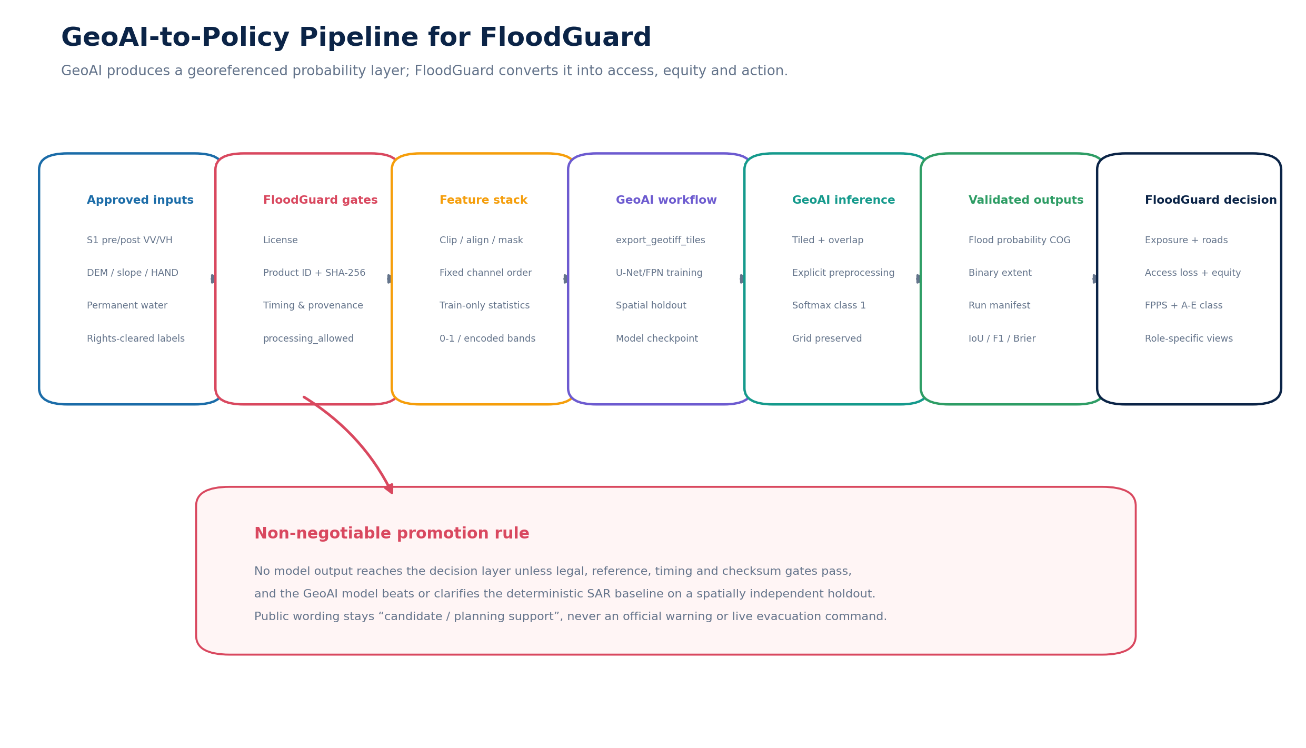
Figure 1. GeoAI is an upstream probability engine; FloodGuard owns the decision chain and promotion gates.

3.1 Why GeoAI is appropriate
The problem combines raster interpretation, temporal change, terrain context, vector networks, population exposure and administrative aggregation. A geospatial AI pipeline is appropriate because the model must preserve CRS, resolution, transform, nodata and spatial context while producing an output that can be intersected with roads, facilities and sub-district boundaries.
FloodGuard uses GeoAI where it adds value: preparing georeferenced training data, training a compact segmentation model, running tiled inference and producing a probability raster. It does not force AI into road closure or policy decisions that lack reliable labels.

3.2 Concrete use of opengeos/geoai
The first bounded GeoAI experiment uses version 0.41.1 in an isolated Python 3.12 environment.
GeoAI capability | FloodGuard use | Visible evidence in the prototype
`export_geotiff_tiles` | Export aligned image and label tiles while preserving georeferencing | Tile manifest and sample tile footprints in Studio
semantic model training | Train a two-class U-Net or FPN on approved Sentinel-1 features | Model card, configuration and checkpoint checksum
overlapping tiled inference | Apply the model over a larger georeferenced raster | Candidate flood-probability layer on map
class probability output | Select class 1 as flood probability in a binary model | One-band `flood_probability_0_1` COG and histogram
raster/vector utilities | Create optional candidate extent polygons | Downloadable candidate GeoJSON/GPKG with limitations
QGIS workflow | Human QA and label review | Documented review checklist, not production automation

GeoAI's optical segment_water workflow is not used as the core event-flood detector because permanent surface water is not equivalent to flood inundation.

3.3 Input feature stack
The initial model uses six to eight aligned bands:
- pre-event VV;
- post-event VV;
- pre-event VH;
- post-event VH;
- VV backscatter change;
- VH backscatter change;
- slope or HAND terrain context;
- permanent-water flag.
Raw SAR and terrain values are transformed through an explicit, frozen preprocessing contract. This is necessary because the inspected stock GeoAI semantic GeoTIFF loader applies a /255 scale. FloodGuard either pre-encodes every channel to a documented 0-1 range or supplies the same custom preprocessing function during training and inference. Channel order, clipping/statistics, nodata and checksums are written to the run manifest.

3.4 Training and validation
The model is not promoted merely because it is a deep model. It is compared with:
- the existing deterministic Sentinel-1 threshold/change baseline;
- the existing weak-label logistic classifier;
- the GeoAI U-Net/FPN candidate.
Validation uses a spatial holdout by tile cluster, connected region or separate event. Random pixel splitting is not accepted as the only evidence. Reported metrics are IoU, F1/Dice, precision, recall, area error ratio, Brier score, calibration and threshold sensitivity. Manual error review covers permanent water, paddy fields, steep terrain, radar shadow, urban double-bounce and mixed pixels.

3.5 Data and promotion gates
No real-data model output may enter the decision pipeline unless:
- the pre/post Sentinel-1 pair and event timing are resolved;
- product IDs, local path hints and SHA-256 checksums are recorded;
- reference-mask geometry and use terms are confirmed;
- every required row has processing_allowed=True;
- model output passes CRS, grid, nodata and probability-range validation;
- validation against the deterministic baseline is documented;
- source timestamp, confidence, assumptions and model identity are present.
A manual weak-reference mask may support a clearly labelled weak-label experiment, but it does not become official validation truth.

4. Data architecture
The project prioritizes competition-provided GISTDA/NGIS layers when their exact access and use terms are confirmed, then uses reproducible open sources to fill gaps.
Layer | Candidate source | Role | Limitation and mitigation
Flood extent/reference | GISTDA/NGIS, Charter, CEMS or other approved product | Event input and validation | Availability and use rights are recorded per product
Sentinel-1 GRD | Copernicus | All-weather pre/post flood features | Timing may miss peak; every acquisition is time-stamped
THEOS-2 | GISTDA competition data | High-resolution urban/building/road context where coverage overlaps | Optical cloud and coverage; never presented as a flood label
Sentinel-2 | Copernicus | Pre-event land cover and water context | Cloud risk; context only
DEM, slope, HAND | Copernicus DEM / approved terrain source | Terrain conditioning and error filtering | Resolution and hydrologic quality documented
Permanent water | JRC or approved GISTDA layer | Reduce permanent-water false positives | Seasonal water remains uncertain
Rainfall | Approved GISTDA/NGIS, TMD context, ERA5/CHIRPS | Antecedent/event context | Not a replacement for gauges or official forecasts
Population by age | WorldPop / approved national data | Exposure and vulnerable-group estimates | Modelled population; communicate uncertainty
Roads and facilities | OSM/HOT or approved agency layer | Routing, shelters and care access | Completeness flag and future agency-data path
Administrative boundaries | NGIS/official/HDX COD | Sub-district aggregation | Version, CRS and effective date fixed

All sources enter a registry containing title, provider, access date, resolution, CRS, license, use scope, checksum and role in the model.

5. End-to-end method
Stage | Method | Output
1 | Register approved data and validate licenses, timestamps, product IDs and checksums | Reproducible data catalog and gate status
2 | Calibrate/prepare Sentinel-1 externally as required; align SAR, terrain, water and labels | Analysis-ready feature stack
3 | Run deterministic SAR change baseline | Benchmark probability/extent and metrics
4 | Use GeoAI to export tiles, train the segmentation candidate and run spatial validation | Model checkpoint, model card and validation report
5 | Run overlapping tiled GeoAI inference and explicitly extract flood class 1 | One-band flood probability and binary extent
6 | Aggregate probability to sub-districts and intersect with roads/facilities | Exposure and likely road-risk evidence
7 | Recompute shortest-path accessibility under normal and disrupted networks | 15/30/60-minute access-loss counts
8 | Compare vulnerable and non-vulnerable access loss | Evacuation Equity Gap
9 | Compute FPPS, sensitivity and A-E class | Ranked decision layer and recommended action
10 | Publish role-specific views, model card and bilingual brief | Public PWA, command center and studio

The current access engine uses shortest travel time to the nearest selected facility at configured thresholds. A capacity-aware 2SFCA extension is a later enhancement after trustworthy capacity data are available; it is not claimed as already implemented.

6. Product and real-world application

6.1 One platform, three surfaces
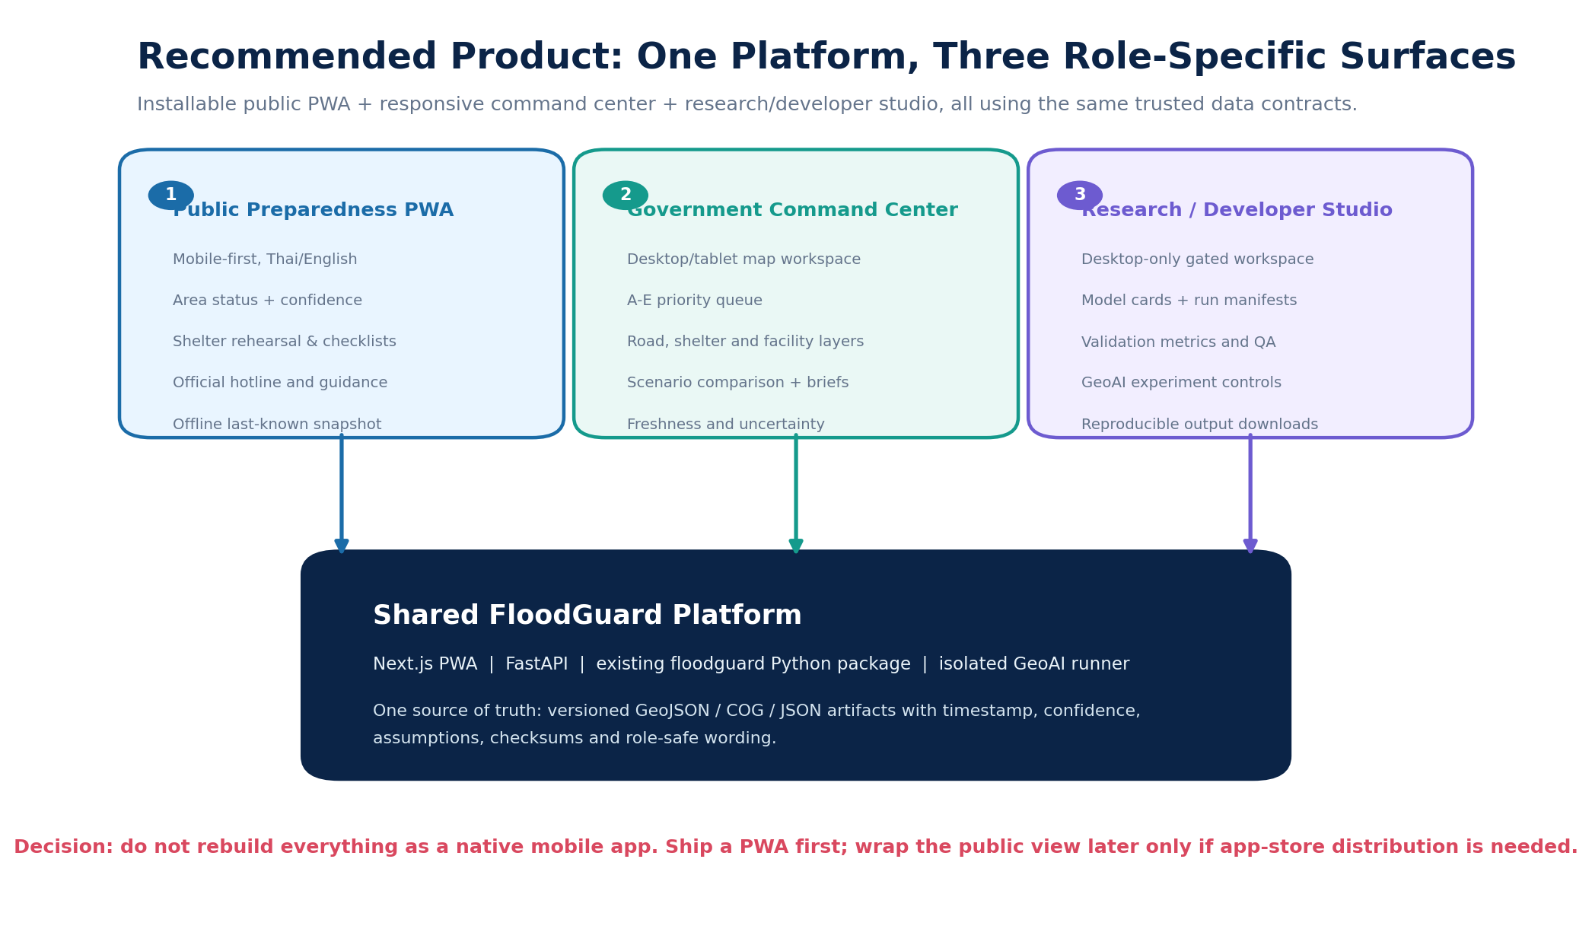
Figure 2. Recommended product: one platform with role-specific information density.
Public Preparedness PWA - mobile first
- plain-language local status with timestamp and confidence;
- official contacts and preparation checklist;
- shelters/facilities where status data are confirmed;
- pre-season route rehearsal, explicitly not live evacuation advice;
- offline last-known snapshot with stale-data label.
Government Command Center - desktop/tablet
- sub-district A-E priority queue;
- map layers for flood probability, roads, facilities, access hotspots and equity;
- explainable score components and uncertainty;
- temporary-shelter and road-closure scenario comparison;
- bilingual one-page action brief and filtered data export.
Research / Developer Studio - desktop
- data readiness and blocked reasons;
- GeoAI model configuration, version and checksum;
- baseline vs GeoAI validation metrics;
- calibration, threshold sensitivity and error review;
- reproducible commands and redacted run manifests.
A responsive PWA is the primary implementation because it supports an installable mobile public experience and rich desktop maps from one codebase. A native wrapper can be added later only if app-store distribution is required.

6.2 Policy decisions supported
- pre-position rescue and field-verification resources;
- identify road links that create disproportionate isolation;
- compare where a temporary shelter most reduces access loss;
- protect continuity of care for communities losing hospital access;
- target preparedness drills and accessible transport support;
- prioritize resilience investment using recurrent exposure plus access/equity evidence.

7. Feasible outputs and scope discipline

Core - must ship
- tested FloodGuard decision pipeline and offline fixture demonstration;
- synthetic/open GeoAI proof showing tile export and georeferenced probability output;
- one gated event experiment if data rights and timing pass;
- public PWA shell, command center and studio connected to typed artifacts;
- A-E ranking, access/equity outputs and bilingual action brief;
- model card, validation summary and explicit non-operational status.

Stretch - only if gates and time allow
- validated THEOS-2 urban context extraction in a pilot-overlap area;
- capacity-aware accessibility extension;
- community report intake as a transparent, moderated evidence layer;
- hosted pilot with authenticated government/studio routes.

Roadmap - not promised for the hackathon
- real-time operational feeds;
- automated citizen-report triage;
- hydrological forecasting or AI-weather integration;
- national-scale production deployment;
- native app-store releases.

8. Implementation plan
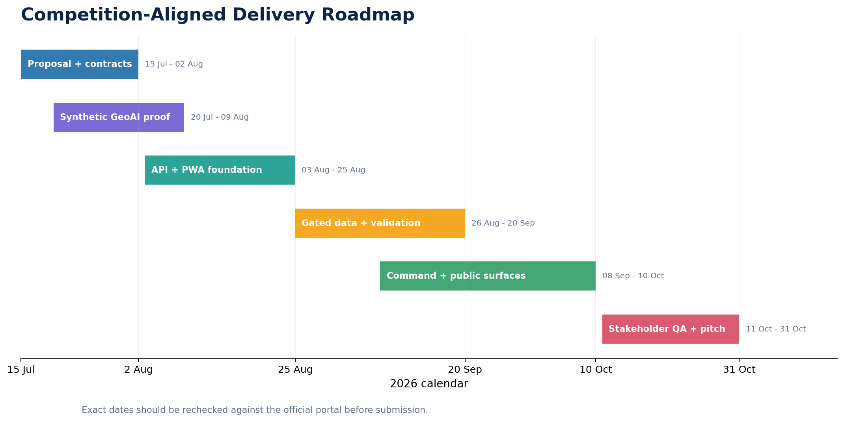
Figure 3. Competition-aligned delivery sequence. Portal dates must be confirmed before submission.
Period | Milestone and proof
Proposal period | Final proposal, architecture, data inventory and synthetic GeoAI proof contract
Pre-finalist / foundation | Responsive PWA shell, API status contract, real map using fixture GeoJSON, offline demo
Mentoring I | Pinned GeoAI runner, tile export proof, gated data decision and baseline comparison design
September | Event feature stack if allowed; GeoAI candidate, spatial validation, decision bridge
Early October | Command center, public view, studio, bilingual briefs and scenario comparison
Mentoring II | Stakeholder review, visual simplification, accessibility and operational-language QA
Final | Offline three-minute demo and backup recording: public -> command -> GeoAI studio -> action brief

9. Team capability and roles
Member | Role | Responsibilities | Evidence to add
`[MEMBER 1]` | Remote sensing / GIS and hazard-policy lead | Sentinel-1/2, terrain, label review, validation, GISTDA/agency bridge and policy framing | `[one course/project/portfolio item]`
`[MEMBER 2]` | ML / data-pipeline lead | GeoAI runner, feature contract, reproducibility, model evaluation, road/access/equity pipeline | `[one course/project/portfolio item]`
`[MEMBER 3]` | Product / visualization lead | PWA, command/studio UX, maps, bilingual content, testing and pitch visuals | `[one course/project/portfolio item]`

All members share responsibility for ethical communication, source documentation and the final pitch. The team starts from a repository with a passing automated test suite, working decision outputs and a mobile UI concept, reducing delivery risk.

10. Governance, ethics and uncertainty
- Privacy by aggregation: no individual vulnerability records are displayed.
- Operational honesty: fixture, candidate and official-input modes are visibly separated.
- No official-warning claim: FloodGuard defers to DDPM, TMD and local authorities.
- Licensing and provenance: every source has a version, use scope and checksum where applicable.
- Model transparency: model version, preprocessing, class mapping, confidence and validation are visible.
- Human review: uncertain and high-impact areas are prioritized for verification rather than hidden.
- Accessible language: public screens use Thai-first plain language and do not rely on color alone.
- Reproducibility: code, parameters, manifests and tests allow an agency or researcher to rerun the analysis.

11. Risks and mitigation
Risk | Impact | Mitigation
Perceived duplication of GISTDA flood maps | High | Lead with access, equity and action; ingest official flood products where available
GeoAI becomes a superficial “badge” | High | Show concrete tile export, model run, probability output, model card and baseline comparison
Unresolved labels or acquisition timing | High | Keep real training blocked; ship synthetic proof and deterministic benchmark
Urban SAR false positives | High | Terrain/water/context filters, confidence classes and separate error review
Raw SAR normalization error | High | Frozen feature contract and identical train/inference preprocessing
Scope too broad for three members | High | One shared app, role routes, core/stretch/roadmap tiers, offline fixture demo
Public UI appears operational | High | Source-driven status wording, no fake live claims, no live evacuation navigation
OSM or shelter data incomplete | Medium | Completeness flag, assumptions and future agency-data path
Score challenged as arbitrary | Medium | Visible components, adjustable/sensitivity-tested weights and explanatory reason
Native mobile delivery delays project | Medium | PWA first; optional native wrapper only after the web platform is stable

12. Judging-criteria alignment
Criterion | Weight | FloodGuard evidence
Problem clarity and Thai relevance | 30 | A precise last-mile policy gap, explicit beneficiaries, Chiang Rai/Mae Sai validation and Hat Yai decision story
Sound GeoAI approach | 30 | Pinned GeoAI workflow, explicit feature/label contracts, spatial validation, baseline comparison, uncertainty and promotion gates
Team capability and diversity | 20 | Three complementary roles across remote sensing/policy, ML/data engineering and product/visualization; evidence fields completed before submission
Feasibility and real-world use | 20 | Existing tested code, bounded core, shared PWA/desktop architecture, offline demo, action briefs and clear agency decisions

The main technical-to-policy bridge is visible in one demonstration: a GeoAI flood-probability pixel changes road accessibility, that loss is compared between population groups, and the result changes a sub-district action priority and recommended intervention.

One-paragraph pitch
Thailand can already see floodwater from space. The harder question is who becomes cut off from help, whether the burden falls on those least able to bear it, and where government should act first. FloodGuard Thailand uses opengeos/geoai to turn approved Sentinel-1 and terrain data into a georeferenced flood-probability layer, then converts that layer into road disruption, shelter and healthcare access loss, an Evacuation Equity Gap and an explainable sub-district action priority. A mobile-first public preparedness view, a government command center and a transparent model studio communicate the same trusted evidence at the right level of detail. FloodGuard moves from pixels to policy while remaining reproducible, uncertainty-aware and explicitly complementary to official Thai warning and disaster-management agencies.

References
- GISTDA, ESA and Delegation of the European Union to Thailand. GeoHackathon 2026 competition website and brief.
- OpenGeoAI project. opengeos/geoai, release 0.41.1 and source documentation.
- FloodGuard Thailand repository. TUPRAM/flood-guard.
- Reuters. Reporting on the November 2025 Hat Yai flood impacts and rainfall.
- Thammaboribal, P. et al. Flood mapping and damage assessment using UN-SPIDER practices: 2024 Chiang Rai case study.
- Bonafilia, D. et al. Sen1Floods11: a georeferenced Sentinel-1 flood dataset.
- Nobre, A. D. et al. Height Above the Nearest Drainage.
- WorldPop. Thailand age and sex structures.
- OpenStreetMap Foundation. OpenStreetMap data and ODbL.
- Copernicus Data Space Ecosystem. Sentinel-1 mission and data access.

