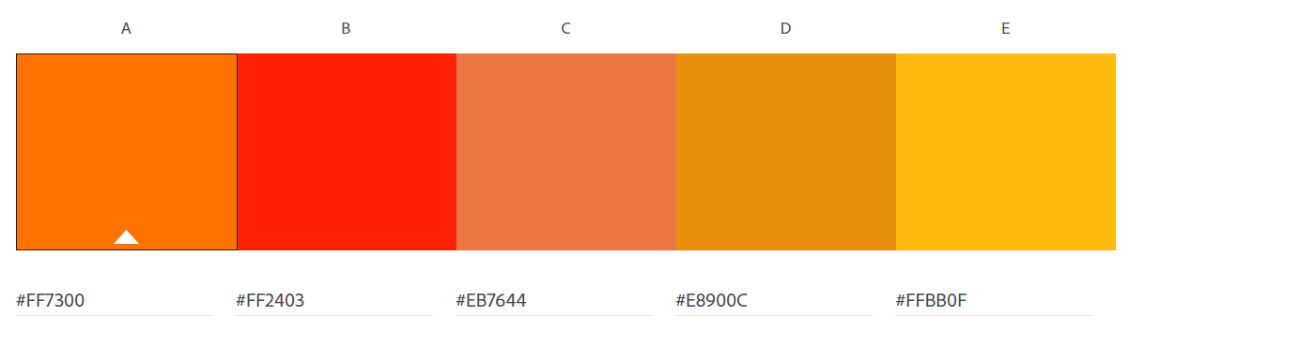

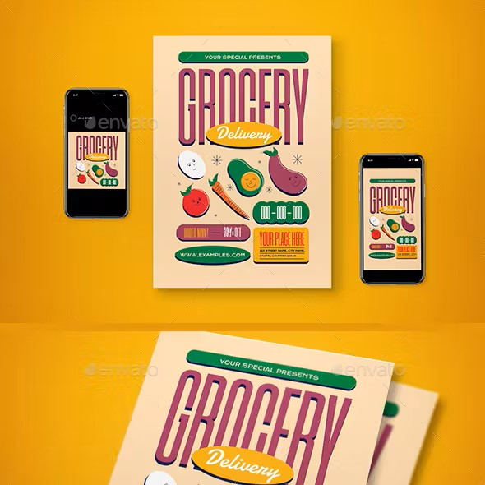

Ubuntu

Designed by [Dalton Maag](https://fonts.google.com/?query=Dalton%20Maag)