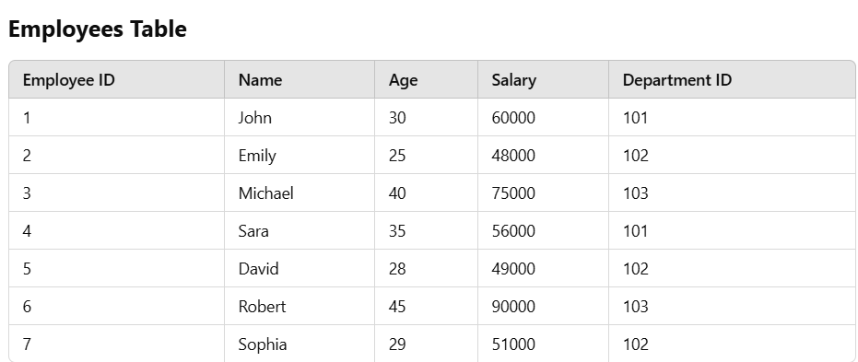

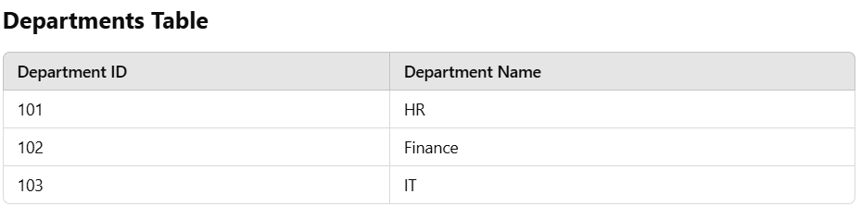

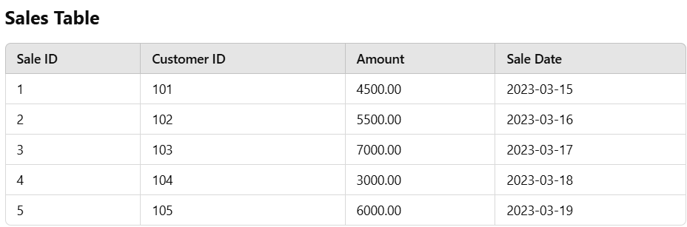

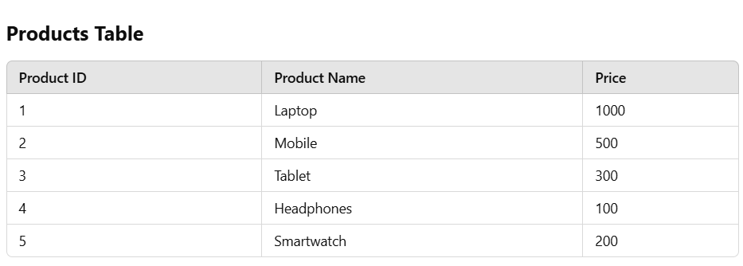

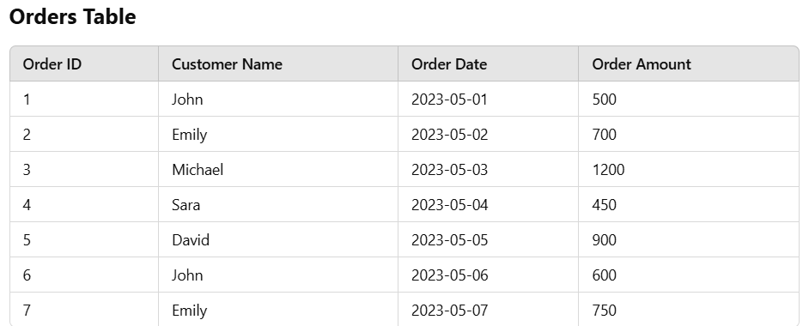

Questions
- Retrieve all employees whose salary is greater than 60000.
- Calculate the total sales amount for each customer from the sales table.
- Retrieve the names and salaries of all employees working in the Finance department.
- Find the total sales amount made on 2023-03-17 from the sales table.
- Get the names of customers who have placed an order of more than 600 from the orders table.

