Question 1 :
An airline tracks flight delays (in minutes) for 20 flights. Analyze the flight delays to calculate percentiles, detect outliers, and evaluate the overall distribution.
DataSet:
delays = [15, 30, 45, 20, 25, 100, 5, 60, 35, 50,
120, 80, 10, 75, 90, 200, 55, 40, 70, 150]
Expected Output:

Percentiles (10th, 25th, 50th, 75th, 90th): [ 14.5 28.75 52.5 82.5 123. ]
IQR: 53.75
Outliers: [200]
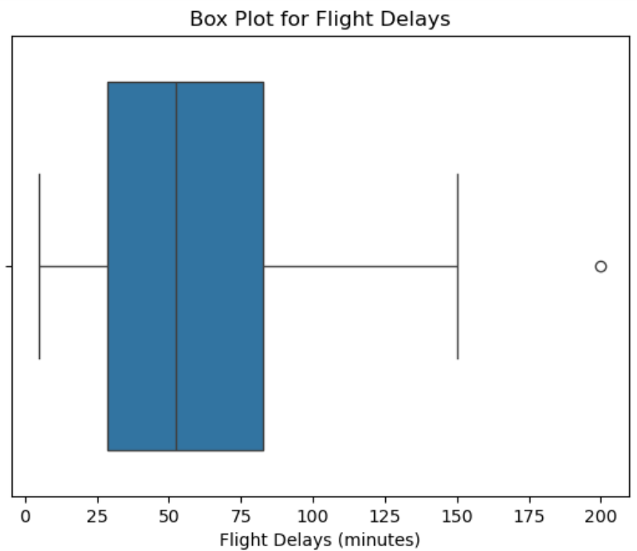
Question 2 :
A company wants to analyze the salary distribution of its employees to understand the central tendency and determine whether the data is skewed.
DataSet:
salaries = [30000, 32000, 35000, 37000, 40000, 42000, 45000, 47000, 50000, 55000,
60000, 62000, 65000, 67000, 70000, 72000, 75000, 80000, 85000, 90000]
Expected Output:
Mean Salary: 56950.0
Median Salary: 57500.0
Mode Salary: 30000
The data is Left Skewed (Negative Skew)
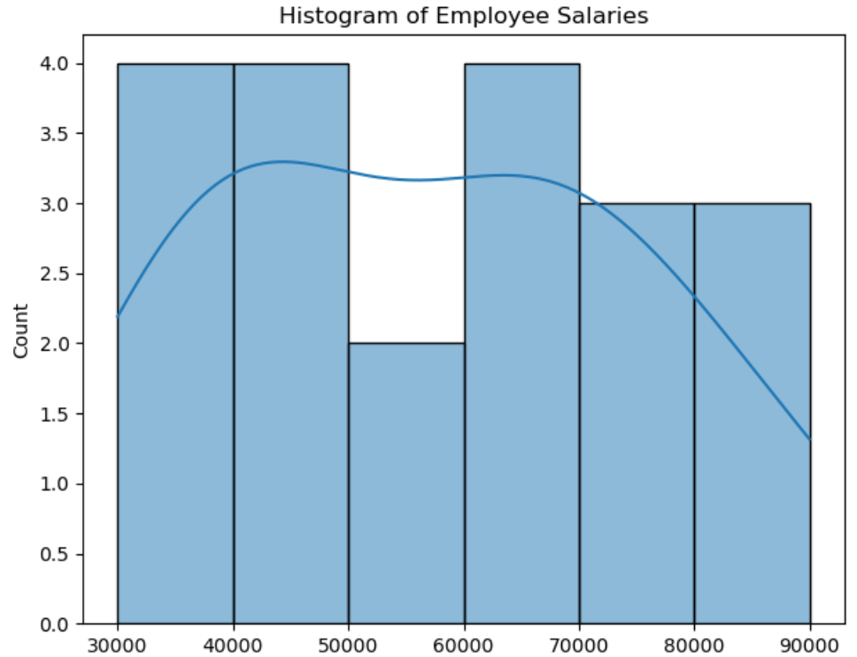
Question 3:

A school wants to analyze the exam performance of students across three subjects: Mathematics, Science, and English. How can Data Science concepts be applied to understand their performance?
DataSet:
data = {
'Student': ['A', 'B', 'C', 'D', 'E', 'F', 'G', 'H', 'I', 'J'],
'Mathematics': [85, 78, 92, 88, 70, 95, 60, 80, 90, 76],
'Science': [80, 85, 88, 70, 75, 92, 55, 82, 89, 78],
'English': [78, 74, 85, 80, 68, 90, 50, 77, 83, 72]
}
Expected Output:
Descriptive Statistics
Histogram(graph)
Correlation Analysis(graph)
HeatMap(graph)
Question 4:
A pharmaceutical company conducted a clinical trial with two groups: one receiving medication and the other a placebo. How do you perform a hypothesis test to determine the effectiveness of the medication?
Dataset:
medication_group = [110, 115, 108, 102, 107, 99, 111, 104, 109, 101]
placebo_group = [120, 125, 130, 122, 128, 119, 124, 127, 123, 126]
Expected Output:
T-Statistic: -9.201427649220966
P-Value: 3.163912817600812e-08
Reject the null hypothesis: The medication is effective.
Question 5 : A company conducted a customer satisfaction survey where customers rated their experience on a scale of 1 to 10. Analyze the survey results to calculate descriptive statistics and visualize the distribution of customer satisfaction ratings.
Sample DataSet:
ratings = [8, 9, 7, 5, 6, 10, 9, 4, 7, 8,
6, 9, 10, 5, 8, 7, 6, 9, 10, 7]
Expected Output:
Mean Rating: 7.5
Median Rating: 7.5
Mode Rating: 7
Standard Deviation: 1.746424919657298
