Question 1:
A retail store wants to identify customers who make frequent purchases. Given the dataset below, write a code to:
- Group customers by their IDs.
- Calculate the total number of purchases per customer.
- Identify the top 3 frequent customers.
Dataset:
data = {'Customer_ID': [101, 102, 103, 101, 104, 102, 101, 105, 102, 103],
'Purchase_Amount': [200, 150, 180, 220, 300, 200, 100, 400, 250, 300]}

Expected Output:

Total Purchases per Customer:
Customer_ID Purchase_Amount
0 101 520
1 102 600
2 103 480
3 104 300
4 105 400

Top 3 Frequent Customers:
Customer_ID Purchase_Amount
1 102 600
0 101 520
2 103 480

Question 2:
A company tracks the daily sales of a product over a month. You are tasked with identifying any abnormal sales data using the IQR (Interquartile Range) method.
Dataset (Daily Sales in Units):

data = {'Day': range(1, 31),
'Sales': [25, 30, 28, 45, 55, 60, 22, 80, 95, 120,
33, 29, 27, 35, 40, 50, 85, 110, 105, 92,
30, 34, 31, 33, 36, 42, 44, 48, 90, 200]}

Tasks:
1. Calculate the Q1 (25th percentile) and Q3 (75th percentile).
2. Determine the IQR.
3. Identify the Lower Bound and Upper Bound.
4. Detect and display the outliers.
5. Replace the Outliers with the Median Value.
Expected Output:
Q1: 31.5, Q3: 83.75, IQR: 52.25
Lower Bound: -46.875, Upper Bound: 162.125
Outliers Detected:
Day Sales
29 30 200
Data After Replacing Outliers with Median:
Day Sales
0 1 25.0
1 2 30.0
2 3 28.0
3 4 45.0
4 5 55.0
5 6 60.0
6 7 22.0
7 8 80.0
8 9 95.0
9 10 120.0
10 11 33.0
11 12 29.0
12 13 27.0
13 14 35.0
14 15 40.0
15 16 50.0
16 17 85.0
17 18 110.0
18 19 105.0
19 20 92.0
20 21 30.0
21 22 34.0
22 23 31.0
23 24 33.0
24 25 36.0
25 26 42.0
26 27 44.0
27 28 48.0
28 29 90.0
29 30 43.0

Question 3:
A pharmaceutical company is testing the effectiveness of a new drug to reduce blood pressure. Two groups of patients were selected:
Group 1 (Treatment): Received the drug
Group 2 (Control): Received a placebo
The company wants to check if there is a significant difference in the blood pressure levels between the two groups using an Independent T-Test.
Dataset:
data = {'Group': ['Treatment']*10 + ['Control']*10,
'Blood_Pressure': [120, 115, 118, 123, 122, 119, 124, 117, 116, 121,
130, 135, 140, 138, 142, 136, 139, 134, 137, 141]}
Tasks:
- Perform an Independent T-Test.
- State the null and alternative hypotheses.
- Calculate the p-value.
- Conclude whether the drug has a significant effect.
Expected Output:
T-Statistic: -11.870553692962726
P-Value: 6.008066605173374e-10
Reject the Null Hypothesis: The drug has a significant effect.

Question 4:
GlobalMart is a large retailer conducting advertisement campaigns in different regions. The company spends money on two types of advertisements: TV Ads and Social Media Ads
They want to analyze how these ads influence their sales.
Your task is to calculate the Covariance and Correlation to determine which type of ad has a stronger impact on sales.

Tasks :
- Calculate the Covariance between ad budgets and sales to measure the direction of the relationship.
- Calculate the Correlation to measure the strength of the relationship.
- Determine which type of ad is more effective for increasing sales.
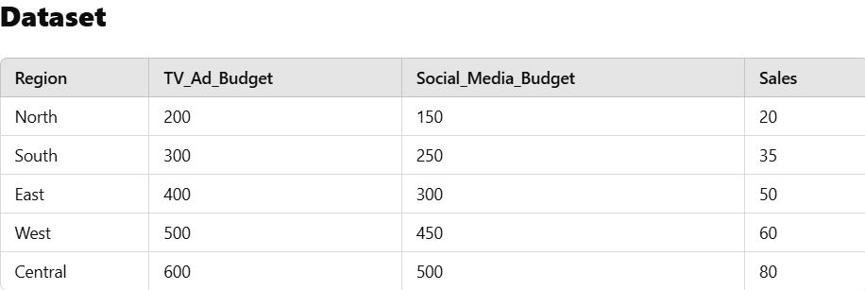

Expected Output:
Covariance (TV vs Sales): 3625.0
Covariance (Social Media vs Sales): 3225.0
Correlation (TV vs Sales): 0.9958640886279954
Correlation (Social Media vs Sales): 0.9724846021568381
TV Ads have a stronger impact on Sales.

Question 5:
A company tracks the delivery time (in minutes) for its online orders. You are given the delivery times for 50 orders.
- Calculate the mean and standard deviation of the delivery times.
- Plot the Probability Density Function (PDF) to visualize the distribution.
Dataset (Delivery Times in Minutes):
[25, 30, 28, 45, 55, 60, 22, 80, 95, 120, 33, 29, 27, 35, 40, 50, 85, 110, 105, 92, 30, 34, 31, 33, 36, 42, 44, 48, 90, 200, 20, 25, 27, 32, 38, 41, 47, 58, 62, 77, 80, 84, 90, 110, 123, 145, 150, 160]
You can try implementing this using libraries like numpy, matplotlib, and scipy
Expected Output:

Mean Delivery Time: 65.0625
Standard Deviation of Delivery Time: 41.718504212759115
