Question 1:

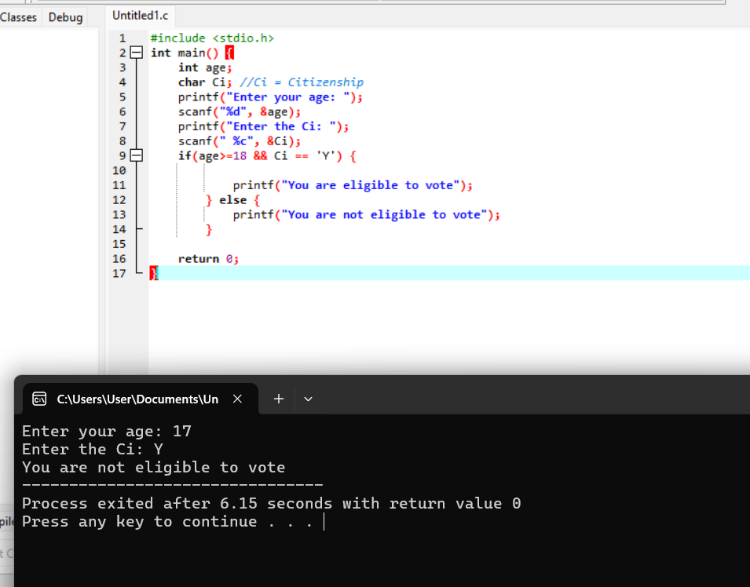

#include <stdio.h>

int main() {

int age;

char Ci; //Ci = Citizenship

printf("Enter your age: ");

scanf("%d", &age);

printf("Enter the Ci: ");

scanf(" %c", &Ci);

if(age>=18 && Ci == 'Y') {

printf("You are eligible to vote");

} else {

printf("You are not eligible to vote");

}

return 0;

}

Question 2:

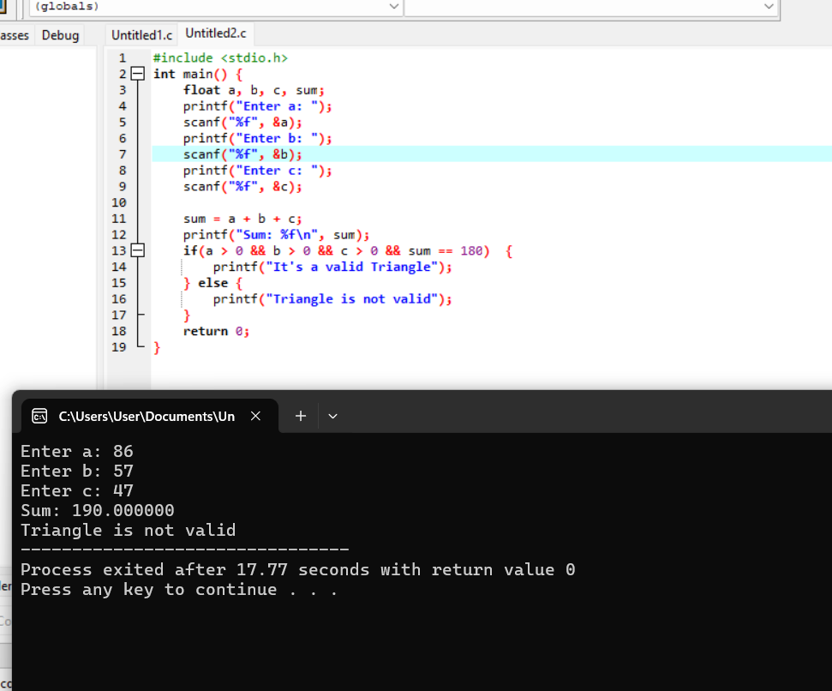

#include <stdio.h>

int main() {

float a, b, c, sum;

printf("Enter a: ");

scanf("%f", &a);

printf("Enter b: ");

scanf("%f", &b);

printf("Enter c: ");

scanf("%f", &c);

sum = a + b + c;

printf("Sum: %f\n", sum);

if(a > 0 && b > 0 && c > 0 && sum == 180) {

printf("It's a valid Triangle");

} else {

printf("Triangle is not valid");

}

return 0;

}

Question 3:

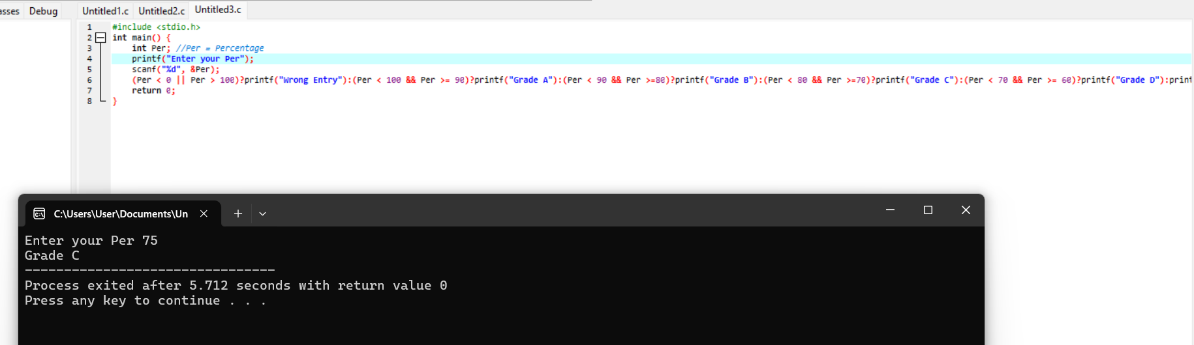

#include <stdio.h>

int main() {

int Per; //Per = Percentage

printf("Enter your Per");

scanf("%d", &Per);

(Per < 0 || Per > 100)?printf("Wrong Entry"):(Per < 100 && Per >= 90)?printf("Grade A"):(Per < 90 && Per >=80)?printf("Grade B"):(Per < 80 && Per >=70)?printf("Grade C"):(Per < 70 && Per >= 60)?printf("Grade D"):printf("Grade F");

return 0;

}

Question 4:

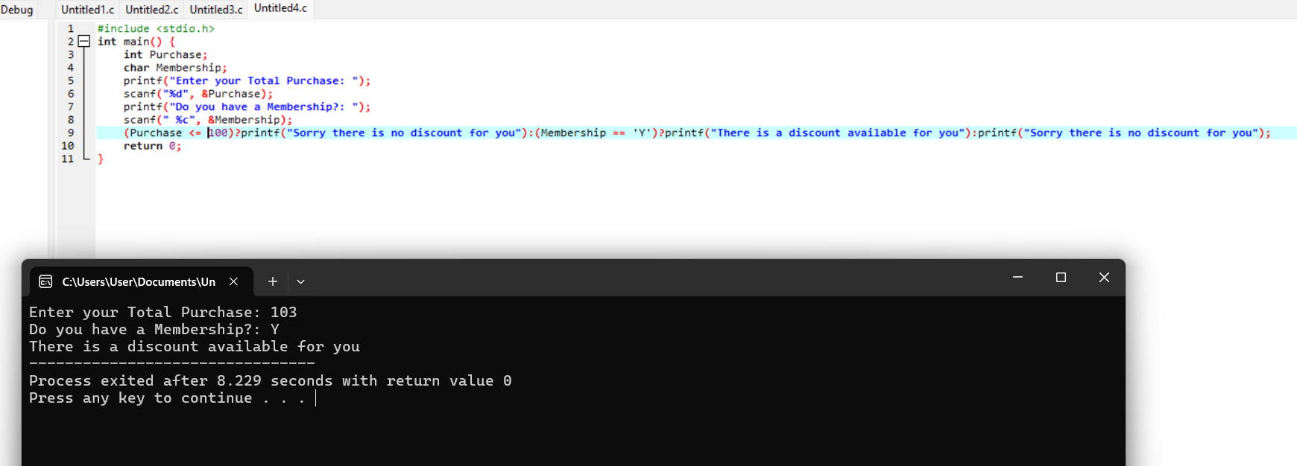

#include <stdio.h>

int main() {

int Purchase;

char Membership;

printf("Enter your Total Purchase: ");

scanf("%d", &Purchase);

printf("Do you have a Membership?: ");

scanf(" %c", &Membership);

(Purchase <= 100)?printf("Sorry there is no discount for you"):(Membership == 'Y')?printf("There is a discount available for you"):printf("Sorry there is no discount for you");

return 0;

}

Question 5:

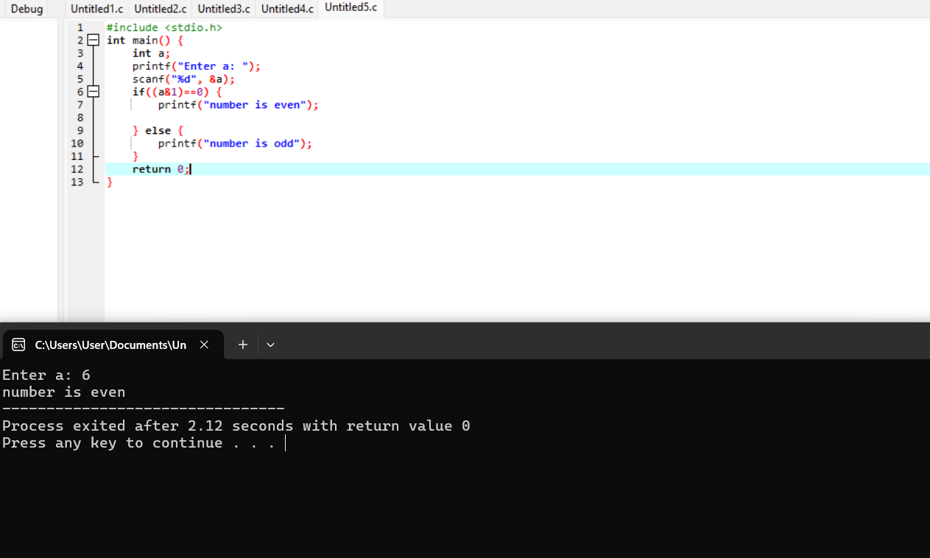

#include <stdio.h>

int main() {

int a;

printf("Enter a: ");

scanf("%d", &a);

if((a&1)==0) {

printf("number is even");

} else {

printf("number is odd");

}

return 0;

}

Question 6:

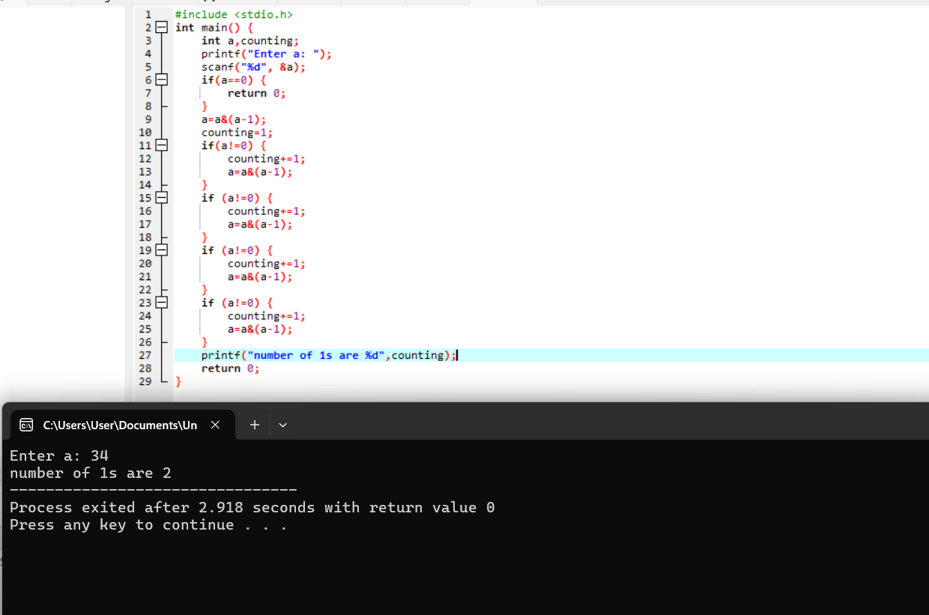

#include <stdio.h>

int main() {

int a,counting;

printf("Enter a: ");

scanf("%d", &a);

if(a==0) {

return 0;

}

a=a&(a-1);

counting=1;

if(a!=0) {

counting+=1;

a=a&(a-1);

}

if (a!=0) {

counting+=1;

a=a&(a-1);

}

if (a!=0) {

counting+=1;

a=a&(a-1);

}

if (a!=0) {

counting+=1;

a=a&(a-1);

}

printf("number of 1s are %d",counting);

return 0;

}