IoT Based Smart Agriculture System

## Abstract:

Internet of Things (IoT) plays a crucial role in smart agriculture. Smart farming is an emerging concept, because IoT sensors capable of providing information about their agriculture fields. The project aims making use of evolving technology i.e. IoT and smart agriculture using automation. Monitoring environmental factors is the major factor to improve the yield of the efficient crops. The feature of this project includes monitoring temperature, humidity and moisture in agricultural field through sensors DHT11, YL69. It will turn ON/OFF motor on the basis of soil moisture.

## Project Details:

### **Problem Statement:**

Nowadays Farmers are dependent on rain and Boring well to irrigate their lands. They need to turn ON/OFF water pump manually but before they have to check whether the soil needs watering or not. This process is time consuming because they have to check the soil manually in regular intervals otherwise the corps can get damage because of failure of water supply.

### **Solution:**

We can automate the whole process with help of IOT by Monitoring environmental factors like temperature, humidity and soil moisture. Sensors can be used to collect these data and by using these data, we can turn ON/OFF motor automatically without the farmer intervention.

Block Diagram:

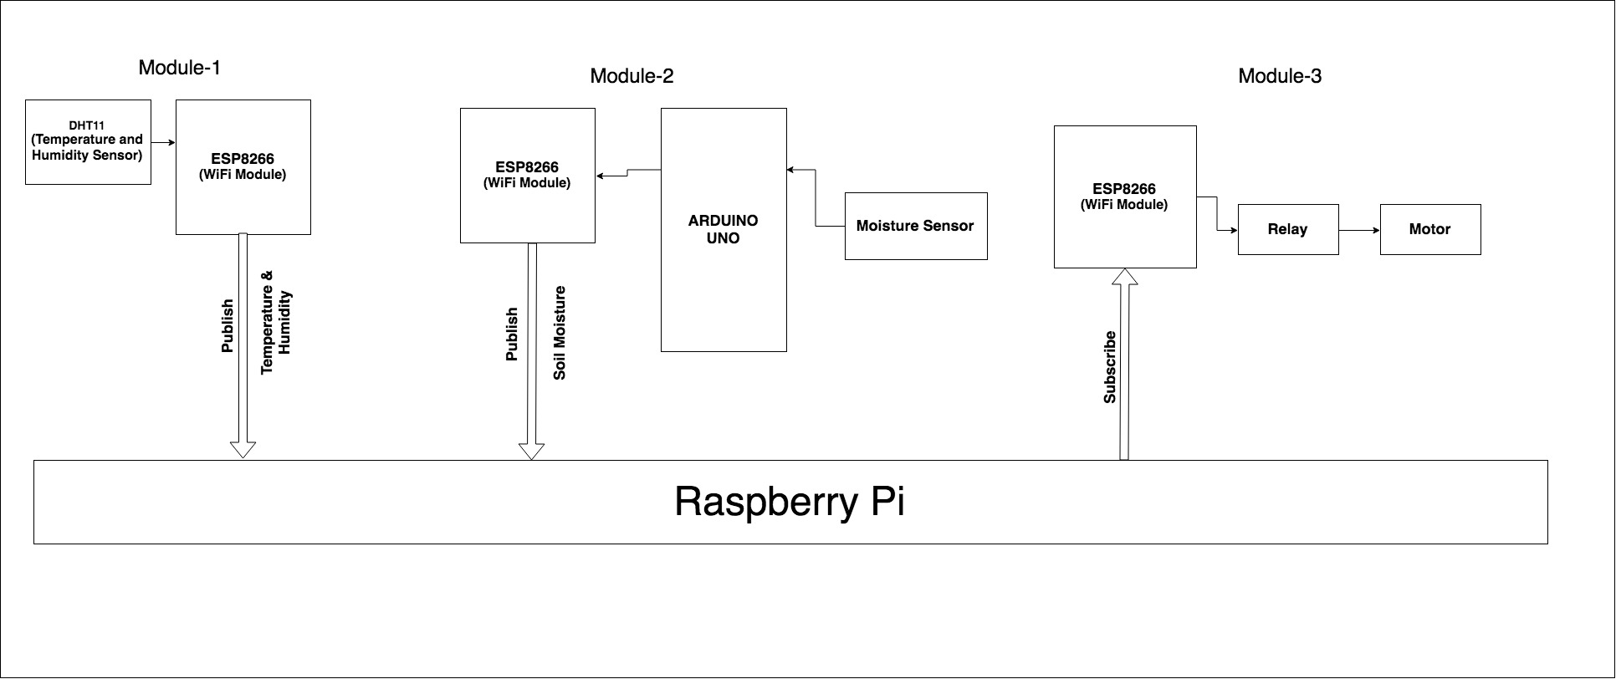

Module Details:

**Module-1:**

In the first module we are using ESP8266 Wi-Fi module that will act as a microcontroller and it will attached to a DHT11 to sense the current temperature and humidity. The module will publish the temperature and humidity data to MQTT broker i.e Raspberry Pi.

**Component Used:**

* **ESP8266 ESP-01:** It is low power consuming Wi-Fi module with integrated TCP/IP protocol stack that can give any microcontroller access to WiFi network. It is self-contained SOC (System On a Chip) that doesn’t necessarily need a microcontroller to manipulate inputs and outputs.
* **DHT11:** It is a temperature and humidity sensor that generates calibrated digital output for temperature and humidity. It uses a humidity sensor and thermistor to measure surrounding environment. It has fast response and excellent quality.

**Module-2:**

In the second module we are using Arduino as a microcontroller that will get the soil moisture through a moisture sensor and publish it to MQTT broker by using ESP8266 Wi-Fi module.

**Component Used:**

* **Arduino Uno:** It is a microcontroller board based on the ATmega328. It has 14 digital I/O pins and 6 analog pins. It just need to connect with computer with a USB cable to upload the code and powered through a AC to DC adapter or a battery.
* **YL-69:** It is soil moisture sensor used to measure water content of soil. It can detect whether the soil is too dry or wet. This sensor uses the two probes to pass current through the soil, and then it reads that resistance to get the moisture level.
* **ESP8266 ESP-01**

**Module-3:**

In this module ESP8266 WiFi Module works as a subscriber who subscribes the moisture data from the MQTT Broker(Rasberry Pi). ESP8266 connected to relay i.e connected to motor and it will turn motor ON/OFF on the basis of soil moisture.

**Component Used:**

* **Relay:** A relay is is an electrically operated switch. It means that it can be turned on or off, letting the current going through or not. when a relay contact is normally open (NO), there is an open contact when the relay is not energized. When a relay contact is Normally Closed (NC), there is a closed contact when the relay is energized.
* **ESP8266 ESP-01**

**Raspberry Pi as Broker:**

MQTT (Message Queue Telemetry Transport) is lightweight messaging protocol for small devices and sensors. It is a publisher-Subscriber based model. Publisher can publish data to broker and subscriber can subscribe topic from broker. So, broker plays a very important role as a middle man.

In this project we are creating raspberry pi as a broker. To make it broker, we are using a Mosquitto MQTT i.e open source implementation of message broker. Raspberry Pi as a broker receives Temperature and Humidity data with a specific topic from arduino microcontroller as described in module1 and also receives soil moisture data with topic information as mentioned in module2.

Now subscriber as module3 here can subscribe data from broker by specifying topic name.

Future Scope:

This system will include the intelligent system which will analyze the frequency of water supply to a specific crop on the basis of weather condition and will identify the amount of water required in the field to prevent the crop from damage and send this information to farmer via SMS or e-Mail to ensure the arrangement of enough water for healthy farming.

Machine learning can be used to detect unidentified objects like to prevent crops from animals using Camera Motion Sensor and further an image can be sent via MMS to farmer as alert message.