操作步骤
第一个控制台
conda activate env_isaaclab
cd /home/ubt/TienKung-Sim-IK /leisaac_v0.1
bash start_sim.sh

第二个控制台
conda deactivate
cd /home/ubt/TienKung-Sim-IK/TienKung_pro_sim_v0.1/leisaac_v0.1
bash ros2_bridge.sh

第三个控制台
conda deactivate
cd /home/ubt/TienKung-Sim-IK/TienKung_pro_sim_v0.1/leisaac_v0.1/tool
export ROS_DOMAIN_ID=146
bash ros_arm.sh

第四个控制台
conda deactivate
cd /home/ubt/TienKung-Sim-IK/tiangong2pro_tf
export ROS_DOMAIN_ID=146
os2 launch tiangong2pro_urdf grasp_pose.launch.py

第五个控制台
conda deactivate
cd /home/ubt/TienKung-Sim-IK/tk_sdk_demo
export ROS_DOMAIN_ID=146
ros2 launch moveit2_config move_group.launch.py

第六个控制台
conda deactivate
cd /home/ubt/TienKung-Sim-IK/tk_sdk_demo
export ROS_DOMAIN_ID=146
python ./src/grab_demo/grab_demo/yolo_detect_node.py --target_classes apple

第七个控制台
conda deactivate
cd /home/ubt/TienKung-Sim-IK/tk_sdk_demo
export ROS_DOMAIN_ID=146
python ./src/grab_demo/grab_demo/grasp_executor_node.py

Q.A

1.每次运行ROS的命令之后，需要export ROS_DOMAIN_ID=146

2.找不到运行的包
conda新建环境之后，出现如下的错误
File "/home/ubt/isaacsim/extscache/omni.kit.pip_archive-0.0.0+69cbf6ad.lx64.cp311/pip_prebundle/coverage/sqldata.py", line 16, in <module>
import sqlite3
File "/home/ubt/miniconda3/envs/env_isaaclab/lib/python3.11/sqlite3/__init__.py", line 57, in <module>
from sqlite3.dbapi2 import *
File "/home/ubt/miniconda3/envs/env_isaaclab/lib/python3.11/sqlite3/dbapi2.py", line 27, in <module>
from _sqlite3 import *
ImportError: /lib/x86_64-linux-gnu/libstdc++.so.6: version `CXXABI_1.3.15' not found (required by /home/ubt/miniconda3/envs/env_isaaclab/lib/python3.11/lib-dynload/../.././libicui18n.so.78)
重装了一下IsaacLab的包，然后更新了libstdc++.so.6的版本，IsaacLab/IsaacSim 环境中 libstdc++.so.6 版本过低，缺少 CXXABI_1.3.15。
conda activate env_isaaclab
conda install -c conda-forge libstdcxx-ng=14 -y
echo 'export LD_LIBRARY_PATH=$CONDA_PREFIX/lib:$LD_LIBRARY_PATH' >> ~/.bashrc
source ~/.bashrc
解决了上述问题

3.运行的python环境
Env_isaaclab环境的python需要3.11
Ros运行的环境需要3.10

4.找不到话题
TF 树非常清晰了。关键发现：
pelvis 帧存在 ✓（是根节点，有子帧 hip_roll_l_link 等）
ob_camera_head_link 存在 ✓（parent 是 head_roll_link）
但 /camera/color/image_raw 的 frame_id 是 camera_link，而 TF 树中没有 camera_link 这个帧
这说明仿真器发布的图像消息用的是 camera_link，但 TF 树里对应的帧叫 ob_camera_head_link。需要把节点中的相机帧名改为 ob_camera_head_link（已经是这个值），并且图像话题改用 /camera/color/image_raw 和 /camera/depth/image_raw（已改好）。
由于订阅的topic 和发布的额topic不一样，需要更改topic
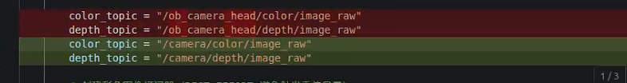
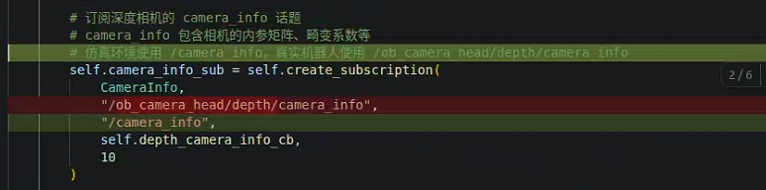
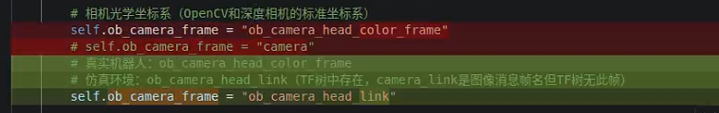

项目 修改前（真实机器人） 修改后（仿真环境）
彩色图话题 /ob_camera_head/color/image_raw /camera/color/image_raw
深度图话题 /ob_camera_head/depth/image_raw /camera/depth/image_raw
相机内参话题 /ob_camera_head/depth/camera_info /camera_info
相机坐标系帧 ob_camera_head_color_frame ob_camera_head_link

5.未知道相机的内部参数
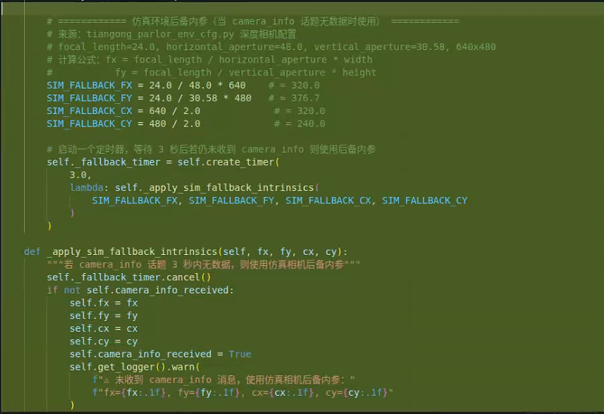
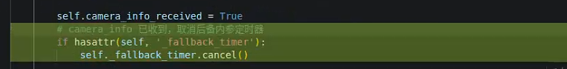

6.执行python /home/nvidia/tk_sdk_demo/src/grab_demo/grab_demo/yolo_detect_node.py --target_classes bottle
出现找不到cuda
Traceback (most recent call last):
File "/home/ubt/TienKung-Sim-IK/tk_sdk_demo/./src/grab_demo/grab_demo/yolo_detect_node.py", line 1604, in <module>
main()
File "/home/ubt/TienKung-Sim-IK/tk_sdk_demo/./src/grab_demo/grab_demo/yolo_detect_node.py", line 1594, in main
rclpy.spin(node)
File "/opt/ros/humble/local/lib/python3.10/dist-packages/rclpy/__init__.py", line 229, in spin
executor.spin_once()
File "/opt/ros/humble/local/lib/python3.10/dist-packages/rclpy/executors.py", line 808, in spin_once
self._spin_once_impl(timeout_sec)
File "/opt/ros/humble/local/lib/python3.10/dist-packages/rclpy/executors.py", line 805, in _spin_once_impl
raise handler.exception()
File "/opt/ros/humble/local/lib/python3.10/dist-packages/rclpy/task.py", line 272, in _execute_coroutine_step
result = coro.send(None)
File "/opt/ros/humble/local/lib/python3.10/dist-packages/rclpy/executors.py", line 488, in handler
await call_coroutine(entity, arg)
File "/opt/ros/humble/local/lib/python3.10/dist-packages/rclpy/executors.py", line 407, in _execute_subscription
await await_or_execute(sub.callback, msg)
File "/opt/ros/humble/local/lib/python3.10/dist-packages/rclpy/executors.py", line 110, in await_or_execute
return callback(*args)
File "/opt/ros/humble/local/lib/python3.10/dist-packages/message_filters/__init__.py", line 113, in callback
self.signalMessage(msg)
File "/opt/ros/humble/local/lib/python3.10/dist-packages/message_filters/__init__.py", line 69, in signalMessage
cb(*(msg + args))
File "/opt/ros/humble/local/lib/python3.10/dist-packages/message_filters/__init__.py", line 423, in add
self.signalMessage(*msgs)
File "/opt/ros/humble/local/lib/python3.10/dist-packages/message_filters/__init__.py", line 69, in signalMessage
cb(*(msg + args))
File "/home/ubt/TienKung-Sim-IK/tk_sdk_demo/./src/grab_demo/grab_demo/yolo_detect_node.py", line 1458, in synchronized_image_cb
results = self.model.predict(
File "/home/ubt/.local/lib/python3.10/site-packages/ultralytics/engine/model.py", line 535, in predict
return self.predictor.predict_cli(source=source) if is_cli else self.predictor(source=source, stream=stream)
File "/home/ubt/.local/lib/python3.10/site-packages/ultralytics/engine/predictor.py", line 225, in __call__
return list(self.stream_inference(source, model, *args, **kwargs)) # merge list of Result into one
File "/home/ubt/.local/lib/python3.10/site-packages/torch/utils/_contextlib.py", line 36, in generator_context
response = gen.send(None)
File "/home/ubt/.local/lib/python3.10/site-packages/ultralytics/engine/predictor.py", line 306, in stream_inference
self.model.warmup(
File "/home/ubt/.local/lib/python3.10/site-packages/ultralytics/nn/autobackend.py", line 878, in warmup
self.forward(im) # warmup model
File "/home/ubt/.local/lib/python3.10/site-packages/ultralytics/nn/autobackend.py", line 658, in forward
y = self.model(im, augment=augment, visualize=visualize, embed=embed, **kwargs)
File "/home/ubt/.local/lib/python3.10/site-packages/torch/nn/modules/module.py", line 1751, in _wrapped_call_impl
return self._call_impl(*args, **kwargs)
File "/home/ubt/.local/lib/python3.10/site-packages/torch/nn/modules/module.py", line 1762, in _call_impl
return forward_call(*args, **kwargs)
File "/home/ubt/.local/lib/python3.10/site-packages/ultralytics/nn/tasks.py", line 137, in forward
return self.predict(x, *args, **kwargs)
File "/home/ubt/.local/lib/python3.10/site-packages/ultralytics/nn/tasks.py", line 154, in predict
return self._predict_once(x, profile, visualize, embed)
File "/home/ubt/.local/lib/python3.10/site-packages/ultralytics/nn/tasks.py", line 176, in _predict_once
x = m(x) # run
File "/home/ubt/.local/lib/python3.10/site-packages/torch/nn/modules/module.py", line 1751, in _wrapped_call_impl
return self._call_impl(*args, **kwargs)
File "/home/ubt/.local/lib/python3.10/site-packages/torch/nn/modules/module.py", line 1762, in _call_impl
return forward_call(*args, **kwargs)
File "/home/ubt/.local/lib/python3.10/site-packages/ultralytics/nn/modules/conv.py", line 89, in forward_fuse
return self.act(self.conv(x))
File "/home/ubt/.local/lib/python3.10/site-packages/torch/nn/modules/module.py", line 1751, in _wrapped_call_impl
return self._call_impl(*args, **kwargs)
File "/home/ubt/.local/lib/python3.10/site-packages/torch/nn/modules/module.py", line 1762, in _call_impl
return forward_call(*args, **kwargs)
File "/home/ubt/.local/lib/python3.10/site-packages/torch/nn/modules/conv.py", line 554, in forward
return self._conv_forward(input, self.weight, self.bias)
File "/home/ubt/.local/lib/python3.10/site-packages/torch/nn/modules/conv.py", line 549, in _conv_forward
return F.conv2d(
RuntimeError: CUDA error: no kernel image is available for execution on the device
CUDA kernel errors might be asynchronously reported at some other API call, so the stacktrace below might be incorrect.
For debugging consider passing CUDA_LAUNCH_BLOCKING=1
Compile with `TORCH_USE_CUDA_DSA` to enable device-side assertions.
查看 CUDA 版本的方法
nvcc –version
查看pytorch的版本
pip show torch
输出
Name: torch
Version: 2.7.1+cu118
Summary: Tensors and Dynamic neural networks in Python with strong GPU acceleration

退出虚拟环境的情况下，运行
python ./src/grab_demo/grab_demo/yolo_detect_node.py --target_classes apple
能够正常识别苹果的图片，会在saved_data环境下保存识别的图片
打开识别的程序之后，再开启抓取的程序
后面再次运行的时候，还是出现了错误，直接改成了CPU推理


