# Modeling chamber experiments

Mentel et al. performed several chamber experiments to study photochemical production of aerosols from real plant emissions. The experiment setup consisted of two chambers: plant chamber and reaction chamber. There were VOC-emitting plants in the plant chamber, from which the gas was led to the reaction chamber. The reaction chamber had a UV-lamp inside which could be turned on and off to control nucleation. In addition to the gas from plant chamber also ozone was pumped into reaction chamber.

In summary, turning on the UV-lamp in the reaction chamber started nucleation events, and the nucleated particles grew quickly by condensation. The condensing vapor may be produced by the reaction between the monoterpene from vegetation and OH-radicals or by the reaction between monoterpene and ozone – or by both reactions. The goal of this study is to find out whether the experimental results can be reproduced by aerosol computer model that has three control parameters: nucleation rate, stoichiometric parameter for vapor reaction with OH (alpha) and the rate of vapor molecules that deposit on chamber walls (gamma). Other parameters, such as dilution and vapor source, are calculated from the experimental data. We were also interested if alpha could be kept constant while varying gamma if needed. Another goal of the study was to determine whether the condensing vapor was produced solely by OH-reaction or if also the ozone-reaction was needed to explain the experimental results.

## Overview

There is an example of a particle distribution that was produced in the experiments in figure 1 below. This particular experiment is used as reference in all the figures in this overview section.

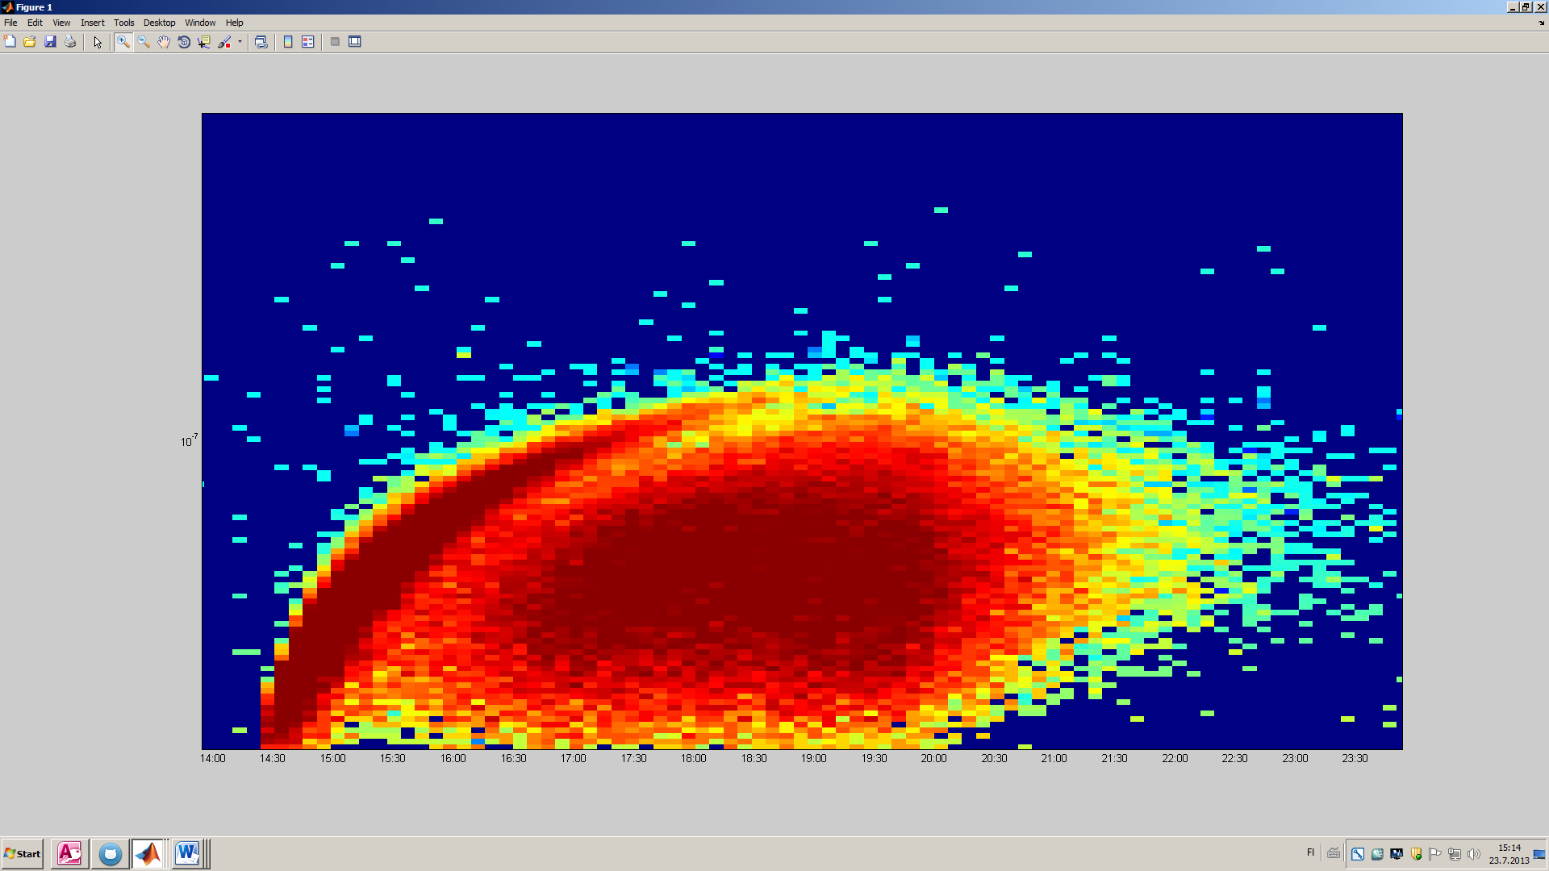

Figure 1

Two nucleation events can be seen in figure 1: one quite short but strong beginning about 14:30 and a longer one beginning at 16:00 and ending at about 20:00, when UV-lamp in the reaction chamber was switched off. To reproduce these nucleation events in the simulation, several particle sources were defined. The particle source rates are seen in the following figure.

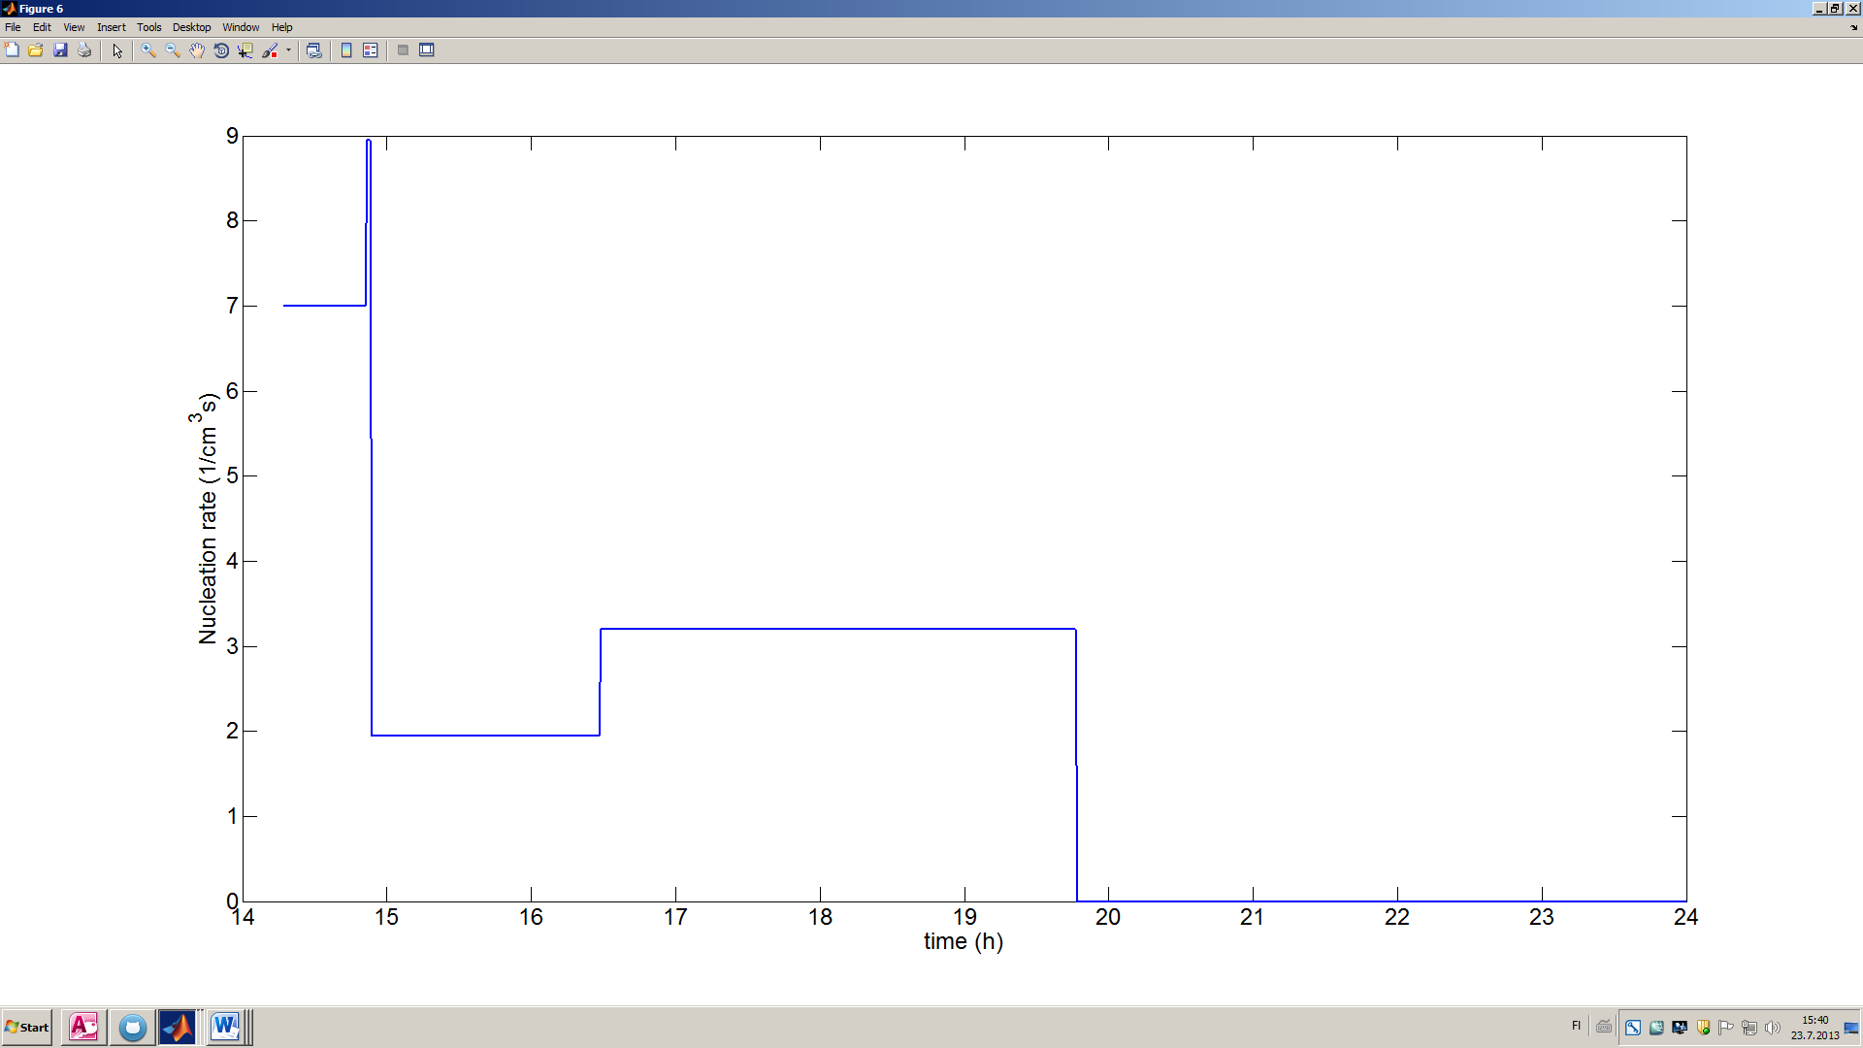

Figure 2

Figure 2 shows that only few different values for nucleation rates are needed to produce a distribution similar to the observed one. The nucleation rate is big in the beginning for the first nucleation event, and smaller for the second event. The nucleation does not cease between these events, but the rate is smaller.

Particle sources in simulation generated 10 nm and 18 nm particles, whereas a realistic value would be about 3 nm. However, SMPS that was used to measure the distribution in the experiments can detect only particles that have diameter of 15 nm and larger. To fit the simulation results to experimental data, the bigger nucleation diameters were used in the simulation.

The nucleation rate defined in simulation affects the total particle concentration. The concentration depends also on coagulation, particle wall losses and dilution that was calculated based on measured dilution flow. The nucleation rates were adjusted so that the total particle concentration in simulation corresponds that of the real data. Particle concentration is plotted in figure 3.

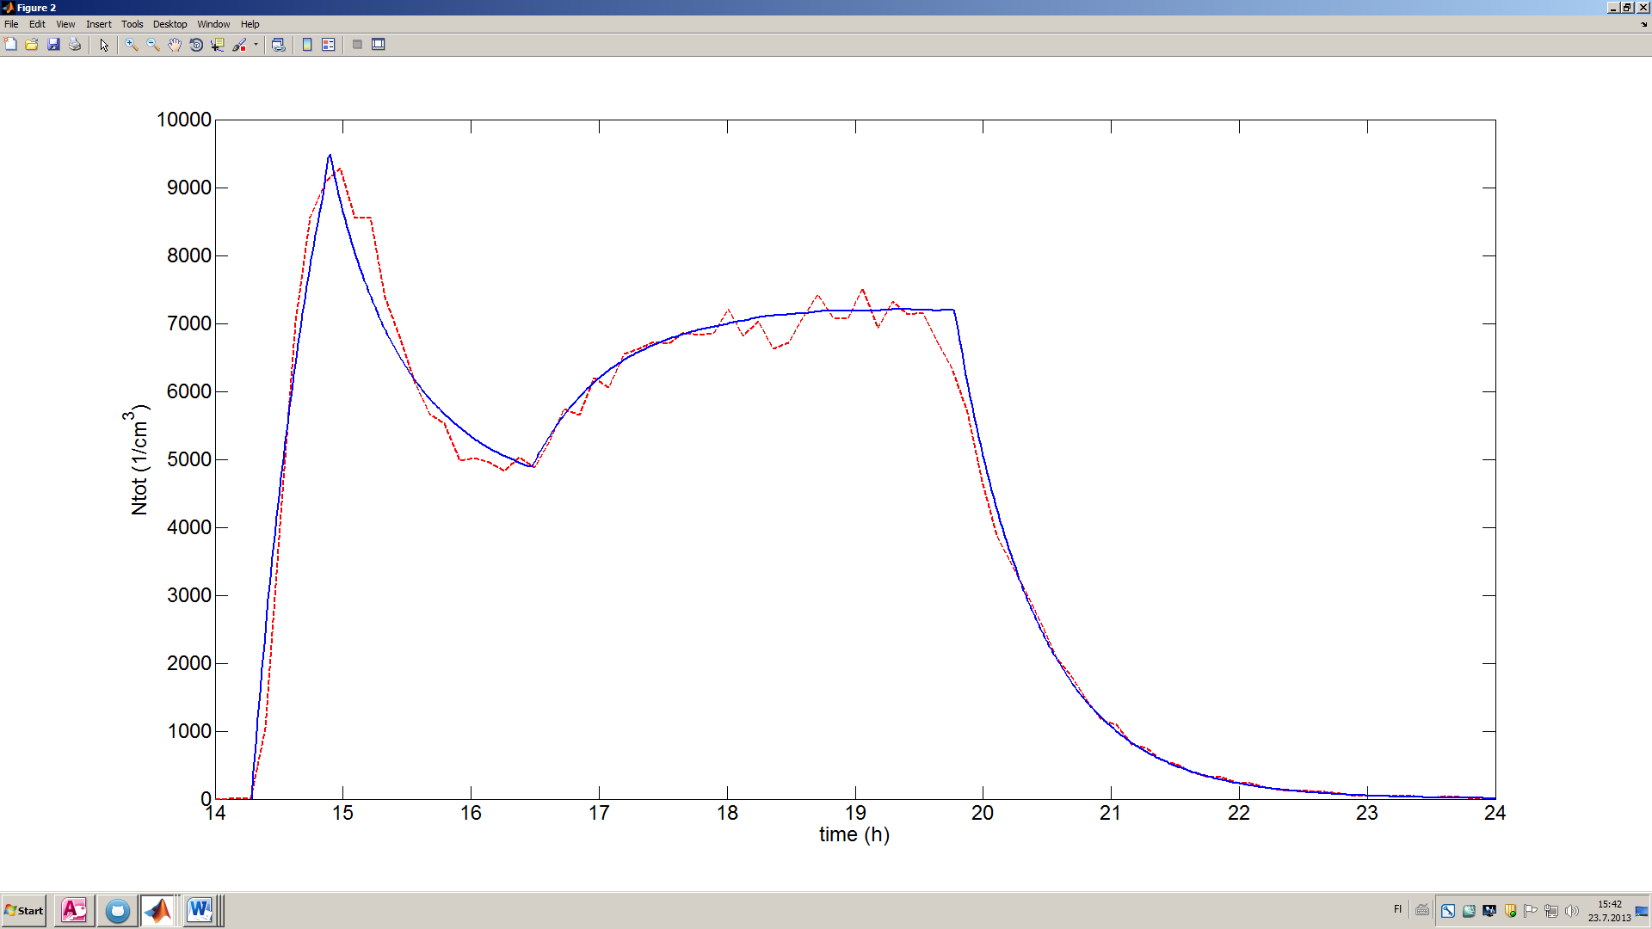

Figure 3

In figure 3 the total number concentration of particles is plotted both for experimental data (red, SMPS) and for simulated data (blue). This shows that despite the simple nucleation rate definition (fig 2), coagulation, dilution and other processes automatically make the number concentration of simulation to behave in a similar way as in real experiment.

The next step was to fit the total volume of particles in the simulation to the experimental data. This can be done by adjusting the stoichiometric parameter alpha and the wall loss parameter gamma. The best values for the experiment under study were alpha=0.38 and gamma = 1/275. These parameters produced a total volume curve that is shown in figure 4.

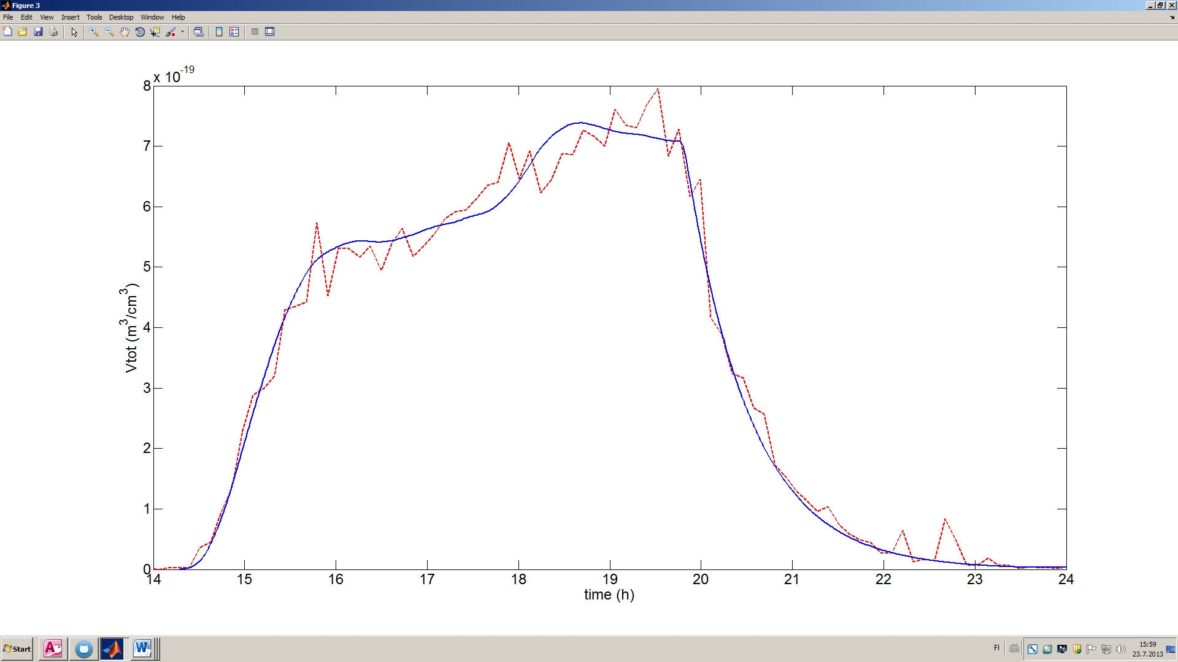

Figure 4

Again, in figure 4, the red curve is total volume of particles in experimental data (calculated from smps distribution) and blue is the total volume in simulation.

If wall losses of vapor were considered very small or zero, the only fitting parameter would be alpha. However, small values of gamma did not produce as good simulation results as the greater ones. Example of this behavior is seen in figure 5, where different values for gamma are used and alpha is used as the only fitting parameter.

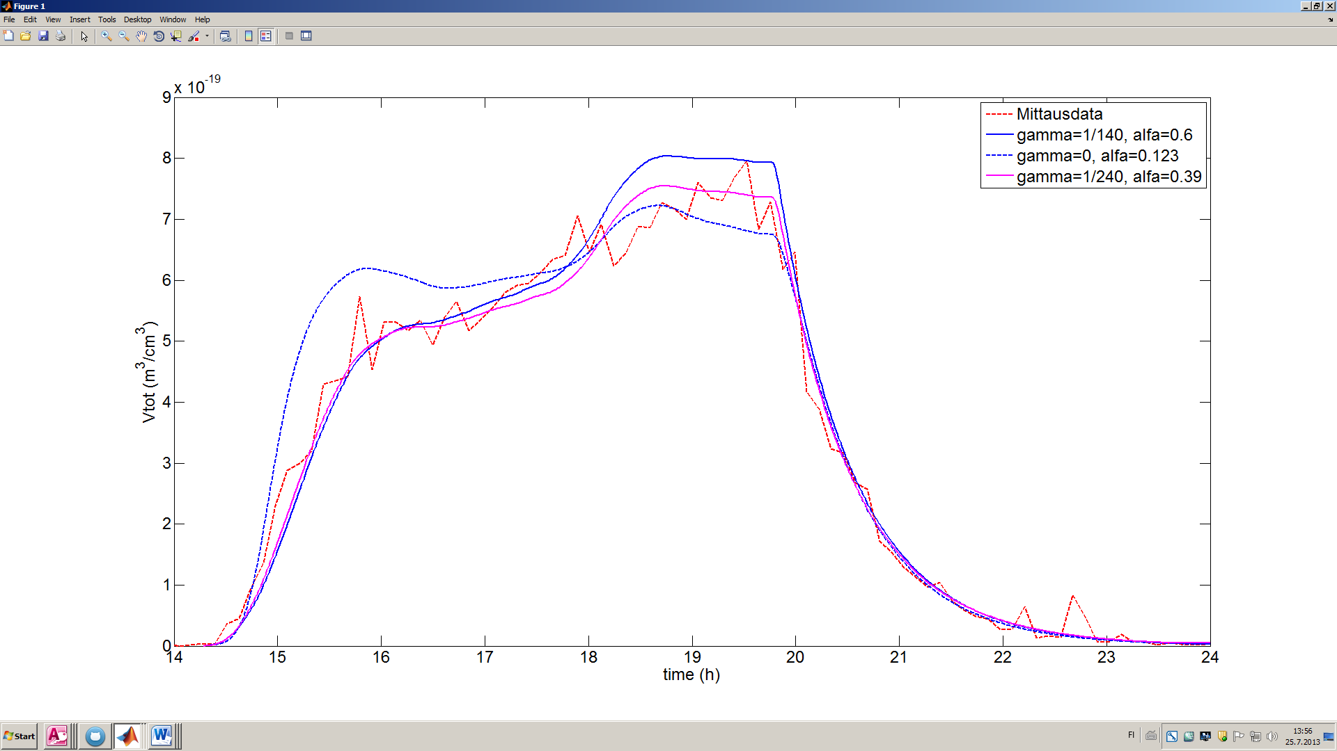

Figure 5

Figure 5 shows that when gamma is zero, the volume grows too much in the beginning of the simulation even though it behaves quite well at the end. This implies that the curve cannot be fitted by only adjusting the value of alpha and so there must be significant vapor wall losses in the experiments. On the other hand, using a high wall loss parameter (1/140) does not produce correct behavior but over-estimates the volume at the end of experiment.

Now that both total volume and number concentration in simulation are quite correct, also the average volume of particles (total volume / total number) can be compared. This is done in figure 6.

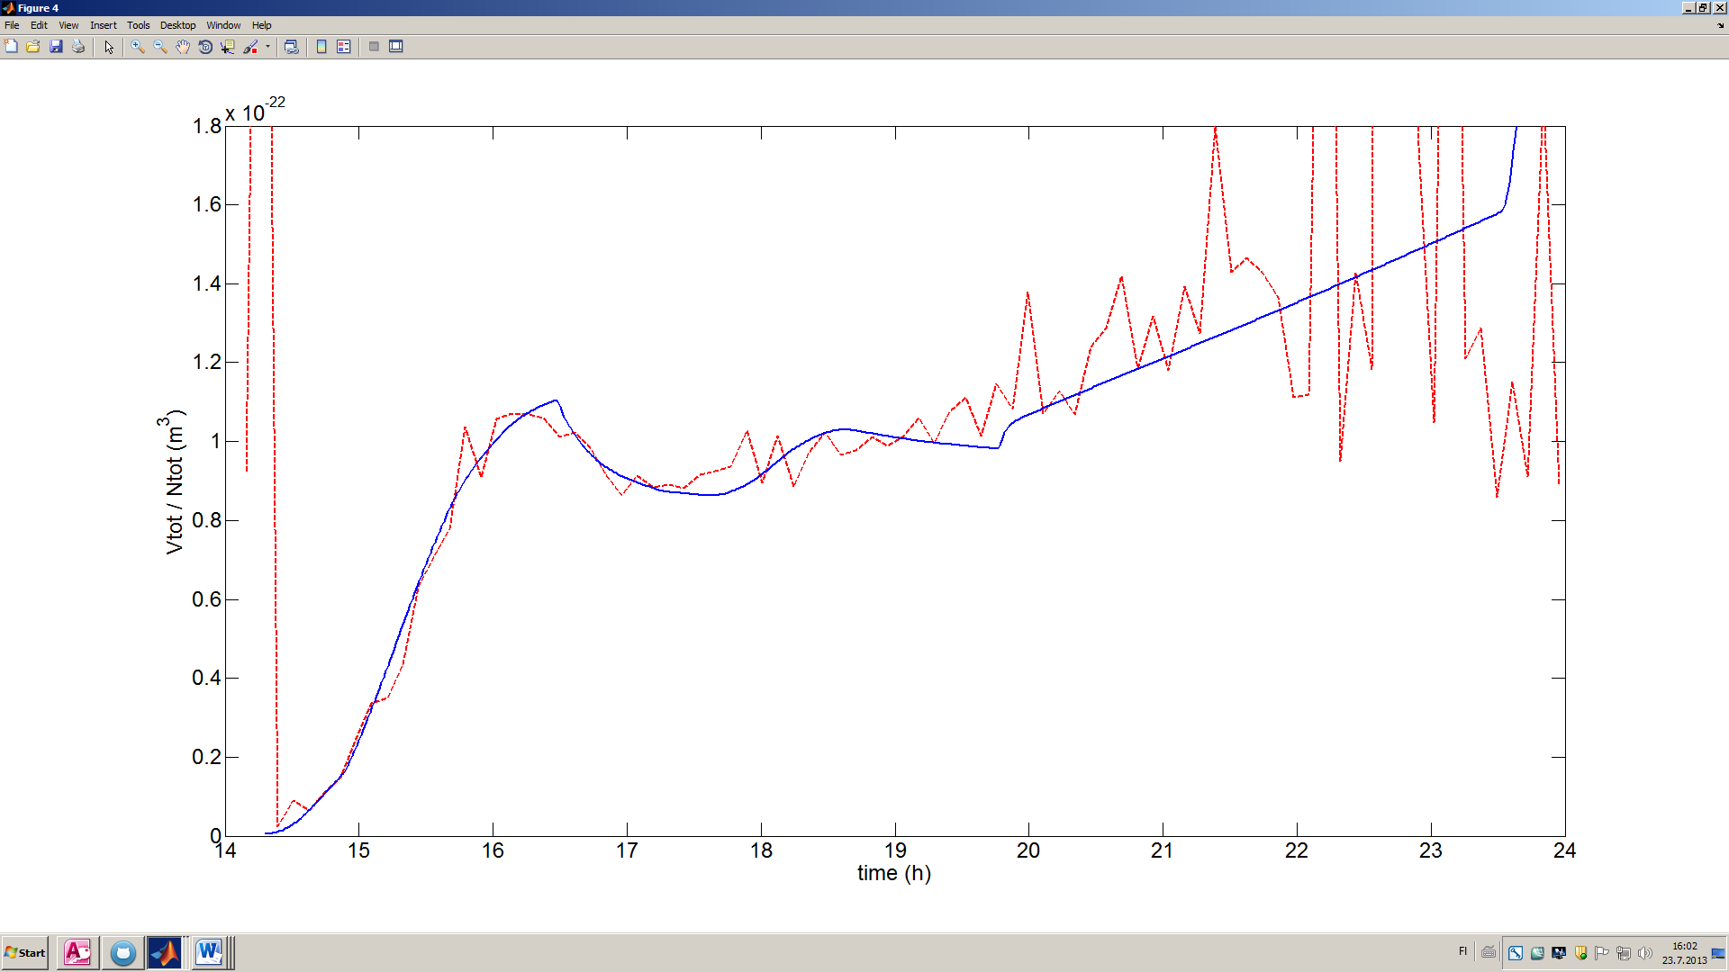

UV off

Figure 6

The average volume of particles seems to be fairly similar in the experiment and simulated case. The behavior of volume after the UV lamp has been switched off is of special interest. After the UV is lit off, the condensing vapor is no longer produced by OH-reaction, but the average volume keeps growing both in experimental data and in simulation. This may depend on two reasons:

1. The smaller particles dilute or deposit on walls faster than the bigger ones. This decreases the number concentration but does not significantly affect the total volume. This seems to be the case in simulation: if the wall deposition of particles (that decreases mostly the number of small particles) is turned off, the average volume does not grow nor shrink after the UV is switched off. If wall deposition is on, the average volume keeps growing after switching the UV off. This can be seen in figure 6, where the particle wall deposition is on.
2. There is another condensing vapor in the reaction chamber in addition to the vapor produced by OH-reaction. This could be the vapor coming from the reaction between monoterpene and ozone that does not need UV-light. If this another source of condensing vapor is taken into account in the simulation, the average volume behaves in the same way after switching UV off as in the experiments. However, the stoichiometric parameter for the reaction between monoterpene and ozone must be relatively low: about 0,09, whereas the same parameter for the reaction between monoterpene and OH is kept in its original value of 0,38.

If both of these reasons above are taken into account in the simulation, the average volume may grow too much after the UV is switched off. The experimental data is quite noisy at the end of experiment, so it is difficult to say how the average volume exactly evolves. The results of simulation where both wall deposition of particles and monoterpene-ozone reaction (with stoichiometric parameter of value 0,09) were taken into account are seen in figure 7.

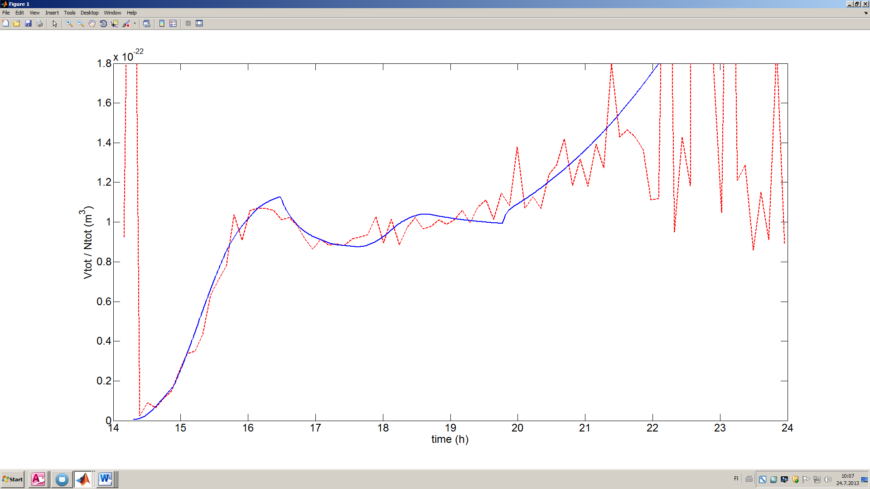

Figure 7

Figure 8 shows particle distribution formed by the simulation. For computational reasons, the distribution is not totally continuous. However, the basic shape resembles that of the measured distribution in figure 1.

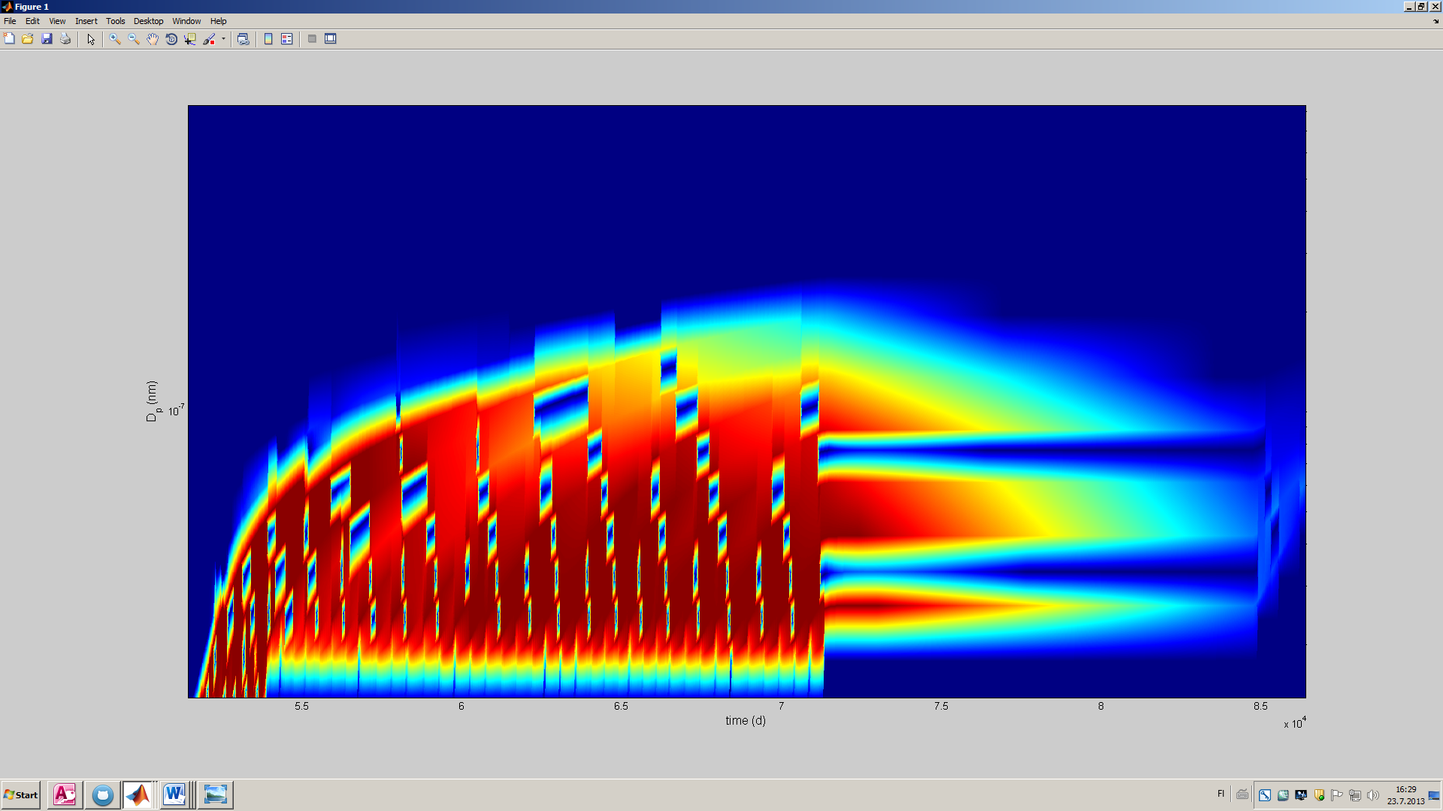

Figure 8 (interpoloitu)

## Summary of experiments

Mentel et al. performed a number of experiments similar to the one that has been studied in this paper so far. In total, there were six (?) experiments that had nearly identical initial conditions. Only RH and the intensity of UV-light in the reaction chamber and the plant chamber were varied. In this study, all these experiments were reproduced using a computer model.

In all studied experiments, the stoichiometric parameters of monoterpene reactions could be kept constants. For OH-monoterpene reaction this parameter had a value of 0,38 and for O3-monoterpene reaction 0,09. This implicates that the effect of O3-monoterpene reaction is small under these conditions: if O3-monoterpene reaction were not taken into account at all, it did not affect the results significantly, except for the average volume after switching UV-light off. If the alpha for O3-reaction was raised, the total volume of particles would be overestimated after switching the UV-light off, because concentration of condensing vapor from O3-reaction increases.

The value of vapor wall loss parameter gamma had to be varied to fit the simulation results to the measured data. At lowest, gamma was 1/300 and highest 1/120. The highest value was obtained when the concentration of monoterpene was remarkably higher than in other experiments. When the monoterpene concentration was approximately constant, the values of gamma varied between 1/300 and 1/230. It has been shown that the vapor wall losses can really vary between experiments even though the used chamber is flushed after each experiment. (lähde?) Hence small changes in wall loss parameter are justified in simulations as well to fit the results to measured data. The difference between 1/120 and 1/300 is however quite large and can depend on some unknown mechanism.

In three consecutive experiments, RH was varied so that during the first experiment it was 65 %, the second 55 % and the last 50%. The value of gamma had to be decreased correspondingly: it was 1/255, 1/230 and 1/260 in respective order. Thus, in these experiments there is no clear correlation between RH and vapor wall deposition, even though previous studies (Loza et al.) show that increasing RH increases wall deposition in a chamber.

In figure X, the MTOH source rate is plotted for four experiments and for each curve the used wall sink coefficient is written above the curve. The wall sink coefficient seems to be in correlation with the condensing vapor source rate so that the higher the source rate, the greater is also the wall sink coefficient.

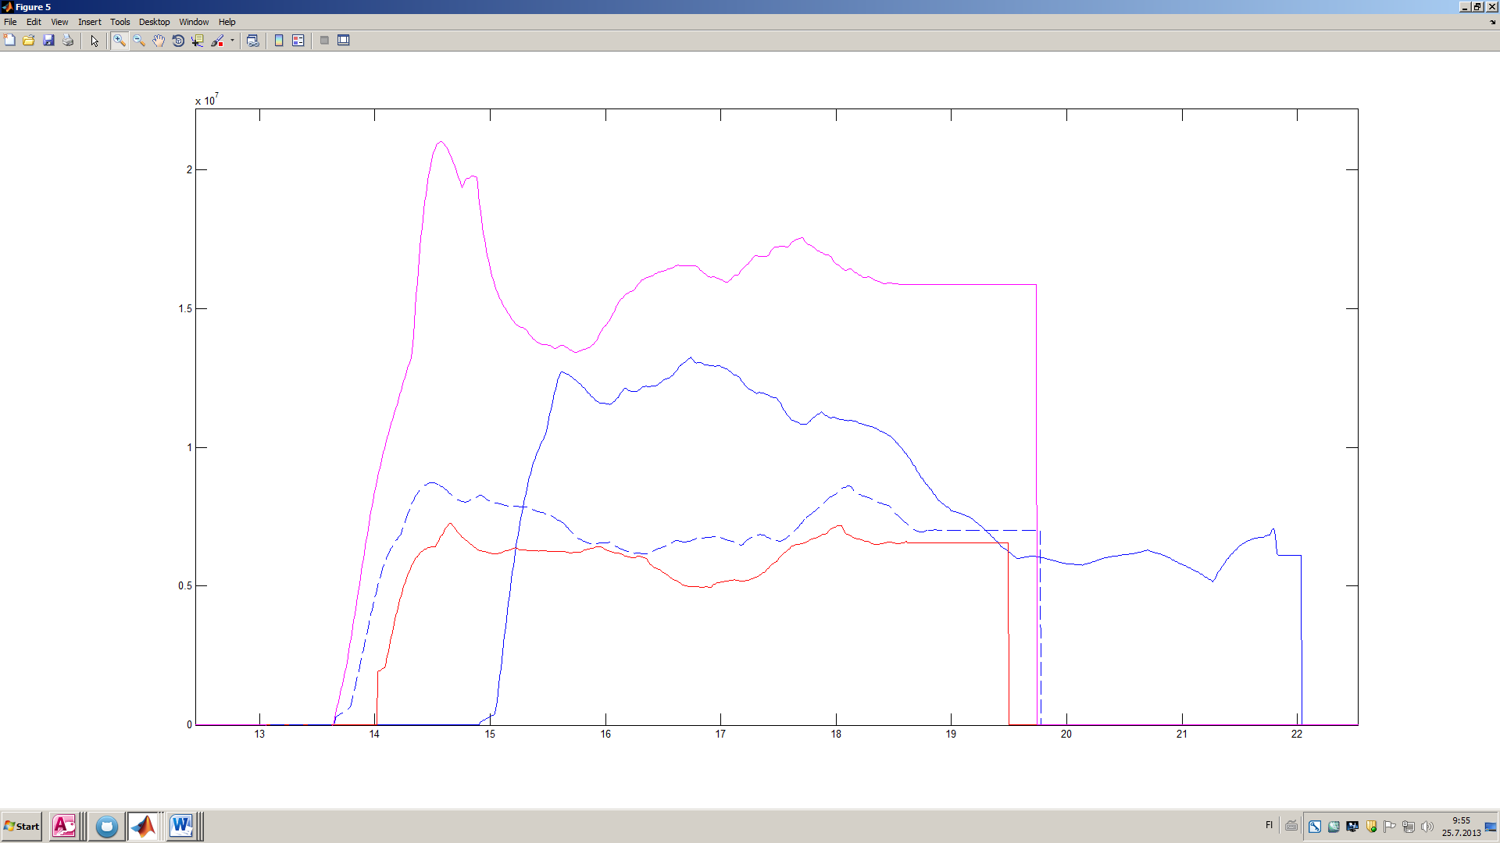

Q_MTOH

Figure 9

In addition to stoichiometric parameters and wall loss coefficient, also the nucleation rates could be adjusted. The rates had to be defined separately for each experiment to successfully model the particle formation. The number concentration of simulation could be fitted to measured data by defining 3 – 6 constant nucleation rates depending on experiment. Typical values for the nucleation rates were 1.0 – 7.0 1/cm^3s.

Using parameters described above, the number concentrations, total volume of particles and volume-particle number –ratios obtained by simulations were almost similar to the experimental results, as in figures 3, 4 and 7.