**Task#1: Virtual Environment**

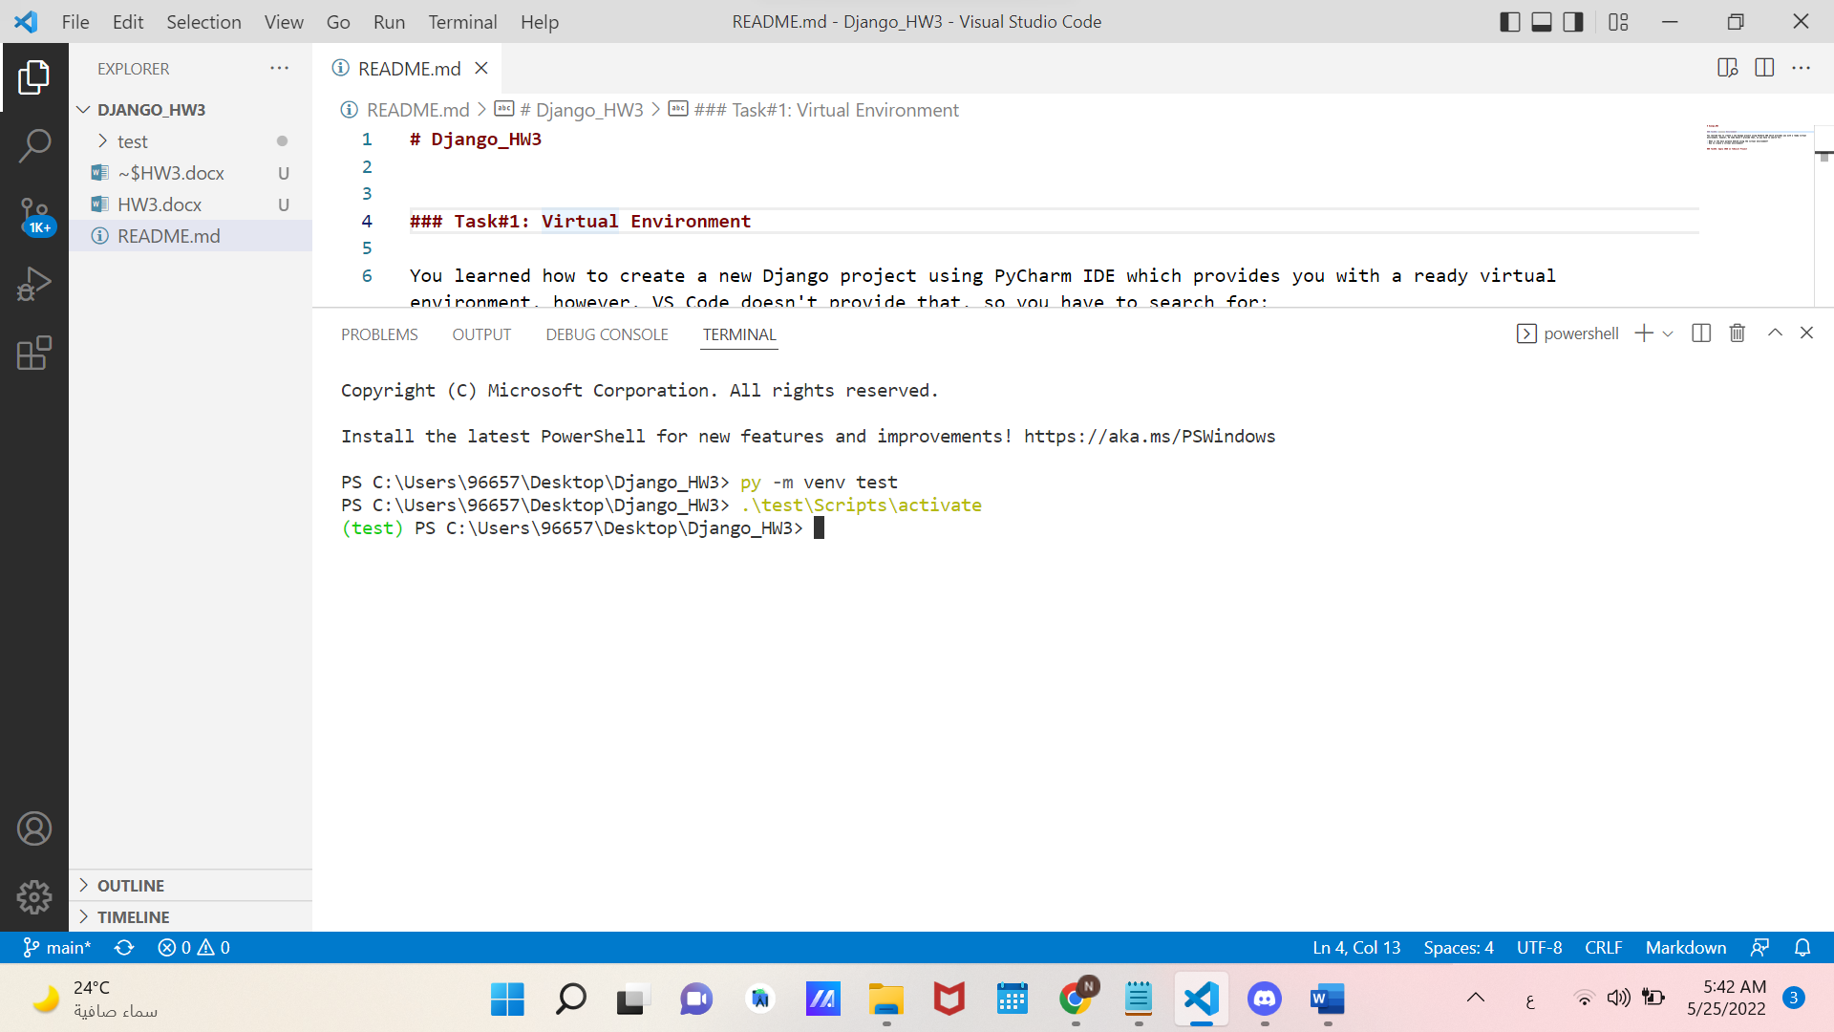

* What is the main purpose behind using the virtual environment?

virtualenv is a tool for creating isolated Python environments containing their own copy of python , pip , and their own place to keep libraries installed from PyPI. It's designed to allow you to work on multiple projects with different dependencies at the same time on the same machine.

* How to create a virtual environment?

1-create virtual environment 'test'

virtualenv test or python -m venv test or py -m venv test

2-active it

.\test\Scripts\activate

### Task#2: Apply CRUD on ToDoList Project