**Gorilla-Sea Cucumber Hash Report**

*By Thor Olesen and Jacob Møiniche*

**Results**

The following table gives the similarity between each pair of species as a number between 0 and 1, higher values meaning “more similar.” We have used the hash function getHashValue(String string) in the implementation with d = 100 and k-grams of length k = 2. As can be seen, the species closest to us is the Gorilla with a similarity value of ~0,99. Also, the species furthest away to us is the Lamprey with a similarity value of ~0.68.

|  |  |  |  |  |  |  |  |  |  |  |  |
| --- | --- | --- | --- | --- | --- | --- | --- | --- | --- | --- | --- |
| Human | Gorilla | Spider | Pig | Horse | Cow | Deer | Gull | Trout | Rockcod | Sea-Cucumber | Lamprey |
| 1.0 | 0.995 | 0.97 | 0.92 | 0.91 | 0.90 | 0.87 | 0.85 | 0.79 | 0.76 | 0.75 | 0.68 |

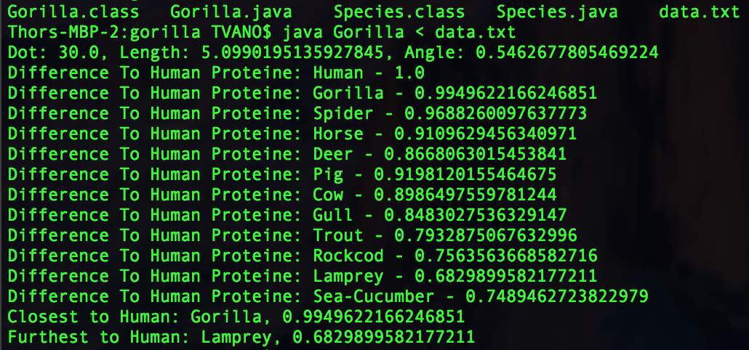

We have also used the implementation with d = 1000/10000 and k-grams of length k = 20 since a smaller k-gram will result in a higher difference:

|  |  |  |  |  |  |  |  |  |  |  |  |
| --- | --- | --- | --- | --- | --- | --- | --- | --- | --- | --- | --- |
| Human | Gorilla | Spider | Pig | Horse | Cow | Deer | Gull | Trout | Rockcod | Sea-Cucumber | Lamprey |
| 1.0 | 0.86 | 0.53 | 0.22 | 0.17 | 0.23 | 0.10 | 0.16 | 0.12 | 0.14 | 0.13 | 0.09 |

**Tests**

Our method getAngle(int[] firstArray, int[] secondArray) computes the cosine of the angle of two vectors of the same dimension d. The angle value determines how different species are related to us, e.g. a small difference means they are closer to each other. We have tested it on the following examples:

|  |  |  |  |
| --- | --- | --- | --- |
| P | Q | D | Value returned |
| (0,1) | (0,1) | 2 | 1 |
| (0,1) | (0,2) | 2 | 1 |
| (0,1) | (1,0) | 2 | 0 |
| (0, 0, 1) | (1, 0, 0) | 3 | 0 |

Similarly, our method getLength(int[] p) computes the length of a vector represented as an array of characters.

Finally, our method getDotProduct() computes the dot product between two vectors represented as arrays of characters.