**Prepare your virtual machine**

Now that your VM is ready and customized the way you want, you are ready to transform it as a VM image. To do so, you need a tool called sysprep. Be sure to be logged in your Windows Server VM on Azure, open a PowerShell window and execute the following:

& "$Env:SystemRoot\system32\sysprep\sysprep.exe" /generalize /oobe /shutdown

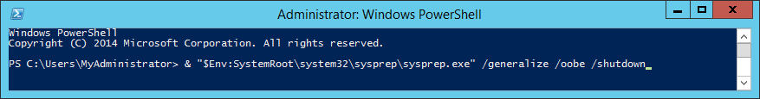

You will see a dialog telling you that Sysprep is working, it will take at least 2-3 minutes.

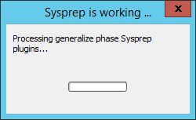

The /shutdown parameter will shut down the VM when sysprep is done generalizing the VM.

Allow a minute or two so that you can see that your VM status is marked as stopped in the portal.   
