HANOI UNIVERSITY OF SCIENCE AND TECHNOLOGY

School of Information and Communications Technology

Software Requirement Specification

Version 1.1

AIMS

*Hanoi, <month, year>*

*<All notations inside the angle bracket are not part of this document, for its purpose is for extra instruction. When using this document, please erase all these notations and/or replace them with corresponding content as instructed. >*

*<This document, written by Prof. NGUYEN Thi Thu Trang, is used as a case study for student with related courses. Any modifications and/or utilization without the consent of the author is strictly forbidden>*

## Table of contents

Table of contents 1

1. Introduction 2
   1. Objective 2
   2. Scope 2
   3. Glossary 2
   4. References 2
2. Overall requirements 3
   1. Actors 3
   2. General use case diagram 3
   3. Lower-level use case diagrams 4
   4. Business processes 5
3. Detail requirements 7
   1. Specification of Use case UC005 - “PlaceOrder” 7
   2. Specification of Use case UC006 - "Pay Order" ………………………………………
4. Supplementary specification …………………………………….
   1. Functionality …………………………………….
   2. Usability …………………………………….
   3. Reliability …………………………………….
   4. Performance …………………………………….
   5. Maintainability …………………………………….
   6. Design Constraints …………………………………….

# Introduction

### Objective

This document presents the detailed description for User management subsystem, user group and their usable function at run time. This document also describes the objectives and features of the system, interfaces and constraints of the system in response to external action.

This document is for stakeholders and related software developers.

### Scope

<Describe the problem statement here>

### Glossary

*<Listing and explaining the terms appearing in the software’s profession and this documents. Any assumption of the reader’s prior knowledge or experience on the subject is ill advised>*

### References

*<Listing the referenced material used in this documents, including the one related to the project>*

1. **Overall requirements**

### Actors

#### Customer: the main actor of the system, can manage cart, place an order

#### Administrator: administrates the aims shop, can view, add, update, delete products, accept or deny orders

### General use case diagram

### Lower-level use case diagrams

### Business processes

1. **Detail requirements**
   1. ***Specification of Use case UC05 - “place order”***
2. **Use case code**

UC05

1. **Brief Description**

This use case describes the interaction between the Customer and the AIMS system, when the customer chose to place an order

1. **Actors**

Customer

1. **Preconditions**
2. **Basic Flow of Events**
   1. The customer requests to place order
   2. The system checks for product availabilities
   3. The system displays the form of delivery information
   4. The customer enters and submits delivery information
   5. The system calculates shipping fees
   6. The system displays the invoice
   7. The customer confirms place order
   8. The system calls UC “Pay Order”
   9. The system creates a new order
   10. The system makes the cart empty
   11. The system sends email about the order notification and information
   12. The system displays the successful order notification and the order information
3. **Alternative flows**

##### Table N-Alternative flows of events for UC Place order

|  |  |  |  |  |
| --- | --- | --- | --- | --- |
| **No** | **Location** | **Condition** | **Action** | **Resume location** |
| 1. | At Step 3 | If the products are not available | * The system notifies the products in the cart are not available and come back to the use case “View Cart” | Use case ends |

|  |  |  |  |  |
| --- | --- | --- | --- | --- |
| 2. | At Step 5 | If the delivery info is invalid | * The system notifies that the delivery info is invalid (blank or wrong format) | Step 3 |
| 3. | At Step 5 | If user chooses to place a rush order | * The system inserts use case “Place Rush Order” | Step 5 |
| 4. | At Step 9 | If order payment is not successful | * Notifies that payment is not successful | Step 8 |

1. **Input data**

##### Table A-Input data of delivery information

|  |  |  |  |  |  |
| --- | --- | --- | --- | --- | --- |
| **No** | **Data fields** | **Description** | **Mandatory** | **Valid condition** | **Example** |
| 1. | Receiver name |  | Yes |  | Tran Duc Dat |
| 2. | Phone number |  | Yes | 10 digits | 0889389266 |
| 3. | Provine | Choose from a list | Yes |  | Ha Noi |
| 4. | Address |  | Yes |  | 39 Hai Ba Trung, Ha Noi |
| 5. | Shipping instructions |  | No |  | Be careful, fragile products |

1. **Output data**

##### Table B-Output data of displaying invoice

|  |  |  |  |  |
| --- | --- | --- | --- | --- |
| **No** | **Data fields** | **Description** | **Display format** | **Example** |
| 1. | Title | Title of media product |  | DVD Marvel |
| 2. | Price | Price of the corresponding media product | * With currency * Comma seperated for 3 digits | 123,000 vnd |
| 3. | Quantity | Quantity of the | - Positive integer | 10 |

|  |  |  |  |  |
| --- | --- | --- | --- | --- |
|  |  | corresponding media |  |  |
| 4. | Amount | Total money of corresponding media | * With currency * Comma seperated for each 3 digits | 1,230,000 vnd |
| 5. | Subtotal Before VAT | Total price of products in the cart before VAT | * With currency * Comma seperated for each 3 digits | 2,000,000 vnd |
| 6. | Shipping fees |  |  |  |
| 7. | Total | Sum of subtotal and shipping fees |  |  |
| 8. | Currency |  |  | vnd |
| 9. | Name |  |  |  |
| 10. | Phone number |  |  |  |
| 11. | Address |  |  |  |
| 12. | Shipping instructions |  |  |  |

1. **Postconditions**
   1. ***Specification of Use case UC06-“Pay Order”***
2. **Use case code**

UC06

1. **Brief Description**

This usecase describes the interaction between the customer, the system, and the Interbank actor, in the process of making a paidment

1. **Actors** Customer Interbank
2. **Preconditions**
3. **Basic Flow of Events**
   1. Customer enters credit card info and confirm to pay order
   2. The system calls Interbank to process payment transaction
   3. The interbank creates a Paymen transaction
   4. The system saves the payment transaction
   5. The system check the payment transaction
   6. The system displays successful payment and display payment info
4. **Alternative Flows**

|  |  |  |  |  |
| --- | --- | --- | --- | --- |
| **No** | **Location** | **Condition** | **Action** | **Resume location** |
| 5. | At Step 5 | If the credit is invalid | * The system notifies the error Invalid credit card | Use case end |
| 6. | At Step 5 | If the credit card info is wrong | * The system notifies the wrong Credit card info is wrong | Use case end |
| 7. | At Step 5 | If the credit card does not have enough balance | * The system notifies | Use case end |

1. **Input Data**

|  |  |  |  |  |  |
| --- | --- | --- | --- | --- | --- |
| **No** | **Data fields** | **Description** | **Mandatory** | **Valid condition** | **Example** |
| 1 | Card holder name |  | Yes | Maximum of 50 characters | NGUYEN VAN A |
| 2 | Card number |  | Yes | 16 digits | 1234 5678 9101 1123 |
| 3 | Expiration date |  | Yes | Consists of month and last 2 digits of year | 01/23 |
| 4 | Security code |  | Yes | 3 digits | 456 |

1. **Output Data**

|  |  |  |  |  |
| --- | --- | --- | --- | --- |
| **No** | **Data fields** | **Description** | **Display format** | **Example** |
| 1 | Transaction ID |  |  |  |
| 2 | Card holder name |  |  |  |
| 3 | Amount |  |  |  |
| 4 | Transaction content |  |  |  |
| 5 | Transaction date |  | Dd/mm/yyyy | 05/9/2023 |

1. **Postconditions**
   1. ***Specification of Use case UC07-“Place Rush Order”***
2. **Use case code**

UC06

1. **Brief Description**

This usecase describes the interaction between the customer when the customer wants to place a rush order

##### Actors

Customer

1. **Preconditions**
2. **Basic Flow of Events**

#### The customer chooses to place a rush order

#### The system checks for rush order support

#### The system checks for rush order address 3a. The system updates the place order screen 3b. The customer resubmit the delivery info

1. **Alternative Flows**

|  |  |  |  |  |
| --- | --- | --- | --- | --- |
| **No** | **Location** | **Condition** | **Action** | **Resume location** |
| 8. | At Step 2 | If there’s no item for rush order | * The system notifies the customer | Use case end |
| 9. | At Step 3 | If the rush order address is not supported | * The system notifies the customer | Step 3a |

1. **Input Data**

#### Input for delivery info of the customer

|  |  |  |  |  |  |
| --- | --- | --- | --- | --- | --- |
| **No** | **Data fields** | **Description** | **Mandatory** | **Valid condition** | **Example** |
| 1 | City | Choose from a predefined list | Yes |  | Ha Noi |
| 2 | Street | Choose from a predefined list | Yes |  | Hoan Kiem |
| 3 | Address |  | Yes |  | 69B 22C Complex |

1. **Output Data**
2. **Post conditions**
3. **Activities Diagram**
   1. **Use Case Place Order**

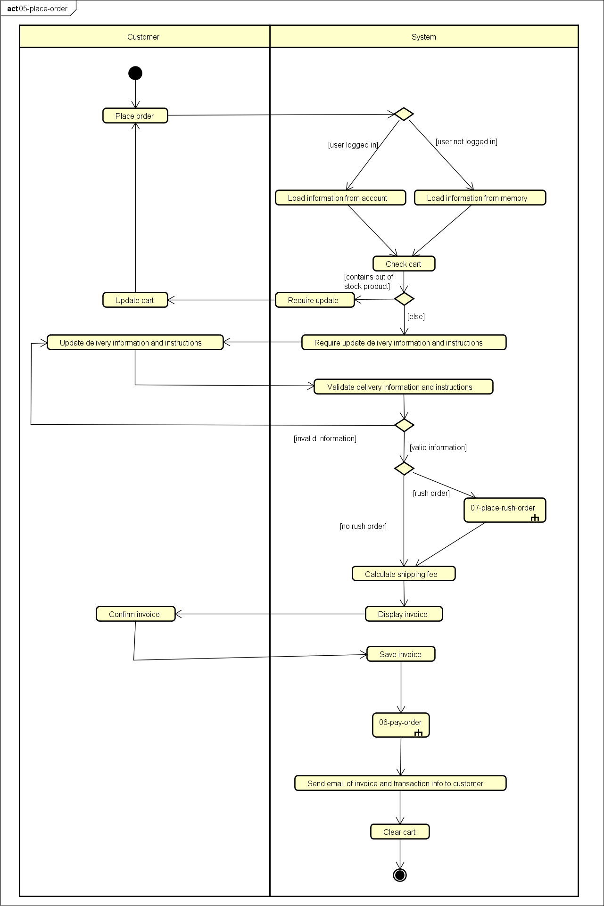

* 1. **Use Case Pay Order**

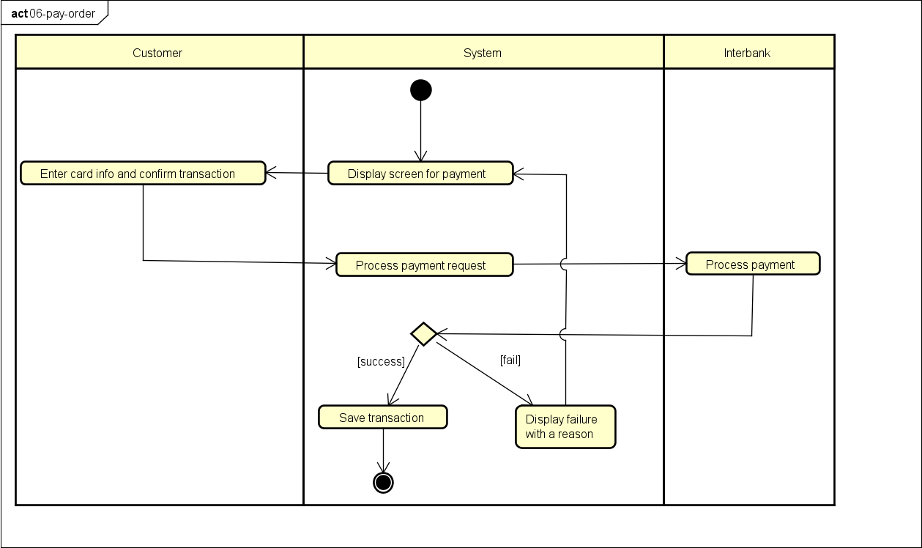

* 1. **Use Case Place Rush Order**

