1. **Mục tiêu**

**LAB 5 LAYOUT**

* + Hiểu và nắm được cách cài đặt Layout cho ứng dụng ASP.NET Core MVC
  + Thực hiện phân vùng ứng dụng, setup Layout

1. **Yêu cầu**
   * Tạo ứng dụng ASP.NET Core Web MVC
   * Tạo phân vùng cho Admin, cài đặt Layout cho phân vùng Admin
2. **Các bước thực hiện B1: Tạo Project**

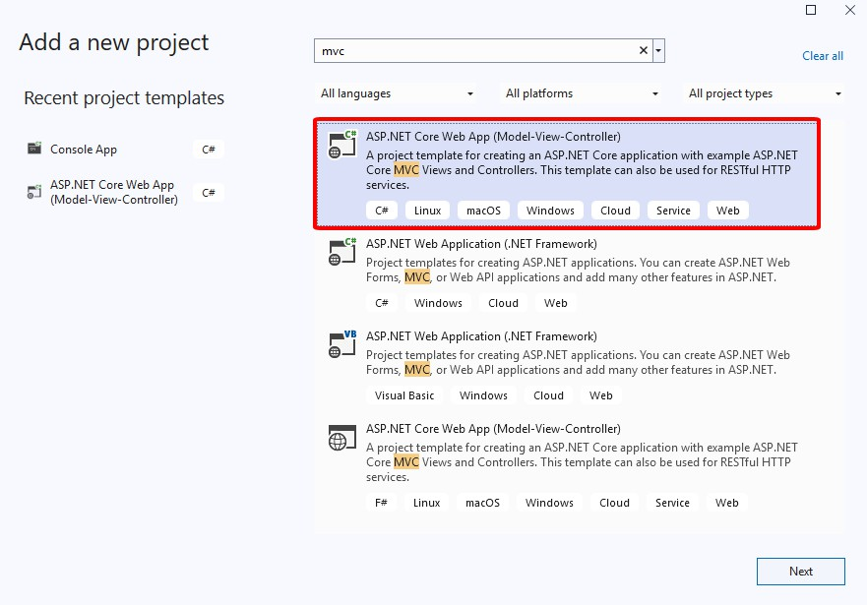

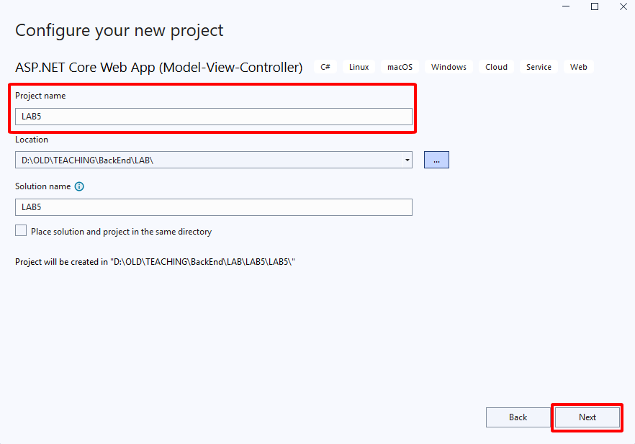

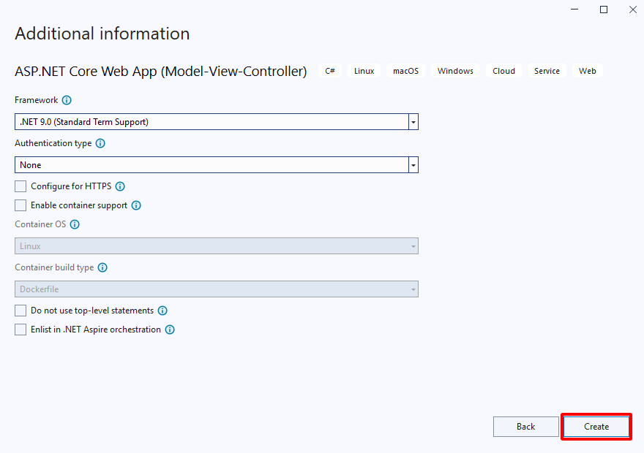

**B2: Thêm phân vùng**

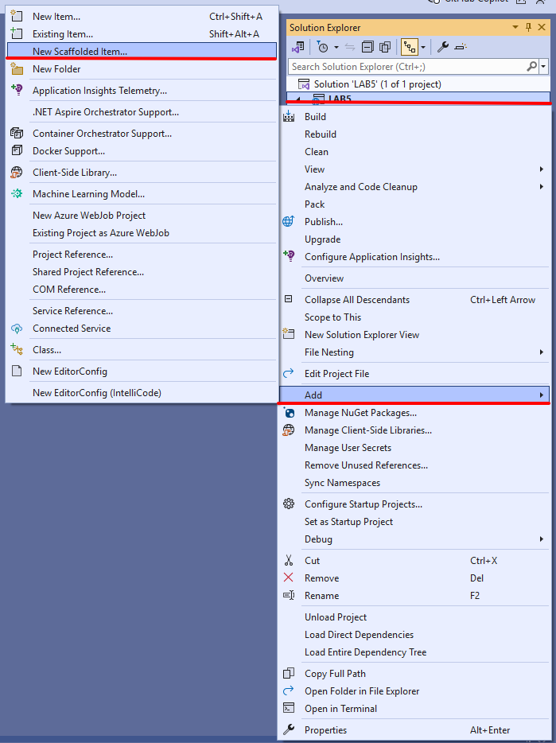

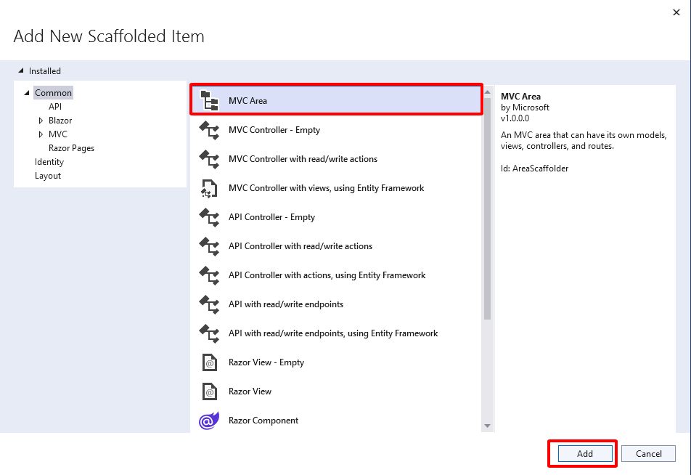

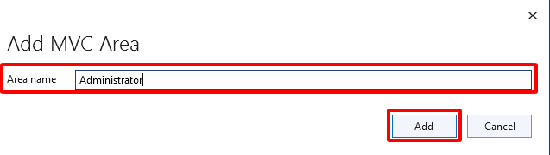

**B3: Thêm Layout cho phân vùng**

Clone template từ github: [https://github.com/BootstrapDash/skydash-free-bootstrap-admin-](https://github.com/BootstrapDash/skydash-free-bootstrap-admin-template) [template](https://github.com/BootstrapDash/skydash-free-bootstrap-admin-template)

Copy 4 folder đã chọn

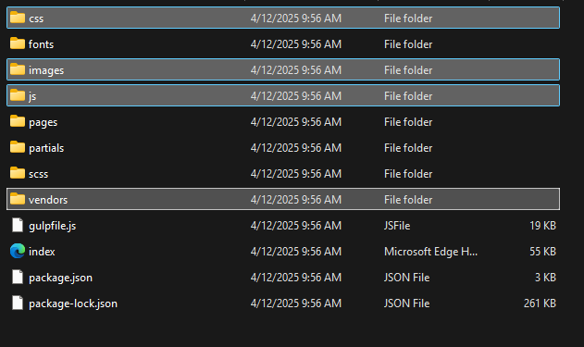

Paste các file đã copy vào folder wwwroot

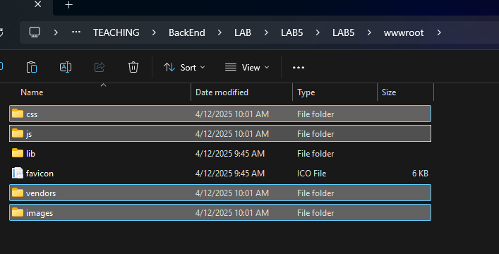

Kết quả

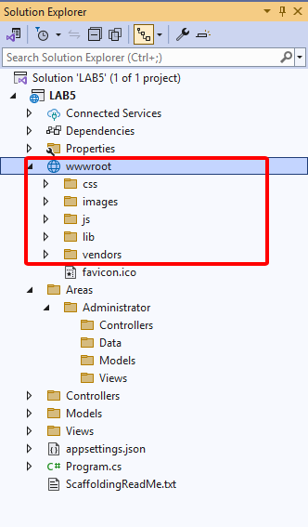

Tạo file Layout

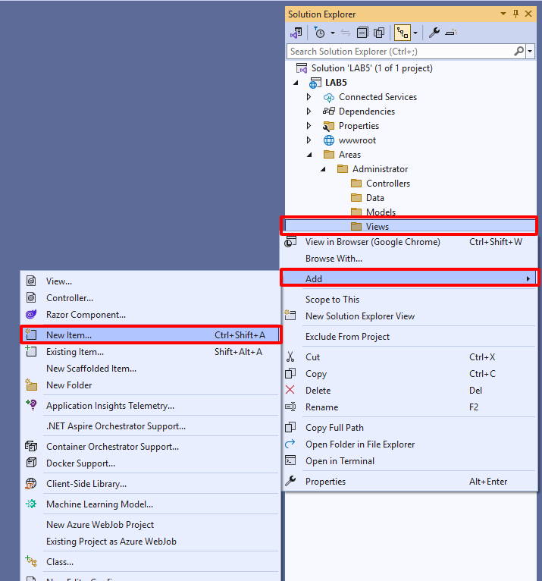

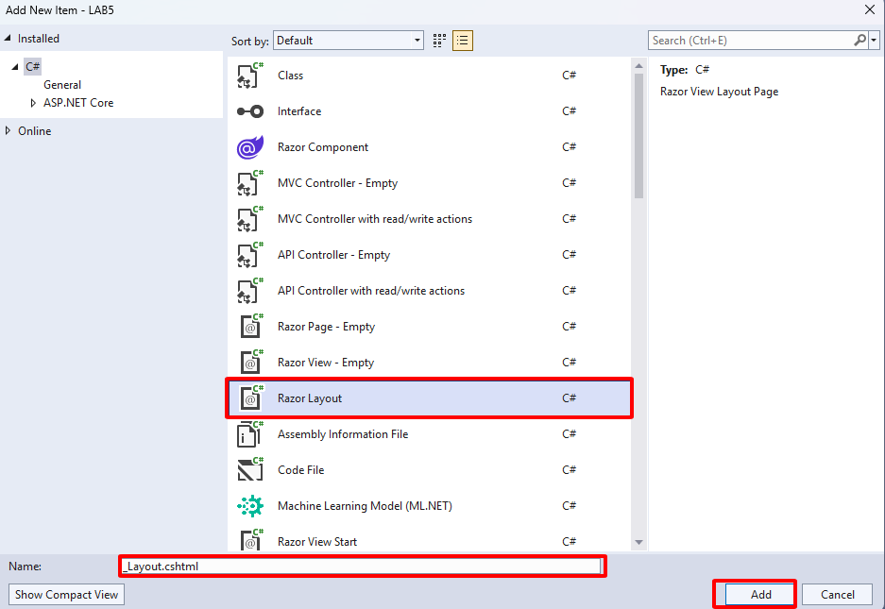

Mở file **_Layout.cshtml** và code như sau:

<!DOCTYPE html>

<html lang="en">

<head>

<!-- Required meta tags -->

<meta charset="utf-8">

<meta name="viewport" content="width=device-width, initial-scale=1, shrink-to-fit=no">

<title>Skydash Admin</title>

<!-- plugins:css -->

<link rel="stylesheet" href="~/vendors/feather/feather.css">

<link rel="stylesheet" href="~/vendors/ti-icons/css/themify-icons.css">

<link rel="stylesheet" href="~/vendors/css/vendor.bundle.base.css">

<!-- endinject -->

<!-- Plugin css for this page -->

<link rel="stylesheet" href="~/vendors/datatables.net-bs4/dataTables.bootstrap4.css">

<link rel="stylesheet" href="~/vendors/ti-icons/css/themify-icons.css">

<link rel="stylesheet" type="text/css" href="~/js/select.dataTables.min.css">

<!-- End plugin css for this page -->

<!-- inject:css -->

<link rel="stylesheet" href="~/css/vertical-layout-light/style.css">

<!-- endinject -->

<link rel="shortcut icon" href="~/images/favicon.png" />

</head>

<body>

<div class="container-scroller">

<!-- partial:partials/_navbar.html -->

<nav class="navbar col-lg-12 col-12 p-0 fixed-top d-flex flex-row">

<div class="text-center navbar-brand-wrapper d-flex align-items-center justify-content- center">

<a class="navbar-brand brand-logo mr-5" href="~/index.html"><img src="~/images/logo.svg" class="mr-2" alt="logo" /></a>

<a class="navbar-brand brand-logo-mini" href="~/index.html"><img src="~/images/logo-mini.svg" alt="logo" /></a>

</div>

<div class="navbar-menu-wrapper d-flex align-items-center justify-content-end">

<button class="navbar-toggler navbar-toggler align-self-center" type="button" data- toggle="minimize">

<span class="icon-menu"></span>

</button>

<ul class="navbar-nav mr-lg-2">

<li class="nav-item nav-search d-none d-lg-block">

<div class="input-group">

<div class="input-group-prepend hover-cursor" id="navbar-search-icon">

<span class="input-group-text" id="search">

<i class="icon-search"></i>

</span>

</div>

<input type="text" class="form-control" id="navbar-search-input" placeholder="Search now" aria-label="search" aria-describedby="search">

</div>

</li>

</ul>

<ul class="navbar-nav navbar-nav-right">

<li class="nav-item dropdown">

<a class="nav-link count-indicator dropdown-toggle" id="notificationDropdown" href="#" data-toggle="dropdown">

<i class="icon-bell mx-0"></i>

<span class="count"></span>

</a>

<div class="dropdown-menu dropdown-menu-right navbar-dropdown preview- list" aria-labelledby="notificationDropdown">

<p class="mb-0 font-weight-normal float-left dropdown- header">Notifications</p>

<a class="dropdown-item preview-item">

<div class="preview-thumbnail">

<div class="preview-icon bg-success">

<i class="ti-info-alt mx-0"></i>

</div>

</div>

<div class="preview-item-content">

<h6 class="preview-subject font-weight-normal">Application Error</h6>

registration</h6>

<p class="font-weight-light small-text mb-0 text-muted"> Just now

</p>

</div>

</a>

<a class="dropdown-item preview-item">

<div class="preview-thumbnail">

<div class="preview-icon bg-warning">

<i class="ti-settings mx-0"></i>

</div>

</div>

<div class="preview-item-content">

<h6 class="preview-subject font-weight-normal">Settings</h6>

<p class="font-weight-light small-text mb-0 text-muted"> Private message

</p>

</div>

</a>

<a class="dropdown-item preview-item">

<div class="preview-thumbnail">

<div class="preview-icon bg-info">

<i class="ti-user mx-0"></i>

</div>

</div>

<div class="preview-item-content">

<h6 class="preview-subject font-weight-normal">New user

<p class="font-weight-light small-text mb-0 text-muted"> 2 days ago

</p>

</div>

</a>

</div>

</li>

<li class="nav-item nav-profile dropdown">

<a class="nav-link dropdown-toggle" href="#" data-toggle="dropdown" id="profileDropdown">

<img src="~/images/faces/face28.jpg" alt="profile" />

</a>

<div class="dropdown-menu dropdown-menu-right navbar-dropdown" aria- labelledby="profileDropdown">

<a class="dropdown-item">

<i class="ti-settings text-primary"></i> Settings

</a>

<a class="dropdown-item">

<i class="ti-power-off text-primary"></i> Logout

</a>

</div>

</li>

<li class="nav-item nav-settings d-none d-lg-flex">

<a class="nav-link" href="#">

<i class="icon-ellipsis"></i>

</a>

</li>

</ul>

<button class="navbar-toggler navbar-toggler-right d-lg-none align-self-center" type="button" data-toggle="offcanvas">

<span class="icon-menu"></span>

</button>

</div>

</nav>

<!-- partial -->

<div class="container-fluid page-body-wrapper">

<!-- partial:partials/_settings-panel.html -->

<div class="theme-setting-wrapper">

<div id="settings-trigger"><i class="ti-settings"></i></div>

<div id="theme-settings" class="settings-panel">

<i class="settings-close ti-close"></i>

<p class="settings-heading">SIDEBAR SKINS</p>

<div class="sidebar-bg-options selected" id="sidebar-light-theme"><div class="img- ss rounded-circle bg-light border mr-3"></div>Light</div>

<div class="sidebar-bg-options" id="sidebar-dark-theme"><div class="img-ss rounded-circle bg-dark border mr-3"></div>Dark</div>

<p class="settings-heading mt-2">HEADER SKINS</p>

<div class="color-tiles mx-0 px-4">

<div class="tiles success"></div>

<div class="tiles warning"></div>

<div class="tiles danger"></div>

<div class="tiles info"></div>

<div class="tiles dark"></div>

<div class="tiles default"></div>

</div>

</div>

</div>

<div id="right-sidebar" class="settings-panel">

<i class="settings-close ti-close"></i>

<ul class="nav nav-tabs border-top" id="setting-panel" role="tablist">

<li class="nav-item">

<a class="nav-link active" id="todo-tab" data-toggle="tab" href="#todo-section" role="tab" aria-controls="todo-section" aria-expanded="true">TO DO LIST</a>

</li>

<li class="nav-item">

<a class="nav-link" id="chats-tab" data-toggle="tab" href="#chats-section" role="tab" aria-controls="chats-section">CHATS</a>

</li>

</ul>

<div class="tab-content" id="setting-content">

<div class="tab-pane fade show active scroll-wrapper" id="todo-section" role="tabpanel" aria-labelledby="todo-section">

<div class="add-items d-flex px-3 mb-0">

<form class="form w-100">

<div class="form-group d-flex">

<input type="text" class="form-control todo-list-input" placeholder="Add

To-do">

<button type="submit" class="add btn btn-primary todo-list-add-btn"

id="add-task">Add</button>

</div>

</form>

</div>

<div class="list-wrapper px-3">

<ul class="d-flex flex-column-reverse todo-list">

<li>

<div class="form-check">

<label class="form-check-label">

<input class="checkbox" type="checkbox"> Team review meeting at 3.00 PM

</label>

</div>

<i class="remove ti-close"></i>

</li>

<li>

<div class="form-check">

<label class="form-check-label">

<input class="checkbox" type="checkbox"> Prepare for presentation

</label>

</div>

<i class="remove ti-close"></i>

</li>

<li>

<div class="form-check">

<label class="form-check-label">

<input class="checkbox" type="checkbox"> Resolve all the low priority tickets due today

</label>

</div>

<i class="remove ti-close"></i>

</li>

<li class="completed">

<div class="form-check">

<label class="form-check-label">

<input class="checkbox" type="checkbox" checked> Schedule meeting for next week

</label>

</div>

js</p>

<i class="remove ti-close"></i>

</li>

<li class="completed">

<div class="form-check">

<label class="form-check-label">

<input class="checkbox" type="checkbox" checked> Project review

</label>

</div>

<i class="remove ti-close"></i>

</li>

</ul>

</div>

<h4 class="px-3 text-muted mt-5 font-weight-light mb-0">Events</h4>

<div class="events pt-4 px-3">

<div class="wrapper d-flex mb-2">

<i class="ti-control-record text-primary mr-2"></i>

<span>Feb 11 2018</span>

</div>

<p class="mb-0 font-weight-thin text-gray">Creating component page build a

<p class="text-gray mb-0">The total number of sessions</p>

</div>

<div class="events pt-4 px-3">

<div class="wrapper d-flex mb-2">

<i class="ti-control-record text-primary mr-2"></i>

<span>Feb 7 2018</span>

</div>

<p class="mb-0 font-weight-thin text-gray">Meeting with Alisa</p>

<p class="text-gray mb-0 ">Call Sarah Graves</p>

</div>

</div>

<!-- To do section tab ends -->

<div class="tab-pane fade" id="chats-section" role="tabpanel" aria-

labelledby="chats-section">

<div class="d-flex align-items-center justify-content-between border-bottom">

<p class="settings-heading border-top-0 mb-3 pl-3 pt-0 border-bottom-0 pb-

0">Friends</p>

<small class="settings-heading border-top-0 mb-3 pt-0 border-bottom-0 pb-0 pr-

3 font-weight-normal">See All</small>

</div>

<ul class="chat-list">

<li class="list active">

<div class="profile"><img src="~/images/faces/face1.jpg" alt="image"><span class="online"></span></div>

<div class="info">

<p>Thomas Douglas</p>

<p>Available</p>

</div>

<small class="text-muted my-auto">19 min</small>

</li>

<li class="list">

<div class="profile"><img src="~/images/faces/face2.jpg" alt="image"><span class="offline"></span></div>

<div class="info">

<div class="wrapper d-flex">

<p>Catherine</p>

</div>

<p>Away</p>

</div>

<div class="badge badge-success badge-pill my-auto mx-2">4</div>

<small class="text-muted my-auto">23 min</small>

</li>

<li class="list">

<div class="profile"><img src="~/images/faces/face3.jpg" alt="image"><span class="online"></span></div>

<div class="info">

<p>Daniel Russell</p>

<p>Available</p>

</div>

<small class="text-muted my-auto">14 min</small>

</li>

<li class="list">

<div class="profile"><img src="~/images/faces/face4.jpg" alt="image"><span class="offline"></span></div>

<div class="info">

<p>James Richardson</p>

<p>Away</p>

</div>

<small class="text-muted my-auto">2 min</small>

</li>

<li class="list">

<div class="profile"><img src="~/images/faces/face5.jpg" alt="image"><span class="online"></span></div>

<div class="info">

<p>Madeline Kennedy</p>

<p>Available</p>

</div>

<small class="text-muted my-auto">5 min</small>

</li>

<li class="list">

<div class="profile"><img src="~/images/faces/face6.jpg" alt="image"><span class="online"></span></div>

<div class="info">

<p>Sarah Graves</p>

<p>Available</p>

</div>

<small class="text-muted my-auto">47 min</small>

</li>

</ul>

</div>

<!-- chat tab ends -->

</div>

</div>

<!-- partial -->

<!-- partial:partials/_sidebar.html -->

<nav class="sidebar sidebar-offcanvas" id="sidebar">

<ul class="nav">

<li class="nav-item">

<a class="nav-link" href="~/Administrator/Home/Index">

<i class="icon-grid menu-icon"></i>

<span class="menu-title">Dashboard</span>

</a>

</li>

<li class="nav-item">

<a class="nav-link" href="~/Administrator/User/Index">

<i class="icon-paper menu-icon"></i>

<span class="menu-title">User</span>

</a>

</li>

</ul>

</nav>

<!-- partial -->

<div class="main-panel">

<div class="content-wrapper"> @RenderBody()

</div>

<!-- content-wrapper ends -->

<!-- partial:partials/_footer.html -->

<footer class="footer">

<div class="d-sm-flex justify-content-center justify-content-sm-between">

<span class="text-muted text-center text-sm-left d-block d-sm-inline- block">Copyright © 2021. Premium <a href="https://[www.bootstrapdash.com/](http://www.bootstrapdash.com/)" target="_blank">Bootstrap admin template</a> from BootstrapDash. All rights reserved.</span>

<span class="float-none float-sm-right d-block mt-1 mt-sm-0 text-center">Hand- crafted & made with <i class="ti-heart text-danger ml-1"></i></span>

</div>

<div class="d-sm-flex justify-content-center justify-content-sm-between">

<span class="text-muted text-center text-sm-left d-block d-sm-inline- block">Distributed by <a href="https://[www.themewagon.com/](http://www.themewagon.com/)" target="_blank">Themewagon</a></span>

</div>

</footer>

<!-- partial -->

</div>

<!-- main-panel ends -->

</div>

<!-- page-body-wrapper ends -->

</div>

<!-- container-scroller -->

<!-- plugins:js -->

<script src="~/vendors/js/vendor.bundle.base.js"></script>

<!-- endinject -->

<!-- Plugin js for this page -->

<script src="~/vendors/chart.js/Chart.min.js"></script>

<script src="~/vendors/datatables.net/jquery.dataTables.js"></script>

<script src="~/vendors/datatables.net-bs4/dataTables.bootstrap4.js"></script>

<script src="~/js/dataTables.select.min.js"></script>

<!-- End plugin js for this page -->

<!-- inject:js -->

<script src="~/js/off-canvas.js"></script>

<script src="~/js/hoverable-collapse.js"></script>

<script src="~/js/template.js"></script>

<script src="~/js/settings.js"></script>

<script src="~/js/todolist.js"></script>

<!-- endinject -->

<!-- Custom js for this page-->

<script src="~/js/dashboard.js"></script>

<script src="~/js/Chart.roundedBarCharts.js"></script>

<!-- End custom js for this page-->

</body>

</html>

**B4: Tạo model User trên phân vùng Administrator**

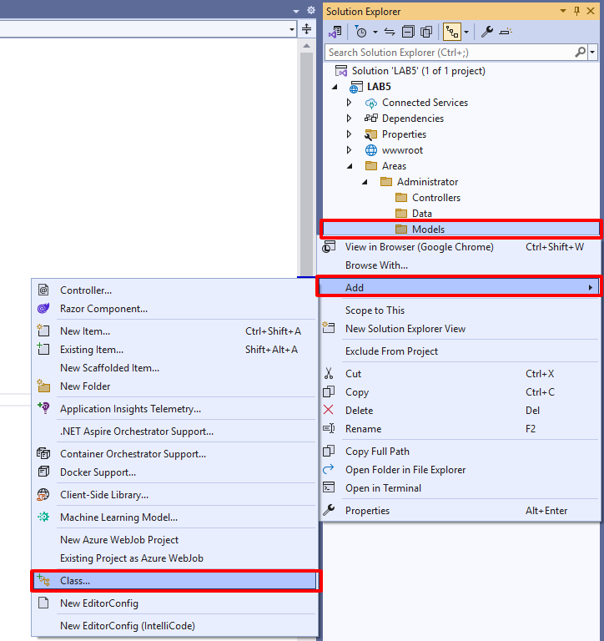

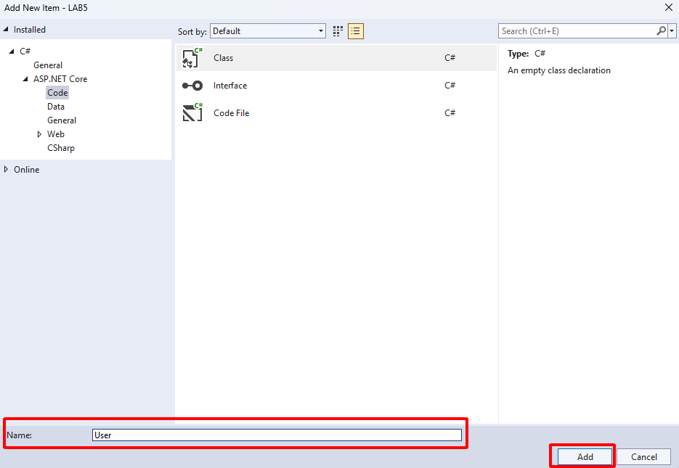

Định nghĩa class User

namespace LAB5.Areas.Administrator.Models

{

public class User

{

public int id { get; set; } public string name { get; set; } public int progress { get; set; }

public double amount { get; set; } public DateTime deadline { get; set; } public string image { get; set; }

}

}

**B5: Tạo UserController**

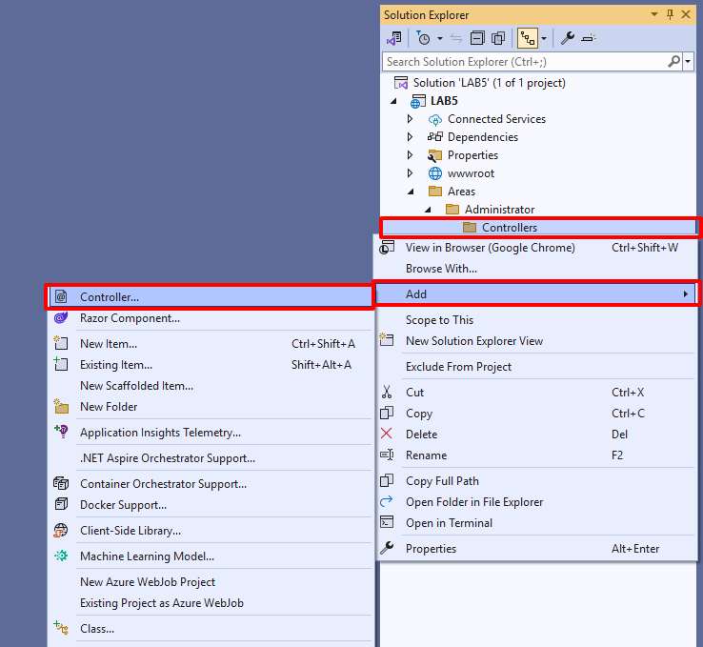

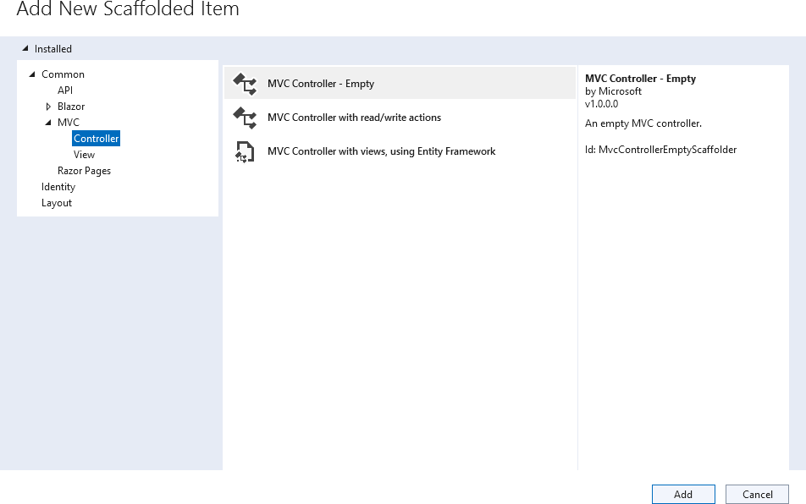

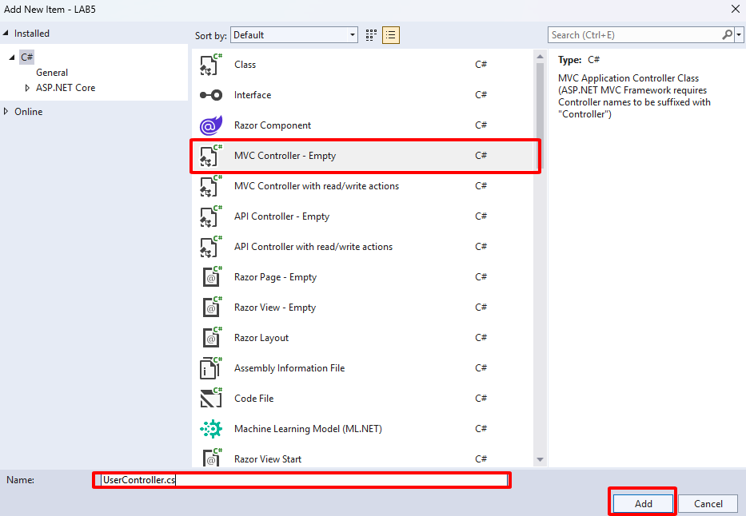

Bổ sung code vào **UserController.cs**

using LAB5.Areas.Administrator.Models; using Microsoft.AspetCore.Mvc;

namespace LAB5.Areas.Administrator.Controllers

{

[Area("Administrator")]

public class UserController : Controller

{

List<User> _users; public UserController()

{

_users = new List<User>()

{

new User() { id = 1, name = "erman Beck", progress = 25, amount = 77.99, deadline = DateTime.ow, image = "face1.jpg" },

new User() { id = 2, name = "Messsy Adam", progress = 75, amount = 222.99, deadline = DateTime.ow, image = "face2.jpg" },

new User() { id = 3, name = "John Richards", progress = 80, amount = 123.99, deadline = DateTime.ow, image = "face3.jpg" },

new User() { id = 4, name = "fleter Meggik", progress = 95, amount = 432.99, deadline = DateTime.ow, image = "face4.jpg" },

new User() { id = 5, name = "Edward", progress = 100, amount = 111.99, deadline = DateTime.ow, image = "face5.jpg" },

new User() { id = 6, name = "John Doe", progress = 30, amount = 22.22, deadline = DateTime.ow, image = "face6.jpg" },

new User() { id = 7, name = "enry Tom", progress = 45, amount = 47.99, deadline = DateTime.ow, image = "face7.jpg" },

};

}

public IActionResult Index()

{

return View(_users);

}

}

}

**B6: Tạo View cho action Index sử dụng Layout của phân vùng Administrator**

Chuột phải vào action Index => Add View…

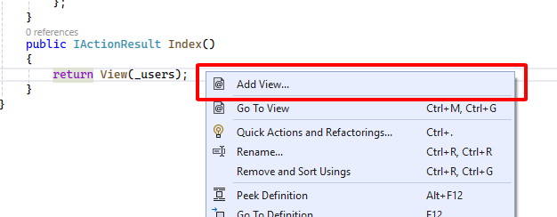

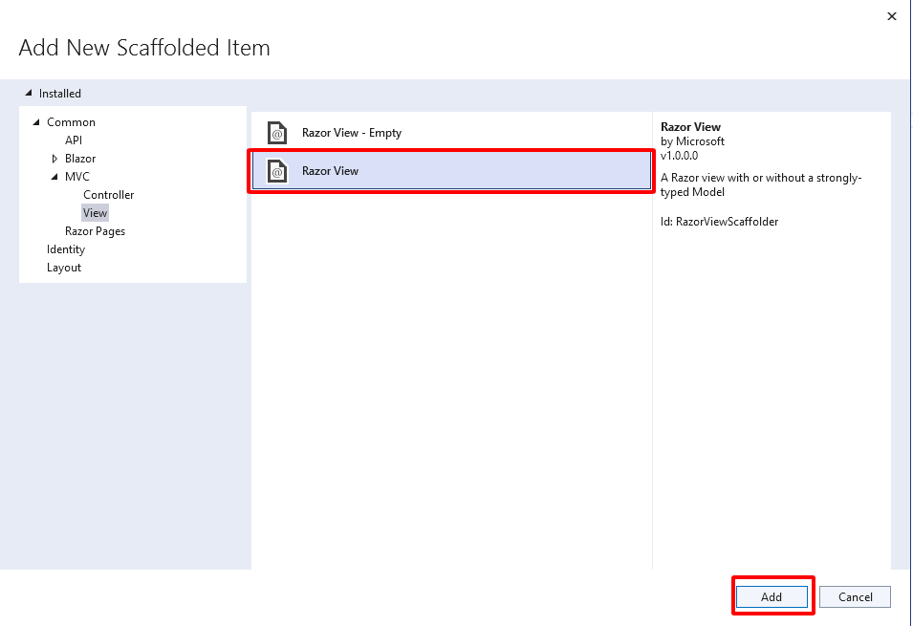

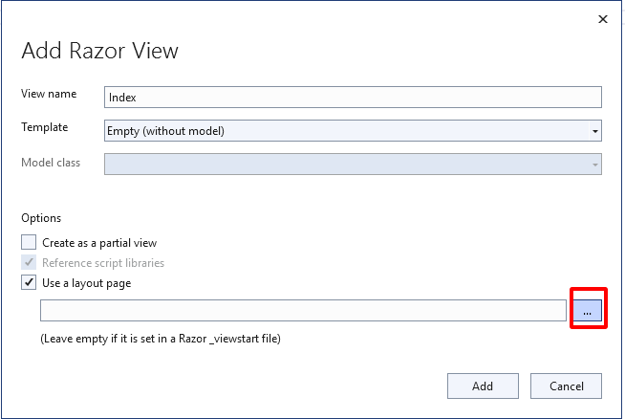

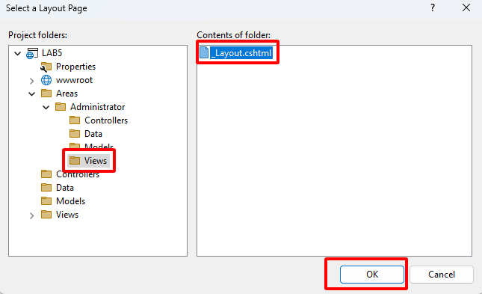

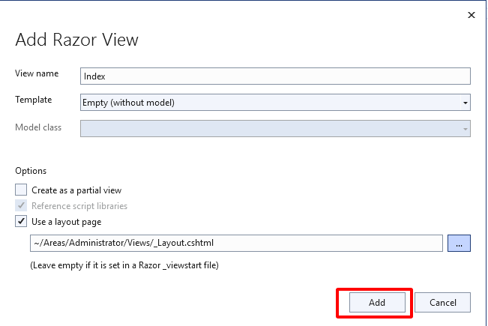

Bổ sung code vào file **User/Index.cshtml** vừa tạo

@using LAB5.Areas.Administrator.Models @model List<User>

@{

ViewData["Title"] = "Index";

Layout = "~/Areas/Administrator/Views/_Layout.cshtml";

}

<div class="col-lg-12 grid-margin stretch-card">

<div class="card">

<div class="card-body">

<h4 class="card-title">User Table</h4>

<div class="table-responsive">

<table class="table table-striped">

<thead>

<tr>

<th>User</th>

<th>First name</th>

<th>flrogress</th>

<th>Amount</th>

<th>Deadline</th>

</tr>

</thead>

<tbody>

@foreach (User user in Model)

{

<tr>

<td class="py-1">

<**img** src="~/images/faces/@user.image"

alt="image">

</td>

<td>@user.name</td>

<td>

<div class="progress">

<div class="progress-bar bg-success" role="progressbar" style="width: @user.progress%" aria-valuenow="@user.progress" aria-valuemin="0" aria-valuemax="@user.progress"></div>

</div>

</td>

<td>$ @user.amount</td>

<td>@user.deadline.ToString("MMMM dd, yyyy")</td>

</tr>

}

</tbody>

</table>

</div>

</div>

</div>

</div>

**B7: Config route cho phân vùng tránh bị xung đột Controller**

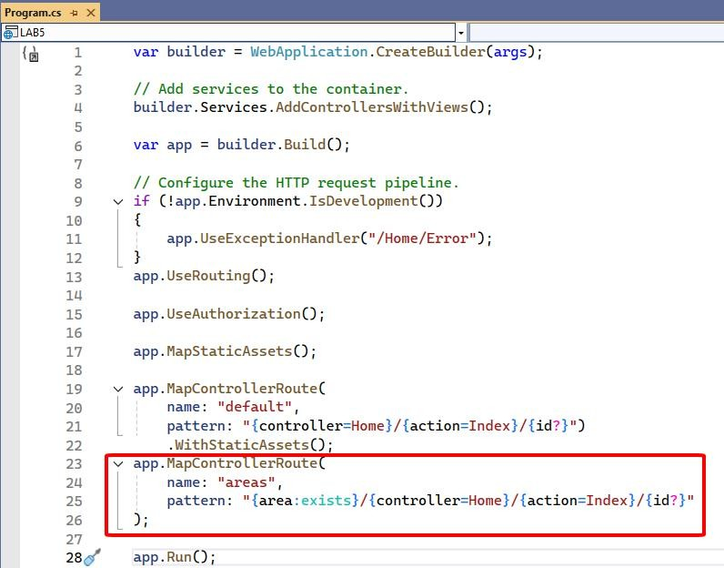

1. **Bài tập**

Tiếp tục phát triển bài LAB thêm các chức năng:

* + Thêm mới User
  + Sửa thông tin của User
  + Xoá User