**KU Data Analytics:**



**Team 7 The Missing Persons Project Boot Camp Lesson 18.1**

Randall Stevenson

Jemi Assefa

Sanita Gurung

Tom VanEyck

**Project Requirements**

***Your Task: Tell A Story with Data***



**Project Description**

1. Your task is to **tell a story** through data visualizations.
2. Focus on providing users an **interactive means** to explore data themselves.
3. Prepare a **10-minute presentation** that lays out your theme, coding approach, data munging techniques, and final visualization.
4. You may choose a project of any theme, but we encourage you to **think broadly**.
5. You will have **ample time in class** to work with your group, but expect to put in **hours outside of class** as well.

**Specific Requirements**

1. Your visualization **must include** a Python Flask–powered RESTful API, HTML/CSS, JavaScript, and at least one database (SQL, MongoDB, SQLite, etc.).
2. Your project should fall into one of the below four tracks:
   1. A custom “creative” D3.js project (i.e., a nonstandard graph or chart)
   2. A combination of web scraping and Leaflet or Plotly
   3. A dashboard page with multiple charts that update from the same data
   4. A “thick” server that performs multiple manipulations on data in a database prior to visualization (**must be approved**)
3. Your project should include at least one **JS library that we did not cover**.
4. Your project must be powered by a data set with **at least 100 records**.
5. Your project must include some level of **user-driven interaction** (e.g., menus, dropdowns, textboxes).
6. Your final visualization should ideally include **at least three views**.

**Schedule**

**Weekly Schedule**

***Day 1 (Wednesday):*** *Between now and Saturday, you will need to start brainstorming topics with your group and researching potential data sets. Your focus should center around*:

* Selecting a topic
* Finding a data set
* Finding inspiration
* “Sketching” your ideal visuals
* Creating a 1-page proposal

***Day 2(Saturday)***: *You will need to create a 1-page proposal that includes*:

* A brief articulation of your chosen topic and rationale
* A link to your data set(s) and a screenshot of the metadata if it exists.
* 3 or 4 screenshots of relevant, “inspiring” visualizations that frame your creative fodder
* A sketch of the final design
* A link to the primary GitHub repository you’ll be housing your work in

***Day 3-7***: *Project Work*

**Daily Schedule**

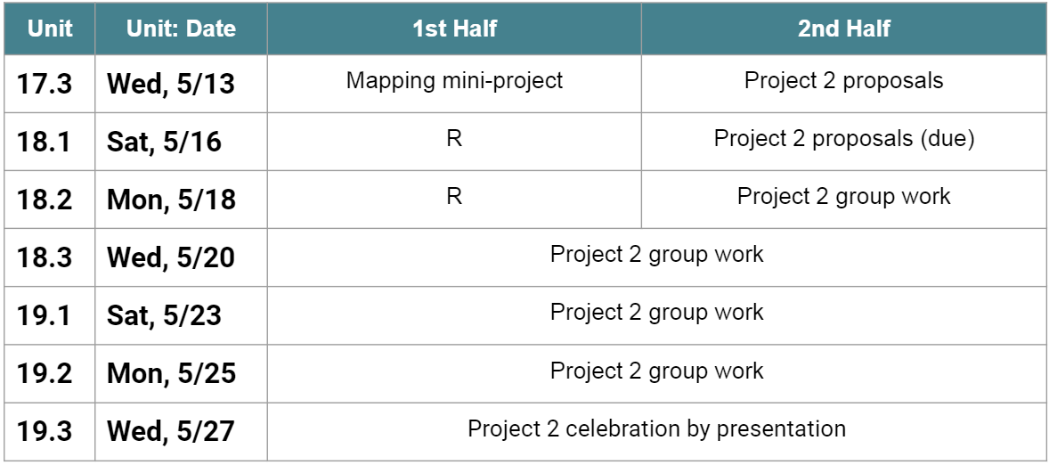

**Final Thoughts**

1. Project week is a great time to tie up loose ends, both with your group and on your own.
2. If there are topics you’d like to review, shoot me and the TAs a message. We’re happy to do (recorded) extra review sessions for small groups during these weeks.
3. Good luck and have fun!

**Project Details**

**GitHub Project Repositories: (invitees:**

Master: <https://github.com/TVanEyck/Project2-Visualization-MissingPersons.git>

Tom VanEyck Branch: Project2-tve