**The Missing Persons Project**

# Team

Jemi Assefa, Sanita Gurung, Randall Stevenson & Tom VanEyck

# Topic

What are the demographic relationships of missing persons? To assess if certain characteristics such as time of year, gender, race, age, location, are more likely to result in a missing person becoming a long-term missing person.

# Data - Links

<https://public.opendatasoft.com/explore/dataset/namus-missings/export/?disjunctive.raceethnicity&sort=modifieddatetime>

<https://www.census.gov/data/developers/data-sets.html>

<https://d3-geomap.github.io/map/choropleth/us-states/>

# Creating Interactive Python Choropleth Maps with Plotly - wellsr.comInspirations

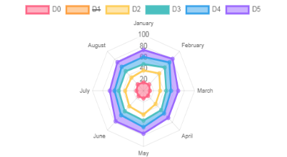

# Sketch of Final Design

* Extract, scrub and manipulate data with Python to create files for use in JS.
* Dashboard to various graphics
* Interactive pie and bar charts for gender, race, and age distributions. (Drop down menu)
* Radar chart using chartjs library to show average daily rate of missing persons by month
* Interactive by year choropleth of US by state with colors indicating ratio of population missing to national average over 5 decades. (Data for 1968-2017).

# GitHub Repository