Python

* Extract
  + Missing Persons database (JSON, EXCEL or CSV or API) – 10,045 records
  + Census data
    - Demographics by gender, race/ethnicity and age (5 year brackets)
    - Issue with Hispanics not being recorded in earlier years
    - Use decennial results and interpolate
  + Web-scrub congressional districts by state (DC=1) for population proportion.
* Scrub
  + Limit to 1968-2017
  + Limit to US states and DC
  + What about undetermined race/ethnicity?
    - Issues with mixed, other, uncertain if not Hispanic/Latino
  + How to handle Hispanic/Latinos?
  + Missing ages for missing people. (remove from age database)
* Produce Source Files for JS
  + Males by year missing and population of males that year
  + Females by year missing
  + Combined by year missing
  + Males by age group
  + Females by age group
  + Combined by age group
  + Race/Ethnicity
    - White/Caucasian
    - Black/African American
    - Hispanic/Latino
    - Native American/Alaskan Native
    - Asian
  + Total number missing by month divided by number of days in month
  + Number by state missing by year and population of state (interim)
  + Number by state missing and average population of state by decade year-by-year
* We could have a standard format for the output files (CSV or JSON) with columns/keys pre-defined so others can work parallel to Python development

A – Extract Census Data

B – Extract Missing Person Data

C – Extract Congressional District Data using web-scrubbing from Wiki (1960-2010)

C – Scrub Data

D – Produce Files in standard format

E – Set up “dummy” files for other developers

Dashboard set up

* Graph of missing persons by year they disappeared (lines for males, females, total) . Also do this for race/ethnicity and age.
* Some photos (like milk carton)
* Brief write up about missing persons
* Bootstrap
* Links to
  + Demographic illustrations
  + Seasonality illustration
  + Rates persons go missing by state compared to national average

A - Produce graph(s)

B – Add some photos (?)

C – Add some verbiage about missing people

D – Set up bootstrap for site

E – Embed Links to other pages with descriptors

Pie/Bar Graph Page(s) set up

* Dropdown between gender, race/ethnicity, age grouping of data from 1968 through 2017 combined
  + Pie chart of distribution of total numbers
  + Bar chart of % missing vs % of population during period

A – Set up graphs/charts for each demographic (gender / race/ethnicity / age grouping

B – Add means of selection between demogrpahics

Radar Chart (use Chartjs library) – easy to do, but will require learning/using a new library.

* Relative rates of persons missing by month in which they went missing combined for years 1968-2017. Probably # per million per day.
* Add some verbiage about normalized for days in months and about why highest rate is in July and lowest in February.

Choropleth of states with hover over year (between 1977 and 2017) and it gives the results for the prior decade. Probably will need to use a logarithmic scale on this due to high variance.

* Red to Blue (high to low)
* Use logarithm base 10 of states rate to national average (otherwise AK will be an outlier and other colors will not change much – see example)
* Method of selecting ending year of decade between 1977 and 2017 to update map, prefer hover over year and map changes
* [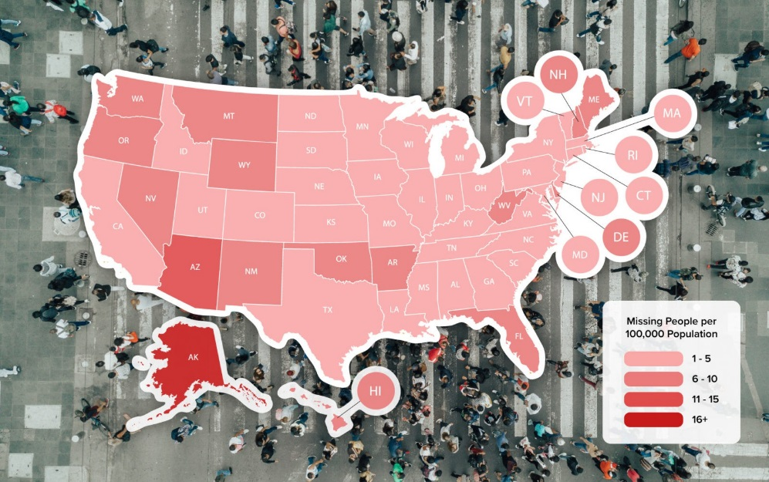](https://www.google.com/url?sa=i&url=https%3A%2F%2Fwww.vivintsource.com%2Fsmart-home-academy%2F2019-missing-persons-by-state%2F&psig=AOvVaw27Ff6p44BQnhi4kb60jbCr&ust=1589651687545000&source=images&cd=vfe&ved=0CAIQjRxqFwoTCKia5I-4tukCFQAAAAAdAAAAABAD)

Here is the color scheme I was considering using with an idea of the counts.

