**20200127HW-Multiple_year_stock_data.xlsm**

Sheet1 - 2016

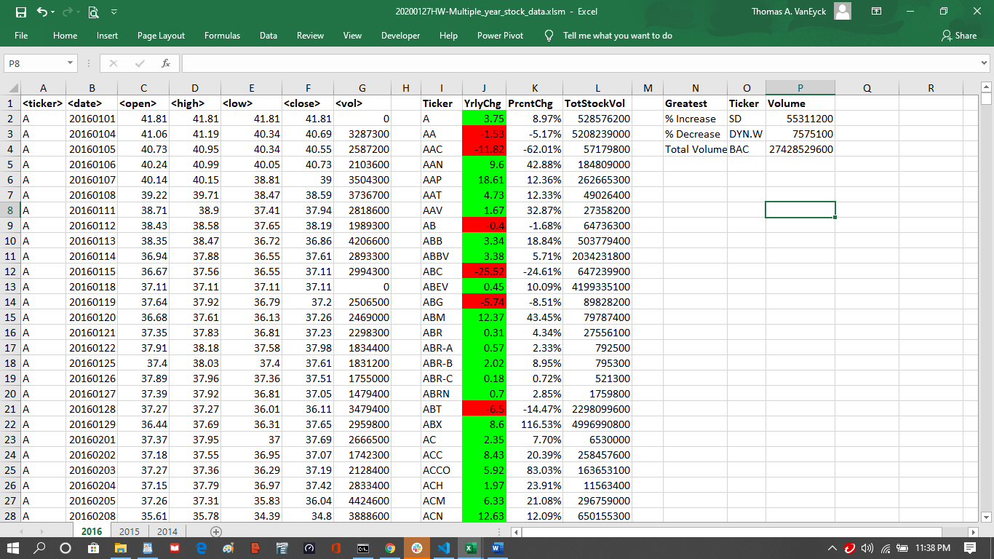

Sheet2 - 2015

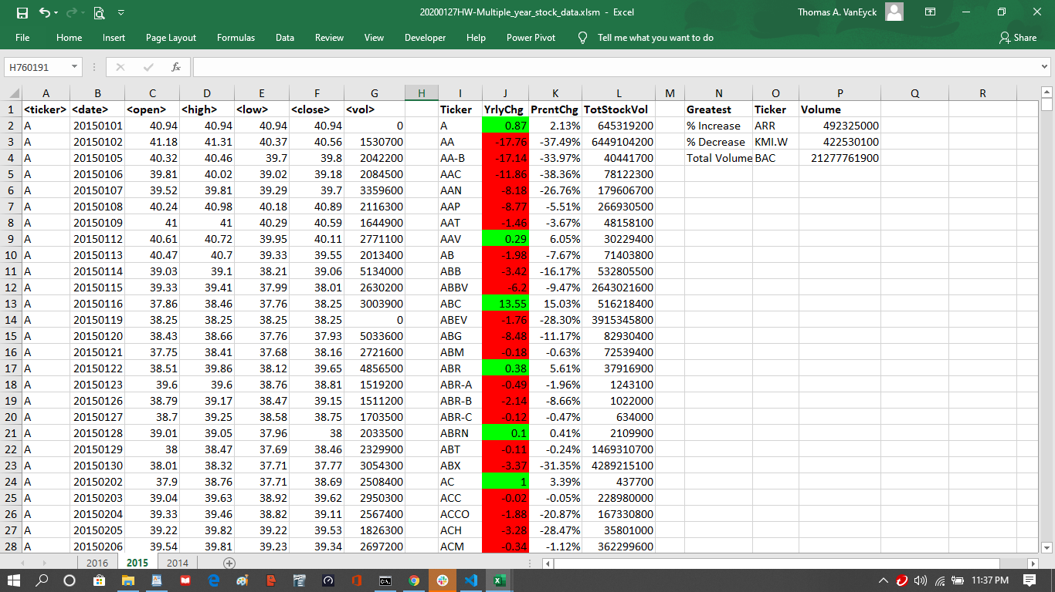

Sheet3 - 2014

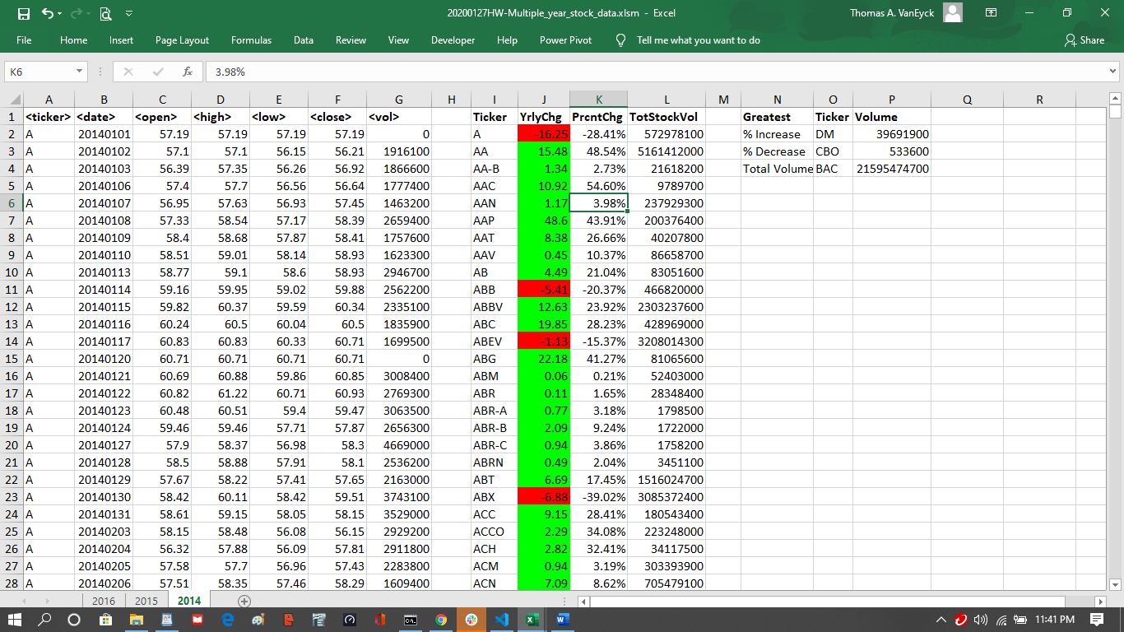

**Sub MultiYrStckData()**

' find last row with a TickerSymbol in it in column 1

Dim MaxRow As Double

' Find the last non-blank cell in column 1

MaxRow = Cells(Rows.Count, 1).End(xlUp).row

' create and define variables as needed...

' create and define row-process variables

Dim col As Integer

col = 1

Dim row As Double

Dim rowTot As Double

rowTot = 0

' create and define Report variables

Dim ticker As Integer

ticker = 2

' create and define Summary variables

Dim GreatestPrctIncrTicker As String

Dim GreatestPrctIncr As Double

Dim GreatestPrctIncrVol As Double

Dim GreatestPrctDecrTicker As String

Dim GreatestPrctDecr As Double

Dim GreatestPrctDecrVol As Double

' Prime the Headings

Cells(1, 9).Value = "Ticker"

Cells(1, 10).Value = "YrlyChg"

Cells(1, 11).Value = "PrcntChg"

Cells(1, 12).Value = "TotStockVol"

Cells(1, 14).Value = "Greatest"

Cells(1, 15).Value = "Ticker"

Cells(1, 16).Value = "Volume"

Cells(2, 14).Value = "% Increase"

Cells(3, 14).Value = "% Decrease"

Cells(4, 14).Value = "Total Volume"

' prime the pump...

Dim openDol As Double

openDol = Cells(2, 3).Value

' Loop through rows in the column

For row = 2 To MaxRow

rowTot = rowTot + Cells(row, 7).Value

' Searches for when the value of the next cell is different than that of the current cell

If Cells(row + 1, col).Value <> Cells(row, col).Value Then

Cells(ticker, 9).Value = Cells(row, 1).Value

Cells(ticker, 10).Value = Cells(row, 6).Value - openDol

' ============================ for testing only ================

' If Cells(row, col).Value = "PLNT" Then

' MsgBox ("Ticker: " & Cells(row, col).Value & " chg to " & Cells(row + 1, col).Value)

' MsgBox ("Ticker " & Cells(ticker, 9).Value & " rowTot " & rowTot)

' MsgBox ("DiffPrct " & Cells(ticker, 11).Value & " openDol " & openDol & " DiffVal>> " & Cells(ticker, 10).Value)

' End If

' ============================

If Cells(ticker, 10).Value < 0 Then

' set to red

Cells(ticker, 10).Interior.ColorIndex = 3

ElseIf Cells(ticker, 10).Value = 0 Then

' set to no fill

Cells(ticker, 10).Interior.ColorIndex = 2

ElseIf Cells(ticker, 10).Value > 0 Then

' set to green

Cells(ticker, 10).Interior.ColorIndex = 4

End If

If openDol <> 0 Then

Cells(ticker, 11).Value = Cells(ticker, 10).Value / openDol

Cells(ticker, 11).Value = Format(Cells(ticker, 11).Value, "Percent")

Else

Cells(ticker, 11).Value = 0

Cells(ticker, 11).Value = Format(Cells(ticker, 11).Value, "Percent")

End If

Cells(ticker, 12).Value = rowTot

' MsgBox ("Ready for Greatest")

' Test for Greatest...

If Cells(ticker, 11).Value > 0 And Cells(ticker, 11).Value > GreatestPrctIncr Then

GreatestPrctIncrTicker = Cells(ticker, 9).Value

GreatestPrctIncrVol = Cells(ticker, 12).Value

GreatestPrctIncr = Cells(ticker, 11).Value

ElseIf Cells(ticker, 11).Value < 0 And Cells(ticker, 11).Value < GreatestPrctDecr Then

GreatestPrctDecrTicker = Cells(ticker, 9).Value

GreatestPrctDecrVol = Cells(ticker, 12).Value

GreatestPrctDecr = Cells(ticker, 11).Value

End If

If Cells(ticker, 12).Value > GreatestTotVol Then

GreatestTotTicker = Cells(ticker, 9).Value

GreatestTotVol = Cells(ticker, 12).Value

End If

' MsgBox ("GreatestIncr " & GreatestPrctIncrTicker & "+" & GreatestPrctIncrVol & "+" & GreatestPrctIncr)

' MsgBox ("GreatestDecr " & GreatestPrctDecrTicker & "+" & GreatestPrctDecrVol & "+" & GreatestPrctDecr)

' MsgBox ("GreatestTot " & GreatestTotTicker & "+" & GreatestTotVol)

' Advance for next ticker

ticker = ticker + 1

rowTot = 0

openDol = Cells(row + 1, 3).Value

End If

' ==============This Code for Testing Purposes =======

' If ticker > 5 Then

' Exit Sub

'

' End If

' ==============This Code for Testing Purposes =======

Next row

' Output Greatest Values

Cells(2, 15).Value = GreatestPrctIncrTicker

Cells(2, 16).Value = GreatestPrctIncrVol

Cells(3, 15).Value = GreatestPrctDecrTicker

Cells(3, 16).Value = GreatestPrctDecrVol

Cells(4, 15).Value = GreatestTotTicker

Cells(4, 16).Value = GreatestTotVol

End Sub