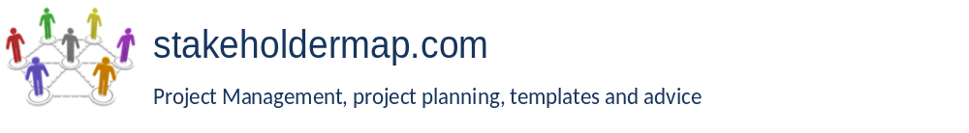

<COMPANY OR PROJECT LOGO>

<Project Name>

<Project Reference>

Project initiation document

Version <1.0>

<dd/mm/yyyy>

Document Control

Document Information

 | Information
Document Id | Out of Scope
Document Owner | Tibo Van Gindertaelen
Issue Date | 07/06/2021
Last Saved Date | 07/06/2021
File Name | Yet To be Established

Document History
Any document history and/or -tracking is delegated to a highly compressed .zip-archive, located
in the publicized Github “Research-Method_Of_Loci-TiboVanGindertaelen-AWM” repository.
The enclosing medium, Github, provides automated version control while the manual archiving
after each scheduled working session in that repository ensures an additional layer of version control.
The underlying requirement here is a timestamped .rar-archive, inside a collective .zip-archive,
inside the active version control platform environment of Github. (My account, public repository)
Given the triple-layer system, and appropriate (size-wise) file types, this ensures proper doc. history.

Documented Roles

- Project Reviewer
- Project Manager
- Quality Manager
- User Representative - source
- Stakeholder Representative - source
Table of Contents
<Project Name> i
<Project Reference> i
Project initiation document i
Version <1.0> i
<dd/mm/yyyy> i
Document Control i
Document Information i
Document History i
Documented Roles i
project summary 1
purpose 1
project objectives 2
scope and exclusions 2
project deliverables 2
interfaces and dependencies 3
assumptions 3
acceptance criteria 3
monitoring and evaluation 3
project delivery 3
iNITIAL RISK LOG 3
quality management 4
quality management of the project 4
quality management of the deliverables 4
project milestones 5
project tolerance and exception process 5

project summary
This program aims to accommodate a single user using the internet in mobile- or monitor format.
By ”accommodate”, a 3D isometric gamification of the loci method is inferred by that language.
The project should allow a user to create his own visual world in which he can manipulate enough
aspects so that a visually landmarked world can serve many ”experienceable” concepts and subjects.
The method of loci shows how you couldn’t name all USA states, but you can with all in-house items.
We are simply better at remembering visuals than at pulling items from thin air via long-term memory.
Like that, a gamers top-notch memorization capability of in-game locations should have its own proper implementation for someone who cannot afford to struggle at memory retrieval when asked to.
Just like Minecraft, it should be a definite “builder”, but it should also be a builder-tool like Unity is.
Such differences are required to make constructs unique, whilst easily replicable for the pro-use.
It should be a fun and personally styled experience with room for real and actual professional gain.
A world builder and -simulator, centered around memorization using places instead of a word-sea.

purpose
Explaining why the project is being carried out, the rationale for the project:
- Why is the project being undertaken?
Because a user could stake memorization goals on the loci method for great results.
- What are the key deliverables?
- A playable game in HTML5 and CSS3 that is backed by an API for data / heavy lifting.
- A way to play it using the Android Appstore as a spectator, rather than a designer.
- A way to play it using a reasonable display at full capability as stated in features.
- A service that is both plugged into the Appstore and the website for cross-compatibility.
- A server that enables all functionality through its hosting of various coded files.
- A process flow that ensures the users minimal requirements are always met.
- A development process where a concept-demo per requirement is extended to full form.
- A development cycle where a component is treated with prevention, rather than intervention.
- What are the key touch points?
- It should be usable through user-friendly design touchpoints.
- It should be usable through bug free and tested accessibility via browser and Appstore.
- It should be usable through session-management, permanent storage and interaction.
- It should be pleasant through shapes, animation, personalization and color.
- It should be interesting through the implementation of inciting and enhancing mechanics.
- It should be fitting to the needs of a student of one or more topics, even when not so visual.

project objectives
This section identifies the key project objectives – what specifically will this project achieve? It should clearly link to the Program Objectives. It is likely to include active verbs such as replace, revise, provide, secure, create etc. It will reference Business Case, which is usually a separate document.

scope and exclusions
Describe the main work streams, work packages and products that will be delivered. This section could include a high-level Work Breakdown Structure (WBS) presented as a graphical hierarchy or as a list with a hierarchy denoted by numbering. For example:
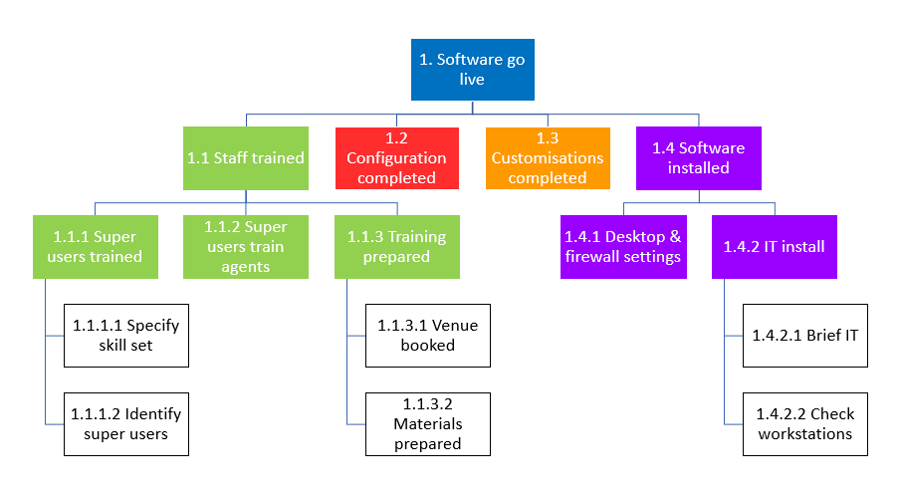
Get a template for a graphical Work Breakdown Structure
Get a template for a Work Breakdown Structure in Excel

project deliverables
Provide a complete list of the deliverables/products the project will produce. Make sure each deliverable has a unique identifier. This section may include links or references to each product’s Product Description.
Deliverable ID | Deliverable Title | Deliverable Description
1.1.3.2.1 | Delegate pack & venue guide | 250 gsm, 20 pages, 2 colour, stapled booklet, 4 colour cover.
1.1.3.2.2 | Delegate pack cover design work | 4 colour cover, logo with library image HT-027-12-TIFF, and training title.

interfaces and dependencies
Note any other groups, projects and organisations that will be involved in the project or will be impacted by the project. Include any dependencies here, for example if the project is dependent on an external product or an external decision.
Interface or dependency with: | Description | Management plan
Recruitment team | Recruitment of project manager by x date | Keys tasks documented in project plan with owners assigned. Job description already in place.
See example job descriptions for project managers

assumptions
List the assumptions that have been made in order to conceive of and plan this project. For example assumptions may have been made around legislation, other projects, market conditions, recruitment etc.

acceptance criteria
Describe in measurable terms the criteria that Project Sponsor will use to evaluate and accept or reject the project deliverables and outputs. This might include conditions that are not related to products like delivery by a certain date.

monitoring and evaluation
Document how the project will be monitored and evaluated. For example:
- How feedback will be collected on the value of this project by users of the products.
- The monitoring and evaluation methods the Project Sponsor will use to determine that the project has been delivered to specification and has had the intended impact
- The time scales and key dates for collecting the above information
- How, when and to whom the feedback and the monitoring and evaluation findings will be reported.

project delivery

iNITIAL RISK LOG
List the known risks to the successful delivery of the project. These should be specific to the project and not just a reiteration of common project risks.
Helpful guides for this section: A guide to Risk Management. Example Risk Register. Possible responses to risk.
Complete the following table:
Description | Likelihood | Impact© | Mitigating Actions
Inability to recruit skilled resource | Low | Very High | Involve retained recruitment consultant to source team members. Consider using consultants on fixed term contracts.
Technology solution is unable to deliver required results | Medium | High | Complete a pilot project against most business critical requirements. Consider using Agile methods to deliver working product in Sprints.
Additional capital expenditure may be required in addition to that approved | Medium | Medium | Monitor project spend as per the project methodology. Report on spend bi-weekly to the project board. Assign PMO Director to support Project Manager in cost control.

quality management
Two aspects of quality management should be considered within the PID: firstly securing high quality project management and secondly ensuring that deliverables are produced to agreed quality standards.

quality management of the project
For some projects quality of project delivery may be provided through pre-existing governance provided by program, portfolio management or a project management office. In these cases this section may just require a reference to pre-existing policies and procedures.
Example text:
Responsibility for checking that all procedures have been correctly followed in preparing this PID rests with: [Insert Name] Senior Project Manager.
Responsibility for checking and signing off this PID and for ensuring it follows the PID guidance rests with: [Insert Name] Program Manager.
Responsibility for ongoing monitoring and supervision to ensure that ongoing project management complies with the agreed procedures and processes rests with [Insert Name] of the Programme Office
quality management of the deliverables
In this section document what the quality standards, quality assurance process and quality checking are for each project deliverable. A table similar to the below may be used.
Deliverable ID and title | Quality standards | Quality assurance | Quality checking
0034 Web pages | Follow existing branding specification.  Meet Accessibility compliance guidelines  Meet browser compatibility policy | Follow publishing review process.  Pre-approved suppliers only. | Web change advisory board via unit test, user acceptance testing and go live testing.

project milestones
List the project milestones (key points in a project life cycle). They might be target dates that must be met or delivery of important work packages or markers of progress. This section will likely contain a table similar to the one below.
Milestone | Milestone target date
Project Kick off | Day month year
Design phase | Day month year to day month year
Build starts
Start of User Acceptance Testing

project tolerance and exception process
Document the agreed Project Tolerances and provide a brief confirmation of the Exception Procedure to be followed if there is a deviation from the approved plan that is forecast to exceed Tolerance. Refer also to the Change Control Process that will be followed for this project. See example cost and time tolerances.

