Project Report
Abstract
This project implements a blockchain-based system to register and fractionalize the African Leadership University (ALU) logo. By leveraging an ERC-721 smart contract to establish immutable proof of authenticity and an ERC-20 contract to split ownership into distributable tokens, this solution ensures transparent, decentralized verification and stakeholder ownership tracking.
Introduction
ALU needs to protect its logo on a blockchain because traditional databases and copyright registries rely on centralized authorities, which are vulnerable to alteration, deletion, or loss. A blockchain provides an immutable, decentralized ledger where the exact state and timestamp of registration are permanently recorded. This ensures undeniable cryptographic proof of existence and authenticity that any party can verify independently without relying on a central entity.
Blockchain Setup
A local blockchain is a simulated network running locally on a developer's computer. Developers use it instead of the real Ethereum network to test smart contracts for free, without spending real ETH, and with instant transaction mining.
Hardhat was set up to spin up this local node. It compiles the Solidity contracts, creates a local blockchain environment, and provides dummy wallet addresses pre-funded with fake ETH. A wallet address is a unique identifier on the blockchain that represents a user's account.
Smart Contract Explanation
A smart contract is a self-executing program deployed on a blockchain. Unlike standard programs that run on centralized servers, smart contracts run on a decentralized network where their code and data are public, immutable, and strictly enforce logic.
An NFT is a unique digital asset. ERC-721 allows each token to have distinct properties.
SHA-256 is a cryptographic function that converts data into a unique hash. Even small changes produce a different hash.
Data on blockchain cannot be changed because blocks are cryptographically linked.
Functions Created:
registerAsset(): registers asset and mints NFT. verifyLogoIntegrity(): checks hash validity.
getAsset(): returns asset details. distributeShares(): distributes ALUT tokens. ownershipPercentage(): calculates ownership share.
Tokenisation
Tokenisation splits ownership into digital tokens. ERC-721 is used for unique asset registration. ERC-20 is used for fungible ownership shares.
Test Results
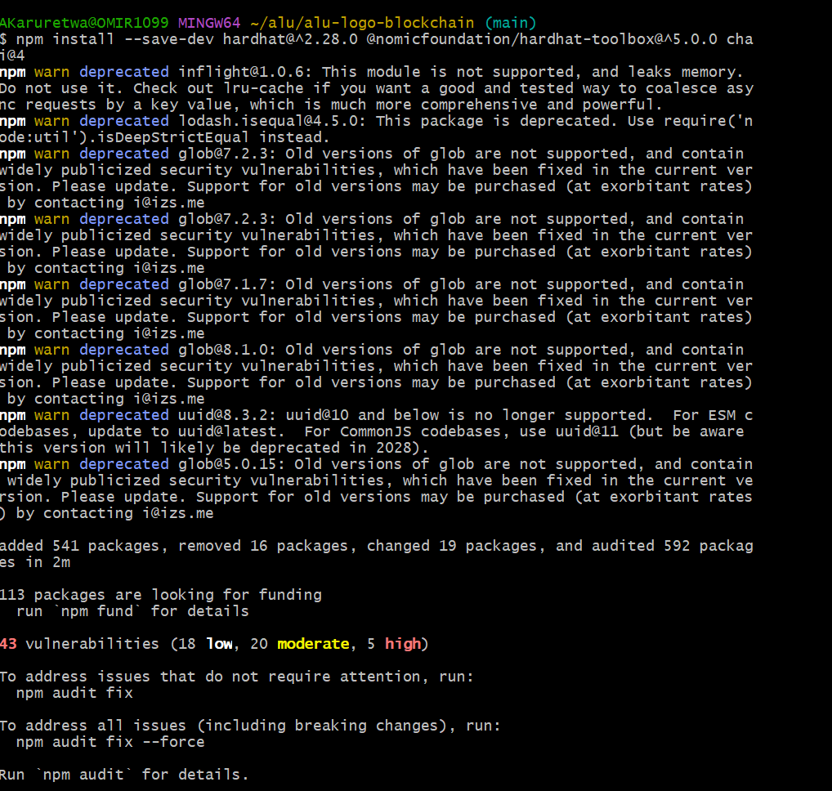

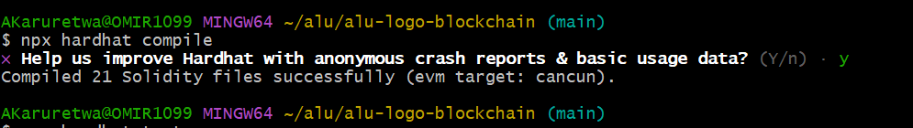

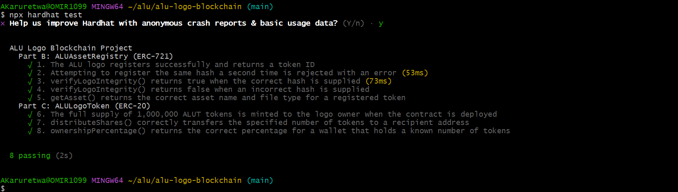
Conclusion
This project combines ERC-721 and ERC-20 to register and tokenize a digital asset.
GitHub Link
https://github.com/TWA-Coder/alu/tree/main/alu-logo-blockchain
Video Link
https://www.awesomescreenshot.com/s/folder/F0PJpawyq8/a497fba71693471f295b84b72c5c87e7

