Machinery Ring Rwanda website content

Home

Access agricultural machinery through farmer cooperation
Machinery Ring Rwanda brings farmers together to access agricultural machinery, practical training and coordinated services. Through local Machinery Rings, farmers organise their needs and access equipment without each household having to buy and maintain every machine it needs.
Our work is rooted in Gashora Sector, Bugesera District, where five local Rings connect farmers with services, learning opportunities and support for their groups.
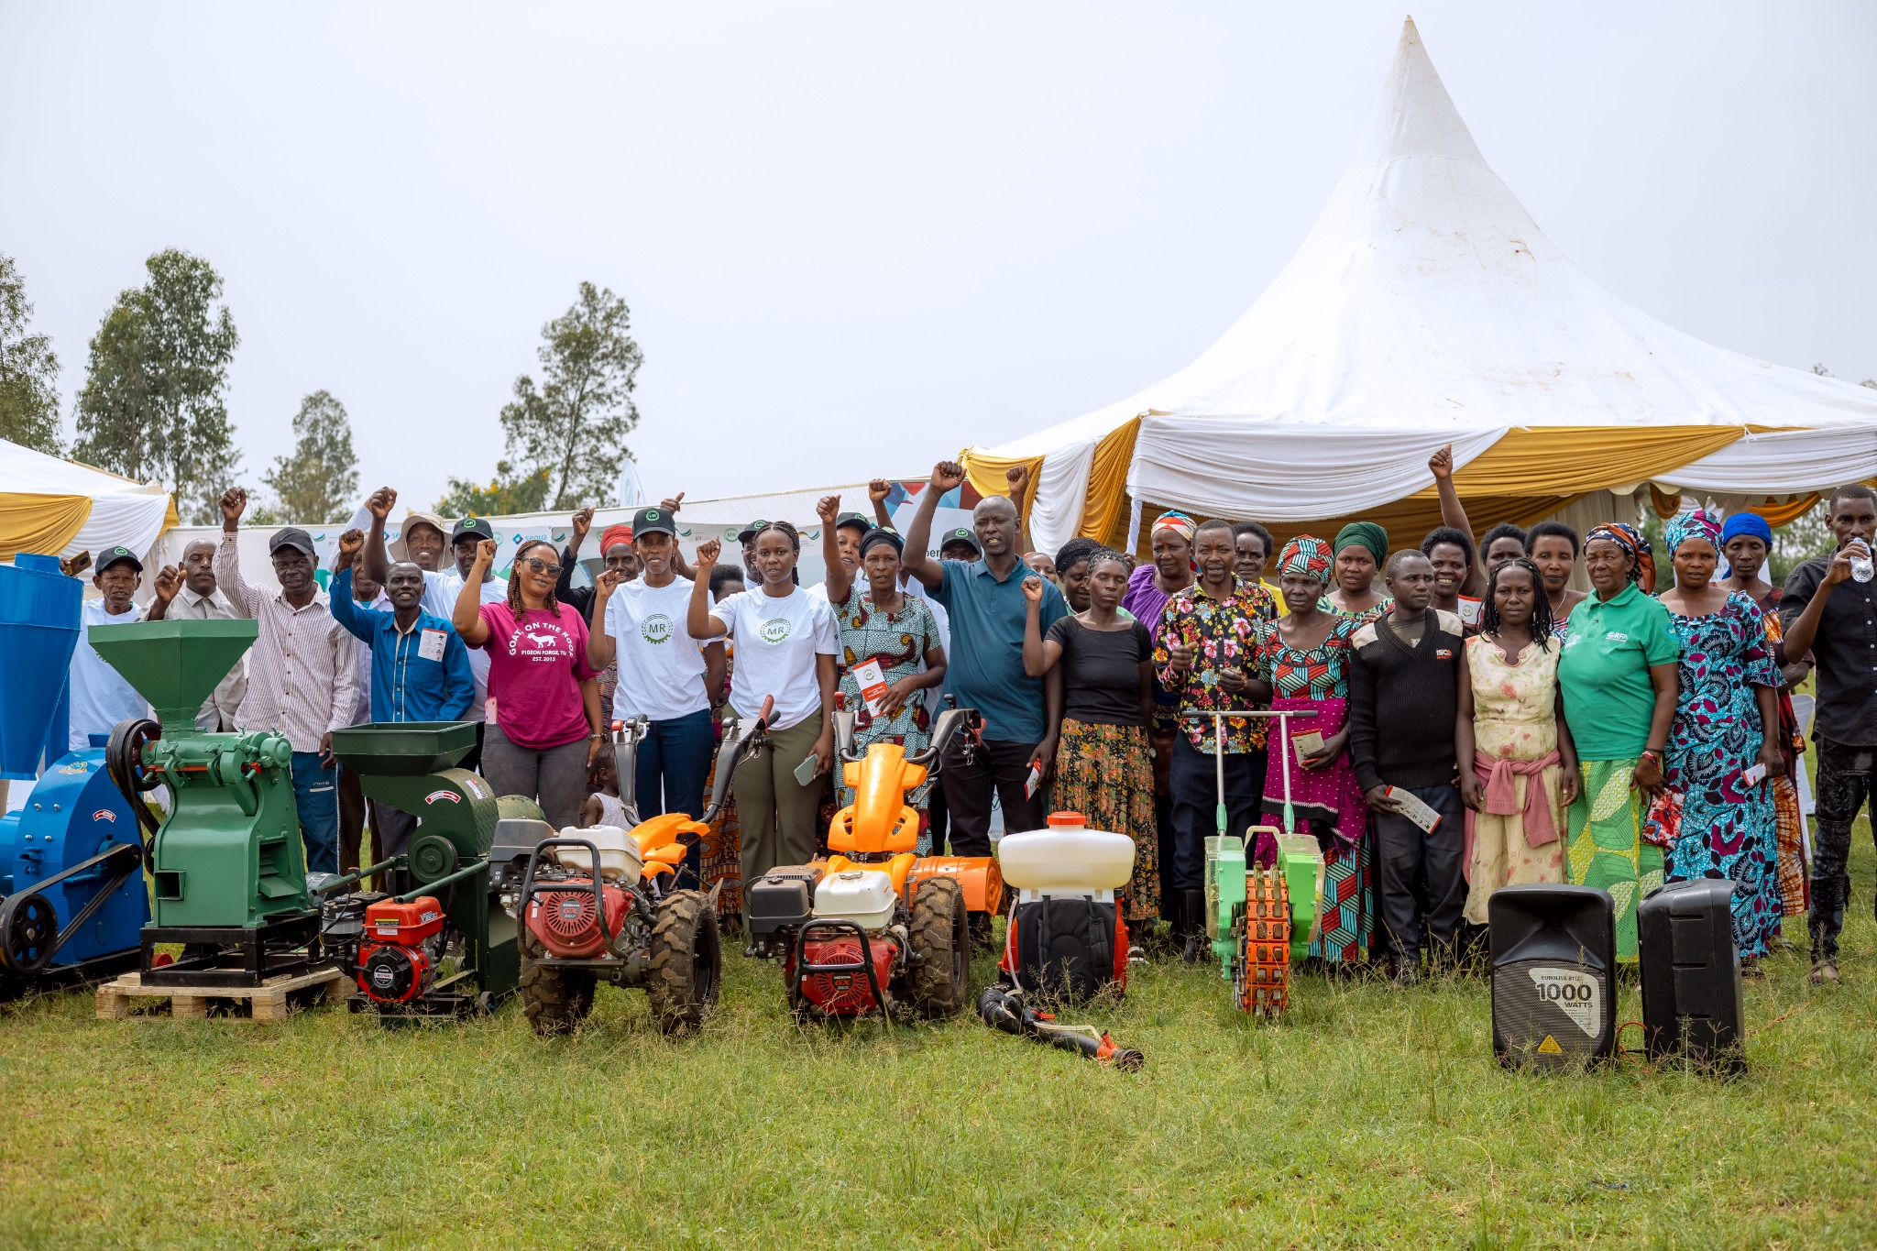
Participants gather around agricultural machinery during an MR Rwanda activity.

How we support farmers
Agricultural services: Planting support, maize shelling and rice threshing, with availability and arrangements confirmed for each request.
Practical learning: Training and demonstrations on machinery use, farming practices, post-harvest handling and farm-business skills.
Farmer organisation: Support for local leadership, group coordination and women’s participation.

Tell us what you need
Contact us with your location, crop, required service and preferred timing. We will discuss availability, cost and the next steps.

About Us

Who we are
Machinery Ring Rwanda supports farmers in accessing agricultural machinery and related services through cooperation. We work with local farmer groups to coordinate service needs, develop practical skills and strengthen the organisation required to manage agricultural activities.

What is a Machinery Ring
A Machinery Ring (MR) is a local, farmer-led self-help organisation that helps members access agricultural machinery and related services through cooperation. Farmers who own machinery can offer services to other members at agreed rates that cover the cost of providing them. A farmer may provide one service while hiring another from a fellow member. This approach improves equipment use and gives farmers access to mechanisation without each farmer having to purchase their own machinery.

Our development in Rwanda
Implementation in Rwanda began in 2024 through a project supporting the Machinery Ring approach in Kenya and Rwanda. Activities have included establishing local Rings, introducing equipment, organising farmer training and developing demonstration farms. Machinery Ring Rwanda obtained legal recognition in 2025.
Our purpose is to strengthen farmers’ access to suitable machinery, practical knowledge and coordinated services. Local participation helps shape which services are needed and how they can be organised.

Our local Rings
Our established network in Gashora Sector, Bugesera District, comprises Kagomasi, Biryogo, Nyabagendwa, Kabuye and Mwendo. Local boards and trained farmer facilitators support communication, group activities and service coordination.

Joining a Machinery Ring
Contact our team or a local Ring representative to learn about membership, the applicable conditions and available services. Farmers can also coordinate requests with neighbours so that work and machinery movements can be planned together. Non-members may enquire about services and the terms that apply to them.

About Us continued

Our team
The project team coordinates activities, supports local Rings and works with technical and development partners. Local Ring boards help organise members and communicate farmers’ priorities.

Simeon Musabende Umunyempuhwe
Project Manager. Simeon coordinates implementation, farmer support, service planning and partner engagement. He works with local Rings and institutions to turn farmers’ needs into practical activities.

Eric Niyonzima
Assistant Project Manager and ICT Personnel. Eric supports field coordination, local boards, service planning and recordkeeping. His work includes using digital tools to organise information and support communication.

Chloella Munezero
Technical Expert for Financial Reporting, Monitoring and Evaluation. Chloella supports financial administration, activity monitoring and reporting. Her work also includes support for women’s savings groups, financial literacy and organisational skills.

Our partners
The Machinery Ring Foundation led the implementation of the Kenya–Rwanda project in Rwanda, with support from GIZ Rwanda and sequa gGmbH under German Development Cooperation. This cooperation has supported the development of local Rings, practical learning and agricultural service activities.
Farmers and local leaders help identify priorities and coordinate participation. Cooperation with technical and local institutions supports specific activities, including business-development training and links between savings groups and local financial services.

Work with us
We welcome discussions about suitable agricultural machinery, farmer training, women’s participation and local service development. Contact us with the location, farming need and proposed area of collaboration.

Services
We coordinate agricultural services and practical support through our local network. Tell us what you need so we can check the equipment, operator, location and timing before confirming the work and price.

Maize and bean planting
Planting support uses available planting equipment, including hand-held planters. The team discusses field readiness, crop requirements and the appropriate equipment for the task. Provide your crop, field location, area in hectares and preferred planting period. Seed, fertiliser and other input arrangements are agreed separately.

Maize shelling and rice threshing
These services separate maize grain from the cob or rice grain from the harvested crop. Requests are assessed against crop readiness, machine suitability and operator availability. Tell us the crop, estimated quantity in kilograms or tonnes, location and preferred date. We will agree the working area, handling arrangements and any transport charges before scheduling.

Training and agricultural advisory support
Our practical learning activities cover machinery use, crop establishment, soil health, spraying practices, post-harvest handling and farm-business skills. Farmers and groups can enquire about training or advisory support for a specific need. Activities are arranged according to the programme and technical support available.

Machinery operation and maintenance learning
We support operators and farmer groups with practical learning on equipment operation, routine checks, cleaning and maintenance. Contact the team with the machine type and the support needed so we can discuss the appropriate next step.

Services being developed
Land preparation depends on securing a suitable tractor, compatible implements and an operator. Farmers may register their interest, but dates can only be agreed once delivery capacity is confirmed.
Irrigation work currently centres on demonstrations and practical learning. Rice transplanting and cassava and maize processing are areas of service development. Contact us to discuss the support available for your location and task.

Prices and confirmation
Contact us for the applicable rate. The team will explain the unit charged, any member or non-member rate and additional costs before you agree to the work. A service request becomes a booking only after availability, timing and price have been confirmed with you.

Our Work

Developing local agricultural services
Our work combines farmer organisation, machinery access and practical learning. Local Rings help bring requests together, while training and field activities support the skills needed to use and manage equipment.

The Kenya and Rwanda mechanisation project
The project “Sustainable mechanization of value chains through innovative, gender-sensitive business models – Machinery Rings in Kenya and Rwanda” runs from November 2023 to October 2026. Work in Rwanda began in 2024, focusing on local Rings, agricultural services, training and demonstration activities in Gashora.

Demonstration farms and practical learning
Demonstration farms give farmers opportunities to examine equipment and farming practices under local conditions. Activities connect seasonal crop management with machinery suitability, soil management and post-harvest learning. Field experience also helps identify where equipment or service arrangements need improvement.

Women’s participation
We support women’s participation through savings-group activities, financial literacy, leadership and digital-skills training. This work includes group management, savings and loan practices, and links with local financial institutions. These activities help women take part in the organisational and business work of their farmer groups.

Our recorded reach
Project records presented in August 2026 report 817 registered farmers across five local Rings. Records for 2024–2026 report 25 training events and more than 900 participant attendances. Attendances include people joining more than one session.

Field updates
September 2024: Field days took place in Mwendo on 4 September and Kagomasi on 5 September as part of the programme of machinery demonstrations and farmer engagement.
January 2026: Further field-day activities took place in Mwendo and Kagomasi on 8–9 January, continuing practical learning through the local Ring network.
January–March 2026: Women’s leadership and communication training in January was followed by Microsoft Word and Excel training in March, supporting participation and practical organisational skills.

Contact

Contact Machinery Ring Rwanda
For services, membership, training or partnership enquiries, contact our team and tell us how we can help.
Simeon Musabende Umunyempuhwe
Project Manager
Telephone: +250 781 707 587
Email: simeon.musabende@machineryrings.org
Our established operating area is Gashora Sector, Bugesera District, Rwanda. Contact us to arrange a visit.

Request a service
Tell us the service you need and where your farm is located. Our team will contact you to discuss availability, timing and cost. Submitting a request does not confirm a booking.

Information to provide
Your name and telephone number; district, sector, cell and village; local Ring or membership status; required service and crop; estimated area in hectares or quantity in kilograms or tonnes; and preferred date or period. Include any access or crop-readiness details that may affect the work.

What happens next
The team reviews your request and contacts you to clarify the work, check availability and agree the price and timing. You can also make your request by telephone.

Common questions
Can non-members enquire? Yes. Contact us to discuss availability and the applicable terms, including any difference in rates.
Can I request a specific date? Yes. Give your preferred date or period. The team will confirm what can be arranged.
Are transport and inputs included? The team will explain what the quoted price covers. Any additional charges and input responsibilities must be agreed before the work.
Can farmers outside Gashora contact us? Yes. Contact us to discuss your location and needs. Support outside the established area depends on what can be arranged.

Appendix for the development team

Website structure and launch scope
Use five navigation items: Home, About Us, Services, Our Work and Contact. The two About Us sections in this document belong to one website page. Keep a Request a Service button visible throughout, linking to the form on Contact. Home should also link to Services and Our Work; membership enquiries should lead to Contact.
Place projects, dated updates and activity photographs within Our Work. Place partners within About Us. Launch with service enquiries handled by the team. Accounts, online payments, automated booking, a separate gallery and newsletter subscriptions are outside this launch scope.

Form fields and response
Field | Input
Name and telephone | Required; do not require an email address.
Farm location | District, sector, cell and village.
Membership | Named local Ring, non-member or unsure.
Service and crop | Enable service options after operational review.
Area or quantity | Show hectares, kilograms or tonnes as appropriate.
Preferred timing | Date or date range; no automatic reservation.
Additional information | Optional access and readiness details.
Contact permission: “I agree that Machinery Ring Rwanda may use these details to contact me and handle this request.” Add a short privacy explanation describing who receives the information and how it is used.
Submission message: “Your request has been received. Our team will contact you to confirm availability, timing and cost. Your booking is confirmed only after the arrangements have been agreed with you.”

Handling requests and maintaining the site
Assign one responsible staff member to receive and track requests. An embedded Google Form or a simple website form is sufficient. Keep telephone access visible and avoid mandatory sign-in or file upload. Test submission, notifications and follow-up before launch. Publish a response-time promise only after the team agrees it can meet it.
Make pages readable on phones and compress photographs. Prepare Kinyarwanda versions of the service, membership and request content, with review by the team. Give MR Rwanda access and instructions for updating text, images and service options, and confirm responsibility for hosting and domain renewals.

Appendix on photographs and final confirmations

Original photographs and placement
File | Placement and caption
9L9A8043.JPG.jpeg | Home. Participants gather around agricultural machinery during an MR Rwanda activity.
9L9A7882.JPG.jpeg | Services. Explaining agricultural equipment during a Machinery Ring Rwanda display.
9L9A2175.JPG.jpeg | Our Work. Participants listen to a practical explanation beside agricultural processing equipment.
Use the original supplied photographs. Confirm publication permission and any added names, dates or locations. The captions above describe the visible activity. Add videos when completed and cleared for use; they are not required for launch. Obtain approved MR and partner logo files and confirm the partner wording and display order.

Confirm these details before publication
Identity and people: Verify the official organisation name and current staff names and titles. The public copy uses a purpose statement rather than presenting drafted mission and vision wording as approved policy. Add formal governance details only when supplied.
Services and machinery: Confirm which services can currently be delivered, their operating areas and working equipment. In particular, establish the number of suitable tractors actually available. Historical records list two walking tractors; this does not establish availability of ride-on tractors for land preparation. Do not publish a fleet total or live availability from delivery records.
Prices and contacts: Confirm the enquiry telephone and email, the staff member handling requests and the office address if it is to be displayed. Add a map only after the office location is verified. Publish a rate card only when current charges, units and additional costs are approved.
Results and project status: Confirm the reporting dates for membership and training figures. Update the project description when its October 2026 period ends. Keep planned expansion separate from established Rings. The public text omits unresolved equipment totals, women’s participation totals and income or yield claims.

