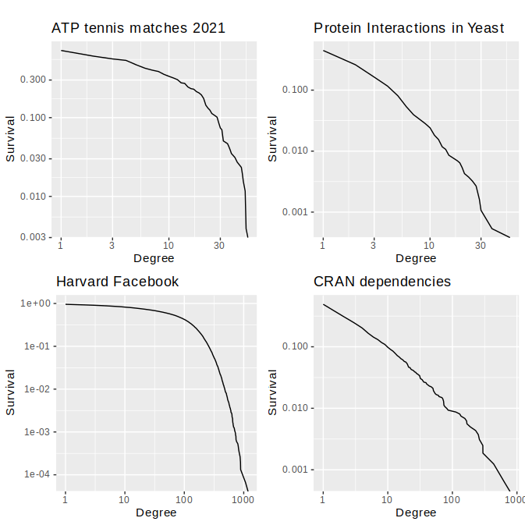
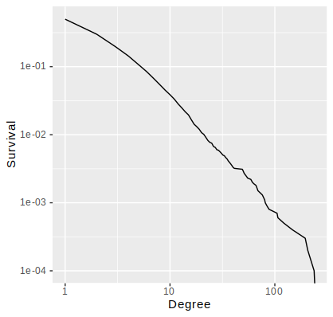
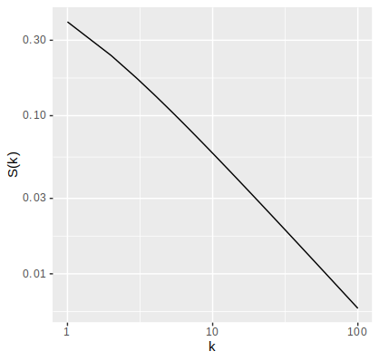
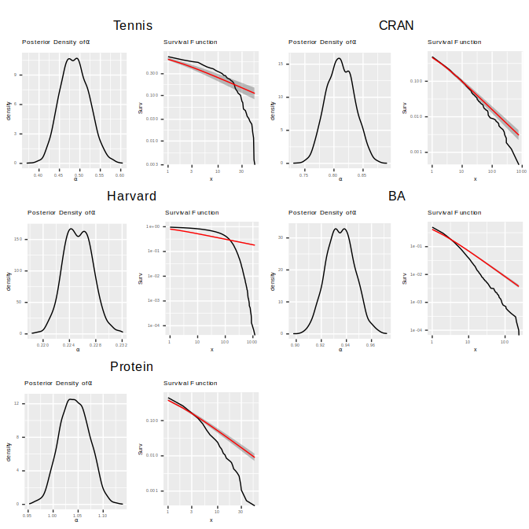
When we talk about a degree distribution following a power law, we mean that it is following the Zeta distribution which has probability mass function:

f(k) = ζ(α+1)⁻¹k^{−(α+1)} ,k=1,2,…

For some α ∈ R^{+.}

This is a very simple model that is only characterised by only one parameter α. An example of what the survival function of this model looks like is below:

The value of α used above is α=1, on the log-log scale it is approximately a straight line and indeed it will be for any value of α
Since the survival function of a power law, it may seem good to use for some of our real networks. So that, in turn, the Barabási-Albert model can be used to model their growth.

However if we fit the power law to our real networks and the simulated one we get the below plots:

We can see that fitting the power law to the entirety of any of our data sets seems to be inadequate, even the simulated network that should have approximately a power law degree distribution.

dfsdfsdfsdf
dfsdfsdfsdf
dfsdfsdfsdf
Scale-freeness and Growth Stability of Realistic Network Models
Some examples of the degree survival functions of real networks
Networks often arise when representing complex systems and the relationships between the components within them. They appear in a huge variety of fields of research from sports modelling to biology. This makes them a very important source of data. One area of interest concerns how these networks formed. We are interested in improving on the models currently used for this.
What are we doing?
This is a model that generates networks in an interpretable and simple way. This is why it is often used to model real network formation. It works by repeating these steps:
1. Growth:At each time step, add a node to the network that will connect to m≤ m₀ nodes (already in the network) with m edges.

2. Preferential Attachment:The probability that an edge from the new node connects to node i is proportional to its current degree k_{i} i.e k_{i} /∑_{j}k_{j} .

This model produces networks with a degree distribution that roughly follows a power law.

Barabási-Albert Model
Barabási-Albert Not Realistic?
While the Barabási-Albert model is attractive to use due to its simplicity and interpretability, it can only produce networks that have a power law degree distribution. An example of what this mean the degree survival function looks like is below:

Clearly this looks like some of the plots to left, but seems to look almost nothing like others. Our aim to to produce a model that can make networks with more realistic behaviour.

The Power Law
How good is the power law?
The Power Law Mixture
The Power Law – Integer Generalised Pareto Mixture

