GEM

A finite element mesh generator and data preparation program for radiation transport and fluids codes

User Notes

by

C.R.E. de Oliveira

Computational Physics and Geophysics Group
T H Huxley School of the Environment, Earth Sciences and Engineering
Imperial College of Science, Technology and Medicine
Prince Consort Road
London SW7 2BP

June 2001
1. Introduction

These notes give basic information on the use of the program GEM. The program is an interactive pre-processor for the radiation transport code EVENT. Its main task is to prepare the finite element mesh for the problem while at the same time incorporating the physical properties. The input specifies the problem by regions to filled with specified element type and specified material and source. The output is a list of elements, nodal coordinates and other items in the format required by EVENT. Though primarily designed for generating two-dimensional meshes, GEM is also capable of preparing input for one-dimensional problems, and has a limited capability for generating three-dimensional meshes.

2. Using GEM

2.1 Input commands

Input to GEM is given using simple free-format commands which are executed one at a time. The first character string on an input instruction is assumed to be a keyword. Subsequent strings may comprise of reserved words, names or numerical values.

The commands may be grouped into the following categories :

GEOMETRY
MESHING
MATERIAL SPECIFICATION
I/O
GRAPHICAL OUTPUT
GENERAL
EVENT RUN

Examples of commands are :

POINT P1 0.0 0.0 ; defines a point with name P1 and x- and y-coordinates (0.0,0.0)
MATERIAL MA11 1.0 0.0 0.0 0.0 1.0 ; defines cross-sectional data for material MA1
READ fred ; read command sequence from file fred

The full list of commands available and their syntax is presented in section 2.4.

2.2 Command sequence

A sequence of input commands should be constructed for each problem. This sequence should essentially :

(i) describe the geometry of the problem in terms of simple natural geometrical objects such as points, lines and regions;
(ii) define physical parameters such as material x/s, sources and boundary conditions, and associate them to the geometrical model;
(iii) define main control parameters for the EVENT run;
(iv) define mesh control parameters and generate mesh;
(v) generate output data.

Steps (i) and (ii) are obligatory and represent the bulk of the command sequence preparation work. Step (iii) may be omitted but default values are used then. Step (iv) usually involves some experimentation with mesh parameters in order to achieve the best compromise between effort and accuracy. This is best done interactively. Step (v) is only required if the objective of the GEM run is to produce an EVENT data file.

2.3 Command rules

(i) Keywords

The first word on cards other than comment or blank cards is the instruction keyword. The keyword is terminated by a blank, and only the first three characters are significant.

(ii) Reserved words

Further words are used in instruction parameters. These are up to six characters significant.

(iii) Keywords and reserved words may be input in lower or uppercase. The rest of the input is case sensitive.

(iv) Names

Identifiers for points, lines, regions, materials, and sources may be made up of any characters except *. All characters are significant in identifiers. Use of reserved words and keywords for identifiers should be avoided.

(v) The instructions occupy one line or more line or "cards" of input.

(vi) The character ^ indicates that the next card is a continuation card.

(vii) Blank cards, or lines beginning with @ are ignored.

2.4 GEM commands

In what follows words in bold and upper case are keywords or reserved words.

{ } denotes synonym
[ ] denotes optional parameters.
.......... denotes a list of parameters of any length.

2.4.1 Geometry

DELETE item list (not operational)

deletes items in the list

Example : DELETE R1

LINE lnam p1 p2 [p3 ] ........ [pn ]

declares a line joining point p1 to point p2, with name lnam .

If p3 is included, the line is an arc centered on p3 . If more than four points
are named then a spline is fitted through the points.

Examples : LINE L1 P1 P2
LINE L10 P15 P16 P3

N.B. Convention is anti-clockwise, i.e. when moving from p1 to p2 .

MOVE pntnam x y z

moves point pntnam to new co-ordinates (x,y,z)

Example : MOVE P1 10.0 20.0

POLYGON polynam l1 l2 l3 .... ln

defines a n-sided polygonal region

CIRCLE circnam p1 r n

defines a circular region centered at point p1 and radius r. The 4 quadrant circular arcs are subdivided into n intervals

RECTANGLE rectnam p1 l h n

defines a rectangular region with lower bottom left-corner at point p1 and length l and height h. The 4 sides are subdivided into n intervals

HEXAGON hexnam p1 p n

defines an hexagonal region centered at point p1 and pitch p The 6 sides are subdivided into n intervals

POINT pntnam x-coord y-coord z-coord
{PNT}

declares a point with name pntnam and co-ordinates (x,y,z)

Example : POINT P1 0.0 0.0 0.0

REGION regnam l1 l2 l3 [l4]
regnam r1 r2 ........
regnam p1 p2 ........

defines a three-, four-sided or many-sided region with name regnam .

Examples : REGION R1 L1 L2 L3
REGION R6 L10 L5 L20 L21
REGION R4 R1 R6

2.4.2 Meshing

DEFAULT keyword value

default value for lines, material, average and source

Example : DEFAULT ITV 10
DEFAULT MATERIAL MA1
DEFAULT AVERAGE 1
DEFAULT SOURCE S1

DIVIDE n linelist ......

lines in linelist are to be divided into n intervals

Example : DIVIDE 10 L1 L2 L3 L4

FILL

fills up lines and regions with nodes and elements. Effect is cancelled by RESET command

INTERVALS lnam n [ratio]
{ITV}

line lnam is to be divided into n intervals ( with an optional common ratio which defaults to 1 ).

Example : INTERVALS L1 10

Default n for lines not appearing on interval cards is n = 1.

Overrides previous INTERVAL cards for same line.

MESH regnam f1 [f2]

region regnam is to be filled according to parameters f1 and f2 .
Overrides previous mesh cards for same region. Permitted values for f1
are (see Fig. 1) :

NONE no mesh for region
SKEW1
SKEW2 for 4 -sided regions
SKEW?
QUAD

TRIANGLE for 3-sided regions

FRONT for n-sided regions
DELAUNAY

Permitted values for f2 are : BLEND (default)
UNIFORM

Example : MESH R1 SKEW1 BLEND
MESH R2 TRIANGLE BLEND

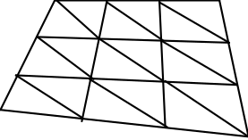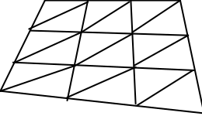
(a) skew1 (b) skew2

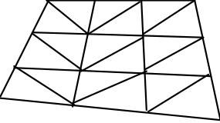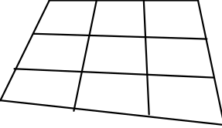
(c) skew? (d) quad
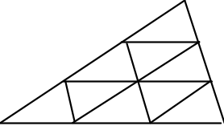

(e) triangle

Fig. 1 Region Element Fill Types

PITCH value

defines average pitch (mesh interval)

STRETCH

smoothes the mesh

DEGREE order

order of finite element polynomial basis functions.

Options are :- 1, 2 or 3

ZONE [zone no. [height [no. of-intervals]]]

define 3-dimensional axial zone parameters

Example : ZONE 1 10.0 20

2.4.3 Material Specification and Boundary Conditions

AVERAGE n reglist.....

assign regions in reglist to EVENT integrating region n ,

Example : AVERAGE 1 R1 R2 R3

BOUNDARY type linlist.......
{BC} {t }
the lines in linlist are associated either with boundary conditions of the specified type, or with surface conditions with surface source t .

Permitted types are :

REFLECTOR
BARE
ZERO
PERIODIC

Bare and surface source lines are filled with 'surface' elements.

Examples : BOUNDARY BARE L1
BOUNDARY REFLECTOR L3

LIBRARY libnam [format]

defines name and format of library from where GEM will read material parameters.

Permitted values for format are : EVENT
FIDO
LASL

Examples : LIBRARY cask

MATERIAL matnam [x/s....]

defines a material with name matnam and given cross-section list. The expected order is σtg, σag, νσtg, and σsgg', g'= g, NGRPS for energy group g.

Example : MATERIAL MA1 1.0 0.5 0.2 0.0 0.5

PROPERTY regnam matnam [S ]

region regnam is given material matnam ( and source S if present )

regnam, matnam and S must have been previously declared.
Example : PROPERTY R1 MA1 S1

SOURCE S [strength]
{VOLUME}
defines a volume source with name S and given strength.

Example : SOURCE S1 1.0

SURFACE T [strength]

defines a surface source with name T and given strength.

Example : SURFACE S2 0.3

VELOCITY v .......
{SPEED}
particle speeds.

Example : VELOCITY 8.0E+9 4.0E+9

SPECTRUM x .......

fission spectrum

Example : SPECTRUM 0.7 0.2 0.15 0.05

XSTAB iht ihs ihm

material x/s table positions and length

2.4.4 Input/Output

DATA [ file ]

outputs present mesh data to given file (default is last opened file or file GEMOUT), as required by program EVENT.

If file has been opened the output is appended. If file does not exist it is created.

PATH [IN] pathnam
[OUT]

assigns input or output to path pathnam .

Examples : PATH IN C:\FEMPN\FRED\GEMDATA
PATH OUT C:\FEMPN\FRED\EVENTDAT

READ filenam

instructions are to be read from filenam until exhausted, when input is next attempted from the terminal. A blank file name redirects input to terminal.

Example : READ fred

CLOSE [ file ]

closes current input channel

Example : CLOSE

REWIND channel no.

rewinds file or channel no.

Example : REWIND 10

WRITE [channel no.]
output is directed to the new channel no. until the next WRITE card. A blank channel no. redirects output to terminal.

Example : REWIND 21

2.4.5 Graphical output

DEVICE device

initiates, or re-initiates, graphical output device.

The following are allowed : X11
PS4
PS4C
PS3
TEK

SHOW items ......

selected items are plotted on the device last specified by the DEVICE card.

Possible items are :- ALL
LINES
NODES
ELEMENTS
DOMAINS
COLOURS
FLUXES

A new picture is started for each item.

2.4.6 General

HELP [ keyword ]

invokes help facility.

Example : HELP LIST

LIST items ........
selected items are listed on the current output channel.

Possible items are : - ALL
ELEMENTS
EVENT
LINES
MATERIALS
NODES
POINTS
REGIONS
SOURCES or VOLUME
SURFACE

Examples : LIST ELEMENTS
LIST ALL

NEWS

RENUMBER [ DUG ]

renumber nodes to reduce matrix half-bandwidth to minimum.

RESET [ ALL ]

A RESET card causes all mesh filling to be forgotten, to allow modifications to ITV and MESH cards, and possibly extension of the mesh by new PNT, LINE and REGION cards.

STOP
{FINISH} finishes the session
{END}

2.4.7 EVENT Control Parameters

TITLE title

specifies a title of up to 76 characters for lineprinter and graphical
output

PRINT item

EVENT print option.

Options are :- NONE
FLUXES
MOMENTS
ALL

PLOT option

EVENT plot option.

Options are :- NONE
FLUXES
MOMENTS
ALL

GRAPH option

graphical output device in EVENT run

Options are :- NOGRAPH
PS4
PS4C
X11

CASE case

EVENT run case.

Options are :- TEST
EIGENVALUE
FIXED
TIME

GEOMETRY geom

problem geometry.
Possible geometries are :- SLAB
SPHERICAL
CYLINDRICAL
XY
RZ
XYZ

MODE mode

problem solution mode

Options are :- FORWARD {DIRECT}
ADJOINT
BOTH

SOLUTION scheme

Solution scheme

Options are :- PCG2
PCG4

ITERATIONS list .......

eigenvalue calculation parameters.

Parameters in list are : MAXITS max. no. of outer iterations
MAXCG max. no. of pcg iterations
EIGTOL eigenvalue error tolerance
VECTOL eigenvector error tolerance

TIME list .......

time zone card containing list of control parameters

Parameters in list are :- NSTEPS no. of time steps
DELTAT time-step size
TIMSCH time integration scheme
NEWSCT angular card flag
NEWGRP energy card flag
NEWMSH mesh cards flag
NEWMIX mixing cards flag
NEWDAT material cards flag
NEWSRC source cards flag

ANGLE n
{MSCTR}
{PN} order of angular approximation

SCATTER n
{NSCTR}
order of scattering anisotropy

GROUPS ngrps

no. of energy groups.

COLLAPSE n list .......

collapse energy group structure to n broad groups with structure given by list ....

LUMP option

lumping approximation of source

Options are :- NONE
ODD
ALL

UPSCATTER flag

upscatter flag

Flag options are :- NO
YES

FORMAT format

material data format.

Options are :- EVENT
LASL
FIDO

MIXTURE [ mixnum mixcom mixden]

mixing instructions for EVENT.

COMMENTS option

Insert GEM run output as comments in EVENT data file

Options are :- NO
YES

3. A worked example

The basic concepts concerning the use of GEM are best illustrated through a worked example. Consider the problem described in Fig.1 which we wish to solve with EVENT. The GEM file is constructed as follows :

(i) define geometry (see Fig. 2) :

@
@ - points
@
PNT P1 0.0 0.0
PNT P2 5.0025714 0.0 @ nb. radius corrected to preserve volume
PNT P3 10.0 0.0
PNT P4 0.0 5.0025714
PNT P5 3.5373522 3.5373522
PNT P6 10.0 5.0
PNT P7 0.0 10.0
PNT P8 5.0 10.0
PNT P9 10.0 10.0
@
@ - lines
@
LINE L1 P1 P2
LINE L2 P2 P3
LINE L3 P1 P4
LINE L4 P1 P5
LINE L5 P2 P5 P1 @ arc of circle
LINE L6 P3 P6
LINE L7 P5 P4 P1 @ arc of circle
LINE L8 P5 P6
LINE L9 P4 P7
LINE L10 P5 P8
LINE L11 P6 P9
LINE L12 P7 P8
LINE L13 P8 P9
@
@ - regions
@
REGION R1 L1 L5 L4
REGION R2 L4 L7 L3
REGION R3 L2 L6 L8 L5
REGION R4 L7 L10 L12 L9
REGION R5 L8 L11 L13 L10
@
@ - regional averages
@
AVERAGE 1 R1 R2
AVERAGE 2 R3 R4 R5
@

(ii) - define physical properties of problem :

@
MAT MA1 0.5 0.1 0.0 0.4
MAT MA2 1.0 0.9990 0.0 0.0 0.0010 @ highly absorbing medium
@
@ - sources
@
SOURCE S1 1.0
SOURCE S2 0.0
@
@ - boundary conditions
@
BOUNDARY BARE L6 L11 L12 L13
BOUNDARY REFLECTOR L1 L2 L3 L9
@

(iii) - assign material properties and sources to regions :

@
PROPERTIES R1 MA1 S1
PROPERTIES R2 MA1 S1
PROPERTIES R3 MA2 S2
PROPERTIES R4 MA2 S2
PROPERTIES R5 MA2 S2
@

(iv) - define EVENT run control parameters :

@
TITLE Case 1 : 5.0 cm sphere embedded in 10cm x 10cm cyl. (5x5 mesh)
CASE FIXED @ fixed-source calculation
GEOMETRY RZ @ r-z geometry
ANGLE 7 @ P7 expansion of the angular flux
GROUPS 1 @ one energy group
COMMENTS NO @ don’t include comment file ( this file )
@

(v) - define mesh control parameters and generate mesh :

@
@ - define type of fill for regions
@
MESH R1 TRIANG BLEND
MESH R2 TRIANG BLEND
MESH R3 QUAD BLEND
MESH R4 QUAD BLEND
MESH R5 QUAD BLEND
@
@ - line subdivisons
@
DIVIDE 4 L1 L3 L4 L5 L6 L7 L12 @ these lines must have same no. of intervals
@
DIVIDE 4 L2 L8 L9 L10 L11 L13 @ ditto
@
@ - fill regions
@
FILL
@

(vi) - generate data :

@
DATA
@

(vii) - end run :

@
STOP
@

The resulting EVENT data file is :

Case 1 : 5.0 cm sphere embedded in 10cm x 10cm cyl. ( 4x4 mesh )
I/O 0 0 2 0 0 0 0
CASE 3 5 0 4 0 0 0
ITER 25 25 9.9999997E-06 9.9999997E-05 2
ANGLE 7 0 0
ENERGY 1 0 0 0
MESHFILE /home/users/staff/cassiano/EVENT/data/exmpl2
SIZES 13 4 2 96 81 17 0 0 0
MATFILE /home/users/staff/cassiano/EVENT/data/exmpl2 EVENT
MATXS 2 0 4 3 4 4 0
NCOM 0
ELEM 1 2 6 1 0 3 25
ELEM 2 2 6 1 0 25 26
ELEM 3 2 6 1 0 26 27
ELEM 4 2 6 1 0 27 6
ELEM 5 2 11 1 0 6 40
ELEM 6 2 11 1 0 40 41
ELEM 7 2 11 1 0 41 42
ELEM 8 2 11 1 0 42 9
ELEM 9 2 12 1 0 7 43
ELEM 10 2 12 1 0 43 44
ELEM 11 2 12 1 0 44 45
ELEM 12 2 12 1 0 45 8
ELEM 13 2 13 1 0 8 46
ELEM 14 2 13 1 0 46 47
ELEM 15 2 13 1 0 47 48
ELEM 16 2 13 1 0 48 9
ELEM 17 1 1 1 1 1 10 19
ELEM 18 1 1 1 1 10 49 19
ELEM 19 1 1 1 1 10 11 49
ELEM 20 1 1 1 1 11 50 49
ELEM 21 1 1 1 1 11 12 50
ELEM 22 1 1 1 1 12 22 50
ELEM 23 1 1 1 1 12 2 22
ELEM 24 1 1 1 1 19 49 20
ELEM 25 1 1 1 1 49 51 20
ELEM 26 1 1 1 1 49 50 51
ELEM 27 1 1 1 1 50 23 51
ELEM 28 1 1 1 1 50 22 23
ELEM 29 1 1 1 1 20 51 21
ELEM 30 1 1 1 1 51 24 21
ELEM 31 1 1 1 1 51 23 24
ELEM 32 1 1 1 1 21 24 5
ELEM 33 1 1 1 1 1 19 16
ELEM 34 1 1 1 1 19 52 16
ELEM 35 1 1 1 1 19 20 52
ELEM 36 1 1 1 1 20 53 52
ELEM 37 1 1 1 1 20 21 53
ELEM 38 1 1 1 1 21 28 53
ELEM 39 1 1 1 1 21 5 28
ELEM 40 1 1 1 1 16 52 17
ELEM 41 1 1 1 1 52 54 17
ELEM 42 1 1 1 1 52 53 54
ELEM 43 1 1 1 1 53 29 54
ELEM 44 1 1 1 1 53 28 29
ELEM 45 1 1 1 1 17 54 18
ELEM 46 1 1 1 1 54 30 18
ELEM 47 1 1 1 1 54 29 30
ELEM 48 1 1 1 1 18 30 4
ELEM 49 11 2 2 2 2 13 22 55
ELEM 50 11 2 2 2 13 14 55 56
ELEM 51 11 2 2 2 14 15 56 57
ELEM 52 11 2 2 2 15 3 57 25
ELEM 53 11 2 2 2 22 55 23 58
ELEM 54 11 2 2 2 55 56 58 59
ELEM 55 11 2 2 2 56 57 59 60
ELEM 56 11 2 2 2 57 25 60 26
ELEM 57 11 2 2 2 23 58 24 61
ELEM 58 11 2 2 2 58 59 61 62
ELEM 59 11 2 2 2 59 60 62 63
ELEM 60 11 2 2 2 60 26 63 27
ELEM 61 11 2 2 2 24 61 5 31
ELEM 62 11 2 2 2 61 62 31 32
ELEM 63 11 2 2 2 62 63 32 33
ELEM 64 11 2 2 2 63 27 33 6
ELEM 65 11 2 2 2 4 30 34 64
ELEM 66 11 2 2 2 30 29 64 65
ELEM 67 11 2 2 2 29 28 65 66
ELEM 68 11 2 2 2 28 5 66 37
ELEM 69 11 2 2 2 34 64 35 67
ELEM 70 11 2 2 2 64 65 67 68
ELEM 71 11 2 2 2 65 66 68 69
ELEM 72 11 2 2 2 66 37 69 38
ELEM 73 11 2 2 2 35 67 36 70
ELEM 74 11 2 2 2 67 68 70 71
ELEM 75 11 2 2 2 68 69 71 72
ELEM 76 11 2 2 2 69 38 72 39
ELEM 77 11 2 2 2 36 70 7 43
ELEM 78 11 2 2 2 70 71 43 44
ELEM 79 11 2 2 2 71 72 44 45
ELEM 80 11 2 2 2 72 39 45 8
ELEM 81 11 2 2 2 5 31 37 73
ELEM 82 11 2 2 2 31 32 73 74
ELEM 83 11 2 2 2 32 33 74 75
ELEM 84 11 2 2 2 33 6 75 40
ELEM 85 11 2 2 2 37 73 38 76
ELEM 86 11 2 2 2 73 74 76 77
ELEM 87 11 2 2 2 74 75 77 78
ELEM 88 11 2 2 2 75 40 78 41
ELEM 89 11 2 2 2 38 76 39 79
ELEM 90 11 2 2 2 76 77 79 80
ELEM 91 11 2 2 2 77 78 80 81
ELEM 92 11 2 2 2 78 41 81 42
ELEM 93 11 2 2 2 39 79 8 46
ELEM 94 11 2 2 2 79 80 46 47
ELEM 95 11 2 2 2 80 81 47 48
ELEM 96 11 2 2 2 81 42 48 9
NODE 1 0.0000000E+00 0.0000000E+00 0.0000000E+00 35
NODE 2 5.0025716E+00 0.0000000E+00 0.0000000E+00 1
NODE 3 1.0000000E+01 0.0000000E+00 0.0000000E+00 31
NODE 4 0.0000000E+00 5.0025716E+00 0.0000000E+00 81
NODE 5 3.5373521E+00 3.5373521E+00 0.0000000E+00 29
NODE 6 1.0000000E+01 5.0000000E+00 0.0000000E+00 23
NODE 7 0.0000000E+00 1.0000000E+01 0.0000000E+00 77
NODE 8 5.0000000E+00 1.0000000E+01 0.0000000E+00 73
NODE 9 1.0000000E+01 1.0000000E+01 0.0000000E+00 69
NODE 10 1.2506429E+00 0.0000000E+00 0.0000000E+00 22
NODE 11 2.5012858E+00 0.0000000E+00 0.0000000E+00 12
NODE 12 3.7519288E+00 0.0000000E+00 0.0000000E+00 5
NODE 13 6.2519288E+00 0.0000000E+00 0.0000000E+00 3
NODE 14 7.5012856E+00 0.0000000E+00 0.0000000E+00 10
NODE 15 8.7506428E+00 0.0000000E+00 0.0000000E+00 20
NODE 16 0.0000000E+00 1.2506429E+00 0.0000000E+00 45
NODE 17 0.0000000E+00 2.5012858E+00 0.0000000E+00 56
NODE 18 0.0000000E+00 3.7519288E+00 0.0000000E+00 68
NODE 19 8.8433802E-01 8.8433802E-01 0.0000000E+00 34
NODE 20 1.7686760E+00 1.7686760E+00 0.0000000E+00 33
NODE 21 2.6530142E+00 2.6530142E+00 0.0000000E+00 32
NODE 22 4.9064484E+00 9.7595328E-01 0.0000000E+00 4
NODE 23 4.6217732E+00 1.9144014E+00 0.0000000E+00 8
NODE 24 4.1594863E+00 2.7792799E+00 0.0000000E+00 18
NODE 25 1.0000000E+01 1.2500000E+00 0.0000000E+00 30
NODE 26 1.0000000E+01 2.5000000E+00 0.0000000E+00 27
NODE 27 1.0000000E+01 3.7500000E+00 0.0000000E+00 26
NODE 28 2.7792795E+00 4.1594863E+00 0.0000000E+00 42
NODE 29 1.9144011E+00 4.6217728E+00 0.0000000E+00 54
NODE 30 9.7595274E-01 4.9064484E+00 0.0000000E+00 67
NODE 31 5.1530142E+00 3.9030142E+00 0.0000000E+00 28
NODE 32 6.7686758E+00 4.2686758E+00 0.0000000E+00 25
NODE 33 8.3843384E+00 4.6343379E+00 0.0000000E+00 24
NODE 34 0.0000000E+00 6.2519288E+00 0.0000000E+00 80
NODE 35 0.0000000E+00 7.5012856E+00 0.0000000E+00 79
NODE 36 0.0000000E+00 8.7506428E+00 0.0000000E+00 78
NODE 37 3.9030142E+00 5.1530142E+00 0.0000000E+00 40
NODE 38 4.2686758E+00 6.7686758E+00 0.0000000E+00 50
NODE 39 4.6343379E+00 8.3843384E+00 0.0000000E+00 61
NODE 40 1.0000000E+01 6.2500000E+00 0.0000000E+00 37
NODE 41 1.0000000E+01 7.5000000E+00 0.0000000E+00 46
NODE 42 1.0000000E+01 8.7500000E+00 0.0000000E+00 58
NODE 43 1.2500000E+00 1.0000000E+01 0.0000000E+00 76
NODE 44 2.5000000E+00 1.0000000E+01 0.0000000E+00 75
NODE 45 3.7500000E+00 1.0000000E+01 0.0000000E+00 74
NODE 46 6.2500000E+00 1.0000000E+01 0.0000000E+00 72
NODE 47 7.5000000E+00 1.0000000E+01 0.0000000E+00 71
NODE 48 8.7500000E+00 1.0000000E+01 0.0000000E+00 70
NODE 49 2.3108866E+00 9.5720041E-01 0.0000000E+00 21
NODE 50 3.6240845E+00 9.7107112E-01 0.0000000E+00 11
NODE 51 3.2492657E+00 1.8759646E+00 0.0000000E+00 19
NODE 52 9.5720017E-01 2.3108866E+00 0.0000000E+00 44
NODE 53 1.8759630E+00 3.2492661E+00 0.0000000E+00 43
NODE 54 9.7106898E-01 3.6240849E+00 0.0000000E+00 55
NODE 55 6.1798358E+00 1.0444648E+00 0.0000000E+00 2
NODE 56 7.4532242E+00 1.1129766E+00 0.0000000E+00 9
NODE 57 8.7266121E+00 1.1814882E+00 0.0000000E+00 17
NODE 58 5.9663296E+00 2.0608010E+00 0.0000000E+00 7
NODE 59 7.3108869E+00 2.2072005E+00 0.0000000E+00 6
NODE 60 8.6554441E+00 2.3536003E+00 0.0000000E+00 16
NODE 61 5.6196151E+00 3.0219603E+00 0.0000000E+00 15
NODE 62 7.0797420E+00 3.2646394E+00 0.0000000E+00 14
NODE 63 8.5398703E+00 3.5073197E+00 0.0000000E+00 13
NODE 64 1.0444651E+00 6.1798368E+00 0.0000000E+00 66
NODE 65 2.0608010E+00 5.9663305E+00 0.0000000E+00 53
NODE 66 3.0219603E+00 5.6196151E+00 0.0000000E+00 41
NODE 67 1.1129768E+00 7.4532242E+00 0.0000000E+00 65
NODE 68 2.2072005E+00 7.3108869E+00 0.0000000E+00 52
NODE 69 3.2646394E+00 7.0797429E+00 0.0000000E+00 51
NODE 70 1.1814884E+00 8.7266121E+00 0.0000000E+00 64
NODE 71 2.3536003E+00 8.6554441E+00 0.0000000E+00 63
NODE 72 3.5073197E+00 8.5398703E+00 0.0000000E+00 62
NODE 73 5.4272604E+00 5.4272604E+00 0.0000000E+00 39
NODE 74 6.9515061E+00 5.7015061E+00 0.0000000E+00 38
NODE 75 8.4757538E+00 5.9757538E+00 0.0000000E+00 36
NODE 76 5.7015061E+00 6.9515061E+00 0.0000000E+00 49
NODE 77 7.1343379E+00 7.1343379E+00 0.0000000E+00 48
NODE 78 8.5671692E+00 7.3171692E+00 0.0000000E+00 47
NODE 79 5.9757538E+00 8.4757538E+00 0.0000000E+00 60
NODE 80 7.3171692E+00 8.5671692E+00 0.0000000E+00 59
NODE 81 8.6585846E+00 8.6585846E+00 0.0000000E+00 57
CONS 1 1 11
CONS 2 2 6
CONS 3 3 6
CONS 4 4 11
CONS 5 7 11
CONS 6 10 6
CONS 7 11 6
CONS 8 12 6
CONS 9 13 6
CONS 10 14 6
CONS 11 15 6
CONS 12 16 11
CONS 13 17 11
CONS 14 18 11
CONS 15 34 11
CONS 16 35 11
CONS 17 36 11
MA1 5.0000001E-01 1.0000000E-01 0.0000000E+00 0.0000000E+00
MA1 4.0000002E-01
MA2 1.0000000E+00 9.9900001E-01 0.0000000E+00 0.0000000E+00
MA2 1.0000000E-03
S1 1.0000000E+00
S2 0.0000000E+00
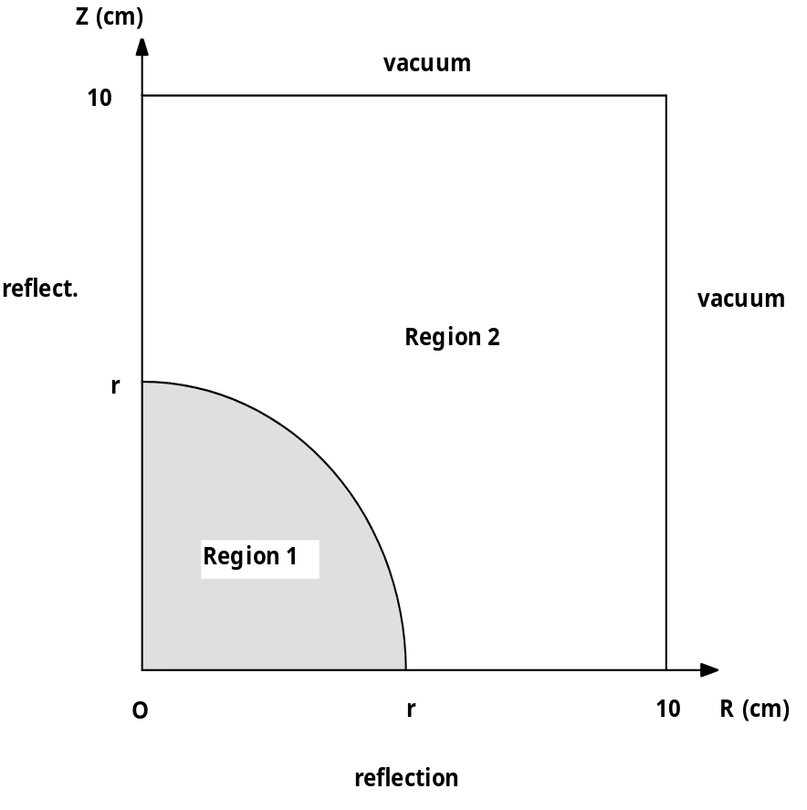

Problem Definition :

- single energy group
- the equation solved is :

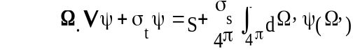

- source S = 1 in in sphere and zero elsewhere
- radius r = 5.0 cm
- in the spherical region : σt = 0.5 ; σs = 0.4 σt = 0.1
- in the external region : σt = 1.0 ; σs = 0.999

Fig 1 Sphere embedded in cylinder problem
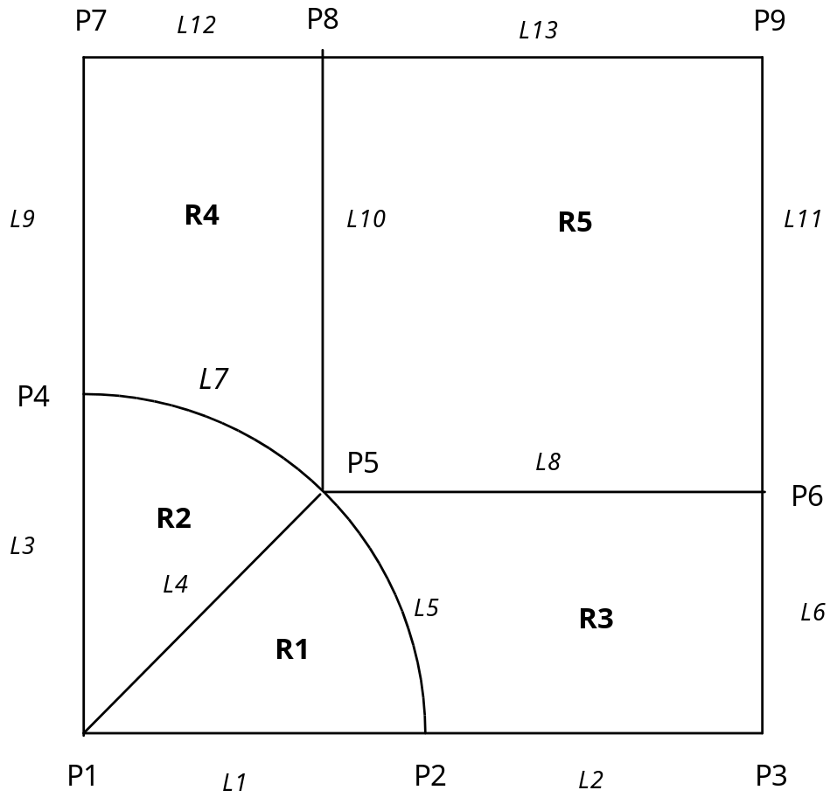

Fig. 2 Geometrical description of sphere embedded in cylinder problem as required by GEM

