第一次python上机作业

3.7.2计算1-100的累加和

代码
sum = 0
for i in range(1, 101):
sum += i
print(f'1+2+3+...+100={sum}')

运行结果
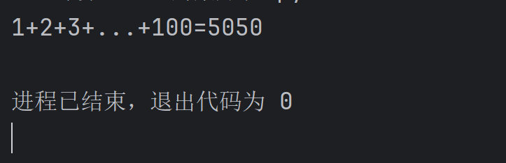

3.7.3计算10-1的累加和

代码
sum = 0
for i in range(10, 0, -1):
sum += i
print(f'10+9+8+...+1={sum}')

运行结果
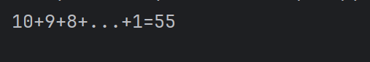

3.7.4计算100内的奇数和

代码
sum_odd = 0
for i in range(1, 100):
if i % 2 != 0:
sum_odd += i
print(f'1+3+5+7+...+99={sum_odd}')

运行结果
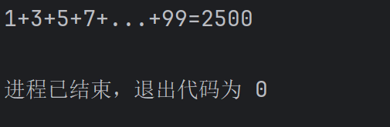

3.7.5计算100内的偶数和

代码
sum_even = 0
for i in range(1, 101):
if i % 2 == 0:
sum_even += i
print(f'2+4+6+8+...+100={sum_even}')

运行结果
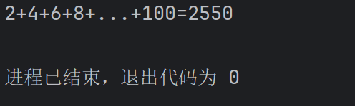

3.7.7计算n项奇数Sn = 1-3+5-7+9-11+...

代码
n = int(input('请输入n的值: '))
sum = 0
Sn = ''
for i in range(1, n + 1):
an = 2 * i - 1
if i % 2 != 0:
sum += an
Sn += '+' + str(an)
else:
sum -= an
Sn += '-' + str(an)
Sn = Sn[1:]

print(f'S{n}={Sn}={sum}')

运行结果
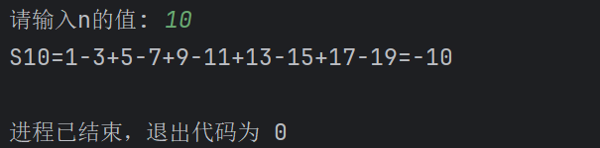

3.7.9九九乘法表

代码
# 左上三角
for i in range(1, 10):
for j in range(1, i + 1):
print('%dx%d=%d' % (j, i, i * j), end='\t')
print()

print("------------------------------------------------------------------------------")

# 等腰上三角
for i in range(1, 10):
for k in range(9 - i):
print('', end='\t')
for j in range(1, i + 1):
print('%dx%d=%d' % (j, i, i * j), end='\t')
print()

print("------------------------------------------------------------------------------")

# 右上三角
for i in range(1, 10):
for k in range(18 - i * 2):
print('', end='\t')
for j in range(1, i + 1):
print('%dx%d=%d' % (j, i, i * j), end='\t')
print()

print("------------------------------------------------------------------------------")

# 左下三角
for i in range(9, 0, -1):
for j in range(1, i + 1):
print('%dx%d=%d' % (j, i, i * j), end='\t')
print()

print("------------------------------------------------------------------------------")

# 等腰下三角
for i in range(9, 0, -1):
for k in range(9 - i):
print('', end='\t')
for j in range(1, i + 1):
print('%dx%d=%d' % (j, i, i * j), end='\t')
print()

print("------------------------------------------------------------------------------")

# 右下三角
for i in range(9, 0, -1):
for k in range(18 - i * 2):
print('', end='\t')
for j in range(1, i + 1):
print('%dx%d=%d' % (j, i, i * j), end='\t')
print()

print("------------------------------------------------------------------------------")

# 矩形
count = 0
for i in range(1, 10):
for j in range(1, i + 1):
count += 1
print('%dx%d=%d' % (j, i, i * j), end='\t')
if count % 9 == 0:
print()

运行结果
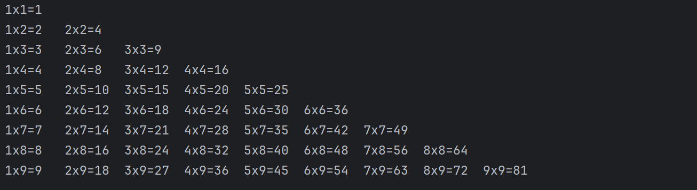
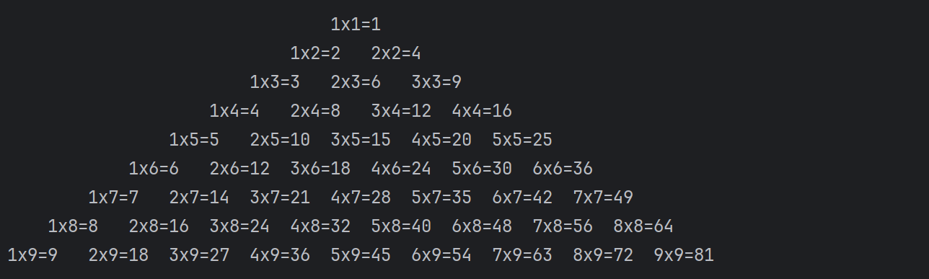
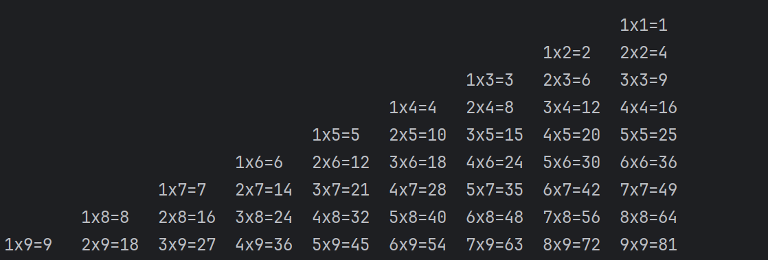
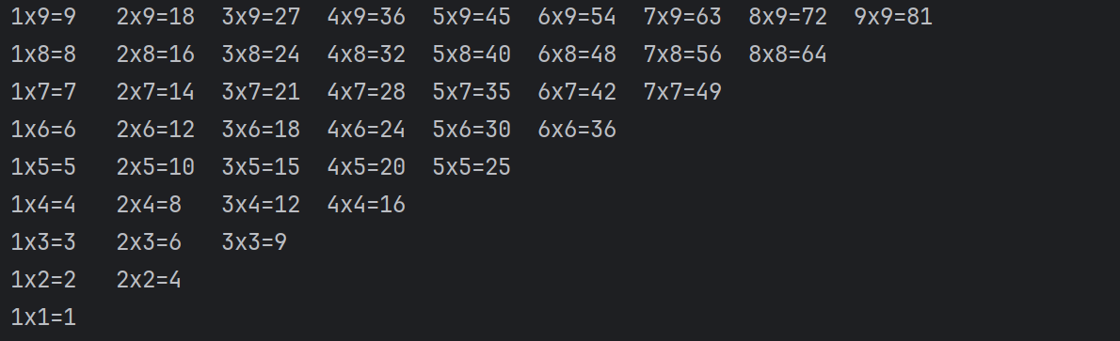
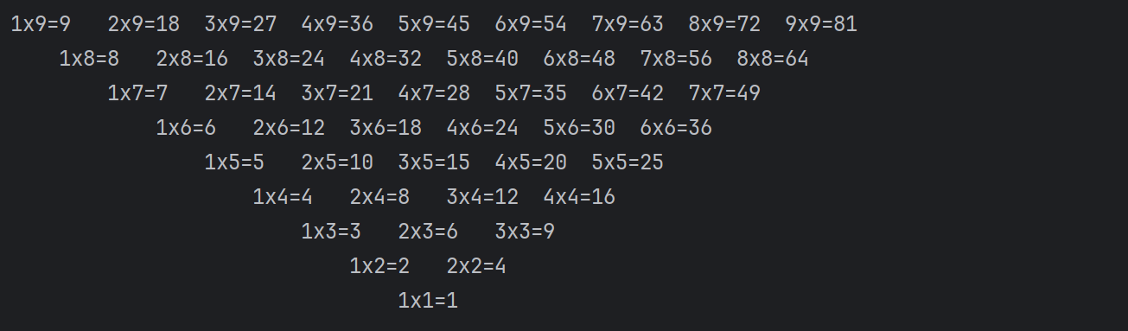
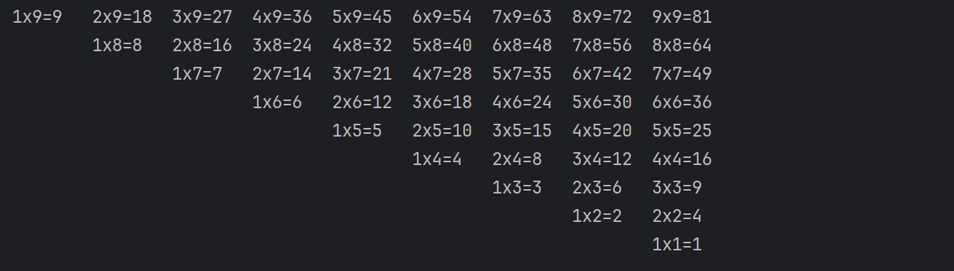
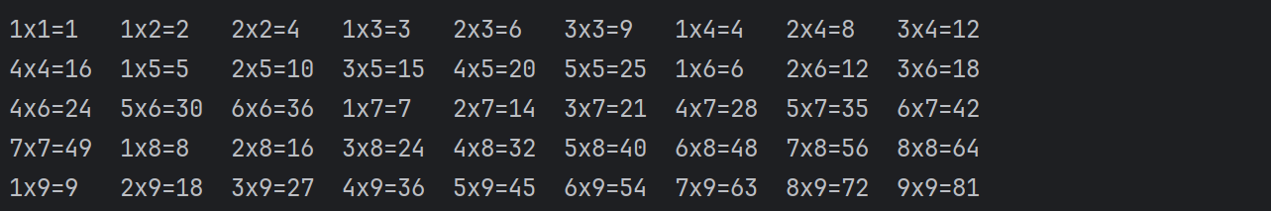

4.14.3求直角三角形面积周长和角度

代码
import math

a = float(input("请输入直角三角形的直角边a(a>0): "))
b = float(input("请输入直角三角形的直角边b(b>0): "))
c = math.sqrt(a ** 2 + b ** 2)
S = round(a * b / 2, 1)
C = round(a + b + c, 1)
A = math.asin(a / c) * 180 / math.pi
B = math.acos(a / c) * 180 / math.pi

print('直角三角形三边分别为: a=%.1f, b=%.1f, c=%.1f' % (a, b, c))
print(f'三角形的周长 = {C}, 面积 = {S}')
print('三角形两个锐角的度数分别为: %.1f 和 %.1f' % (A, B))

运行结果
