第三次python上机作业

4.14.11中国余数

代码
# 用3除余2 用5除余3 用7除余2

print("0-1000中,用3除余2, 用5除余3, 用7除余2的数有: ")
for i in range(1001):
if i % 3 == 2 and i % 5 == 3 and i % 7 == 2:
print(i, end=" ")

运行结果
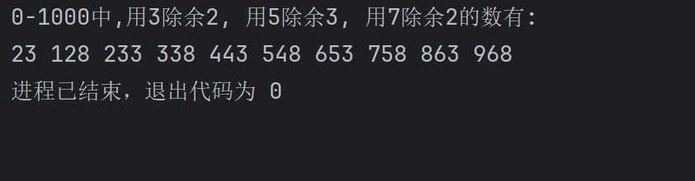

5.11..2统计字符串中字母数字空格和其它字符的个数

代码
str = input("请输入字符串: ")
alphabet_count = 0
number_count = 0
space_count = 0
others_count = 0
total = 0

for i in str:
if i.isalpha():
alphabet_count += 1
elif i.isdigit():
number_count += 1
elif i.isspace():
space_count += 1
else:
others_count += 1
total = alphabet_count + number_count + space_count + others_count
print(f'''
所有字符的总数为: {total}
英文字母出现的次数: {alphabet_count}
数字出现的次数: {number_count}
空格出现的次数: {space_count}
其它字符出现的次数: {others_count}
''')

运行结果
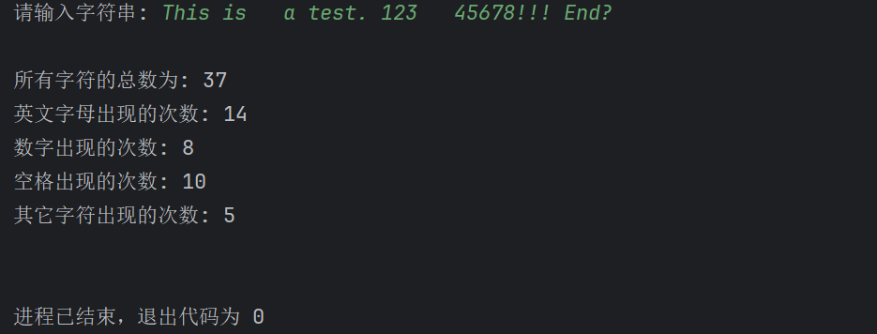

5.11.4列表去重

代码
def remove_duplicates(iterable):
iterable = set(iterable)
return list(iterable)

my_list = [1, 2, 3, 4, 5, 5, 6, 2, 3, 7, 7, 8, 8, 9, 10]
print(f"去重前: {my_list}")
list_remove_duplicates = remove_duplicates(my_list)
print(f"去重后: {list_remove_duplicates}")

运行结果
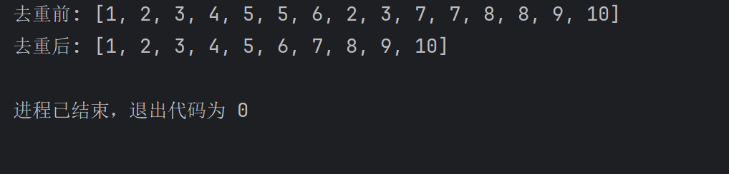

5.11.5求列表元素个数最大值最小值和平均值

代码
from numpy.ma.extras import average

s = [9, 7, 8, 3, 2, 1, 55, 6]

# 方法一
count = len(s)
max_s = max(s)
min_s = min(s)
sum_s = sum(s)
average_s = average(s)
print(f"元数个数: {count}, 最大值: {max_s}, 最小值: {min_s}, 元素之和: {sum_s}, 平均值: {average_s}")

# 方法二
count = 0
max_s = s[0]
min_s = s[0]
sum_s = 0
average_s = 0
for item in s:
count += 1
if item > max_s:
max_s = item
elif item < min_s:
min_s = item
sum_s += item
average_s = sum_s / count
print(f"元数个数: {count}, 最大值: {max_s}, 最小值: {min_s}, 元素之和: {sum_s}, 平均值: {average_s}")

运行结果
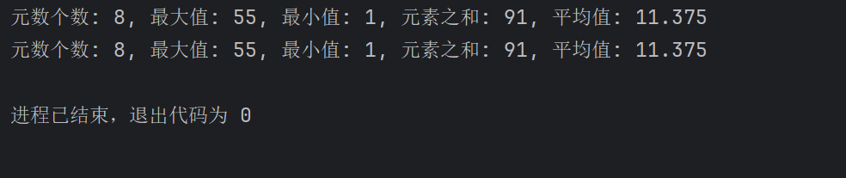

5.11.9学号成绩字典

代码
studs = [{'sid': '103', 'Chinese': 90, 'Math': 95, 'English': 92},
{'sid': '101', 'Chinese': 80, 'Math': 85, 'English': 82},
{'sid': '102', 'Chinese': 70, 'Math': 75, 'English': 72}]
scores = {}
for stud in studs:
sid = stud['sid']
Chinese = stud['Chinese']
Math = stud['Math']
English = stud['English']
score = [Chinese, Math, English]
scores[sid] = score
scores = dict(sorted(scores.items(), key=lambda x: x[0]))
for sid, score in scores.items():
print(f"{sid}: {score}")

运行结果
