第二次python上机作业

3.7.13求n的阶乘

代码
import math

n = 0
while True:
n = input("请输入非负整数: ")
n = float(n)
if n >= 0 and n == math.floor(n):
n = int(n)
break

sum = 1
for i in range(1, n + 1):
sum *= i
print(f"while循环: {n}! = {sum}")

sum = 1
i = n
while i >= 1:
sum *= i
i -= 1
print(f"for循环: {n}! = {sum}")

运行结果
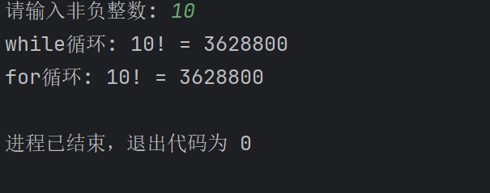

3.7.16求三位数的个十百位上的数字

代码
a = int(input("请输入一个三位自然数: "))

# 方法一
ones_place = a % 10
tens_place = a // 10 % 10
hundreds_place = a // 100 % 10

print(f"方法一: {hundreds_place} {tens_place} {ones_place}")

# 方法二
b, ones_place = divmod(a, 10)
c, tens_place = divmod(b, 10)
_, hundreds_place = divmod(c, 10)
print(f"方法二: {hundreds_place} {tens_place} {ones_place}")

# 方法三
hundreds_place, tens_place, ones_place = map(int, str(a))
print(f"方法三: {hundreds_place} {tens_place} {ones_place}")

运行结果
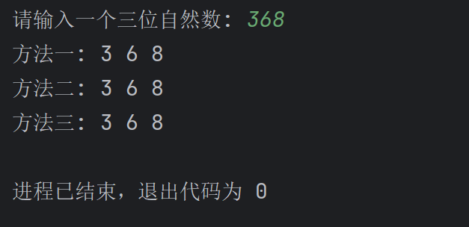

3.7.18自幂数

代码
n = int(input("请输入自幂数位数(>=1且<=10): "))

count = 0
digit_list = []
# 预存0-9的n次方
catch = [i ** n for i in range(10)]
start, end = pow(10, n-1), pow(10, n)
for digit in range(start, end):
sum = 0
temp = digit
# digit_per_list = list(map(int, str(digit)))
# for digit_per in digit_per_list:
# sum += pow(digit_per, n)
while temp > 0:
per = temp % 10
sum += catch[per]
if sum > digit:
break
temp = temp // 10
if sum == digit:
count += 1
digit_list.append(digit)
if n == 1:
print(f"独身数{count}个: {digit_list}")
elif n == 2:
print(f"两位数没有自幂数{count}个: {digit_list}")
elif n == 3:
print(f"水仙花数{count}个: {digit_list}")
elif n == 4:
print(f"玫瑰花数{count}个: {digit_list}")
elif n == 5:
print(f"五角星数{count}个: {digit_list}")
elif n == 6:
print(f"六合数{count}个: {digit_list}")
elif n == 7:
print(f"北斗七星数{count}个: {digit_list}")
elif n == 8:
print(f"八仙数{count}个: {digit_list}")
elif n == 9:
print(f"九九重阳数{count}: {digit_list}")
elif n == 10:
print(f"十全十美数{count}: {digit_list}")

运行结果
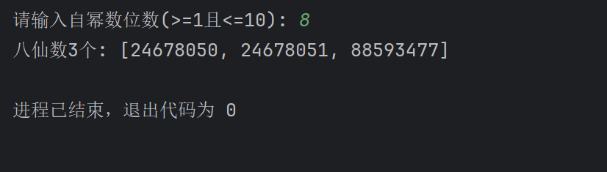

4.14.2杨辉三角

代码
def get_pascals_triangle(n: int):
# 数据
triangle = []

# 将每行数据初始化为1
for i in range(n):
row = [1] * ( i + 1)
# 计算中间元素的值
for j in range(1, i):
row[j] = triangle[i - 1][j - 1] + triangle[i - 1][j]
triangle.append(row)
return triangle # list[list]

n = int(input("请输入要打印杨辉三角的行数: "))

triangle = get_pascals_triangle(n)

for i, row in enumerate(triangle):
for k in range(n-i-1):
print('', end='\t')
for col in row:
print(col, end='\t\t')
print()

运行结果
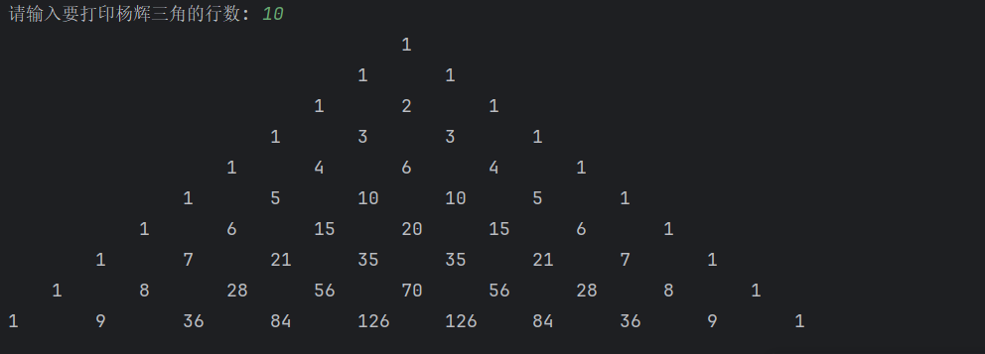

4.14.4排序

代码
import math
import random

a = math.floor(random.random() * 101)
b = math.floor(random.random() * 101)
c = math.floor(random.random() * 101)
print(f"原始值: a = {a}, b = {b}, c = {c}")

# 方法一
x, y, z = a, b, c
if x > y:
x, y = y, x
if x > z:
x, z = z, x
if y > z:
y, z = z, y
print(f"(方法一)升序值: a = {x}, b = {y}, c = {z}")

# 方法二
min_number = min(a, b, c)
max_number = max(a, b, c)
sum = a + b + c
second = sum - min_number - max_number
print(f"(方法二)升序值: a = {min_number}, b = {second}, c = {max_number}")

# 方法三
x, y, z = sorted([a, b, c])
print(f"(方法三)升序值: a = {x}, b = {y}, c = {z}")

运行结果
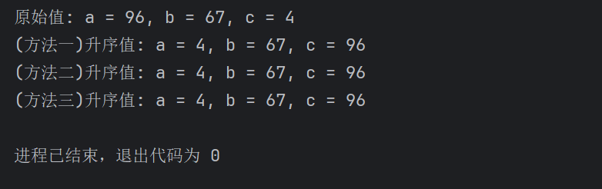

4.14.6计算器

代码
x = input("请输入操作数x: ")
y = input("请输入操作数y: ")
op = input("请输入操作符: ")
result = 0
try:
x = float(x)
y = float(y)
if op == "+":
result = x + y
elif op == "-":
result = x - y
elif op == "*":
result = x * y
elif op == "/":
result = x / y
elif op == "%":
result = x % y
else:
print("操作符不合法")
except ZeroDivisionError:
print("分母 = 0, 零除异常!")
except ValueError:
print("操作数不合法!")
else:
print(f"{x} {op} {y} = {result}")

运行结果
