第五次python上机作业

6.15.11成绩统计

数据

代码
# 存储每个学生学号及对应成绩到字典中
stu_dict = {}
with open("class_score.txt", "r", encoding="utf-8") as f:
for line in f:
stu_id = line.split(" ")[0]
score_chinese = float(line.split(" ")[1])
score_math = float(line.split(" ")[2])
stu_dict[stu_id] = (score_chinese, score_math)

# 分别计算语文和数学的平均分,保留1位小数
total_chinese = 0
total_math = 0
for scores in stu_dict.values():
total_chinese += scores[0]
total_math += scores[1]
avg_chinese = round(total_chinese / len(stu_dict), 1)
avg_math = round(total_math / len(stu_dict), 1)
print(f"全班语文成绩的平均分为{avg_chinese} ,数学成绩的平均分为{avg_math}")

# 输出两门课都不及格学生的学号和成绩
print("两门课都不及格的学生信息如下:")
for stu_id in stu_dict:
score_chinese = stu_dict[stu_id][0]
score_math = stu_dict[stu_id][1]
if score_chinese < 60 and score_math < 60:
print(stu_id, score_chinese, score_math)

# 输出两门课平均分>=90的学生的学号,语文成绩, 数学成绩, 平均成绩
print("两门课成绩的平均分在90分以上的学生信息如下:")
for stu_id in stu_dict:
score_chinese = stu_dict[stu_id][0]
score_math = stu_dict[stu_id][1]
avg_chinese_math = (score_chinese + score_math) / 2
if avg_chinese_math >= 90:
print(stu_id, score_chinese, score_math, avg_chinese_math)

运行结果
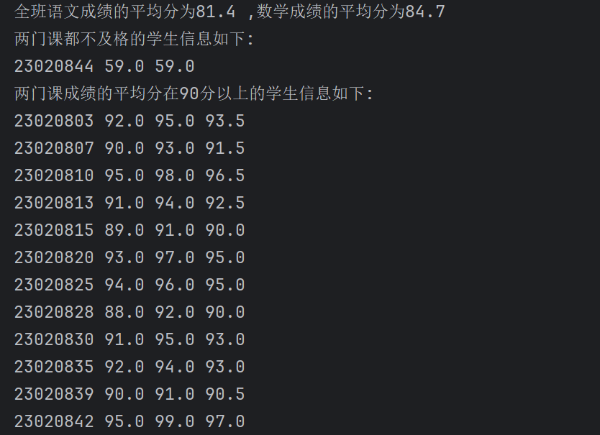

8.11.2求阶乘

代码
def fact_1(n):
if n == 0 or n == 1:
return 1
return n * fact_1(n - 1)

def fact_2(n):
ret = 1
while n > 1:
ret *= n
n -= 1
return ret

n = int(input("请输入整数n(n>=0): "))
print(f"{n}! = {fact_1(n)}")
print(f"{n}! = {fact_2(n)}")

运行结果
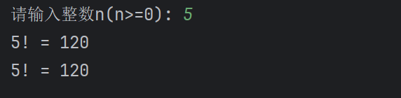

8.11.3斐波那契数列

代码
def fib(n = 0):
if n <= 0:
return -1
if n <= 2:
return 1
return fib(n - 1) + fib(n - 2)

def get_n_fib(n = 0):
if n <= 0:
return -1
i = 1
while i <= n:
if i % 10 == 0:
print(f"{fib(i):5}")
else:
print(f"{fib(i):5}", end="")
i += 1

get_n_fib(20)

运行结果
