第四次python上机作业

5.11.6偶数平方

代码
s = [9, 7, 8, 3, 2, 1, 5, 6]

print(f"交换前: s= {s}")

# 偶数平方, 奇数不变
for i, e in enumerate(s):
if e % 2 == 0:
s[i] = e ** 2

print(f"交换后: s= {s}")

运行结果
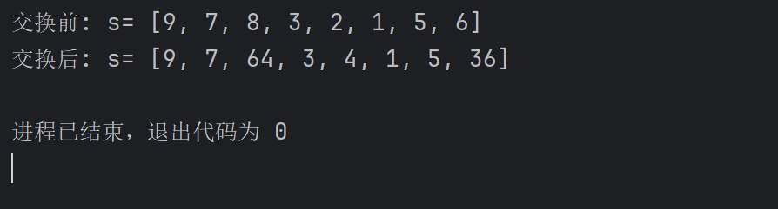

5.11.7字符串转ascll码表

代码
s_str = input("请输入一个字符串:")

# 用于存放ascll码
s_list = []

for i in s_str:
s_list.append(ord(i))

print(s_list)

运行结果
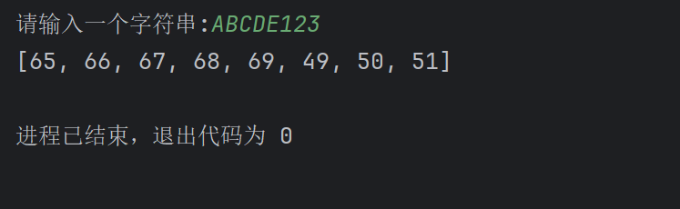

5.11.8字典

代码
weekday_dict = {1:"Monday", 2:"Tuesday", 3:"Wednesday", 4:"Thursday",5:"Friday", 6:"Saturday", 7:"Sunday"}

# 输出键
for k in weekday_dict:
print(k, end=" ")

print()

# 输出值
for v in weekday_dict.values():
print(v, end=" ")

print()

# 输出键值对(元组形式)
for k, v in weekday_dict.items():
print((k, v), end=" ")

运行结果
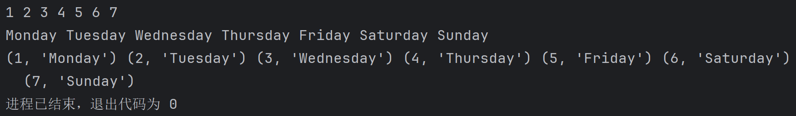

5.11.11回文字符串

代码
s = input("输入字符串: ")
# 方法一
if s == s[::-1]:
print(f"方法一: {s}是回文字符串")

# 方法二
s_reverse_list = list(reversed(s))
if list(s) == s_reverse_list:
print(f"方法二: {s}是回文字符串")

# 方法三
if s == "".join(reversed(s)):
print(f"方法三: {s}是回文字符串")

# 方法四
flag = True
for i, e in enumerate(s):
if e != s[len(s) - i - 1]:
flag = False
break
if flag:
print(f"方法四: {s}是回文字符串")

# 方法五
def check(s: str) -> bool:
left, right = 0, len(s) - 1
if left >= right:
return True
if s[left] != s[right]:
return False
else:
return check(s[left + 1:right])

if check(s):
print(f"方法五: {s}是回文字符串")

运行结果
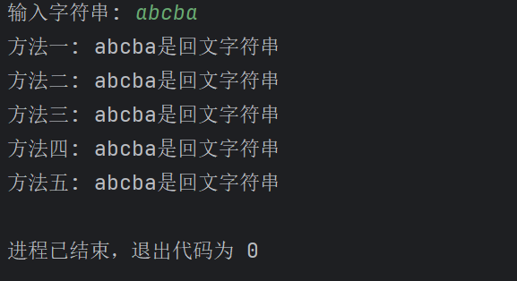

6.15.7随机密码

代码
import random

# 随机数种子
random.seed(0x1010)

# 生成10个随机密码, 长度为10, 由字母大小写, 数字以及"!,@,#,$,%,^,&,*"八个特俗符号组成, 每个密码首字符不能一样

characters = "abcdefghijklmnopqrstuvwxyzABCDEFGHIJKLMNOPQRSTUVWXYZ0123456789!@#$%^&*"
password_first_char_list = []
with open("随机密码.txt", "w", encoding="utf-8") as f:
for _ in range(10):
password = ""

# 生成首字符
while True:
first_char = random.choice(characters)
if first_char not in password_first_char_list:
password += first_char
password_first_char_list.append(first_char)
break
# 生成剩余9个字符
for i in range(9):
password += random.choice(characters)

# 将密码写入文件
f.write(password + '\n')

运行结果
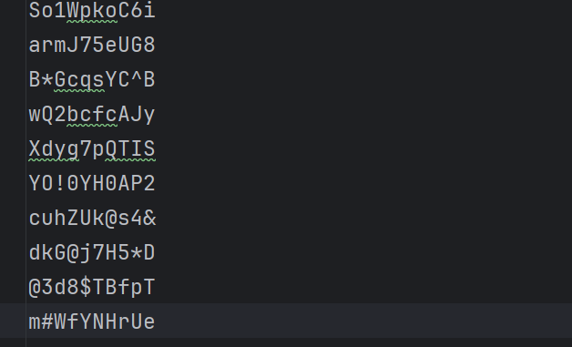

8.11.5可变参数函数求最小值

代码
def min_n(a, b, *c):
min_value = a if a < b else b
for i in c:
if i < min_value:
min_value = i
return f"最小值为 {min_value}"

print(min_n(8, 2))
print(min_n(16, 1, 7, 4, 15))

运行结果
