PROG103 - PRINCIPLE OF STRUCTURED PROGRAMMING FINAL GROUP PROJECT
HarvestHelp SL: GUI-Based Agriculture Support System

Group Name: BIT1203F GROUP 2

Class: BIT1203F

Examiner: Elijah Fullah Submission Deadline: Week 11

Project Rationale
HarvestHelp SL is a GUI-based Python application designed to support smallholder farmers in Sierra Leone. Agriculture is an important source of income and food for many households, but many farmers still make planting and sales decisions using rough estimates. A farmer may know the crop they want to grow, but may not clearly estimate the seed required, total production cost, expected yield, likely revenue and final profit before investing money. This can lead to weak planning, unnecessary debt and poor market decisions.
The system focuses on a practical problem: helping farmers make basic production decisions before the planting season. The user enters farmer name, district, crop, land size, seed cost, fertilizer cost, labor cost, expected price per kilogram and risk level. The program then processes the data and produces a clear result showing seed requirement, expected yield, district-adjusted market price, estimated revenue, total cost, estimated profit, decision status and farming advice. This makes the system useful for students, extension workers, farmer groups and small community agriculture offices.
The selected project area is Agriculture Support System. It is unique because it combines farm planning, simple financial projection and local district market adjustment in one beginner-friendly GUI. It does not try to be an advanced commercial agriculture platform; instead, it is designed to demonstrate structured programming principles while solving a real Sierra Leone community problem. The interface is simple, clean and functional, which matches the project brief and supports users who may not be comfortable with terminal-based programs.
The project aligns with SDG 2: Zero Hunger. Better farm planning can improve productivity, reduce wasted inputs and support household food security. It also relates to SDG 8 because profitable farm planning supports decent work and local economic growth. By exporting farm projections to CSV, the system also supports data accessibility and interoperability, allowing records to be reused in spreadsheets or shared with agriculture support officers.

- System Explanation
The application allows a user to enter farmer name, district, crop, land size, seed cost, fertilizer cost, labor cost, expected market price and production risk level. It then calculates seed required, expected yield, adjusted district price, estimated revenue, total cost, profit and decision status. Results are displayed in a formatted output area and can be exported to CSV for data accessibility.

Structured Programming Application
The program demonstrates structured programming through constants, variables, dictionaries, functions, decision structures, loops and separated modules. GUI code is placed in a class, while calculation and formatting functions remain separate from interface code. The source file includes more than three user-defined functions: safe_float, calculate_projection, format_currency, build_result_text and main.
Decision structures are used for input validation and profit classification. Loops are used to clear fields, save multiple records to CSV and build interface elements. Meaningful names and comments are used to improve readability.

Data, Privacy and Compliance
The system stores only basic farm planning records. It avoids unnecessary sensitive information and exports records locally as CSV so users can access and reuse their data. Ethical use of data is supported by transparency: farmers can see what they entered and how the result is calculated. Interoperability is supported through CSV export.

Open Source Standards
The project is prepared for GitHub publication under the MIT License. The repository includes README.md, LICENSE, Python source code, screenshots, diagrams and documentation. The recommended repository name is PROG103_FinalProject_Class BIT1203F GROUP 2.

Functional Requirements Mapping

Requirement | How HarvestHelp SL satisfies it
Input module | Entry fields and combo boxes collect farmer, crop,  district, acres, costs, price and risk.
Processing module | Functions calculate yield, seed needs, revenue, total  cost, profit and status.
Output module | Text output area displays clear formatted results and  farming advice.
GUI requirements | Labels, entries, buttons, output display, simple layout  and clean colors are included.
Structured programming | Variables, data types, decisions, loops and more than  three user-defined functions are used.

Diagrams and Screenshots System Structure Diagram
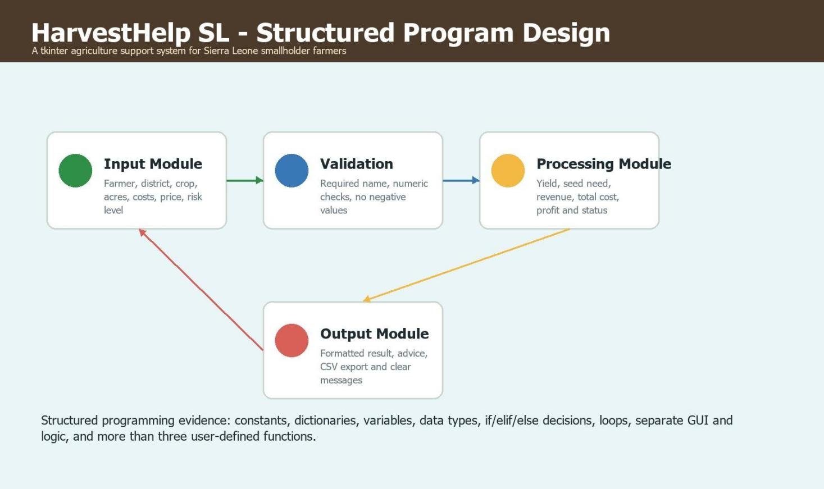

Program Flowchart
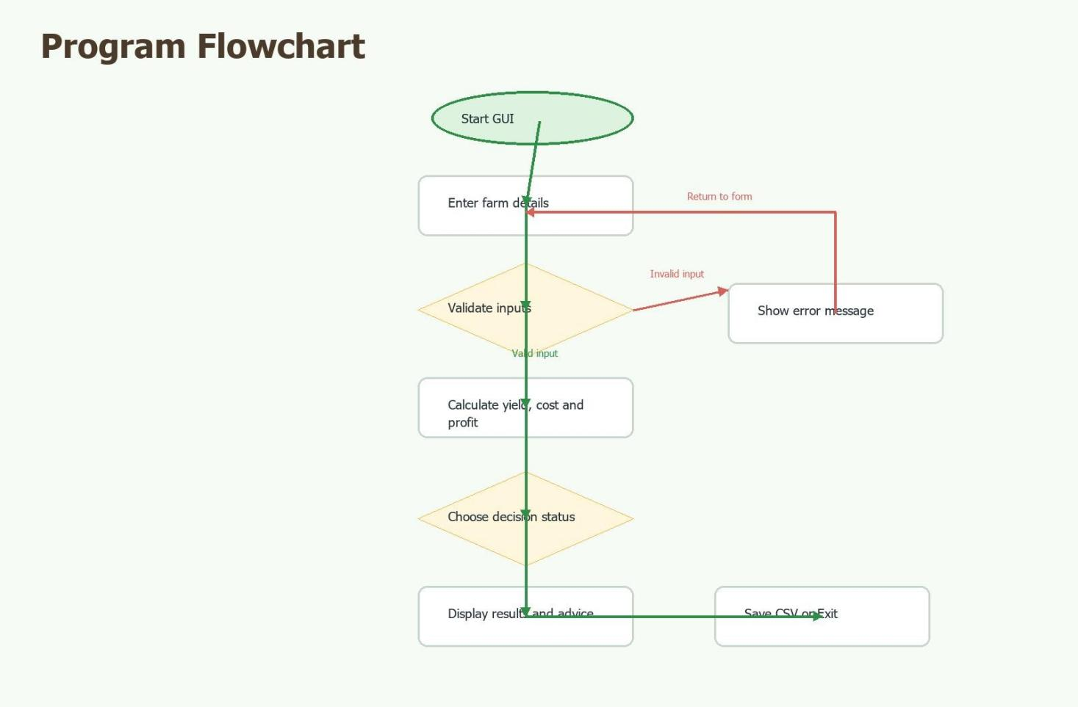

System Screenshot 1
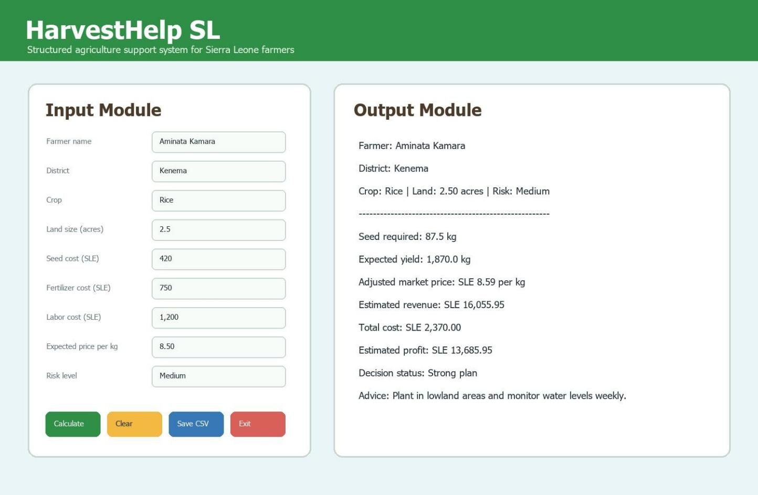

System Screenshot 2
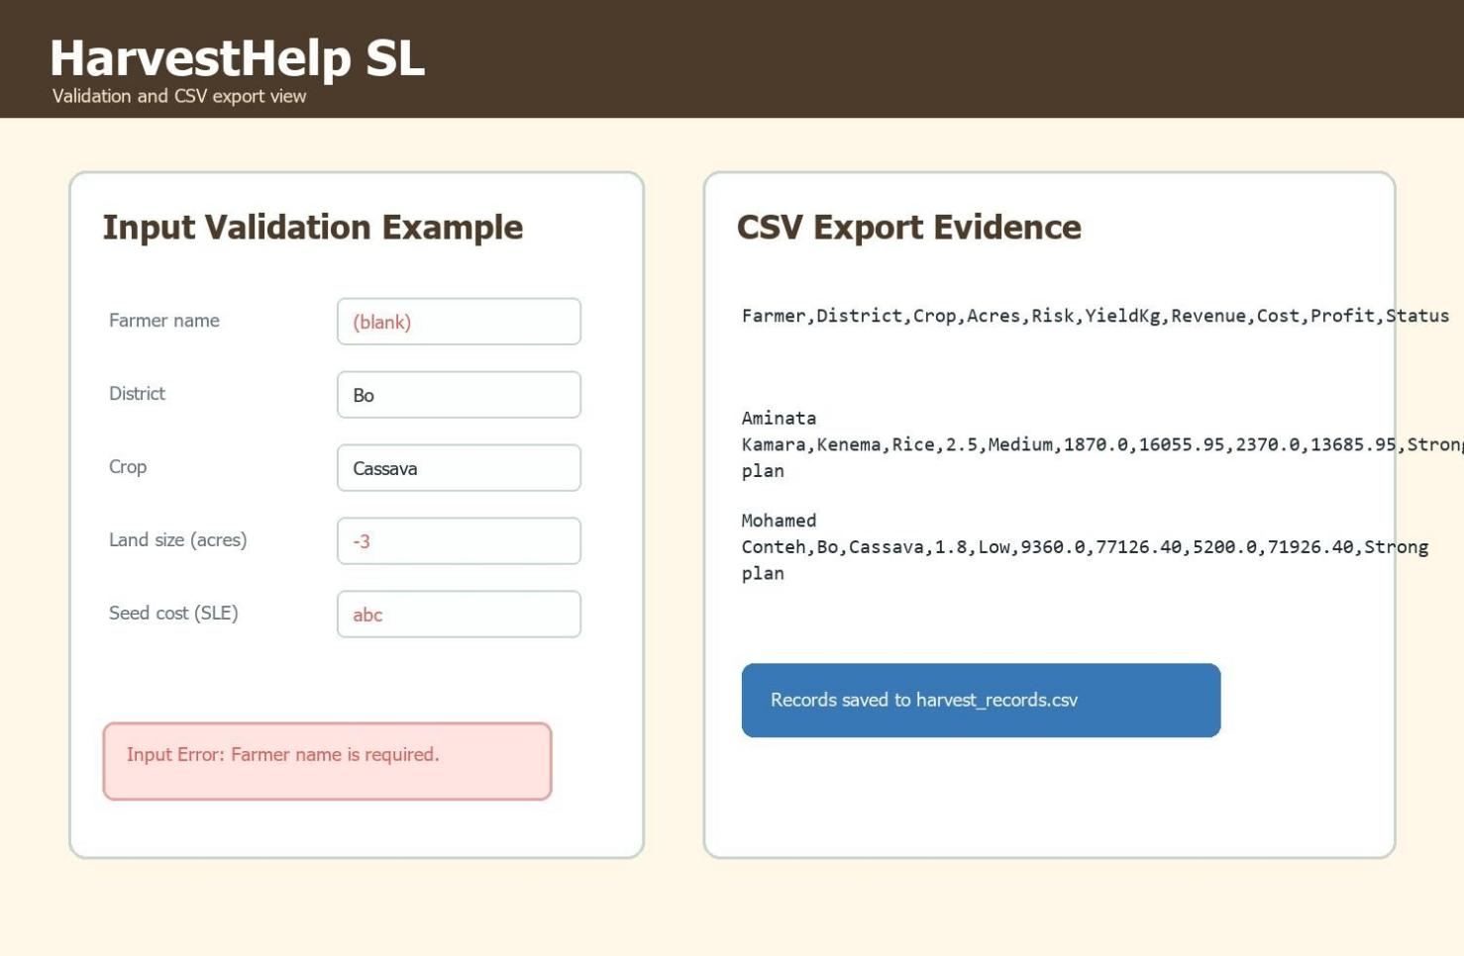

Source Code Screenshot 1
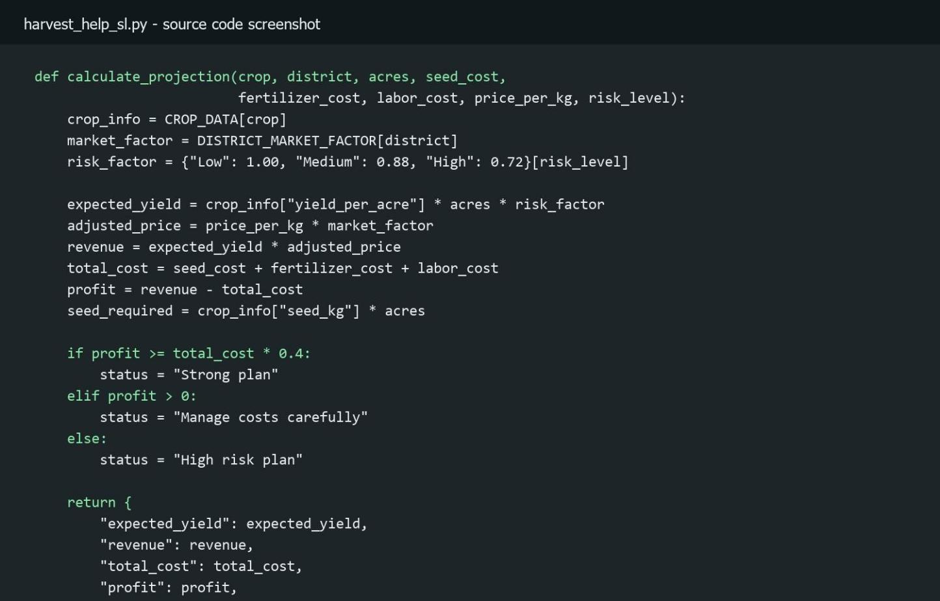

Source Code Screenshot 2
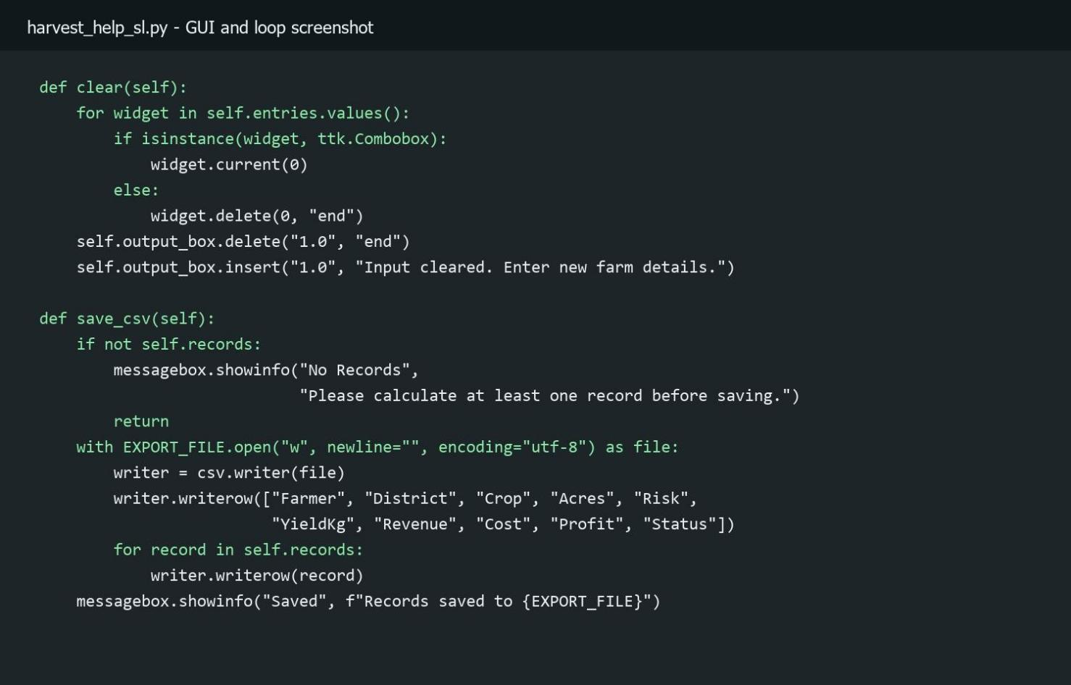

GitHub Evidence Screenshot
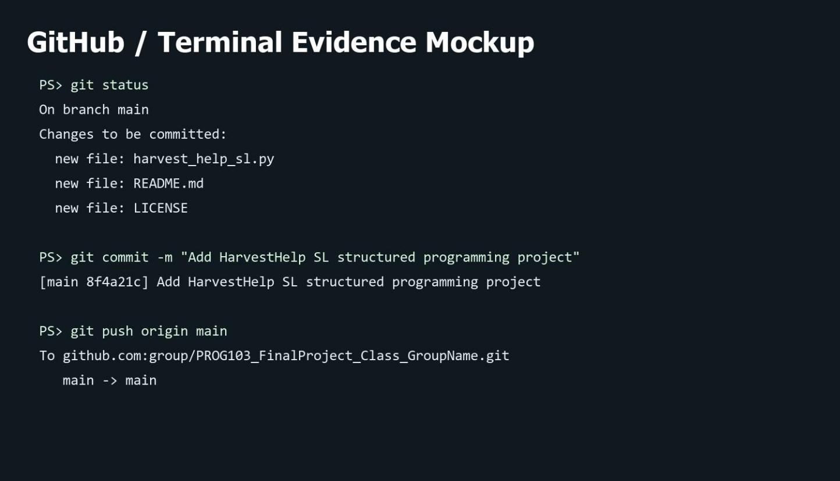

Conclusion
HarvestHelp SL meets the PROG103 final project requirements by providing a GUI-based Python system that solves a real Sierra Leone agriculture problem, applies structured programming principles, supports open-source submission, considers privacy and data accessibility, and provides a clean user experience for demonstration.

