

**NORTH DAKOTA PHYSICAL EDUCATION CONTENT STANDARDS GRADES K–12**

**JULY 2024**

North Dakota Department of Public Instruction Kirsten Baesler, State Superintendent 600 East Boulevard Avenue, Dept. 201 Bismarck, North Dakota 58505-0440

[www.nd.gov/dpi](http://www.nd.gov/dpi)

### DOCUMENT REVISION LOG

|  |  |  |
| --- | --- | --- |
| **Date Revised** | **Description of Revision** | **Page** |
|  |  |  |
|  |  |  |
|  |  |  |
|  |  |  |
|  |  |  |

**CONTENTS**

DOCUMENT REVISION LOG 2

ND PHYSICAL EDUCATION CONTENT STANDARDS WRITING COMMITTEE 5

ND PHYSICAL EDUCATION CONTENT STANDARDS REVIEW COMMITTEE 5

PROJECT SUPPORT STAFF 5

SUPERINTENDENT’S FOREWORD 6

INTRODUCTION 7

HOW TO READ THE STANDARDS 8

ELEMENTARY MOTOR SKILLS DEVELOPMENT 10

ELEMENTARY KNOWLEDGE TO MOVE 15

ELEMENTARY PERSONAL AND SOCIAL SKILLS 16

ELEMENTARY MOTIVATED TO MOVE 17

MIDDLE SCHOOL MOTOR SKILLS DEVELOPMENT 18

MIDDLE SCHOOL KNOWLEDGE TO MOVE 20

MIDDLE SCHOOL PERSONAL AND SOCIAL SKILLS 22

MIDDLE SCHOOL MOTIVATED TO MOVE 24

HIGH SCHOOL MOTOR SKILLS DEVELOPMENT 25

HIGH SCHOOL KNOWLEDGE TO MOVE 27

HIGH SCHOOL PERSONAL AND SOCIAL SKILLS 29

HIGH SCHOOL MOTIVATED TO MOVE 31

CONTENT STANDARDS SKILLS PROGRESSIONS 32

HOW TO READ THE SKILLS PROGRESSIONS 33

K-12 Motor Skills Development 34

K-12 Knowledge to Move 38

K-12 Personal and Social Skills 41

K-12 Motivated to Move 43

GLOSSARY 45

APPENDICES 49

Appendix A – Quality Resources to Enhance Instruction 49

Appendix B – Movement Wheel 50

Appendix C – Cues for Fundamental Movement Skills 51

Appendix D – Rating of Perceived Exertion 52

Appendix E – Tips for Monitoring Aerobic Exercise Intensity 53

Appendix F – Muscle Diagram 54

REFERENCES 55

|  |  |  |  |
| --- | --- | --- | --- |
| *Samuel Burns Fargo Public Schools* | *Dr. Kelsey Higginson Minot State University* | *Alaina Reller*  *West Fargo Public Schools* | *Cassandra Torrance Wahpeton Public Schools* |
| *Alyssa Cool West Fargo Public*  *Schools* | *Heather Kramer Turtle Lake-Mercer Public*  *Schools* | *Nicole Seyfried*  *West Fargo Public Schools* | *Madalyn Vaudrin Central Cass Public Schools* |
| *Kate Cristaldi Bowman Co. Public Schools* | *Nicole Lindgren Minot Public Schools* | *Jason Steele Minot Public Schools* | *Leah Wheeling Bismarck Public Schools* |
| *Tyler Hetland Fargo Public Schools* | *Sheila Peterson Bismarck Public Schools* | *Leah Swedberg West Fargo Public Schools* | *Dr. Jenny Linker Zarak North Dakota State University* |

### ND PHYSICAL EDUCATION CONTENT STANDARDS REVIEW COMMITTEE

|  |  |
| --- | --- |
| *Dr. Brandon Foye General Public* | *Krysten Stutlien Community Leader* |

### PROJECT SUPPORT STAFF

|  |  |  |  |
| --- | --- | --- | --- |
| *Davonne Eldredge Assistant Director Academic Support NDDPI* | *Ann Ellefson Director Academic Support NDDPI* | *Michelle Woodcock Special Education Coordinator Specially Designed Services*  *NDDPI* | *Jane Gratz Staff Support*  *Academic Support NDDPI* |

In North Dakota, our schools are committed to helping children grow in every way. As learners grow and develop, they need to develop not only cognitive skills but also the skills and knowledge that will allow them to enjoy physical activities and stay healthy throughout their lives.

The new North Dakota K-12 Physical Education Content Standards were designed to help learners develop motor skills and fitness concepts, learn to work effectively in teams, and understand the importance of maintaining an active lifestyle. These standards provide schools with basic guidelines to assist instruction and introduce learners to activities they can participate in throughout their lives.

The North Dakota Department of Public Instruction convened a committee of physical education professionals from across the state to create these new standards. This group started their work in October 2023 and completed it in June 2024. As part of this process, they produced drafts that were shared with the public and a review committee to obtain feedback, which was later used to revise the standards.

No one is better qualified to prepare our schools' physical education content standards than our North Dakota educators. We are grateful to the physical educators on this committee for their dedication to ensuring our learners have the tools they need to pursue a healthy lifestyle.

The new standards are a resource for schools to use as they develop their physical education programs. With these standards, we hope all learners in North Dakota will have the skills and motivation to lead healthy, active lives.

These new standards reflect North Dakota’s commitment to a well-rounded education. We recognize that physical education plays a crucial role in improving cognitive skills, promoting sustained health, and encouraging lifelong healthy habits. We are proud to support our schools and educators in this important way.

Sincerely, Kirsten Baesler

North Dakota State Superintendent of Public Instruction

North Dakota’s Physical Education Content Standards are a result of a commitment to enhancing physical literacy and the development of well-rounded learners. The standards serve as an important framework designed to ensure consistency and quality across the state.

The Physical Education Content Standards encourage exploration and reflection. These standards are based on the belief that physical education is crucial to the development of the whole child, encompassing physical, mental, emotional, and social well-being. Additionally, physical activity improves cognitive skills that support learning and promote positive behaviors. By developing knowledge, skills, confidence, and motivation, these standards equip learners to pursue lifelong physical activity, allowing them to engage positively within their communities. The focus on enjoyable and meaningful physical activities helps build a foundation for lifelong habits that contribute to sustained health and wellness.

Adapted from the SHAPE America National Physical Education Standards Educator Kit (2024), the North Dakota Physical Education Content Standards are essential for maintaining consistency and quality across educational programs. They guide teachers, administrators, and policymakers in curriculum design, resource allocation, and assessment of learner progress.

The new standards make four notable changes:

* a more learner-centered approach through personal exploration and reflection
* an expansion from physical literacy to a physical literacy journey showing a holistic approach through physical education and beyond
* a shift to grade spans to include multiple grade levels and stages of development
* changing to four domains embedding health-related fitness into those domains

The development of the new standards was a collaborative effort initiated by State Superintendent of Public Instruction Kirsten Baesler in November 2023. A diverse team of physical education professionals representing all instructional levels, from elementary to university, was assembled to draft the standards. This committee leveraged insights from state and national standards, particularly drawing from the 2024 SHAPE America Physical Education Standards. Public feedback and review played a role in refining the standards, ensuring they meet the needs and expectations of the community while being inclusive of all learners. By promoting a culture of lifelong physical activity and health, these standards not only contribute to the personal growth of individuals but also prepare them to thrive as healthy, capable members of their communities, setting the foundation for future generations.

The standards are organized into four main domains: Motor Skills Development, Knowledge to Move, Personal and Social Skills, and Motivated to Move, broken into smaller sub-domains under each main domain and finally into individual standards under each sub-domain. The standards in grades K-5 are organized in two bands to provide flexibility for developmental levels. In grades 6-8, the standards are organized by grade level to allow more focus on skills at particular levels. In grades 9-12, the standards are organized into two levels. Skills in level one are taught in required courses. The level two skills build upon those skills and are taught in elective courses.

**K-8**

**Motor Skill Development (MSD)**

**DOMAIN**

*The learner will utilize movement skills to engage at a participant level of proficiency in a variety of physical activities.*

Rationale: The learner develops a variety of motor skills for use in physically active settings, which increases the learner’s ability and motivation to participate in an active lifestyle.

**STANDARDS**

**CODING EXAMPLE**

K-2 Skills may include:

* Walking, running, hopping
* Shuffle, gallop
* Skip, leap

3-5 Skills may include:

* Chasing
* Fleeing
* Dodging

**3-5.MSD.1 Locomotor.** Demonstrate a variety of locomotor skills in a dynamic environment with developmentally appropriate techniques.

**K-2.MSD.1 Locomotor.** Demonstrate a variety of locomotor skills in a non- dynamic environment with developmentally appropriate techniques.

**CLARIFICATIONS**

**GRADE 3-5 STANDARDS**

**KINDERGARTEN-GRADE 2 STANDARDS**

**SU**

**Fundamental Movement and Combinations (Locomotor)**

**B-DOMAIN**

**CLARIFICATIONS**

**K-2 – Grade Span MSD – Domain**

**1 – Standard Number**

**L1 – Level MSD – Domain**

**Motor Skill Development (MSD)**

**DOMAIN**

*The learner will utilize movement skills to engage at a participant level of proficiency in a variety of physical activities.*

Rationale: The learner develops a variety of motor skills for use in physically active settings, which increases the learner’s ability and motivation to participate in an active lifestyle.

**Fundamental Movement and Combinations** *NOTE: The Fundamental Movement and Combination standards had been mastered by the end of eighth grade.*

**SUB-DOMAIN**

**CLARIFICATIONS**

**CODING EXAMPLE**

Individual and dual activities may include:

* target games (e.g., bocce, cornhole, bowling)
* outdoor pursuits (e.g., rock climbing, kayaking, hiking, skating, snowshoeing)
* combat (e.g., Tae kwon do, jiu- jitsu, self-defense)
* aquatics (e.g., swimming, aerobics, lifesaving skills)

**EL**

**L2.MSD.1** Demonstrate proficiency in advanced activity-specific movement skills in a variety of lifetime physical activities (individual or dual).

**LEV**

**L1.MSD.1** Demonstrate proficiency in activity-specific movement skills in a variety of lifetime physical activities (individual or dual).

**LEVEL 2**

**LEVEL 1**

**Specialized Movement and Combinations**

**CLARIFICATIONS**

**1 – Level Number**

|  |  |  |
| --- | --- | --- |
| **Motor Skill Development (MSD)**  *The learner will utilize movement skills to engage at a participant level of proficiency in a variety of physical activities.*  Rationale: The learner develops a variety of motor skills for use in physically active settings, which increases the learner’s ability and motivation to participate in an active lifestyle. | | |
| **Fundamental Movement and Combinations (Locomotor)** | | |
| **KINDERGARTEN-GRADE 2 STANDARDS** | **GRADE 3-5 STANDARDS** | **CLARIFICATIONS** |
| **K-2.MSD.1 Locomotor.** Demonstrate a variety of locomotor skills in a non-dynamic environment with developmentally appropriate techniques. | **3-5.MSD.1 Locomotor.** Demonstrate a variety of locomotor skills in a dynamic environment with developmentally appropriate techniques. | K-2 Skills may include:   * walking, running, hopping * shuffle, gallop * skip, leap |
|  |  | 3-5 Skills may include:   * chasing * fleeing * dodging See Appendix B |
| **Fundamental Movement and Combinations (Non-Manipulative)** | | |
| **K-2.MSD.2 Jumping.** Demonstrate jumping and landing on, off, and over objects in a non- dynamic environment. | **3-5.MSD.2 Jumping.** Demonstrate jumping and landing in a dynamic environment. | Skills may include:   * standing broad jump * jumping off steps on the playground * jumping over objects (e.g., jumping the creek)   See Appendix B and C |
| **K-2.MSD.3 Balancing/Weight Transfer.** Demonstrate balancing and weight transfer on different body parts in a non-dynamic environment. | **3-5.MSD.3 Balancing/Weight Transfer.** Demonstrate balancing and weight transfer on different body parts in a dynamic environment. | Static Balancing skills may include:   * handstand * tripod * tree pose |
|  |  | Dynamic Weight Transfer skills may include:   * cutting/Juking * burpees * hee-haw (donkey kick) * jumping jacks * hands down, jump around See Appendix B and C |

|  |  |  |
| --- | --- | --- |
| **Fundamental Movement and Combinations (Non-Manipulative)** | | |
| **KINDERGARTEN-GRADE 2 STANDARDS** | **GRADE 3-5 STANDARDS** | **CLARIFICATIONS** |
| **K-2.MSD.4 Gymnastics.** Demonstrate safety body rolling actions. | **3-5.MSD.4 Gymnastics.** Demonstrate gymnastic movements. | K-2 Skills may include:   * forward roll * log roll * egg roll   3-5 Skills may include:   * cartwheel * wall walk * handstand * hip circle See Appendix B |
| **K-2.MSD.5 Dance/Movement.** Demonstrate locomotor, non-locomotor, and manipulative movements based on various rhythmic movements. | **3-5.MSD.5 Dance/Movement.** Combine locomotor, non-locomotor, and manipulative movements based on various rhythmic movements. | Skills may include:   * various styles of dance * rhythmic movement activities – cardio drumming, scarf dancing, parachute routines   See Appendix B |

|  |  |  |
| --- | --- | --- |
| **Fundamental Movement and Combinations (Manipulative)** | | |
| **KINDERGARTEN-GRADE 2 STANDARDS** | **GRADE 3-5 STANDARDS** | **CLARIFICATIONS** |
| **K-2.MSD.6 Throwing/Catching.** Demonstrate catching and throwing in a non-dynamic environment. | **3-5.MSD.6 Throwing/Catching.** Demonstrate catching and throwing in a dynamic environment. | **\*\***Typically, these skills are taught together but assessed separately.  K-2 Skills may include:   * self-toss and catch * drop and catch before the second bounce * partner throwing and catching * underhand and overhand throwing   3-5 Skills may include:   * underhand and overhand throwing * catching above/below waist * catching above head See Appendix B and C |
| **K-2.MSD.7 Ball Control with Feet.** Demonstrate passing, receiving, and dribbling with feet in a non-dynamic environment. | **3-5.MSD.7 Ball Control with Feet.** Demonstrate passing, receiving, and dribbling with feet in a dynamic environment. | **\*\***Typically, these skills are taught together but assessed separately.  K-2 Skills may include:   * walk and dribble the ball * pass the ball in a specific direction * trap ball with foot   3-5 Skills may include:   * various speeds dribbling the ball * pass the ball to a target * receive a pass from peers See Appendix B and C |

|  |  |  |
| --- | --- | --- |
| **Fundamental Movement and Combinations (Manipulative)** | | |
| **KINDERGARTEN-GRADE 2 STANDARDS** | **GRADE 3-5 STANDARDS** | **CLARIFICATIONS** |
| **K-2.MSD.8 Striking with Implements.** Demonstrate striking with a short-handled implement in a non-dynamic environment. | **3-5.MSD.8 Striking with Implements.** Demonstrate striking with short-handled and long-handled implements in a dynamic environment. | K-2 Skills may include:   * striking with hand * striking with paddle * striking with racquet   3-5 Skills may include:   * striking with hand * striking with paddle * striking with racquet * striking with a hockey stick * striking with a bat See Appendix B and C |
| **K-2.MSD.9 Ball Control with Hands.** Demonstrate bouncing and dribbling a ball with hands in a non-dynamic environment. | **3-5.MSD.9 Ball Control with Hands.** Demonstrate bouncing and dribbling a ball with hands in a dynamic environment. | K-2 Skills may include:   * drop and catch/bounce a ball (e.g., beach ball, playground ball, tennis ball)   3-5 Skills may include:   * bouncing/dribbling while moving * bouncing/dribbling in a game of tag See Appendix B and C |
| **K-2.MSD.10 Kicking.** Demonstrate kicking a ball in a non-dynamic environment. | **3-5.MSD.10 Kicking.** Demonstrate kicking a ball in a dynamic environment. | K-2 Skills may include:   * kicks a stationary ball using various speeds   3-5 Skills may include:   * kicks a ball using various speeds with accuracy * punting * kicks ball in the air See Appendix B and C |

|  |  |  |
| --- | --- | --- |
| **Fundamental Movement and Combinations (Manipulative)** | | |
| **KINDERGARTEN-GRADE 2 STANDARDS** | **GRADE 3-5 STANDARDS** | **CLARIFICATIONS** |
| **K-2.MSD.11 Rolling an Implement.** Demonstrate rolling an implement in a non- dynamic environment. | **3-5.MSD.11 Rolling an Implement.** Demonstrate rolling an implement in a dynamic environment. | K-2 Skills may include:   * rolling an implement (ball, hula hoop, deck ring, etc.) to a partner or target using various speeds   3-5 Skills may include:   * incorporate K-2 skills into a dynamic environment, e.g., tag, bowling, bean bag toss, pitching in kickball   See Appendix B and C |
| **K-2.MSD.12 Volleying.** Demonstrate volleying with hands in a non-dynamic environment. | **3-5.MSD.12 Volleying.** Demonstrate volleying with hands in a dynamic environment. | K-2 Skills may include:   * balloon volley * lightweight ball in a plastic bag * beach ball   3-5 Skills may include:   * balloon volley * beach ball * volleyball   See Appendix B and C |
| **K-2.MSD.13 Jumping Rope.** Demonstrate consecutive jumps using a rope or other equipment in a non-dynamic environment. | **3-5.MSD.13 Jumping Rope.** Demonstrate a variety of jump rope skills. | K-2 Skills may include:   * using modified equipment (e.g., hula hoop, line jumping, jump rope on the floor, modified jump rope)   3-5 Skills may include:   * various skills using a continuously turned jump rope.   See Appendix B and C |
| **K-2.MSD.14 Functional Fitness.** Demonstrate a variety of developmentally appropriate functional fitness movements. | **3-5.MSD.14 Functional Fitness.** Demonstrate a variety of developmentally appropriate functional fitness movements. | Movements may include:   * gait * hinge/bend * lunge * pull * push * rotation/twist * squat   See Appendix B and C |

|  |  |  |
| --- | --- | --- |
| **Knowledge to Move (KM)**  *The learner will apply knowledge and strategies to movement and fitness concepts.*  Rationale: Knowledge helps learners refine motor performance and analyze behaviors to cultivate health. | | |
| **Movement Concepts and Strategies** | | |
| **KINDERGARTEN-GRADE 2 STANDARDS** | **GRADE 3-5 STANDARDS** | **CLARIFICATIONS** |
| **K-2.KM.1 Movement Concepts.** Demonstrate where to move to avoid objects and others in personal and general space. | **3-5.KM.1 Movement Concepts.** Apply movement concepts and strategies to avoid objects within dynamic environments. | Movement Concepts:   * body awareness * space awareness * varying speeds * ability to move in relation to other people |
| **K-2.KM.2 Pacing.** Demonstrate concepts of pacing. | **3-5.KM.2 Pacing.** Apply pacing within dynamic environments. | Pacing: A rate at which a physical activity or series of movements is conducted. It can be critical for effective energy management in endurance sports or activities. Pacing helps individuals optimize performance and avoid  fatigue. |
| **Fitness Concepts and Strategies** | | |
| **K-2.KM.3 Fitness Activities.** Demonstrate  developmentally appropriate physical activities that contribute to health-related fitness. | **3-5.KM.3 Fitness Activities.** Demonstrate  developmentally appropriate physical activities that contribute to health-related fitness. |  |
| **K-2.KM.4 Body Responses to Movement.** Identify physiological changes in the body during physical activities. | **3-5.KM.4 Body Responses to Movement.** Describe how physical activity influences physiological changes in the body. |  |
| **K-2.KM.5 Warm-Up/Cool-Down.** Identify how a warm-up and cool-down affect the body. | **3-5.KM.5 Warm-Up/Cool-Down.** Describe how a warm-up and cool-down affect the body. |  |
| **K-2.KM.6 Dimensions of Health.** Identify how physical activity supports each dimension of health. | **3-5.KM.6 Dimensions of Health.** Explain how physical activity supports each dimension of health. | Dimensions of Health:   * physical * social * mental * emotional |

|  |  |  |
| --- | --- | --- |
| **Personal and Social Skills (PSS)**  *The learner will demonstrate responsible personal and social skills with consideration for self and others.*  Rationale: The learner demonstrates the personal and social skills necessary to make responsible decisions with consideration of self and others to  produce a positive and safe learning environment. Physical Education provides a great environment to teach communication, teamwork, respect, leadership, and collaboration skills. | | |
| **Personal Responsibility** | | |
| **KINDERGARTEN-GRADE 2 STANDARDS** | **GRADE 3-5 STANDARDS** | **CLARIFICATIONS** |
| **K-2.PSS.1 Emotional Management.** Manage emotions and behaviors through practicing techniques with a teacher's guidance. | **3-5.PSS.1 Emotional Management.** Develop emotional and behavioral control by applying techniques with teacher prompts. | Examples may include:   * calm down techniques * breathing techniques * self-regulation techniques |
| **K-2.PSS.2 Etiquette.** Demonstrate responsible, respectful, and safe behaviors | **3-5.PSS.2 Etiquette.** Demonstrate responsible, respectful, and safe behaviors. |  |
| **K-2.PSS.3 Problem Solving.** Discuss problems and solutions with teacher support | **3-5.PSS.3 Problem Solving.** Solve problems with peers independently |  |
| **K-2.PSS.4 Personal Hygiene.** Identify concepts of personal hygiene | **3-5.PSS.4 Personal Hygiene.** Explain personal hygiene. |  |
| **Social Awareness** | | |
| **K-2.PSS.5 Emotions.** Recognize the emotions or feelings of others during a variety of physical activities | **3-5.PSS.5 Emotions.** Acknowledge the emotions or feelings of others during a variety of physical activities |  |
| **K-2.PSS.6 Cooperation.** Demonstrate cooperation with peers. | **3-5.PSS.6 Cooperation.** Demonstrate behaviors that promote teamwork and cooperation. |  |
| **K-2.PSS.7 Communication.** Use communication skills to share space and equipment. | **3-5.PSS.7 Communication.** Use communication skills to negotiate roles and responsibilities. |  |
| **K-2.PSS.8 Feedback.** Respond appropriately to directions and feedback from the teacher. | **3-5.PSS.8 Feedback.** Implement feedback from the teacher when prompted. |  |

|  |  |  |
| --- | --- | --- |
| **Motivated to Move (MM)**  *The learner will pursue personal and meaningful physical activity.*  Rationale: The learner understands how movement is relevant and meaningful to increase their level of enjoyment and likelihood of lifetime physical activity. | | |
| **Development of Self-Awareness** | | |
| **KINDERGARTEN-GRADE 2 STANDARDS** | **GRADE 3-5 STANDARDS** | **CLARIFICATIONS** |
| **K-2.MM.1 Choice.** Identify preferred physical activities based on personal interests. | **3-5.MM.1 Choice.** Express how personal  interests influence participation in physical activity. |  |
| **K-2.MM.2 Resilience.** Recognize strengths and growth opportunities through movement and the need for practice for individual improvement. | **3-5.MM.2 Resilience.** List strengths and growth opportunities through movement and opportunities for practice for individual improvement. |  |
| **K-2.MM.3 Reflection.** Reflect on physical activity experiences. | **3-5.MM.3 Reflection.** Reflect on physical activity experiences. |  |
| **Goal Setting** | | |
| **K-2.MM.4 Goal Setting.** Set observable short- term goals to enhance skill development. | **3-5.MM.4 Goal Setting.** Set observable and attainable long-term goals to enhance skill  development. |  |
| **Engagement in Physical Activity** | | |
| **K-2.MM.5 Participation.** Participate in a variety of developmentally appropriate physical activities. | **3-5.MM.5 Participation.** Participate in a variety of developmentally appropriate physical activities. |  |

|  |  |  |  |
| --- | --- | --- | --- |
| **Motor Skill Development (MSD)**  *The learner will utilize movement skills to engage at a participant level of proficiency in a variety of physical activities.*  Rationale: The learner develops a variety of motor skills for use in physically active settings, which increases the learner’s ability and motivation to participate in an active lifestyle. | | | |
| **Fundamental Movement and Combinations** | | | |
| **GRADE 6** | **GRADE 7** | **GRADE 8** | **CLARIFICATIONS** |
| **6.MSD.1 Passing.** Demonstrate  passing with accuracy to a stationary target. | **7.MSD.1 Passing.** Demonstrate  passing with accuracy to a moving target. | **8.MSD.1 Passing.** Demonstrate  passing with accuracy in a modified game. | See Appendix C - refer to throwing cues |
| **6.MSD.2 Receiving.** Receive passes with a mature pattern while stationary. | **7.MSD.2 Receiving.** Receive passes with a mature pattern while moving. | **8.MSD.2 Receiving.** Receive passes with a mature pattern while moving in a modified game. | See Appendix C |
| **6.MSD.3 Serving.** Demonstrate the proper activity-specific underhand serving technique. | **7.MSD.3 Serving.** Demonstrate the proper activity-specific technique  and accuracy of an underhand and overhand serve. | **8.MSD.3 Serving.** Demonstrate the proper activity-specific technique  and accuracy of an underhand and overhand serve in a modified game. | See Appendix C |
| **6.MSD.4 Striking.** Demonstrate activity-specific striking technique. | **7.MSD.4 Striking.** Demonstrate activity-specific striking technique with accuracy. | **8.MSD.4 Striking.** Demonstrate activity-specific striking technique with accuracy in a modified game. | See Appendix C |
| **6.MSD.5 Volleying.** Demonstrate activity-specific volleying technique. | **7.MSD.5 Volleying.** Demonstrate activity-specific volleying technique with accuracy. | **8.MSD.5 Volleying.** Demonstrate activity-specific volleying technique with accuracy in a modified game. | See Appendix C - refer to striking |
| **6.MSD.6 Dribbling.** Demonstrate activity-specific dribbling technique. | **7.MSD.6 Dribbling.** Demonstrate  activity-specific dribbling technique with control. | **8.MSD.6 Dribbling.** Demonstrate  activity-specific dribbling technique with control in a modified game. | See Appendix C |
| **6.MSD.7 Forehand/Backhand Stroke.** Demonstrate the technique of a forehand stroke with an implement. | **7.MSD.7 Forehand/Backhand Stroke.** Demonstrate technique of a forehand or backhand stroke with an implement. | **8.MSD.7 Forehand/Backhand Stroke.** Demonstrate forehand and backhand stroke technique with an implement in a practice task or modified game. | See Appendix C - refer to striking with an implement |
| **6.MSD.8 Shooting.** Demonstrate  the technique of an activity-specific shot on a goal. | **7.MSD.8 Shooting.** Demonstrate  the technique of an activity-specific shot on a goal with accuracy. | **8.MSD.8 Shooting.** Demonstrate a  shot on a goal in a variety of practice tasks or modified games. | Shooting cues vary by sport and implements needed. |
| **6.MSD.9 Underhand Throwing.** Demonstrate underhand throwing techniques. | **7.MSD.9 Underhand Throwing.** Demonstrate underhand throwing techniques in a practice task. | **8.MSD.9 Underhand Throwing.** Demonstrate underhand throwing techniques in a variety of practice tasks and modified games. | See Appendix C  This skill is needed to participate in lifetime and recreational sports. |

|  |  |  |  |
| --- | --- | --- | --- |
| **Specialized Movement and Combinations** | | | |
| **GRADE 6** | **GRADE 7** | **GRADE 8** | **CLARIFICATIONS** |
| **6.MSD.10 Outdoor Pursuit.** Demonstrate technique in an outdoor pursuit. | **7.MSD.10 Outdoor Pursuit.** Demonstrate technique in an outdoor pursuit. | **8.MSD.10 Outdoor Pursuit.** Demonstrate technique in an outdoor pursuit. |  |
| **6.MSD.11 Dance/Movement.**  Demonstrate movement sequences  within varied dance styles or rhythmic activities. | **7.MSD.11 Dance/Movement.**  Demonstrate movement sequences  within varied dance styles or rhythmic activities. | **8.MSD.11 Dance/Movement.**  Demonstrate movement sequences  within varied dance styles or rhythmic activities. |  |
| **Fitness Movement** | | | |
| **6.MSD.12 Fitness Activity.** Demonstrate a movement-specific technique in a muscular endurance activity for a major muscle group. | **7.MSD.12 Fitness Activity.** Demonstrate movement-specific techniques in a variety of muscular endurance training activities for some major muscle groups. | **8.MSD.12 Fitness Activity.** Demonstrate movement-specific techniques in a variety of muscular endurance or muscular strength  training activities for some major muscle groups. |  |

|  |  |  |  |
| --- | --- | --- | --- |
| **Knowledge to Move (KM)**  *The learner will apply knowledge and strategies to movement and fitness concepts.*  Rationale: Knowledge helps learners refine motor performance and analyze behaviors to cultivate health. | | | |
| **Movement Concepts and Strategies** | | | |
| **GRADE 6** | **GRADE 7** | **GRADE 8** | **CLARIFICATIONS** |
| **6.KM.1 Create Open Space.** Create open space by staying spread out on offense. | **7.KM.1 Create Open Space.** Create open space by using an offensive tactic. | **8.KM.1 Create Open Space.** Create open space by using multiple offensive tactics. | Examples may include:   * pivots * passes * fakes * give and go |
| **6.KM.2 Reduce Open Space.** Reduce open space by using a defensive strategy. | **7.KM.2 Reduce Open Space.** Reduce open space using multiple defensive strategies. | **8.KM.2 Reduce Open Space.** Reduce open space through team defensive strategies. | Examples may include:   * person to person * zone * proximity |
| **6.KM.3 Transitions.** Transition from  offense to defense and defense to offense by recovering quickly. | **7.KM.3 Transitions.** Transition from  offense to defense and defense to offense by recovering quickly. | **8.KM.3 Transitions.** Transition from  offense to defense and defense to offense by recovering quickly. |  |
| **6.KM.4 Create Space and Variation.** Create open space by varying force in striking, net/wall, or field games. | **7.KM.4 Create Space and Variation.** Create open space by varying directions in striking, net/wall, or field games. | **8.KM.4 Create Space and Variation.** Create open space by varying force, placement and/or direction in striking, net/wall, or field games. | Examples may include:   * using a drop shot * smash * angles to gain offensive advantage |
| **Fitness Concepts and Strategies** | | | |
| **6.KM.5 Fitness Components.** Define and provide examples of movement activities for developing the health-related fitness  components. | **7.KM.5 Fitness Components.** Define and provide examples of movement activities for developing the health-related and skill-related  fitness components. | **8.KM.5 Fitness Components.** Apply the knowledge of health and skill-related fitness components to different types of physical activity. |  |
| **6.KM.6 Principles of Exercise.**  Identify the principles of exercise. | **7.KM.6 Principles of Exercise.**  Describe the principles of exercise. | **8.KM.6 Principles of Exercise.**  Apply the principles of exercise. | Examples may include:   * Borg Rating of Perceived Exertion * target heart rate * specificity * F.I.T.T. * overload |
| **6.KM.7 Pacing.** Demonstrate pacing in cardiovascular activities. | **7.KM.7 Pacing.** Demonstrate pacing in cardiovascular activities. | **8.KM.7 Pacing.** Demonstrate pacing in cardiovascular activities. |  |

|  |  |  |  |
| --- | --- | --- | --- |
| **Fitness Concepts and Strategies** | | | |
| **GRADE 6** | **GRADE 7** | **GRADE 8** | **CLARIFICATIONS** |
| **6.KM.8 Target Heart Rate.** Define resting and target heart rate and describe its relationship to aerobic fitness and the Borg Rating of Perceived Exertion (RPE) Scale. | **7.KM.8 Target Heart Rate.** Define how the Borg Rating of Perceived Exertion (RPE) Scale and Target Heart Rate can be used to adjust  workout intensity during physical activity. | **8.KM.8 Target Heart Rate.** Apply the Borg Rating of Perceived Exertion (RPE) Scale and Target Heart Rate to adjust workout intensity during physical activity. | See Appendix D |
| **6.KM.9 Anatomy.** Identify major muscles. | **7.KM.9 Anatomy.** Identify major muscles and give an example of exercises that utilize those muscles. | **8.KM.9 Anatomy.** Identify major muscles and give examples of exercises that utilize those muscles. | See Appendix F |
| **6-8.KM.10 Warm-Up/Cool-Down.** Identify and demonstrate dynamic and static stretching to exercise in  warm-up and cool-down activities. | **6-8.KM.10 Warm-Up/Cool-Down.** Identify and demonstrate dynamic and static stretching to exercise in  warm-up and cool-down activities. | **6-8.KM.10 Warm-Up/Cool-Down.** Identify and demonstrate dynamic and static stretching to exercise in  warm-up and cool-down activities. |  |

|  |  |  |  |
| --- | --- | --- | --- |
| **Personal and Social Skills (PSS)**  *The learner will demonstrate responsible personal and social skills with consideration for self and others.*  Rationale: The learner demonstrates the personal and social skills necessary to make responsible decisions with consideration of self and others to produce a positive and safe learning environment. Physical Education provides a great environment to teach communication, teamwork, respect, leadership, and collaboration skills. | | | |
| **Personal Responsibility** *NOTE: Some standards are repeated to reinforce lifelong practices.* | | | |
| **GRADE 6** | **GRADE 7** | **GRADE 8** | **CLARIFICATIONS** |
| **6.PSS.1 Identify Emotions.** Identify the impact of emotions during physical activity. | **7.PSS.1 Identify Emotions.** Identify the impact of expressed emotions on self and others during physical  activity. | **8.PSS.1 Identify Emotions.** Identify the impact of emotions and adjust behavior during physical activity. |  |
| **6.PSS.2 Emotional Management.** Demonstrate emotional and behavioral management by applying  techniques. | **7.PSS.2 Emotional Management.** Demonstrate emotional and behavioral management by applying  techniques. | **8.PSS.2 Emotional Management.** Demonstrate emotional and behavioral management by applying  techniques. | Examples may include:   * taking a break * deep breathing * self-reflection |
| **6.PSS.3 Integrity.** Demonstrate  integrity in a variety of physical activities. | **7.PSS.3 Integrity.** Demonstrate  integrity in a variety of physical activities. | **8.PSS.3 Integrity.** Demonstrate  integrity in a variety of physical activities. |  |
| **6.PSS.4 Safety.** Recognize and implement safe and appropriate behaviors. | **7.PSS.4 Safety.** Recognize and implement safe and appropriate behaviors. | **8.PSS.4 Safety.** Recognize and implement safe and appropriate behaviors. |  |
| **6.PSS.5 Problem Solving.** Solve problems independently with teammates and others. | **7.PSS.5 Problem Solving.** Solve problems independently with teammates and others. | **8.PSS.5 Problem Solving.** Solve problems independently with teammates and others. |  |
| **6.PSS.6 Etiquette.** Demonstrate activity-specific etiquette. | **7.PSS.6 Etiquette.** Demonstrate activity-specific etiquette. | **8.PSS.6 Etiquette.** Demonstrate activity-specific etiquette. |  |
| **6.PSS.7 Hygiene.** Demonstrate personal responsibility and social awareness through personal  hygiene practices. | **7.PSS.7 Hygiene.** Demonstrate personal responsibility and social awareness through personal  hygiene practices. | **8.PSS.7 Hygiene.** Demonstrate personal responsibility and social awareness through personal  hygiene practices. | Examples may include:   * practices to avoid body odor * wearing activewear |
| **6.PSS.8 CPR.** Demonstrate hands only Cardiopulmonary Resuscitation (CPR). | **7.PSS.8 CPR.** Demonstrate hands only Cardiopulmonary Resuscitation (CPR). | **8.PSS.8 CPR.** Demonstrate hands only Cardiopulmonary Resuscitation (CPR). | Opportunities to learn basic CPR should be offered before high school. This standard may be addressed in a required health  course based on individual school district curriculum. |

|  |  |  |  |
| --- | --- | --- | --- |
| **Social Awareness** *NOTE: Standards are repeated to reinforce lifelong practices.* | | | |
| **GRADE 6** | **GRADE 7** | **GRADE 8** | **CLARIFICATIONS** |
| **6.PSS.9 Acceptance.** Understand and accept others’ differences in a variety of physical activities. | **7.PSS.9 Acceptance.** Understand and accept others’ differences in a variety of physical activities. | **8.PSS.9 Acceptance.** Understand and accept others’ differences in a variety of physical activities. |  |
| **6.PSS.10 Respect.** Demonstrate respect for self and others. | **7.PSS.10 Respect.** Demonstrate respect for self and others. | **8.PSS.10 Respect.** Demonstrate respect for self and others. |  |
| **6.PSS.11 Communication.** Apply communication skills to negotiate strategies and tactics. | **7.PSS.11 Communication.** Apply communication skills to negotiate strategies and tactics. | **8.PSS.11 Communication.** Apply communication skills to negotiate strategies and tactics. | Examples may include:   * conflict resolution * verbal and non-verbal * “I-statements” |
| **6.PSS.12 Feedback.** Provide and/or accept constructive feedback. | **7.PSS.12 Feedback.** Provide and/or accept constructive feedback. | **8.PSS.12 Feedback.** Provide and/or accept constructive feedback. |  |
| **6.PSS.13 Cultural Awareness.** Demonstrate cultural awareness in a variety of physical activities. | **7.PSS.13 Cultural Awareness.** Demonstrate cultural awareness in a variety of physical activities. | **8.PSS.13 Cultural Awareness.** Demonstrate cultural awareness in a variety of physical activities. | Create opportunities for learners to experience a variety of games, activities, and vocab from multiple cultures. |

|  |  |  |  |
| --- | --- | --- | --- |
| **Motivated to Move (MM)**  *The learner will pursue personal and meaningful physical activity.*  Rationale: The learner understands how movement is relevant and meaningful to increase their level of enjoyment and likelihood of lifetime physical activity. | | | |
| **Development of Self-Awareness** *NOTE: Standards are repeated to reinforce lifelong practices.* | | | |
| **GRADE 6** | **GRADE 7** | **GRADE 8** | **CLARIFICATIONS** |
| **6.MM.1 Choice.** Identify how choice and personal strengths impact  individual engagement in physical activity. | **7.MM.1 Choice.** Identify how choice and personal strengths impact  individual engagement in physical activity. | **8.MM.1 Choice.** Identify how choice and personal strengths impact  individual engagement in physical activity. |  |
| **6.MM.2 Reflection.** Reflect on physical activity experiences specifically related to personal meaning and enjoyment. | **7.MM.2 Reflection.** Reflect on physical activity experiences specifically related to personal meaning and enjoyment. | **8.MM.2 Reflection.** Reflect on physical activity experiences specifically related to personal meaning and enjoyment. |  |
| **6.MM.3 Resilience.** Identify barriers to enjoyment and strategies to increase meaning in physical activity. | **7.MM.3 Resilience.** Identify barriers to enjoyment and strategies to increase meaning in physical activity. | **8.MM.3 Resilience.** Identify barriers to enjoyment and strategies to increase meaning in physical activity. | Barriers may include:   * lack of physical activity * dangerous behaviors * use of illicit substances * poor dietary habits * access/resources |
| **6.MM.4 Goal Setting.** Set a goal based on examining individual ability in a physical activity. | **7.MM.4 Goal Setting.** Set a goal and create action steps for a goal  based on examining individual ability in a physical activity. | **8.MM.4 Goal Setting.** Set a goal, create action steps, and reflect on  goals by examining individual ability in a physical activity. |  |
| **6.MM.5 Action Steps.** Participate in physical activity to achieve self- selected goals. | **7.MM.5 Action Steps.** Participate in physical activity to achieve self- selected goals. | **8.MM.5 Action Steps.** Participate in physical activity to achieve self- selected goals. |  |
| **Engagement in Physical Activity** *NOTE: Standards are repeated to reinforce lifelong practices.* | | | |
| **6.MM.6 Participation.** Participate in a variety of physical activities in physical education. | **7.MM.6 Participation.** Participate in a variety of physical activities in physical education. | **8.MM.6 Participation.** Participate in a variety of physical activities in physical education. |  |
| **6.MM.7 Engagement.** Engage in individual and group challenges in  physical education. | **7.MM.7 Engagement.** Engage in individual and group challenges in  physical education. | **8.MM.7 Engagement.** Engage in individual and group challenges in  physical education. |  |

|  |  |  |
| --- | --- | --- |
| **Motor Skill Development (MSD)**  *The learner will utilize movement skills to engage at a participant level of proficiency in a variety of physical activities.*  Rationale: The learner develops a variety of motor skills for use in physically active settings, which increases the learner’s ability and motivation to participate in an active lifestyle. | | |
| **Fundamental Movement and Combinations** *NOTE: The Fundamental Movement and Combination standards had been mastered by the end of eighth grade.* | | |
| **Specialized Movement and Combinations** | | |
| **LEVEL 1** | **LEVEL 2** | **CLARIFICATIONS** |
| **L1.MSD.1** Demonstrate proficiency in activity- specific movement skills in a variety of individual or dual lifetime physical activities. | **L2.MSD.1** Demonstrate proficiency in advanced activity-specific movement skills in a variety of individual or dual lifetime physical activities. | Individual and dual activities may include:   * target games (e.g., bocce, cornhole, bowling) * outdoor pursuits (e.g., rock climbing, kayaking, hiking, skating, snowshoeing) * combat (e.g., Tae kwon do, jiu-jitsu, self- defense) * aquatics (e.g., swimming, aerobics, lifesaving skills) |
| **L1.MSD.2** Demonstrate a variety of dance styles (e.g., social, cultural, contemporary, creative) or rhythmic activities. | **L2.MSD.2** Choreograph or create a dance or rhythmic activity to perform. | Examples may include:   * ballroom dancing * salsa * line dancing * aerobic dance * agility patterns * cardio drumming * tinikling |
| **L1.MSD.3** Demonstrate combinations of movement skills in a variety of lifetime physical activities. | **L2.MSD.3** Demonstrate combinations of movement skills in a variety of self-selected physical activities. |  |

|  |  |  |
| --- | --- | --- |
| **Fitness Movement** | | |
| **L1.MSD.4** Demonstrate techniques in flexibility in various activities. | **L2.MSD.4** Create and perform a flexibility routine for a selected activity. |  |
| **L1.MSD.5** Demonstrate form, pacing, and breathing techniques in cardiovascular activities. | **L2.MSD.5** Sustain form, pacing, and breathing techniques in cardiovascular activities for a prolonged period of time. | Examples may include:   * aquatics * jogging |
| **L1.MSD.6** Demonstrate techniques in a number of muscular strength and endurance training activities for each major muscle group. | **L2.MSD.6** Demonstrate techniques in a number of compound strength training activities. | Examples may include:  **Level 1**: quadriceps – lunges, squats, leg presses, box step-ups.  **Level 2**: lift types - snatch, deadlift, squats, cleans. |
| **L1.MSD.7** Demonstrate techniques for at least two skill-related fitness components. | **L2.MSD.7** Demonstrate techniques in three or more skill-related fitness components. |  |

|  |  |  |
| --- | --- | --- |
| **Knowledge to Move (KM)**  *The learner will apply knowledge and strategies to movement and fitness concepts.*  Rationale: Knowledge helps learners refine motor performance and analyze behaviors to cultivate health. | | |
| **Movement Concepts and Strategies** | | |
| **LEVEL 1** | **LEVEL 2** | **CLARIFICATIONS** |
| **L1.KM.1** Analyze motor performance of self and/or others in relation to movement concepts and principles. | **L2.KM.1** Develop a plan to improve performance using movement concepts and principles. |  |
| **L1.KM.2** Compare similarities and differences in various styles of dance and rhythmic activities. | **L2.KM.2** Identify how dance and rhythmic activities contribute to skill development in other  physical activities. |  |
| **L1.KM.3** Use technology to analyze and improve motor performance. | **L2.KM.3** Use technology to develop a plan to improve motor performance. | Technology will look different at each site, and teachers may adapt based on availability and access, but it could include video analysis, an app, or software. |
| **L1.KM.4** Evaluate risks and identify safety considerations for physical activities. | **L2.KM.4** Evaluate risks and identify safety considerations that may affect physical activity  participation throughout life. |  |
| **Fitness Concepts and Strategies** | | |
| **L1.KM.5** Apply fitness concepts across all five health-related components within fitness activities. | **L2.KM.5** Apply fitness concepts beyond fitness activities. | **Level 1**: Fitness concepts may include maximum heart rate, perceived level of exertion, F.I.T.T. principle, and overload, specificity.  **Level 2**: Examples include net/wall, target games, and individual performance. |
| **L1.KM.6** Analyze the health benefits of self- selected fitness activity. | **L2.KM.6** Analyze how fitness and activity will impact quality of life throughout the lifespan. |  |
| **L1.KM.7** Use technology to analyze exertion and fitness levels. | **L2.KM.7** Use technology to develop a plan to improve fitness levels. | Technology will look different at each site, and teachers may adapt based on availability and access, but it could include video analysis, an app, or software. |

|  |  |  |
| --- | --- | --- |
| **Fitness Concepts and Strategies** | | |
| **LEVEL 1** | **LEVEL 2** | **CLARIFICATIONS** |
| **L1.KM.8** Develop a personal fitness plan to improve one health-related fitness component. | **L2.KM.8** Analyze and provide feedback on a personal fitness plan (self or others) in relation to its intended goals. |  |
| **L1.KM.9** Evaluate risks and identify safety considerations for fitness activities. | **L2.KM.9** Evaluate risks and identify safety considerations that may affect fitness participation throughout life. |  |
| **L1.KM.10** Identify several ways to incorporate physical activity throughout the entire day. | **L2.KM.10** Evaluate opportunities for physical activity in various occupations and how those occupations contribute to meeting daily  guidelines for physical activity. |  |
| **L1.KM.11** Identify valid resources for physical activity and fitness. | **L2.KM.11** Evaluate the validity of advertising for products and/or programs pertaining to fitness and a healthy, active lifestyle. |  |

|  |  |  |
| --- | --- | --- |
| **Personal and Social Skills (PSS)**  *The learner will demonstrate responsible personal and social skills with consideration for self and others.*  Rationale: The learner demonstrates the personal and social skills necessary to make responsible decisions with consideration of self and others to produce a positive and safe learning environment. Physical Education provides a great environment to teach communication, teamwork, respect, leadership, and collaboration skills. | | |
| **Personal and Social Responsibility** *NOTE: Some standards are repeated to reinforce lifelong practices.* | | |
| **LEVEL 1** | **LEVEL 2** | **CLARIFICATIONS** |
| **L1.PSS.1** Demonstrate emotional and behavioral management by consistently implementing techniques in physical activity settings both in  and outside of physical education. | **L2.PSS.1** Demonstrate emotional and behavioral management by consistently implementing techniques in physical activity settings both in  and outside of physical education. |  |
| **L1.PSS.2** Assume a leadership role in a physical activity setting. | **L2.PSS.2** Reflect upon leadership skills and identify strengths and opportunities for growth in  physical activity settings both in and outside of physical education. |  |
| **L1.PSS.3** Apply best practices for participating safely in physical activity both in and outside of physical education. | **L2.PSS.3** Apply best practices for participating safely in physical activity both in and outside of physical education. |  |
| **L1.PSS.4** Analyze ethical situations in physical activity both in and outside of physical education, and how choices impact self and others. | **L2.PSS.4** Develop personal strategies to address ethical dilemmas in physical activity settings both in and outside of physical education. |  |
| **L1.PSS.5** Demonstrate competency in performing cardiopulmonary resuscitation (CPR) and associated skills (e.g., automated external defibrillator (AED) and first aid) gained through psychomotor skills practice based on current  national guidelines. |  | Opportunities to recertify should be offered before graduation. This standard may be addressed in a required health course based on individual school district curriculum. |
| **L1.PSS.6** Demonstrate awareness of others’ emotions and perspectives in a physical activity setting both in and outside of physical education. | **L2.PSS.6** Respond constructively to others’ emotions and perspectives in physical activity  settings both in and outside of physical education. |  |
| **L1.PSS.7** Demonstrate etiquette and respect for self, others, equipment, and facilities in physical activity settings both in and outside of physical education. | **L2.PSS.7** Demonstrate etiquette and respect for self, others, equipment, and facilities in physical activity settings both in and outside of physical education. |  |

|  |  |  |
| --- | --- | --- |
| **Social Awareness** *NOTE: Some standards are repeated to reinforce lifelong practices.* | | |
| **LEVEL 1** | **LEVEL 2** | **CLARIFICATIONS** |
| **L1.PSS.8** Encourage, support, and positively contribute when working with others in a physical activity setting both in and outside of physical education. | **L2.PSS.8** Encourage, support, and positively contribute when working with others in physical activity settings both in and outside of physical education. | Examples may include:   * working collaboratively while problem- solving with others * using constructive feedback * applying conflict management strategies |
| **L1.PSS.9** Understand and respond constructively to cultural values, traditions, and differences in physical activity settings both in and outside of physical education. | **L2.PSS.9** Understand and respond constructively to cultural values, traditions, and differences in physical activity settings both in and outside of physical education. | Examples may include:   * recognizing the value of differing perspectives * respecting the practices/customs of other cultures * incorporating games and dances from different cultures |

|  |  |  |
| --- | --- | --- |
| **Motivated to Move (MM)**  *The learner will pursue personal and meaningful physical activity.*  Rationale: The learner understands how movement is relevant and meaningful to increase their level of enjoyment and likelihood of lifetime physical activity. | | |
| **Development of Self-Awareness** | | |
| **LEVEL 1** | **LEVEL 2** | **CLARIFICATIONS** |
| **L1.MM.1** Assess personal strengths, interests, and growth opportunities and how they influence  the level of challenge selected in fitness and physical activities. | **L2.MM.1** Identify and participate in physical activity and fitness opportunities in the community  that accommodate personal strengths, interests, and growth opportunities. |  |
| **L1.MM.2** Assess personal stress levels before and after various physical activities. | **L2.MM.2** Track emotions, mood, and physical activity to reflect upon the interaction of these factors and their influence on personal well-being. |  |
| **L1.MM.3** Identify physical activities that meet the need for self-expression, enjoyment, and/or social interaction. | **L2.MM.3** Select and participate in physical activity in the community to meet the need for  self-expression, enjoyment, and/or social interaction. |  |
| **L1.MM.4** Evaluate opportunities and potential barriers to physical activity participation. | **L2.MM.4** Develop strategies to address potential barriers to physical activity. | Barriers and opportunities may be inside or outside physical education. |
| **L1.MM.5** Identify how technology could be used for personal motivation to engage in physical activity. | **L2.MM.5** Use technology to motivate self before, during, and/or after participating in physical activity |  |
| **L1.MM.6** Reflect upon personal physical activity experiences in physical education specifically related to lifelong fitness. | **L2.MM.6** Reflect upon lifetime physical activity participation that occurs both in and outside of physical education. |  |
| **Goal Setting** | | |
| **L1.MM.7** Set a fitness goal and develop a progressive action plan. | **L2.MM.7** Set a fitness goal and develop and implement a progressive action plan. |  |
| **L1.MM.8** Reflect on progress and adjust fitness goals and/or action steps as needed. | **L2.MM.8** Reflect on progress and adjust fitness goals and/or action steps as needed. |  |
| **Engagement in Physical Activity** | | |
| **L1.MM.9** Participate in self-directed physical activities in physical education. | **L2.MM.9** Participate in self-directed physical activities both in and outside of physical education. |  |

# K-12 PHYSICAL EDUCATION CONTENT STANDARDS SKILLS PROGRESSIONS

This section of the standards shows how skills develop over time. It is organized by specific skills.

The standards document contains a chart of skill progressions. This portion of the document shows how the skills identified in the standards develop over time.

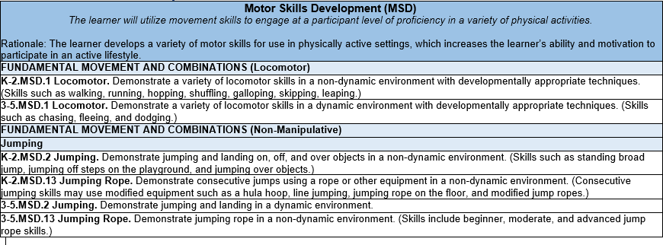

**SKILL**

**GRADE LEVEL/SPAN STANDARDS IN WHICH**

**SKILL IS TAUGHT**

**SUB-DOMAIN**

**DOMAIN**

|  |
| --- |
| **Motor Skills Development (MSD)**  *The learner will utilize movement skills to engage at a participant level of proficiency in a variety of physical activities.*  Rationale: The learner develops a variety of motor skills for use in physically active settings, which increases the learner’s ability and motivation to participate in an active lifestyle. |
| **FUNDAMENTAL MOVEMENT AND COMBINATIONS (Locomotor)** |
| **K-2.MSD.1 Locomotor.** Demonstrate a variety of locomotor skills in a non-dynamic environment with developmentally appropriate techniques. (Skills such as walking, running, hopping, shuffling, galloping, skipping, leaping.) |
| **3-5.MSD.1 Locomotor.** Demonstrate a variety of locomotor skills in a dynamic environment with developmentally appropriate techniques. (Skills such as chasing, fleeing, and dodging.) |
| **FUNDAMENTAL MOVEMENT AND COMBINATIONS (Non-Manipulative)** |
| **Jumping** |
| **K-2.MSD.2 Jumping.** Demonstrate jumping and landing on, off, and over objects in a non-dynamic environment. (Skills such as standing broad jump, jumping off steps on the playground, and jumping over objects.) |
| **K-2.MSD.13 Jumping Rope.** Demonstrate consecutive jumps using a rope or other equipment in a non-dynamic environment. (Consecutive jumping skills may use modified equipment such as a hula hoop, line jumping, jumping rope on the floor, and modified jump ropes.) |
| **3-5.MSD.2 Jumping.** Demonstrate jumping and landing in a dynamic environment. |
| **3-5.MSD.13 Jumping Rope.** Demonstrate jumping rope in a non-dynamic environment. (Skills include beginner, moderate, and advanced jump rope skills.) |
| **Balancing & Weight Transfer** |
| **K-2.MSD.3 Balance/Weight Transfer.** Demonstrate balancing and weight transfer on different body parts in a non-dynamic environment. (Skills such as tree position, downward dog – 4-point, 3-point, 2-point, balancing objects on different body parts.) |
| **3-5.MSD.3 Balance/Weight Transfer.** Demonstrate balancing and weight transfer on different body parts in a dynamic environment. (Skills such as chasing, fleeing, and dodging.) |
| **Gymnastics** |
| **K-2.MDS.4 Gymnastics.** Demonstrate safety rolling actions. (Skills such as forward roll, log roll, egg roll.) |
| **3-5.MSD.4 Gymnastics.** Demonstrate gymnastic movements. (Skills such as cartwheels, wall walk, handstands, hip circles) |
| **FUNDAMENTAL MOVEMENT AND COMBINATIONS (Manipulative)** |
| **Catching and Throwing** |
| **K-2.MSD.6 Throwing/Catching.** Demonstrate catching and throwing in a non-dynamic environment. (Skills such as self-toss and catch, drop and catch before the second bounce, partner throwing and catching underhand and overhand throwing.) |
| **3-5.MSD.6 Throwing/Catching.** Demonstrate catching and throwing in a dynamic environment. (Skills such as underhand and overhand throwing, catching above/below the waist, catching above the head.) |
| **6.MSD.9 Underhand Throwing.** Demonstrate underhand throwing techniques. |
| **7.MSD.9 Underhand Throwing.** Demonstrate underhand throwing techniques in a practice task. |
| **8.MSD.9 Underhand Throwing.** Demonstrate underhand throwing techniques in a variety of practice tasks and modified games. |

|  |
| --- |
| **Passing** |
| **K-2.MSD.7 Ball Control with Feet.** Demonstrate passing, receiving, and dribbling with feet in a non-dynamic environment. (Skills include passing the ball in a specific direction.) |
| **3-5.MSD.7 Ball Control with Feet.** Demonstrate passing, receiving, and dribbling with feet in a dynamic environment. (Skills include passing the ball to a target.) |
| **6.MSD.1 Passing.** Demonstrate passing with accuracy to a stationary target. |
| **7.MSD.1 Passing.** Demonstrate passing with accuracy to a moving target. |
| **8.MSD.1 Passing.** Demonstrate passing with accuracy in a modified game. |
| **Serving** |
| **6.MSD.3 Serving.** Demonstrate the proper underhand serving technique. |
| **7.MSD.3 Serving.** Demonstrate the proper technique and accuracy of an underhand and overhand serve. |
| **8.MSD.3 Serving.** Demonstrate the proper technique and accuracy of an underhand and overhand serve in a modified game. |
| **Receiving** |
| **K-2.MSD.7 Ball Control with Feet.** Demonstrate passing, receiving, and dribbling with feet in a non-dynamic environment. (Skills include trapping the ball with the foot.) |
| **3-5.MSD.7 Ball Control with Feet.** Demonstrate passing, receiving, and dribbling with feet in a dynamic environment. (Skills include receiving a pass from peers.) |
| **6.MSD.2 Receiving.** Receive with a mature pattern while stationary. |
| **7.MSD.2 Receiving.** Receive passes with a mature pattern while moving. |
| **8.MSD.2 Receiving.** Receive passes with a mature pattern while moving in a modified game. |
| **Striking** |
| **K-2.MSD.8 Striking with Implements.** Demonstrate striking with a short-handled implement in a non-dynamic environment. (Skills include striking with hand and striking with paddle/tennis racquet.) |
| **3-5.MSD.8 Striking with Implements.** Demonstrate striking a ball with short-handled and long-handled implements in a dynamic environment. (Skills include striking with hand and striking with paddle/tennis racquet.) |
| **6.MSD.4 Striking.** Demonstrate game-specific striking technique. |
| **7.MSD.4 Striking.** Demonstrate game-specific striking technique with accuracy. |
| **8.MSD.4 Striking.** Demonstrate game-specific striking technique with accuracy in a modified game. |
| **Forehand/Backhand Stroke** |
| **6.MSD.7 Forehand/Backhand Stroke.** Demonstrate the technique of a forehand stroke with an implement. |
| **7.MSD.7 Forehand/Backhand Stroke.** Demonstrate technique of a forehand or backhand stroke with an implement. |
| **8.MSD.7 Forehand/Backhand Stroke.** Demonstrate the technique of a forehand and backhand stroke with an implement in a practice task or modified game. |

|  |
| --- |
| **Bouncing and Dribbling** |
| **K-2.MSD.7 Ball Control with Feet.** Demonstrate passing, receiving, and dribbling with feet in a non-dynamic environment. (Skills include walking and dribbling the ball.) |
| **K-2.MSD.9 Ball Control with Hands.** Demonstrate bouncing and dribbling a ball with hands in a non-dynamic environment. (Skills include dropping and catching/bouncing a ball such as a beach ball, playground ball, or tennis ball.) |
| **3-5.MSD.7 Ball Control with Feet.** Demonstrate passing, receiving, and dribbling with feet in a dynamic environment. (Skills include dribbling the ball at various speeds.) |
| **3-5.MSD.9 Ball Control with Hands.** Demonstrate bouncing and dribbling a ball with hands in a dynamic environment. (Skills include bouncing/dribbling while moving, bouncing/dribbling in a tag game.) |
| **6.MSD.6 Dribbling.** Demonstrate game-specific dribbling technique. |
| **7.MDS.6 Dribbling.** Demonstrate game-specific dribbling technique with control. |
| **8.MDS.6 Dribbling.** Demonstrate game-specific dribbling technique with control in a modified game. |
| **Kicking a Ball** |
| **K-2.MSD.10 Kicking.** Demonstrate kicking a ball in a non-dynamic environment. (Skills include kicking stationary using various speeds.) |
| **3-5.MSD.10 Kicking.** Demonstrate kicking a ball in a dynamic environment. (Skills include kicking at various speeds with accuracy, punting, and kicking the ball in the air.) |
| **Rolling an Implement** |
| **K-2.MSD.11 Rolling an Implement.** Demonstrate rolling an implement in a non-dynamic environment. (Skills include rolling an implement to a partner or target using various speeds.) |
| **3-5.MSD.11 Rolling an Implement.** Demonstrate rolling an implement in a dynamic environment. (Skills include incorporating skills rolling an implement in a dynamic environment such as tag, bowling, bean bag toss, or pitching a kickball.) |
| **Volleying** |
| **K-2.MSD.12 Volleying.** Demonstrate volleying with hands in a non-dynamic environment. (Skills include balloon volley, lightweight ball in a garbage bag, and beach ball.) |
| **3-5.MSD.12 Volleying.** Demonstrate volleying with hands in a dynamic environment. (Skills include balloon volley, beach ball, and volleyball.) |
| **6.MSD.5 Volleying.** Demonstrate activity-specific volleying technique. |
| **7.MSD.5 Volleying.** Demonstrate activity-specific volleying technique with accuracy. |
| **8.MSD.5 Volleying.** Activity-specific volleying technique with accuracy in a modified game. |
| **Shooting** |
| **6.MSD.8 Shooting.** Demonstrate the technique of a game-specific shot on a goal. |
| **7.MSD.8 Shooting.** Demonstrate technique of a game-specific shot on a goal with accuracy. |
| **8.MSD.8 Shooting.** Demonstrate a shot on a goal in a variety of practice tasks or modified games. |

|  |
| --- |
| **SPECIALIZED MOVEMENT AND COMBINATIONS** |
| **Outdoor Pursuit** |
| **6-8.MSD.10 Outdoor Pursuit.** Demonstrate technique in an outdoor pursuit. |
| **Dance/Movement Sequences** |
| **K-2.MSD.5 Dance/Movement.** Demonstrate locomotor, non-locomotor, and manipulative movements based on various rhythmic movements. |
| **3-5.MSD.5 Dance/Movement.** Combines locomotor, non-locomotor, and manipulative movements based on various rhythmic movements. |
| **6-8.MSD.11 Dance/Movement.** Demonstrate movement sequences within varied dance styles or rhythmic activities. |
| **L1.MSD.2** Demonstrate a variety of dance styles (e.g., social, cultural, contemporary, creative) or rhythmic activities. |
| **L2.MSD.2** Choreograph or create a dance or rhythmic activity to perform. |
| **FITNESS MOVEMENT** |
| **Functional Movement** |
| **K-5.MSD.14 Functional Fitness.** Demonstrate a variety of developmentally appropriate functional fitness movements. (Movements include pull, push, lunge, bend/hinge, rotation/twist, gait.) |
| **6-8.KM.10 Warm-Up/Cool-Down.** Identify and demonstrate dynamic and static stretching to exercise in warm-up and cool-down activities. |
| **L1.MSD.4** Demonstrate techniques in flexibility for various activities. |
| **L2.MSD.4** Create and perform a flexibility routine for a selected activity. |
| **Strength and Endurance** |
| **6.MSD.12 Fitness Activity.** Demonstrate a movement-specific technique in a muscular endurance activity for a major muscle group. |
| **7.MSD.12 Fitness Activity.** Demonstrate techniques in a variety of muscular endurance training activities for some major muscle groups. |
| **8.MSD.12 Fitness Activity.** Demonstrate techniques in a variety of muscular endurance or muscular strength training activities for some major muscle groups. |
| **L1.MSD.6** Demonstrate techniques in a number of muscular strength and endurance training activities for each major muscle group. |
| **L1.MSD.7** Demonstrate techniques for at least two skill-related fitness components. |
| **L2.MSD.6** Demonstrate technique in a number of compound strength training activities. |
| **L2.MSD.7** Demonstrate techniques in three or more skill-related fitness components. |
| **Cardiovascular Techniques** |
| **L1.MSD.5** Demonstrate form, pacing, and breathing techniques in cardiovascular activities. |
| **L2.MSD.5** Sustain form, pacing, and breathing techniques in cardiovascular activities for a prolonged period of time. |
| **Lifetime Physical Activity Skills** |
| **L1.MSD.1** Demonstrate proficiency in activity-specific movement skills in a variety of individual or dual lifetime physical activities. |
| **L2.MSD.1** Demonstrate proficiency in advanced activity-specific movement skills in a variety of individual or dual lifetime physical activities. |
| **L1.MSD.3** Demonstrate combinations of movement skills in a variety of lifetime physical activities. |
| **L2.MSD.3** Demonstrate combinations of movement skills in a variety of self-selected physical activities. |

|  |
| --- |
| **Knowledge to Move (KM)**  *The learner will apply knowledge and strategies to movement and fitness concepts.*  Rationale: Knowledge helps learners refine motor performance and analyze behaviors to cultivate health. |
| **MOVEMENT CONCEPTS AND STRATEGIES** |
| **Space** |
| **K-2.KM.1 Movement Concepts.** Demonstrate where to move to avoid objects and others in personal and general space. |
| **3-5.KM.1 Movement Concepts.** Apply movement concepts and strategies to avoid objects within dynamic environments. |
| **Space (Game Strategy)** |
| **6.KM.1 Create Open Space.** Create open space by staying spread out on offense. |
| **7.KM.1 Create Open Space.** Create open space by using an offensive tactic. |
| **8.KM.1 Create Open Space.** Create open space by using multiple offensive tactics. |
| **6.KM.2 Reduce Open Space.** Reduce open space by using a defensive strategy. |
| **7.KM.2 Reduce Open Space.** Reduce open space using multiple defensive strategies. |
| **8.KM.2 Reduce Open Space.** Reduce open space through team defensive strategies. |
| **6.KM.4 Create Space and Variation.** Create open space by varying force in striking, net/wall, or field games. |
| **7.KM.4 Create Space and Variation.** Create open space by varying directions in striking, net/wall, or field games. |
| **8.KM.4 Create Space and Variation.** Create open space by varying force, placement and/or direction in striking, net/wall, or field games. |
| **Offensive and Defensive Transitions (Game Strategy)** |
| **6.KM.3 Transitions.** Transition from offense to defense and defense to offense by recovering quickly. |
| **7.KM.3 Transitions.** Transition from offense to defense and defense to offense by recovering quickly. |
| **8.KM.3 Transitions.** Transition from offense to defense and defense to offense by recovering quickly. |
| **Motor Performance** |
| **L1.KM.1** Analyze motor performance of self and/or others in relation to movement concepts and principles. |
| **L1.KM.3** Use technology to analyze and improve motor performance. |
| **L2.KM.1** Develop a plan to improve performance using movement concepts and principles. |
| **L2.KM.3** Use technology to develop a plan to improve motor performance. |
| **Dance and Rhythmic Activity Concepts** |
| **L1.KM.2** Compare similarities and differences in various styles of dance and rhythmic activities. |
| **L2.KM.2** Identify how dance and rhythmic activities contribute to skill development in other physical activities. |
| **Risk and Safety Considerations** |
| **L1.KM.4** Evaluate risks and identify safety considerations for physical activities. |
| **L2.KM.4** Evaluate risks and identify safety considerations that may affect physical activity participation throughout life. |

|  |
| --- |
| **FITNESS CONCEPTS AND STRATEGIES** |
| **Impacts of Physical Activity** |
| **K-5.KM.3 Fitness Activities.** Demonstrate developmentally appropriate physical activities that contribute to health-related fitness. |
| **K-2.KM.4 Body Responses to Movement.** Identify physiological changes in the body during physical activities. |
| **3-5.KM.4 Body Responses to Movement.** Describe how physical activity influences physiological changes in the body. |
| **K-2.KM.5 Warm-Up/Cool-Down.** Identify how a warm-up and cool-down affect the body. |
| **3-5.KM.6 Warm-Up/Cool-Down.** Describe how a warm-up and cool-down affect the body. |
| **6-8.KM.10 Warm-Up/Cool-Down.** Identify and demonstrate dynamic and static stretching to exercise in warm-up and cool-down activities. |
| **K-2.KM.6 Dimensions of Health.** Identify how physical activity supports each dimension of health. |
| **3-5.KM.6 Dimensions of Health.** Explain how physical activity supports each dimension of health. |
| **L1.KM.6** Analyze the health benefits of self-selected fitness activity. |
| **L2.KM.6** Analyze how fitness and activity will impact quality of life throughout the lifespan. |
| **Fitness Components/Concepts** |
| **6.KM.5 Fitness Components.** Define and provide examples of movement activities for developing the health-related fitness components. |
| **7.KM.5 Fitness Components.** Define and provide examples of movement activities for developing the health-related and skill-related fitness components. |
| **8.KM.5 Fitness Components.** Apply the knowledge of health and skill-related fitness components to different types of physical activity. |
| **6.KM.6 Principles of Exercise.** Identify the principles of exercise. |
| **7.KM.6 Principles of Exercise.** Describe the principles of exercise. |
| **8.KM.6 Principles of Exercise.** Apply the principles of exercise. |
| **L1.KM.5** Apply fitness concepts across all five health-related components within fitness activities. |
| **L2.KM.5** Apply fitness concepts beyond fitness activities. |
| **Cardiovascular Activities** |
| **K-2.KM.2 Pacing.** Demonstrate concepts of pacing. (Concepts include fast and slow.) |
| **3-5.KM.2 Pacing.** Apply pacing within dynamic environments. |
| **6-8.KM.7 Pacing.** Demonstrate pacing in cardiovascular activities. |
| **6.KM.8 Target Heart Rate.** Define resting and target heart rate and describe its relationship to aerobic fitness and the Borg Rating of Perceived Exertion (RPE) Scale. |
| **7.KM.8 Target Heart Rate.** Define how the Borg Rating of Perceived Exertion (RPE) Scale and Target Heart Rate can be used to adjust workout intensity during physical activity. |
| **8.KM.8 Target Heart Rate.** Apply the Borg Rating of Perceived Exertion (RPE) Scale and Target Heart Rate to adjust workout intensity during physical activity. |
| **L1.KM.7** Use technology to analyze exertion and fitness levels. |
| **L2.KM.7** Use technology to develop a plan to improve fitness levels. |
| **Muscles** |
| **6.KM.9 Anatomy.** Identify the major muscles. |
| **7.KM.9 Anatomy.** Identify the major muscles and give an example of exercises that utilize that muscle group. |
| **8.KM.9 Anatomy.** Identify the major muscle groups and give examples of exercises that utilize that muscle group. |

|  |
| --- |
| **Fitness Planning** |
| **L1.KM.7** Use technology to analyze exertion and fitness levels. |
| **L2.KM.7** Use technology to develop a plan to improve fitness levels. |
| **L1.KM.8** Develop a personal fitness plan to improve one health-related fitness component. |
| **L2.KM.8** Analyze and provide feedback on a personal fitness plan (self or others) in relation to its intended goals. |
| **Risk and Safety Considerations** |
| **L1.KM.9** Evaluate risks and identify safety considerations for fitness activities. |
| **L2.KM.9** Evaluate risks and identify safety considerations that may affect fitness participation throughout life. |
| **Incorporation of Fitness in Life** |
| **L1.KM.10** Identify several ways to incorporate physical activity throughout the entire day. |
| **L2.KM.10** Evaluate opportunities for physical activity in various occupations and how those occupations contribute to meeting daily guidelines for physical activity. |
| **Fitness Resources** |
| **L1.KM.11** Identify valid resources for physical activity and fitness. |
| **L2.KM.11** Evaluate the validity of advertising for products and/or programs pertaining to fitness and a healthy, active lifestyle. |

|  |
| --- |
| **Personal and Social Skills (PSS)**  *The learner will demonstrate responsible personal and social skills with consideration for self and others.*  Rationale: The learner demonstrates the personal and social skills necessary to make responsible decisions with consideration of self and others to produce a positive and safe learning environment. Physical Education provides a great environment to teach skills such as communication, teamwork, respect, leadership, and collaboration. |
| **PERSONAL RESPONSIBILITY** |
| **Management of Emotions and Behavior** |
| **6.PSS.1 Identify Emotions.** Identify the impact of emotions during physical activity. |
| **7.PSS.1 Identify Emotions.** Identify the impact of expressed emotions on self and others during physical activity. |
| **8.PSS.1 Identify Emotions.** Identify the impact of emotions and adjust behavior during physical activity. |
| **L1.MM.2** Assess stress levels before and after various physical activities. |
| **L2.MM.2** Track emotions, mood, and physical activity to reflect upon the interaction of these factors and their influence on personal well-being. |
| **K-2.PSS.1 Emotional Management.** Manage emotions and behaviors through practicing techniques with a teacher’s guidance. |
| **3-5.PSS.1 Emotional Management.** Develop emotional and behavioral management by applying techniques with teacher prompts. |
| **6-8.PSS.2 Emotional Management.** Demonstrate emotional and behavioral management by applying techniques. |
| **L1-L2.PSS.1** Demonstrate emotional and behavioral management by consistently implementing techniques during physical activities both in and outside of physical education. |
| **Respect/Responsibility/Ethics** |
| **K-5.PSS.2 Etiquette.** Demonstrate responsible, respectful, and safe behaviors |
| **6-8.PSS.6 Etiquette.** Demonstrate activity-specific etiquette. |
| **6-8.PSS.10 Respect.** Demonstrate respect for self and others. |
| **6-8.PSS.3 Integrity.** Demonstrate integrity in a variety of physical activities. |
| **L1.PSS.4** Analyze ethical situations in physical activity both in and outside of physical education and how choices impact self and others. |
| **L2.PSS.4** Develop personal strategies to address ethical dilemmas in physical activity both in and outside of physical education. |
| **K-2.PSS.4 Personal Hygiene.** Identify concepts of personal hygiene. |
| **3-5.PSS.4 Personal Hygiene.** Explain personal hygiene. |
| **6-8.PSS.7 Hygiene.** Demonstrate personal responsibility and social awareness through personal hygiene practices. |
| **L1-L2.PSS.7** Exhibit etiquette and respect for self, others, equipment, and facilities in physical activity settings both in and outside of physical education. |
| **Problem-Solving** |
| **K-2.PSS.3 Problem Solving.** Discuss problems and solutions with teacher support. |
| **3-5.PSS.3 Problem Solving.** Solve problems with peers independently. |
| **6-8.PSS.5 Problem Solving.** Solve problems independently with teammates and others. |
| **L1.MM.4** Evaluate opportunities and potential barriers to physical activity participation. |
| **L2.MM.4** Develop strategies to address potential barriers to physical activity. |

|  |
| --- |
| **Leadership** |
| **6-8.PSS.3 Integrity.** Demonstrate integrity in a variety of physical activities. |
| **6-8.PSS.5 Problem Solving.** Solve problems independently with teammates and others. ~~opponents~~. |
| **6-8.PSS.11 Communication.** Apply communication skills to negotiate strategies and tactics. |
| **L1.PSS.2** Assume a leadership role in a physical activity setting. |
| **L2.PSS.2** Reflect upon leadership skills and identify strengths and opportunities for growth in physical activity settings both in and outside of physical education. |
| **Safety** |
| **K-5.PSS.2 Etiquette.** Demonstrate responsible, respectful, and safe behaviors. |
| **6-8.PSS.4 Safety.** Recognize and implement safe and appropriate behaviors. |
| **L1-L2.PSS.3** Apply best practices for participating safely in physical activity both in and outside of physical education. |
| **6-8.PSS.8 CPR.** Demonstrate hands only Cardiopulmonary Resuscitation (CPR). |
| **L1.PSS.5** Demonstrate competency in performing cardiopulmonary resuscitation (CPR) and associated skills (e.g., automated external defibrillator (AED) and first aid) gained through psychomotor skills practice based on current national guidelines. |
| **SOCIAL AWARENESS** |
| **Awareness of Others/Cultural Awareness** |
| **K-2.PSS.5 Emotions.** Recognize the emotions or feelings of others during a variety of physical activities. |
| **3-5.PSS.5 Emotions.** Acknowledge the emotions or feelings of others during a variety of physical activities. |
| **6-8.PSS.9 Acceptance.** Understand and accept others’ differences. |
| **L1.PSS.6** Demonstrate awareness of others’ emotions and perspectives in physical activity settings in and outside of physical education. |
| **L2.PSS.6** Respond constructively to others’ emotions and perspectives in physical activity settings in and outside of physical education. |
| **6-8.PSS.13 Cultural Awareness.** Demonstrate cultural awareness in a variety of physical activities. |
| **L1-L2.PSS.9** Understand and respond constructively to cultural values and differences in physical activity settings in and outside of physical education. |
| **Cooperation and Teamwork** |
| **K-2.PSS.6 Cooperation.** Demonstrate cooperation with peers. |
| **3-5.PSS.6 Cooperation.** Demonstrate behaviors that promote teamwork and cooperation. |
| **6-8.PSS.9 Acceptance.** Understand and accept others’ differences in a variety of physical activities. |
| **6-8.PSS.10 Respect.** Demonstrate respect for self and others. |
| **L1-L2.PSS.8** Encourage, support, and positively contribute when working with others in activity settings in and outside of physical education. |
| **Communication** |
| **K-2.PSS.7 Communication.** Use communication skills to share space and equipment. |
| **3-5.PSS.7 Communication.** Use communication skills to negotiate roles and responsibilities |
| **6-8.PSS.11 Communication.** Apply communication skills to negotiate strategies and tactics. |
| **L1-L2.PSS.8** Encourage, support, and positively contribute when working with others in physical activity settings in and outside of physical education. |
| **Feedback** |
| **K-2.PSS.8 Feedback.** Respond appropriately to directions and feedback from the teacher |
| **3-5.PSS.8 Feedback.** Implement feedback from the teacher when prompted |
| **6-8.PSS.12 Feedback.** Provide and/or accept constructive feedback. |
| **L1-L2.PSS.8** Encourage, support, and positively contribute when working with others in physical activity settings in and outside of physical education. |

|  |
| --- |
| **Motivated to Move (MM)**  *The learner will pursue personal and meaningful physical activity.*  Rationale: The learner understands how movement is relevant and meaningful to increase their level of enjoyment and likelihood of lifetime physical activity. |
| **DEVELOPMENT OF SELF-AWARENESS** |
| **Personal Interests** |
| **K-2.MM.1 Choice.** Identify preferred physical activities based on personal interests. |
| **3-5.MM.1 Choice.** Express how personal interests influence participation in physical activity. |
| **6-8.MM.1 Choice.** Identify how choice and personal strengths impact individual engagement in physical activity. |
| **K-2.MM.2 Resilience.** Recognize strengths and growth opportunities through movement and the need for practice for individual improvement. |
| **3-5.MM.2 Resilience.** List strengths and growth opportunities through movement and opportunities for practice for individual improvement. |
| **6-8.MM.3 Resilience.** Identify barriers to enjoyment and strategies to increase meaning in physical activity. |
| **L1.MM.1** Assess personal strengths, interests, and opportunities for growth and how they influence the level or challenge selected in physical activities. |
| **L2.MM.1** Identify and participate in physical activity opportunities in the community that accommodate personal strengths, interests, and opportunities for growth. |
| **L1.MM.3** Identify physical activities that meet the need for self-expression, enjoyment, and/or social interaction. |
| **L2.MM.3** Select and participate in physical activities that meet the need for self-expression, enjoyment, and/or social interaction. |
| **Reflection** |
| **K-5.MM.3 Reflection.** Reflect on physical activity experiences. |
| **6-8.MM.2 Reflection.** Reflect on physical activity experiences specifically related to personal meaning and enjoyment. |
| **L1.MM.6** Reflect upon physical activity experiences in physical education specifically related to lifelong fitness. |
| **L2.MM.6** Reflect upon lifetime physical activity participation that occurs both in and outside of physical education. |
| **L1.MM.4** Evaluate opportunities and potential barriers to physical activity participation. |
| **L2.MM.4** Develop strategies to address potential barriers in physical activity. |
| **GOAL SETTING** |
| **K-2.MM.4 Goal Setting.** Set observable short-term goals to enhance skill development. |
| **3-5.MM.4 Goal Setting.** Set observable and attainable long-term goals to enhance skill development. |
| **6.MM.4 Goal Setting.** Set a goal based on an examination of individual ability in a physical activity. |
| **7.MM.4 Goal Setting.** Set a goal and create action steps for a goal based on an examination of individual ability in a physical activity. |
| **8.MM.4 Goal Setting.** Set a goal, create action steps, and reflect on goals based on an examination of individual ability in a physical activity. |
| **6-8.MM.5 Action Steps.** Participate in physical activity to achieve self-selected goals. |
| **L1.MM.7** Set a fitness goal and develop a progressive action plan. |
| **L2.MM.7** Set a fitness goal and develop and implement a progressive action plan. |
| **L1-L2.MM.8** Reflect on progress and adjust fitness goals and/or action steps as needed. |

|  |
| --- |
| **ENGAGEMENT IN PHYSICAL ACTIVITY** |
| **K-5.MM.5 Participation.** Participate in a variety of developmentally appropriate physical activities. |
| **6-8.MM.6 Participation.** Participate in a variety of physical activities in physical education. |
| **6-8.MM.7 Engagement.** Engage in individual and group challenges in physical education. |
| **L1.MM.5** Identify how technology could be used for personal motivation |
| **L2.MM.5** Use technology to promote personal motivation in physical activity. |
| **L1.MM.9** Participate in self-directed physical activities in physical education. |
| **L2.MM.9** Participate in self-directed physical activities both in and outside of physical education. |

**Aerobic Capacity:** The highest amount of oxygen consumed during maximal exercise in activities that use the large muscle groups in the legs or arms and legs combined.

**Agility Patterns**: Drills or exercises of the body that enhance the ability to change direction, speed, and position efficiently and effectively. They are used in sports and physical training to improve neuromuscular coordination and responsiveness to stimuli.

**Anaerobic Capacity:** The body's capacity to run its systems without using oxygen.

**Anatomy**: A branch of science concerned with the bodily structure of humans, animals, and other living organisms, especially as revealed by dissection and the separation of parts. In fitness and health, a basic understanding of anatomy helps one understand how the body works and how it responds to exercise and injury.

**Barriers to Activity**: Factors that hinder individuals or groups from engaging in physical activity. These barriers could include physical (lack of time, accessibility), psychological (lack of motivation, fear of injury), or environmental (poor weather conditions, unsafe neighborhoods). Other examples found in clarifications in middle school standards are lack of physical activity, dangerous behaviors, use of illicit substances, poor dietary habits, and access to resources.

**Borg Rating of Perceived Exertion (RPE) Scale:** A way of measuring physical activity intensity level. It is based on the physical sensations a person experiences during physical activity, including increased heart rate, increased respiration or breathing rate, increased sweating, and muscle fatigue.

**Cardiorespiratory endurance:** Cardiorespiratory endurance is the ability of the heart and lungs to absorb, transport, and utilize oxygen over an extended period of physical exertion.

**Cardiovascular System**: The system comprising the heart and blood vessels, which circulates blood throughout the body.

**Clean (Lift)**: A weightlifting movement where a barbell or other weight is lifted from the floor to a racked position at the shoulders in one fluid motion. It is commonly used in strength and conditioning programs to develop explosive power and muscular coordination.

**Communication**: An imparting or exchanging of information by speaking, writing, or using some other medium. Effective communication is vital in ensuring information is clearly understood and actions are effectively coordinated among individuals or groups.

**Community Setting**: Various environments or locations within a community where activities take place, such as schools, parks, recreation centers, or community halls.

**CPR (Cardiopulmonary Resuscitation)**: A lifesaving technique used in emergencies where someone's breathing or heartbeat has stopped, typically after an electric shock, a heart attack, or drowning. CPR involves chest compressions and, if trained, mouth-to-mouth resuscitation to maintain circulatory flow and oxygenation during cardiac arrest.

**Cultural Awareness**: An understanding of the differences and similarities between cultures without assigning values, such as better or worse, right or wrong. Cultural awareness promotes effective communication, respects diversity, and improves social and professional interactions.

**Developmentally Appropriate**: Activities or practices that are suitable for the age, ability, and developmental stage of an individual or group.

**Dynamic Environment**: An environment that requires individuals to adapt physically and mentally, characterized by constant change and variability, which can influence the type of physical activities performed. Examples include invasion games such as ultimate and soccer and net/wall games such as volleyball and tennis.

**Dynamic Stretching**: A form of stretching involving movement, where muscles are stretched through active movements that mimic the sport or activity to be performed. Dynamic stretching is often used as part of a warm-up to prepare the body for physical activity, improving range of motion and reducing the risk of injuries.

**Emotional Management**: The ability to be aware of and handle one's emotions in a productive and healthy manner. It involves techniques that help individuals control their responses to emotional triggers in their environment.

**Ethical Situation**: A situation in which a decision must be made about appropriate conduct when choices involve a conflict where values are in opposition. Examples may include intentional fouls, performance-enhancing substances, and sports gambling.

**Etiquette**: Refers to the rules and manners observed in gym settings, sports competitions, or group exercise classes to ensure safety, respect, and a positive environment for all participants.

**Exercise**: Activity requiring physical effort, carried out to sustain or improve health and fitness.

**Fitness activities:** Activities with a focus on improving or maintaining fitness.

**Fitness Goal:** A specific, measurable, attainable, relevant, and time-bound (SMART) objective set by an individual or a coach to improve one’s physical condition.

#### Functional Fitness Movements

* **Gait**—The technique of walking. Exercises include jogging, jumping, and farmer’s walk.
* **Hinge/Bend**—The movement executed by sitting your butt back and leaning your torso forward while maintaining a neutral spine—like when picking up something off the floor.
* **Lunge**—The movement involving your body in a less stable position of one foot further forward than the other.
* **Pull**—The pulling motion consists of pulling a weight/object toward your body or your body toward your hands. This can be a vertical or horizontal pull, such as a pull-up or barbell row, respectively. The muscles targeted are the mid and upper back, biceps, forearms, and rear shoulders.
* **Push**—The opposite of pull, push involves pushing a weight or object away from your body or your body away from an object. The muscles targeted are the triceps and front shoulders.
* **Rotation/Twist**—Rotation is seen while throwing a ball, kicking a ball, changing directions while running, and many other actions.
* **Squat**—Variations of the squat include goblet squats, sumo squats, front squats, and much more. The squat targets the glutes, core, quadriceps, and, to a slight degree, the hamstring muscles.

**Health Related Fitness Components**: Fundamental principles based on physical fitness and exercise. Concepts include muscular strength, muscular endurance, cardiovascular endurance, body composition, and flexibility, as well as principles related to exercise programming, progression, specificity, and overload.

**Hygiene**: Conditions or practices conducive to maintaining health and preventing disease, especially through cleanliness. In sports and fitness settings, hygiene includes practices like washing hands, cleaning equipment, and using clean attire to prevent infections and maintain a healthy environment.

**Integrity**: Consistency in actions, values, methods, measures, principles, expectations, and outcomes.

**Lifetime Physical Activity**: Activities that an individual can participate in throughout their life to maintain health and wellness. Lifetime physical activities can be adapted to changing life stages, preferences, and physical capabilities.

**Long-handled Implement**: Equipment used in physical activities with a long handle that enhances leverage and reach. Common examples include lacrosse sticks, hockey sticks, baseball bats, and golf clubs.

**Locomotor Skills**: Fundamental movement patterns that involve moving the body in any direction from one point to another. Locomotor skills include walking, running, hopping, skipping, jumping, sliding, and galloping.

**Manipulative Skills**: Involve handling, moving, or controlling objects with the hands or feet while standing still or moving. Examples may include throwing, catching, kicking, dribbling, and striking.

**Mature Pattern**: Refers to the fully developed stage of a movement skill, where the individual performs with a high degree of coordination, control, and efficiency.

**Maximum Heart Rate**: The highest number of heartbeats per minute during maximum physical exertion. Maximum heart rate is typically calculated by subtracting the person's age from 220.

**Modified Game**: A sport or game that has been adapted to suit the abilities, equipment, or number of participants. Modifications may include changes to rules, equipment, playing area, or duration to make the game more inclusive, safer, or age-appropriate.

**Non-Dynamic Environment**: An environment that remains relatively stable and unchanging during physical activity, allowing for more controlled and predictable movements.

**Non-Manipulative Skills**: Physical activities that involve moving the body using large muscle groups but do not involve controlling objects. Examples may include bending, stretching, twisting, turning, and balancing.

**Outdoor Pursuits**: Recreational or educational activities performed in natural settings, which often involve exploration and adventure. Examples may include hiking, canoeing, rock climbing, and orienteering.

**Pacing**: A rate at which a physical activity or series of movements is conducted. It helps individuals optimize performance and avoid fatigue.

**Physical Activity**: Any bodily movement produced by skeletal muscles that results in energy expenditure. It encompasses everyday activities, exercise, and sports.

**Physical Education**: A formal instructional program that provides learners the opportunity to develop knowledge, skills, and motivation related to physical literacy. It aims to develop physical competence, health-related fitness, and a lifelong commitment to meaningful movement experiences.

#### Principles of Exercise

* **Specificity)**—the principle that involves training to be relevant and appropriate to the sport for which the individual is training in order to produce the desired effect.
* **Overload**—involves increasing the intensity, time, type, or frequency of activity more than usual to increase fitness.
* **FITT Principle—**an acronym for Frequency, Intensity, Time, and Type, the FITT principle increases the amount of work the body does to achieve overload.
* **Perceived Level of Exertion (Borg’s RPE)**—a way of measuring physical activity intensity. The Borg Rating of Perceived Exertion (RPE) is a scale from 6 to 20, where 6 means no exertion at all and 20 means maximal exertion.

**Problem-Solving**: The process of finding solutions to difficult or complex issues.

**Progressive Action Plan**: A strategy involving the setting of a series of short-term goals that build progressively towards mid- to long-term goals, ensuring continual improvement.

**Psychomotor Skills**: Skills involving the coordination of cognition and motor skills.

**Respect**: Involves acknowledging the rights, beliefs, and customs of others and treating them with consideration and courtesy.

**Risk**: A potential for loss, injury, or other adverse effects resulting from physical activity.

**Rhythmic Movement**: a movement that follows a pattern or sequence that may be repeated and involves a tempo or rhythm. It can include activities like dancing, agility footwork, swimming, and gymnastics.

**Self-Directed Physical Activity**: Physical activities chosen by the individual that require minimal to no supervision. This independence in fitness allows for adapting exercise routines to personal schedules, preferences, and goals.

**Short-handled Implement**: A tool or equipment used in sports or physical activities with a short handle for mobility and control, such as a pickleball paddle.

**Skill-Related Fitness Components**: Aspects of fitness that form the basis for successful sport or activity participation. This includes agility, balance, coordination, power, reaction time, and speed.

**Small-Sided Game**: A modified, scaled-down version of a game designed to focus on specific skills or tactics. These games involve fewer players and often a smaller playing area.

**Snatch (Lift)**: A type of weightlifting exercise where a barbell is lifted from the ground to overhead in one continuous motion, requiring substantial strength, agility, and coordination.

**Static Stretching**: Stretching a muscle (or group of muscles) to its furthest point and then maintaining or holding that position. It is often done after exercising to help with muscle recovery.

**Striking**: Hitting or attacking an object or opponent with a tool, implement, or body part, such as a bat, racquet, or hand. It is commonly used in sports like baseball, tennis, and martial arts.

**Target Heart Rate**: The desired range of heart rate reached during aerobic exercise, which enables one’s heart and lungs to receive the most benefit from a workout. This range varies by age and physical condition.

**Weight Transfer**: The shifting of body weight from one part of the body to another to achieve movement or stability.

## Appendix A – Quality Resources to Enhance Instruction

**National PE Organization:** SHAPE America

<https://www.shapeamerica.org/standards/pe/new-pe-standards.aspx>

SHAPE America National Physical Education Standards Pocket Planner, 2024 SHAPE America National Physical Education Standards Educator Kit, 2024

National Physical Education Standards are used under license from SHAPE America. © 2024, SHAPE America, [https://www.shapeamerica.org/.](https://www.shapeamerica.org/) All rights reserved.

**State Physical and Health Educator Organization:** North Dakota Society of Health and Physical Educators - [www.ndshape.org](http://www.ndshape.org/)

**OPEN:** Free online resource that provides lesson plans and progression for every unit you can possibly imagine. Professional development and networking options are also available. <https://openphysed.org/>

**Dynamic PE ASAP:** Online resource with lesson plans, lesson plan generator, and professional development <https://www.dynamicpeasap.com/pages/elementary/>

**Believe In You** - Empowerment, Leadership, Professional Development resources. Great Google Classroom and PDF leadership program. Three Season Video Series on Leadership and Belief in Self. <https://believeinyou.varsityuniversity.org/>

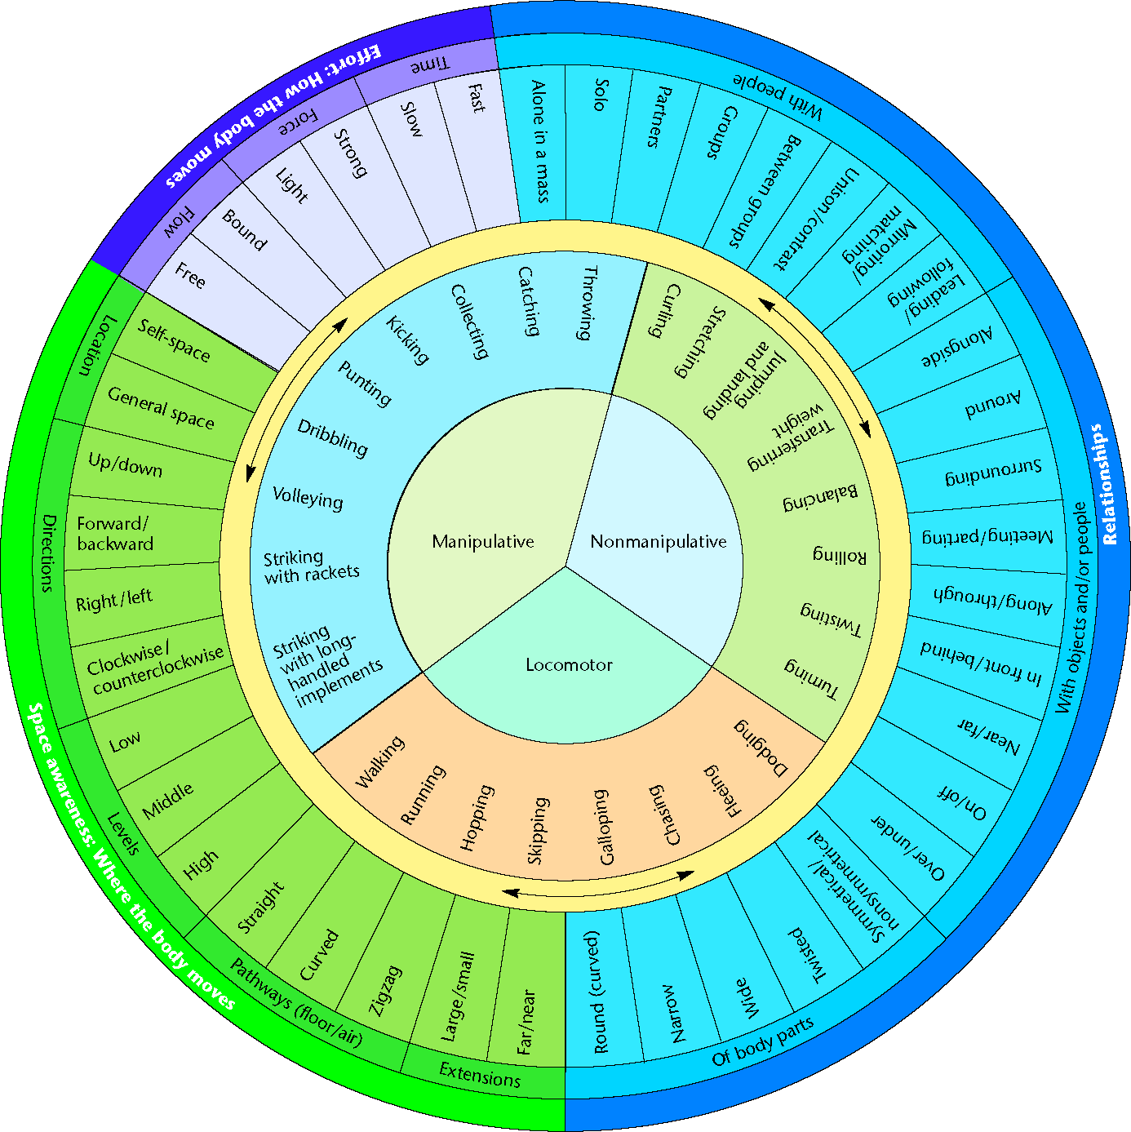

Graham, G., Holt-Hale, S.A., Parker, M., Hall, T., Patton, K. (2020) *Children Moving: A reflective approach to teaching physical education.* (10th ed.) McGraw Hill Education.

|  |  |  |
| --- | --- | --- |
| **Jumping**   * Knees bent * Arms swing * Push off ground * Extend legs * Bend knees * Land softly | **Static Balancing**   * Eyes focused * Adjust body   **Dynamic Balance**   * Posture/Utilize Core Muscles * Arms as needed * Eyes focused on fixed object | **Rolling Implement**   * Step with the opposite foot * Swing Arm * Release implements low-to-ground * Follow through with a hand toward the target |
| **Kicking**   * Plant foot next to a ball * Contact ball * Follow through toward the target | **Throwing Overhand**   * Step with the opposite foot * Reach back * Side to target * Follow through toward the target with body rotation. | **Throwing Underhand**   * Face target * Step in opposition * Reach back * Release the ball between the knees and chest * Follow through |
| **Catching**   * Eyes on object * Reach out arms * Thumbs above waist * Pinkies below waist * Track object to hands * Bring the object to the body | **Receiving**   * Eyes on object * Reach out (with/without implement) * Accept/absorb impact | **Serving**   * Face target * Step in opposition * Striking hand back/forward * Follow through |
| **Dribbling with hands**   * Finger pads * Firm push ball flexible wrist * Consistent force push * Eyes up | **Dribbling with feet**   * Contact ball with inside and outside of feet * Alternate feet as you move forward * Small taps for control * Eyes forward | **Jumping Rope**   * Elbows close to sides * Spin from wrists * Eyes forward * Jump on balls of feet * Stand tall * Jump small |
| **Striking**   * Feet position (athletic stance) * Track object * Contact ball * Follow through toward the target | **Striking with Short Implement (one-handed implements)**   * Eyes on object * Non-striking shoulder towards the target step with the opposite foot (forehand) * Striking shoulder towards the target, step with same foot (backhand) * Implement back * Follow through | **Striking with Long Implements (two-handed implements)**   * Appropriate grip for specific implement * Eyes on object * Side to target (consider forehand/ backhand shot) * Truck rotation (sport specific) * Follow through |

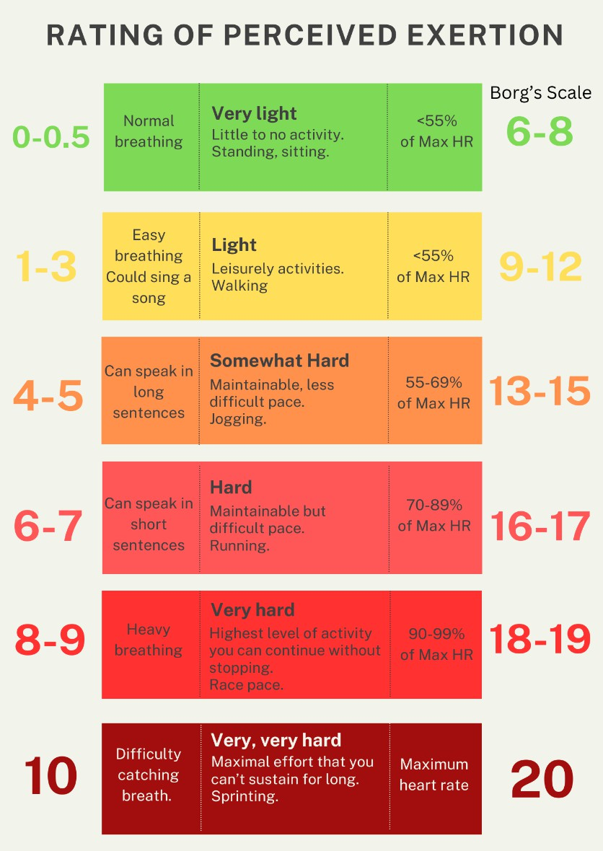

Adapted from Watson, Thomas. “Rate of Perceived Exertion: Why Rpe Is the Best Running Metric.” *Marathon Handbook*, 17 June 2021, marathonhandbook.com/rate-of- perceived-exertion/.

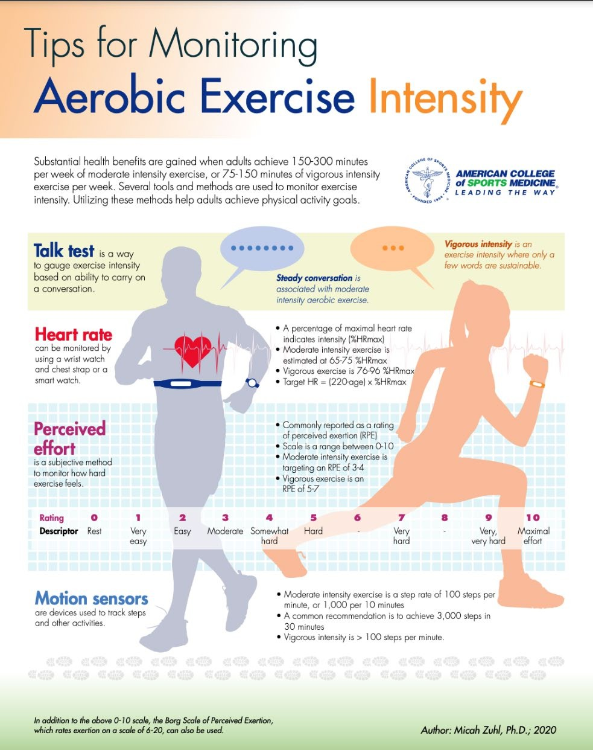

American College of Sports Medicine <https://www.acsm.org/blog-detail/acsm-certified-blog/2020/05/01/monitoring-aerobic-exercise-intensity-download>

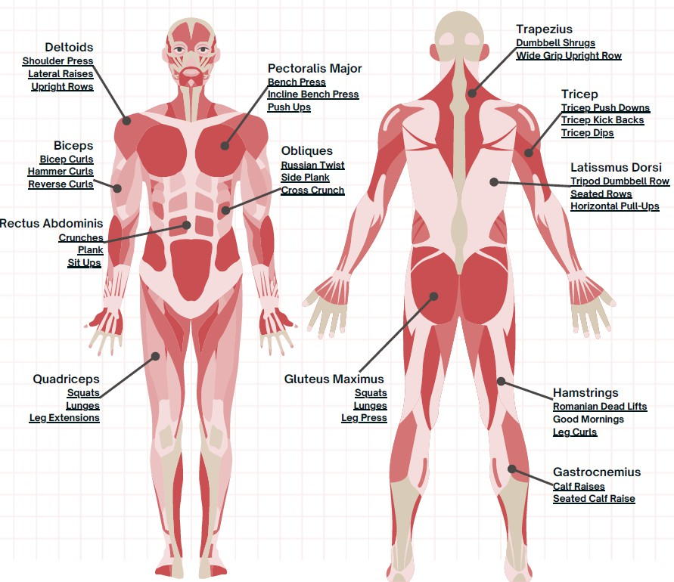

Swedberg, Leah. “Parts of the Human Muscular System,” *Canva*, 1 Jan. 2024. Accessed 16 Apr. 2024.

Absolute Balance. (2024). *RPE-based training – What is the Borg RPE scale, and how can I apply it to my workouts?* Absolute Balance Exercise Physiology Group. Retrieved April 16, 2024, from [https://absolutebalance.com.au](https://absolutebalance.com.au/)

Borg, G. A. (1982). Psychophysical bases of perceived exertion. *Medicine and Science in Sports and Exercise, 14*, 377-381. <https://doi.org/10.1249/00005768-198205000-00012>

Centers for Disease Control and Prevention. (2019, December 4). *Target heart rate and estimated maximum heart rate* | Physical activity | CDC. Retrieved April 16, 2024, from <https://www.cdc.gov/physicalactivity/basics/measuring/index.html>

Cooper Aerobics Health and Wellness. (2024). *Pump up your workout with heart rate tracking.* Cooper Aerobics. Retrieved April 16, 2024, from <https://www.cooperaerobics.com/Health-Tips/Fitness-Files/Pump-Up-Your-Workout-with-Heart-Rate-Tracking.aspx>

Graham, G., Holt-Hale, S. A., Parker, M., Hall, T., & Patton, K. (2020). *Children moving: A reflective approach to teaching physical education* (10th ed.). McGraw Hill Education.

Kentucky Academic Standards for Physical Education. (2018). Retrieved April 15, 2024, from <https://education.ky.gov/curriculum/standards/kyacadstand/Documents/Kentucky_Academic_Standards_for_Physical_Education.pdf>

National Physical Education Standards are used under license from SHAPE America. (2024). SHAPE America. Retrieved from <https://www.shapeamerica.org/>

North Dakota Physical Education Content Standards. (2015, July). Retrieved April 15, 2024, from

<https://www.nd.gov/dpi/sites/www/files/documents/Academic%20Support/FINAL%20PE%20Standards%202024.pdf>

Swedberg, L. (2024, January 1). Parts of the human muscular system. Canva. Retrieved April 16, 2024, from [https://www.canva.com](https://www.canva.com/)

Wisconsin Standards for Physical Education. (2020, May). Retrieved April 15, 2024, from <https://dpi.wi.gov/sites/default/files/imce/standards/New%20pdfs/PhysicalEducationStandards2020.pdf>

NOTE: Artificial Intelligence (AI) was used to assist with the editing and wording of this document in the introduction and glossary.