MISS Intervention Referral

Student Profile

|  |  |  |  |
| --- | --- | --- | --- |
| Student Name: |  | DOB: | |
|  |  |  |  |

Grade:

* IEP

Teacher:

* 504 Plan ❑ Attendance Issues ❑ Has Been Retained ❑ ELL

Has this student had a vision screening? Yes No Unsure

Has this student had a hearing screening? Yes No Unsure

How many times has this student been counted absent?

How many times has this student been counted tardy?

Student Living Situation (circle all that apply):

Parent(s) Grand Parents Other Relatives Foster Care

Current Pull-Out Services (If Applicable)

|  |  |  |  |
| --- | --- | --- | --- |
| Area | Amount of Time | Days Per Week | Teacher |
| Speech |  |  |  |
| Math |  |  |  |
| Reading |  |  |  |
| Tutoring |  |  |  |

Who Reported Concern: ❑ Teacher ❑ Parent Date:

Area Of Concern: Reading Writing Math Behavior Speech

Hearing Vision Other:

MTSS Intervention Referral Student Data

Assessment Date

Student Score

Benchmark Goal

|  |  |  |  |  |  |
| --- | --- | --- | --- | --- | --- |
| DIBELS (elementary): |  |  |  |  |  |
| Assessment Date | Student Score | Benchmark Goal |  |  | Notes/ Accommodations: |
|  |  |  |  |  |
|  |  |  |  |  |
|  |  |  |  |  |
|  |  |  |  |  |
|  |  |  |  |  |

STAR Reading:

*Please include a STAR Math diagnostic report by going to: reading assessments > reports > diagnostic > student selection

|  |
| --- |
| Notes/ Accommodations: |

STAR Math:

*Please include a STAR Math diagnostic report by clicking reading assessments > reports > diagnostic > student selection

Grades (MS & HS Use)

Notes/ Accommodations:

Assessment Date

Student Score

Benchmark Goal

|  |  |  |  |  |  |
| --- | --- | --- | --- | --- | --- |
| Area | Q1 | 02 | Q3 | Q4 | Teacher |
|  |  |  |  |  |  |
|  |  |  |  |  |  |
|  |  |  |  |  |  |
|  |  |  |  |  |  |
|  |  |  |  |  |  |

MTSS intervention Referral Observation/Notes

**Date: Observation/Notes**

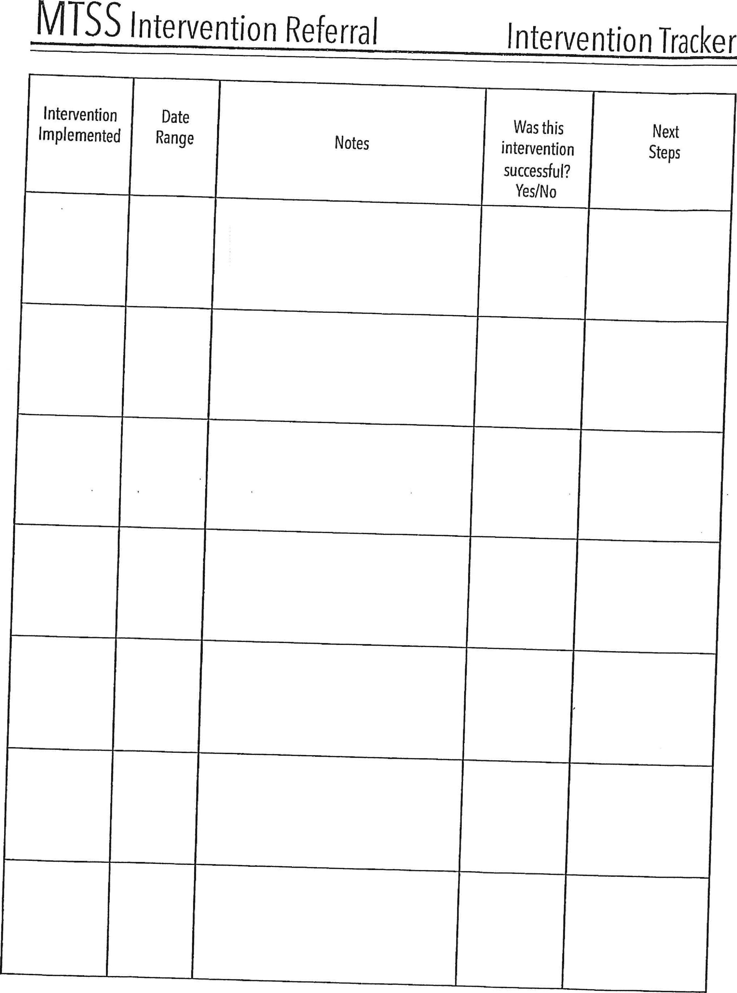

Intervention Date

Implemented Range

Notes

Was this Next

intervention Steps

successful?

Yes/No

MISS Intervention Referral Intervention Tracker

MISS Intervention Referral Meeting Notes

Date: Meeting Notes Next Steps