QT 5.6

Gaming-shot :

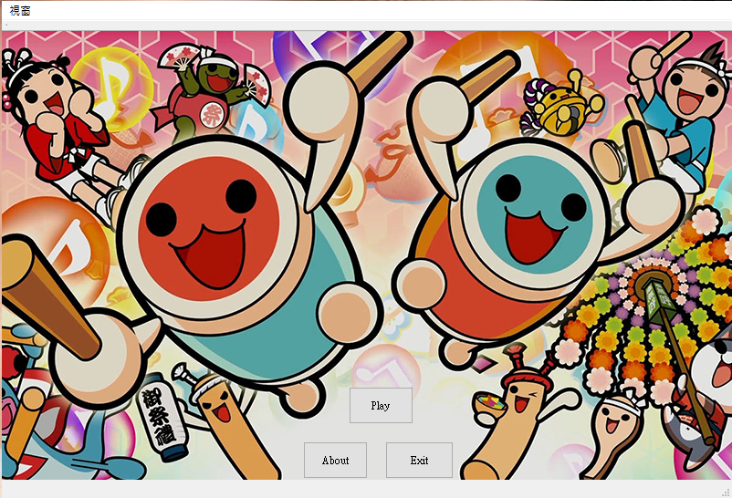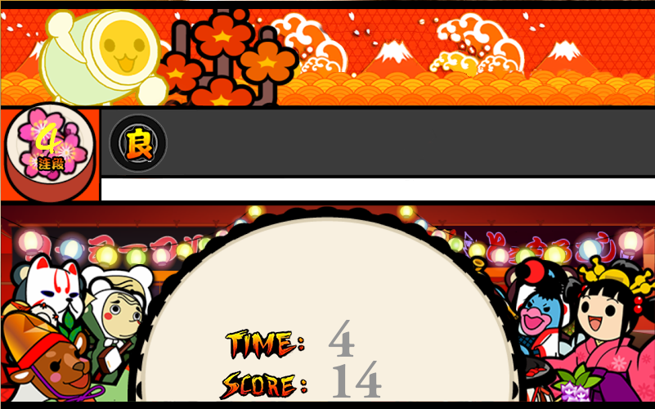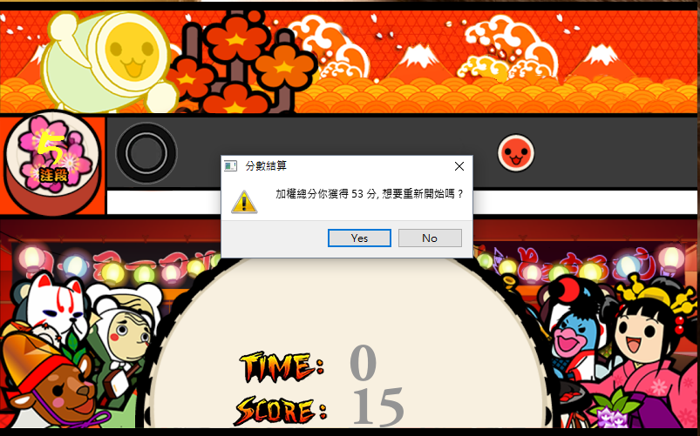

How to play :

按主頁的About

用 J (紅臉) 和 L(藍臉)

Program architecture:

先把視窗的各項物件replace 好

再將PushButton,Slot……等Function寫好

然後照著網路上的太鼓達人遊戲畫面仿作

最後用QMessagebox表示紀錄分數和詢問是否重新在玩一次

UML class diagram :

|  |
| --- |
| MainWindow  Member Function:  -void on_start_clicked();  -void on_about_clicked();  -void on_exit_clicked(); |
| About  Member Function  -void on_pushButton_clicked(); |
| OpenGUI.h :  Member Function:  +void setup();  +void taikorun();  +void EndDL();  -void *keyPressEvent*(QKeyEvent*);  -void Event(QEvent*);  -void wait(unsigned int msec); |